Project Check-in 1
EV Charging Data Analysis Across NYC Lots
Team ID: 3
Zubaer Chowdhury, Tasmia Alamgir, Tasin Tayeba Khan, Matthew Goldman
- What dataset you are planning to use (a short description and link suffices).
The dataset includes electric vehicle (EV) charging data collected from charging stations in NYC municipal lots and garages.
Link: https://data.cityofnewyork.us/Transportation/Electric-Vehicle-EV-Charging-Data-Municipal-Lots-a/kj7g-u4gp/about_data
- At least two examples of aspects of the data you would like to visualize using tools from descriptive statistics.
- Barplots: “Count of sessions” per “Station Name”
- Boxplots: Compare Energy Provided by Station Name, Location, or Session Status
- Histograms: Distribution of Energy Provided (kWh) or Charge Duration (min)
- Quantile plots: For Energy Provided to check normality
- Box–Cox transform: To normalize skewed variables like Energy Provided
- At least two examples of what types of hypothesis tests you're planning to run.
- Welch t-test: For the same Station, does the average Energy Provided differ between Weekdays and Weekends?
- Weekday pattern (goodness-of-fit): Are sessions uniformly distributed across the 7 weekdays?
Test: χ² goodness-of-fit on counts by weekday.
- Two-prop z test: Weekdays work hours vs weekdays non-work hours
From date→ we can get time stamps from connected_time and disconnected_time and compare p(Valid) weekdays work hours vs weekdays non-work hours (Two-prop z.)
- Correlation Analysis:
- Charge duration vs Energy Provided
  - Are charge_duration_min and Energy Provided (kWh) strongly correlated? (Pearson/Spearman.)
- Connected vs charge duration
  - Are connected_duration_min and charge_duration_min strongly correlated? (Pearson/Spearman.)
Project Check-in 2
Electric Vehicle (EV) Charging Station Analysis

Zubaer Chowdhury, Tasmia Alamgir, Tasin Tayeba Khan, Matthew Goldman

Q. Please write two paragraphs about your group's progress on the project in the last week (from 11/6 through 11/13). Only one member of each group needs to submit.
We inspected the dataset and performed null checks, column type checks, reviewed the documentation regarding each of the column headings and data types. This helped us figure out the scope of the dataset we will be working on including total number of rows and columns as well as the types of statistical calculations that we would like to perform on the data.
The following data preprocessing steps will be taken:
- Data Preprocessing Steps:
  - Choose ID tag as unique identifier
  - Remove columns: Driver_id and Invalidity_reason, country
  - Sort the data based on date
    - Take data points those have metadata
  - Get rid of the session_status: Disconnected
  - Pick one: Station_name or Charger_id
  - We will check null values and get rid of that
  - We want to add week day
  - We can put holidays column for a specific year: 2024
  - We can generate different tables for specific locations
- We are doing coding part for performing descriptive analysis and different tests

Project Check-in 3
Electric Vehicle (EV) Charging Station Analysis

Zubaer Chowdhury, Tasmia Alamgir, Tasin Tayeba Khan, Matthew Goldman

Q. Please write two paragraphs about your group's progress on the project in the last week (from 11/13 through 11/20). Only one member of each group needs to submit.
We added boiler plate code outline for each of the stages: importing, preprocessing, graphing and analysis. We configured the R Markdown environment and loading the required libraries for data cleaning, visualization, and statistical analysis. The EV charging dataset is then imported and performs a series of preprocessing steps: removing duplicate entries based on the ID Tag identifier, dropping irrelevant columns, converting date fields, sorting observations chronologically, filtering out disconnected charging sessions, and removing rows with missing values. Additional features such as weekday labels and a holiday indicator for 2024 are created to support later exploratory analysis. This prepares us for a clean, structured dataset suitable for both descriptive and inferential work.

After cleaning the EV dataset, we are preparing to perform a general exploratory data analysis workflow using the built-in mtcars dataset as a placeholder. It produces frequency tables, bar plots, summary statistics, box plots, correlation matrices, histograms, Q-Q plots, and normality tests for both categorical and numerical variables. For numerical features that do not follow a normal distribution, the code applies Box-Cox transformations and visualizes before-and-after effects on distributions. In the end, we will be summarizing the dataset characteristics and outlining where users should add project-specific interpretations and findings
Sample Dataset: https://data.cityofnewyork.us/api/v3/views/kj7g-u4gp/query.json?pageNumber=1&pageSize=50&app_token=KWKmRET1rNRGvKsXfmcuJHsux

Data Cleaning Ideas
- Remove commas
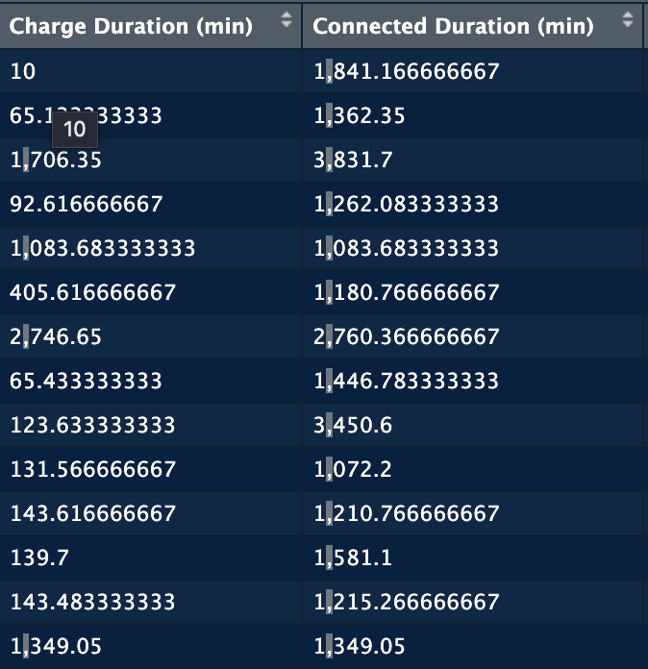
- Check for negative values or zeros that don't make sense (e.g., 0 kWh energy with long charge time)
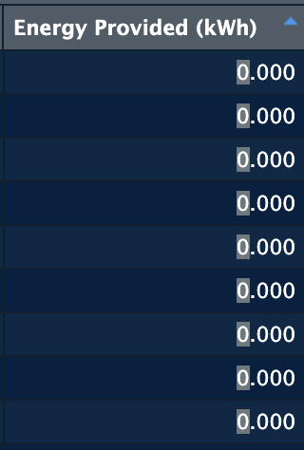
- Standardize location naming to avoid confusion of one place having different names
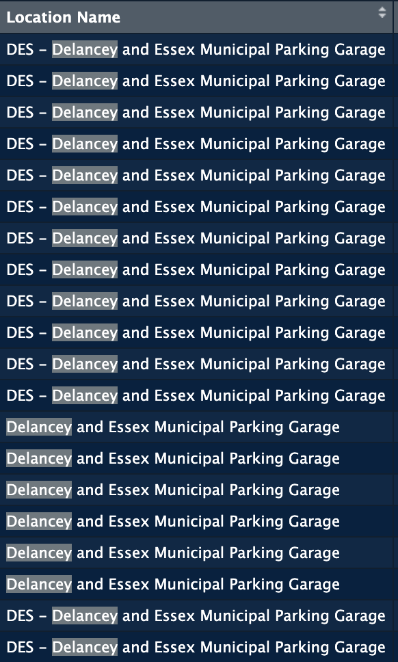
Create Derived Variables
- Extract charger manufacturer from Station Name (BTC Power, EVB, EVX, Tritium, Unknown)
  - Why
    - Popular company?
    - By which company the power was consumed most?
    - Etc etc
  - How to extract the name? Pattern matching (regex) → Idea is already given in the dataset description
- Calculate charging efficiency: Energy / Charge Duration (kWh per minute)
  - Which company is more efficient?
- Create a "Weekend" flag (Saturday/Sunday vs weekdays)
- Extract hour of day from Connected Time (for peak hour analysis)
- Idle_Time: Connected Duration − Charge Duration
- Average charging power (kW) = Energy (kWh) / Charge Duration (kWh per minute) ​
- We can compare:
  - Average power by manufacturer,
  - Or by location,
  - Or by time of day (peak vs off-peak power usage).
- Time-of-day categories:
  - Time block:
    - morning (6–11),
    - midday (11–16),
    - evening (16–22),
    - night (22–6).
This lets us do cleaner barplots/ANOVAs than using raw hours.
Handle Anomalies
- Sessions with very short duration but high energy (or vice versa) - for descriptive analysis
- Sessions where Connected Duration >> Charge Duration (vehicle parked but not charging)
Descriptive Statistics Ideas
- Frequency table → Session Status distribution; Weekday distribution; Location distribution
- Frequency barplot → Sessions by weekday; Sessions by location; Sessions by charger manufacturer
- Center & dispersion → For Energy Provided (kWh) and Charge Duration (min): mean, median, trimmed mean, IQR, variance, CV, skewness
- Side-by-side boxplots → Energy by weekday; Charge duration by location; Energy by Session Status (Paid vs Roaming)
- Scatterplot + correlation → Charge Duration vs Energy Provided; Connected Duration vs Charge Duration
- Histogram with mean/median → Energy Provided distribution; Charge Duration distribution
- Quantile plot (Q-Q) → Check normality of Energy Provided or Charge Duration
- Box-Cox transformation → Apply to Energy or Duration if heavily skewed (likely right-skewed)
- Heatmap of temporal usage : Using your weekday + hour of day:
  - Heatmap (or tile plot) of:
    - Number of sessions by weekday × hour of day,
    - Or average energy per session in that grid.
    - This visually shows “rush hours” for charging (e.g., weekday evenings vs weekend afternoons).
Interesting patterns to explore from these desc stat:
- Do weekends have longer charging sessions than weekdays?
- Which locations deliver the most energy per session?
- Is there a difference between "Paid" vs "Roaming" session characteristics?
- Holiday vs non-holiday charging behavior
Hypothesis Testing Ideas
- Inference about mean(s) (Two-sample t-test or CI) →
  - Is the mean energy provided on weekends different from weekdays?
- Inference about variance(s) (F-test) →
  - Is the variance in charge duration the same across two locations (e.g., Bay Ridge vs Court Square)?
- Inference about proportion(s) (One-proportion z-test or CI) →
  - Is the proportion of successful (PAID) sessions ≥ 90%?
- Inference about two proportions (Two-proportion z-test) →
  - Is the proportion of ROAMING sessions different on holidays vs non-holidays?
- Chi-square (Chi-square test of independence) →
  - Is Session Status independent of Weekday?; Is charger manufacturer independent of location?
- ANOVA (One-way ANOVA) →
  - Does mean energy provided differ across the 7 weekdays?; Does mean energy differ across locations?
- Inference about correlation (Pearson correlation with CI) →
  - Is there a significant correlation between Charge Duration and Energy Provided?
- Regression (Multiple linear regression) →
  - Can we predict Energy Provided from Charge Duration, Location, and Weekday?
Narrative
- Efficiency Analysis: Which locations or charger types deliver energy most efficiently? Are newer chargers (by station name pattern) more efficient?
- Usage Patterns: How does EV charging behavior differ between weekdays and weekends? Between holidays and regular days?
- Session Success: What factors are associated with session status? Are certain stations more prone to failed sessions?
- Peak Hours: When do people charge most? Does this vary by location?
- Idle Time: How much time do vehicles stay connected without actively charging (Connected Duration − Charge Duration)?

Inferential Statistics:
1) Inference about mean(s)
- Mean sessions per charger-day: Is the mean daily session count per charger greater than 3?
Test: one-sample t-test on site-day means. H0: μ = 3 vs H1: μ > 3.
- Mean energy per session: Is the mean kWh per session at municipal chargers at least 12 kWh?
Test: one-sample t-test on session-level kwh.
- Mean energy per valid session
H0: μ_{energy_provided_kwh} = 12 vs H1: μ ≠ 12. (One-sample t.)
Filter: session_status="Valid" & invalidity_reason is null.
- Mean charge duration
H0: μ_{charge_duration_min} ≤ 60 vs H1: μ > 60. (One-sample t.)
- Mean sessions per station-day (aggregate first)
Build station-day counts from date, station_name; test H0: μ = 3. (One-sample t.)

2) Inference about variance(s)
- Stability across boroughs: Is the variance of daily sessions per site different between Manhattan and Queens?
Test: F-test (two groups) on site-day sessions.
- Session duration spread by charger type: Do Level 2 chargers have a different variance in session_minutes than DCFC?
Test: F-test on session_minutes by charger_type.
- Variance of charge duration by connector
H0: Var(charge_duration_min | connector 1) = Var(... | connector 2). (F-test/Levene.)
- Variance of energy delivered across stations
Aggregate mean kWh per station; test equality of variances between two chosen stations or between top vs bottom quartile stations. (F-test/Levene.)
- Does variance of charge time change from earlier in the year than later in the year? Does it infer more usage of car/slower charging/less frequent charging at stations?

3) Inference about proportion(s)
- Share of DC fast chargers: Is the proportion of DCFC among all municipal ports ≥ 20%?
Test: one-sample z-test for a proportion on charger_type == "DCFC".
- Peak-hour usage: Is the proportion of sessions starting 5–9 pm above 30%?
Test: one-sample z-test for proportion on start_hour bucket.
- Proportion of valid sessions
H0: p_{Valid} = 0.95 vs H1: p < 0.95 using session_status. (One-sample z for a proportion.)
- Proportion of sessions ≥ 30 kWh
Create indicator energy_provided_kwh ≥ 30; H0: p = 0.25. (One-sample z.)
4) Inference about two proportions
- DCFC mix by area: Is the proportion of DCFC ports higher in Manhattan than in the outer boroughs?
Test: two-proportion z-test on counts of DCFC vs total ports by area.
- Session success rate: Is the successful-session proportion (e.g., non-error completions) different between Vendor A and Vendor B?
Test: two-proportion z-test on success_flag.
- Validity rate: weekdays vs weekends
From date→weekday; compare p(Valid) weekday vs weekend. (Two-prop z.)
- Long-session rate by connector
Indicator connected_duration_min ≥ 120; compare p between connector_id 1 vs 2. (Two-prop z.)

5) χ² inference (goodness-of-fit / independence)

Weekday pattern (goodness-of-fit): Are sessions uniformly distributed across the 7 weekdays?
Test: χ² goodness-of-fit on counts by weekday.
- Type × Borough (independence): Is charger type (Level 2 vs DCFC) independent of borough?
Test: χ² test of independence on contingency table borough × charger_type.
- Facility × Outcome: Is facility type (lot vs garage) independent of session outcome (success/fail)?
Test: χ² test of independence.
- Independence: session status × connector
Contingency table of session_status (Valid/Invalid) by connector_id. (χ² independence.)

6) ANOVA
- Energy delivered by borough: Do mean kWh per session differ across boroughs?
Test: One-way ANOVA with kwh ~ borough. (Post-hoc: Tukey.)
- Utilization by charger type: Do mean sessions per charger-day differ among Level 2, DCFC-50kW, DCFC-150kW (if subtypes exist)?
Test: One-way ANOVA with sessions ~ charger_power_bin.
- Parking policy effect: If you have parking_fee groups (free vs paid tiers), do mean dwell times differ across fee tiers?
Test: One-way ANOVA with session_minutes ~ fee_tier.

7) Inference about correlation
- Scale vs demand: Is there a linear correlation between number of ports at a site and daily sessions?
Test: Pearson correlation on site-level num_ports vs avg sessions.
- Power vs duration: Is charger rated power (kW) negatively correlated with session duration?
Test: Pearson/Spearman correlation power_kw vs session_minutes.
- Price vs utilization (if available): Is price/kWh negatively correlated with utilization rate (% time occupied)?
Test: Pearson/Spearman price_per_kwh vs utilization_pct.
- Connected vs charge duration
Are connected_duration_min and charge_duration_min strongly correlated? (Pearson/Spearman.)
- Energy vs charge duration
Correlation between energy_provided_kwh and charge_duration_min; expect positive but check linearity & outliers.
- Temporal drift
Convert date to ordinal; test correlation with energy_provided_kwh to see if delivered energy trends up/down over time.

8) Regression
- Drivers of utilization (linear): What explains daily sessions per site?
Model: Linear regression: sessions_site_day ~ borough + charger_type + num_ports + power_kw + parking_fee + weekday + month (+ weather, if merged).
- Energy prediction (linear): Predict kWh per session from charger type, session_minutes, start_hour, borough.
Model: Linear regression: kwh ~ charger_type + session_minutes + start_hour + borough.
- Probability of long session (logistic): What factors predict a long session (e.g., session_minutes ≥ 120)?
Model: Logistic regression: long_session ~ charger_type + start_hour + parking_fee + borough + power_kw.
- DCFC siting (logistic, site-level): Which site attributes predict being configured with DCFC?
Model: Logistic regression: is_dcfc_site ~ borough + num_ports + lot_vs_garage + near_highway (if available).
- Drivers of energy delivered (linear)
Model: energy_provided_kwh ~ charge_duration_min + connected_duration_min + C(connector_id) + C(station_name) + start_hour.
- Probability of a long connection (logistic)
Outcome: connected_duration_min ≥ 120. Predictors: charge_duration_min, connector_id, station_name, start_hour, day_of_week.
- Station-day utilization (linear)
Aggregate to station-day: sessions_per_day. Predict with %Valid, mean energy_provided_kwh, mean charge_duration_min, and day-of-week dummies.

Inferential Statistic
- Weekend vs weekday differences
  - Two-sample t-tests (or Wilcoxon based on normality) on Charge Duration and Energy Provided:
    - H0: Mean of Weekend = Mean of Weekdays.
  - 95% CI for the difference in means.
  - Have to check for normality (or lack of it) using the histograms + Q–Q plots from desc stats.
- Location differences
  - One-way ANOVA on Energy Provided across, let's say, the top 3–4 Location Name categories in the frequency table.
  - If ANOVA assumptions fail (from Q–Q plots, boxplots), do Kruskal–Wallis instead.
  - Chi-square test of independence between Location Name and Energy Provided using the contingency table.
- Proportion inference
  - One-sample proportion CI and test for weekend sessions:
    - H0: weekend = 0.3 or some reference value.
  - Two-sample proportion test: compare weekend usage between two specific locations.

- Variance/spread comparisons
  - F-test for variance in Energy Provided (kWh) between two groups:
    - PAID vs ROAMING (Session Status) or weekend vs weekday.
- Correlation and regression (uses num_data)
  - Correlation test between Charge Duration and Energy Provided.
  - Simple linear regression:
    - Energy Provided ~ Charge Duration.
Multiple regression adding is_weekend and a few major Location Names.

