Task 1) imports a list of students and their grades in json format and converts it to a csv file, which also includes their GPA.

Given input: see “student_score.json” file.

Sample output:

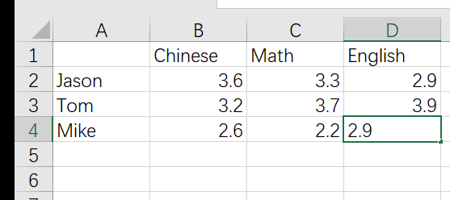

Task 2) get all the file names in a directory, rank them by size, and calculate the number of files for each file extension.

Given input: see “experiment_directory” directory.

Sample output: docx：3，xlsx：3，txt：4

Task 3) read a text file and count the frequency of each word and output the top 100 high frequency words to a text file. In this task, we ignore the impact of punctuation. If there are some characters between two blanks, then we consider it as a word.

Given input: see “test_txt.txt” file.

Task 4) Read in the student's name from the console, and then randomly divide them into N groups, and save the group into a json.

Given input: The user enters the names of several students from the console, ends with an empty student name, and then enters a number as the number of groups N, and then prints out the grouping situation. For example, user enter “John, Jackson, Tom, Sally” and number 2.

Sample output: [John, Sally] [Jackson, Tom]