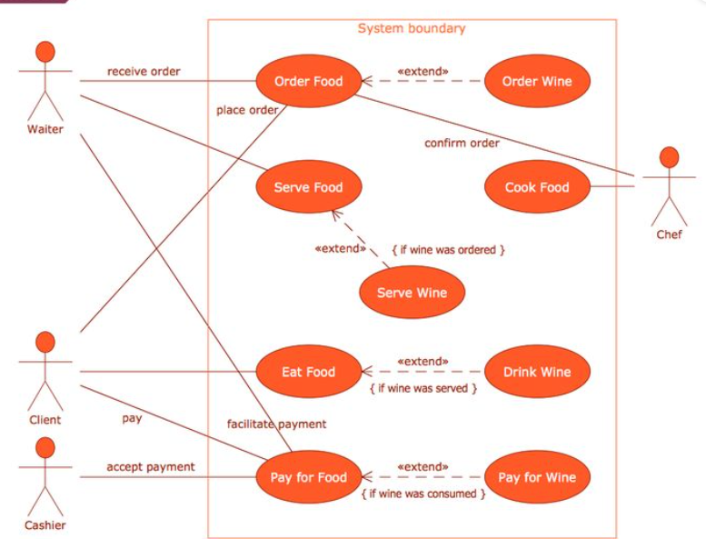
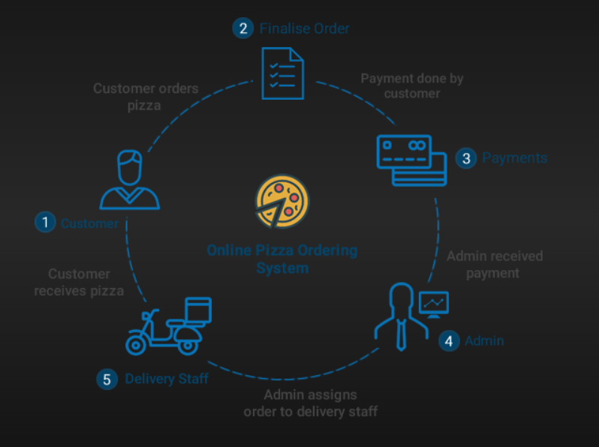
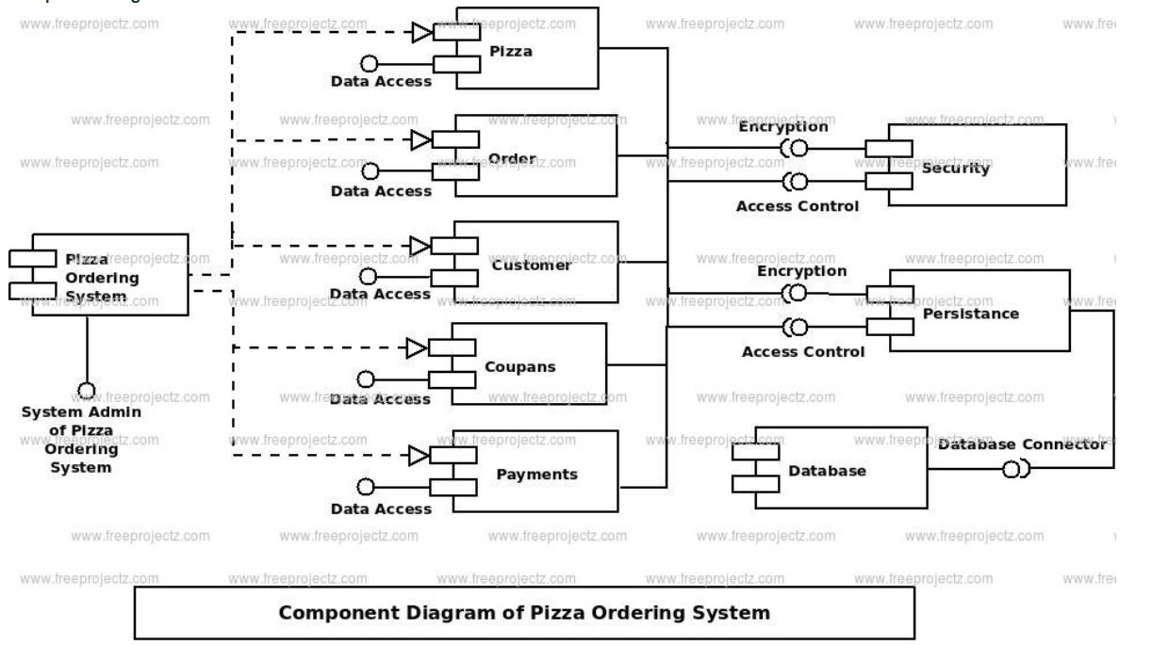
Online Pizza Ordering System
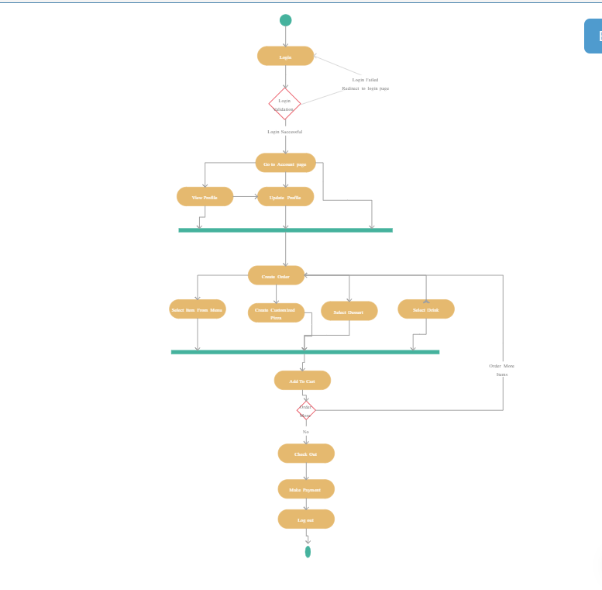

- In this system, while accessing for the first time, customers needs to register themselves by filling up basic registration details.
- Once the registration is successful, customer need to login with a valid username and password for secure login.
- After successful log in, customer will see the homepage where various types of pizzas will be listed with their image.
- The menu will be visible to the customer with the pizzas. All the ingredients will be shown with their prices.
- After selecting a desired pizza, customers can view the details of pizza such as price, category and toppings.
- Customer can specify the extra toppings (if required) and enter the quantity required and add a pizza to cart.
- Customer can directly click on buy now to place an order.
- Now payment option is shown to the customer. He has to choose from the various online payment methods or cash on delivery option.
- Once the order is placed and order id will be provided to the customer using which he/she can track the ordered pizza.
- Customer can notify the admin about the system by writing a feedback message.
- Customers can change their old password with new one whenever required.
- Admin can add various pizzas into the system, also can view/edit/delete the added pizza.
- All the orders will be displayed to the admin where admin can update the order details.
- Admin can view the pizza sales details based on any two selected dates.
- Also can view feedback messages received from the registered customers.
- Online Order Pizza Management System project is a web application, which is implemented in Asp .net platform.
Modules:
The system comprises of 2 major modules with their sub-modules as follows:
- Admin:
- Add Pizza: Add different types of pizza’s in veg and non-veg category.
- View/Edit/Delete: Có thể xem / cập nhật / xóa pizza đã thêm khỏi cơ sở dữ liệu.
- View/Update Order: Có thể xem tất cả các đơn đặt hàng nhận được từ khách hàng và thay đổi chi tiết đơn hàng cho phù hợp.
- View Sales: Can view sales details based on any two between dates.
- View Feedback: Admin can see user’s feedback.
- User:
- Registration: User can register his detail.
- Login: User Login his account.
- Home page: Người dùng có thể truy cập trang chủ của mình.
- Pizza Detail: Có thể xem chi tiết pizza bằng cách chọn một chiếc bánh pizza và xem chi tiết của nó như giá cả, toppings, vv ...
  - Add to Cart: Customer can add the selected pizza into cart and can check out further.
  - Buy Now: Can buy a selected pizza and can also enter required toppings (If needed) and specify the quantity.
- Track Order: Can track the ordered pizza by order id to know the order status.
- Write Feedback: User can write his review as feedback.
- Change Password: User can change his current password and make new password.
Software Requirements:
- Windows 7 or higher.
- SQL 2008
- Visual studio 2010
Hardware Components:
- Processor – i3
- Hard Disk – 5 GB
- Memory – 1GB RAM
- Internet Connection
Advantages:
- It overcomes all the problems of existing system
- Pizza can be order in way that is more convenient.
- Payment can be easily done using various online mode or cash on delivery (COD).
- It makes system very effective for ordering a pizza.
- Admin can view sales report, which can be helpful for decision-making.
- Easy add/update/delete process of pizza.
- Rich and attractive GUI.
Disadvantages:
- It requires a reliable internet connection.
- System may provide inaccurate results if data not entered correctly.

Application:
This system can be applied in pizza stores.

Reference:
- https://ivi.fnwi.uva.nl/fcn/teaching/2007-dbp-ik/Studentprojectreport/group1.pdf
- https://www.google.co.in/url?sa=t&rct=j&q=&esrc=s&source=web&cd=7&cad=rja&uact=8&ved=0ahUKEwiN_YSXusbSAhWCp48KHYjGBlcQFgg6MAY&url=http%3A%2F%2Fproject.esolweb.com%2Fall-books%2Ffyp%2FDomino%2520Pizza%2520Order%2520Booking%2520System-BS-2010.pdf&usg=AFQjCNHT_QiVtO25Jvs43HNs0FS16-amIg&bvm=bv.149093890,d.c2I

https://www.google.co.in/url?sa=t&rct=j&q=&esrc=s&source=web&cd=7&cad=rja&uact=8&ved=0ahUKEwiN_YSXusbSAhWCp48KHYjGBlcQFgg6MAY&url=http%3A%2F%2Fproject.esolweb.com%2Fallbooks%2Ffyp%2FDomino%2520Pizza%2520Oder%2520Booking%2520System-BS-2010.pdf&usg=AFQjCNHT_QiVtO25Jvs43HNs0FS16-amIg&bvm=bv.149093890,d.c2I

