# Lab Assignment 5

Name: Taskia Siddika

ID:20301417

Section:03

# Task 1:

def convert_mirror(root):

#To Do

if root:

location = root.left

root.left = root.right

root.right = location

convert_mirror(root.left)

convert_mirror(root.right)

return root

**# Output Screenshot**

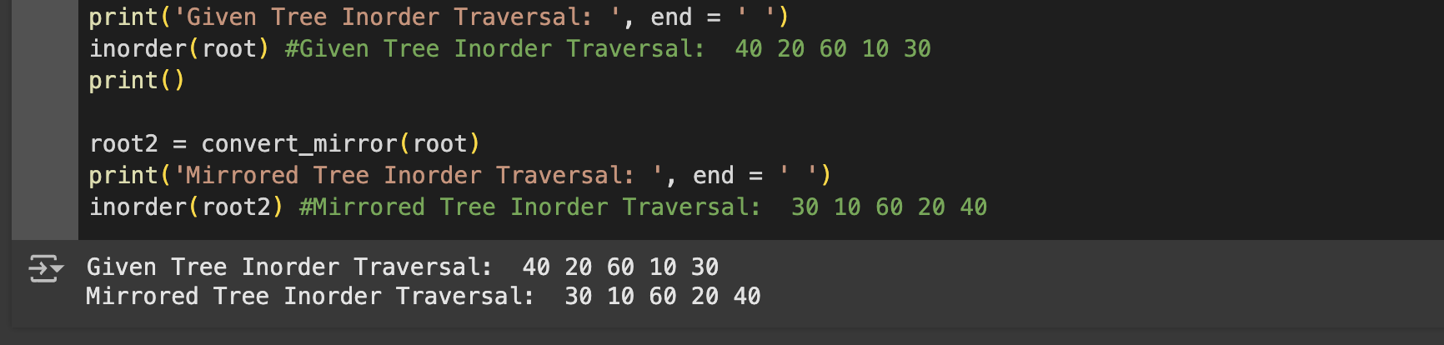

# 

# 

# 

# 

# 

# 

# Task 2:

def smallest_level(root, level=None, i=0):

if level == None:

level = {}

if root == None:

return level

if i in level:

level_now = level[i]

else:

level_now = None

if level_now == None:

level[i] = root.elem

else:

node_now = root.elem

if node_now < level_now:

level[i] = node_now

smallest_level(root.left, level, i + 1)

smallest_level(root.right, level, i + 1)

return level

**# Output Screenshot**

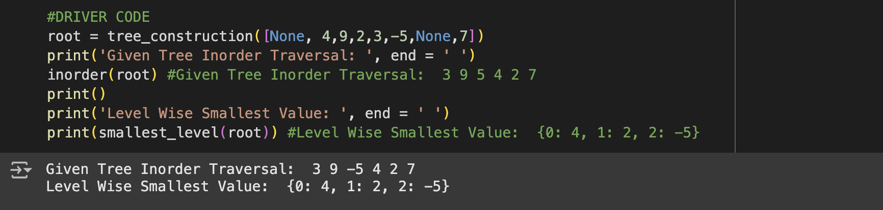

# Task 3:

def sumTree(root):

l_sum = h_Sum(root.left)

r_sum = h_Sum(root.right)

return root.elem + l_sum + r_sum

def h_Sum(root, lvl=1):

if root is None:

return 0

c = root.elem % lvl

if (root.left == None) and (root.right == None):

return c

l = h_Sum(root.left, lvl + 1)

r = h_Sum(root.right, lvl + 1)

return c + l + r

**# Output Screenshot**



# Task 4:

def swap_child(root, level, M):

if root is None:

return root

c_lvl = level

m_lvl = M

if m_lvl == 0:

l_node = root.left

r_node = root.right

root.left = r_node

root.right = l_node

return root

if (c_lvl >= m_lvl) or (root == None):

return

n_lvl = c_lvl + 1

l_child = swap_child(root.left, n_lvl, m_lvl)

r_child = swap_child(root.right, n_lvl, m_lvl)

l_temp = root.left

r_temp = root.right

root.left = r_temp

root.right = l_temp

return root

#Driver Code

root=BTNode('A')

Node1 = BTNode('B')

Node2 = BTNode('C')

Node3 = BTNode('D')

Node4 = BTNode('E')

Node5 = BTNode('F')

Node6 = BTNode('G')

Node7 = BTNode('H')

Node8 = BTNode('I')

Node9 = BTNode('J')

root.left = Node1

root.right = Node2

Node1.left = Node3

Node1.right = Node4

Node2.left = None

Node2.right = Node5

Node3.left = Node6

Node3.right = Node7

Node4.left = Node8

Node4.right = None

Node5.left = Node9

Node5.right = None

#output screenshot

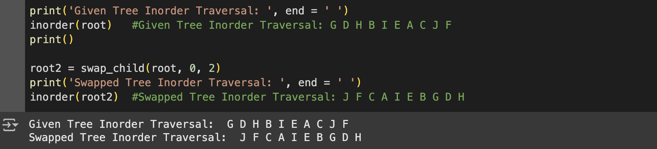

TASK 5:

def subtract_summation(root):

if root is None:

return 0

l_sum = jogfol(root.left)

r_sum = jogfol(root.right)

return l_sum - r_sum

def jogfol(root):

if root is None:

return 0

final = root.elem

final += jogfol(root.left)

final += jogfol(root.right)

return final

#Driver Code

root = BTNode(71)

Node1 = BTNode(27)

Node2 = BTNode(80)

Node3 = BTNode(75)

Node4 = BTNode(87)

Node5 = BTNode(56)

Node6 = BTNode(62)

Node7 = BTNode(41)

Node8 = BTNode(3)

Node9 = BTNode(19)

Node10 = BTNode(89)

root.left = Node1

root.right = Node6

Node1.left = Node2

Node1.right = Node3

Node2.left = Node4

Node2.right = Node5

Node6.left = Node7

Node6.right = Node8

Node8.left = Node9

Node8.right = Node10

#output screenshot

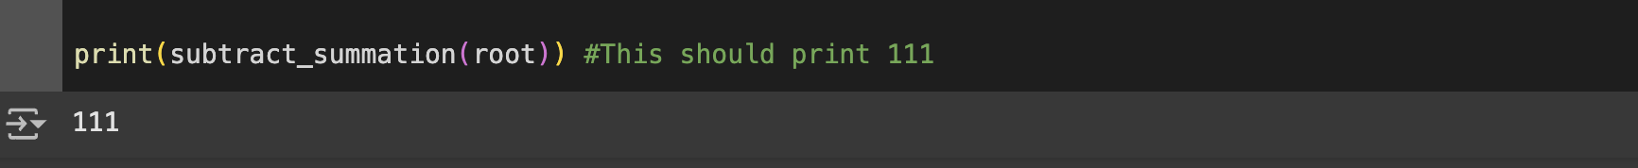

TASK 6:

def level_sum(root, level=1):

if root is None:

return 0

curr = level

curr = root.elem

lchild = level_sum(root.left, curr + 1)

rchild = level_sum(root.right, curr + 1)

if curr % 2 == 0: # Even level

total = curr + lchild + rchild

else: # Odd level

total = -curr + lchild + rchild

return total

#output screenshot

