Peako (PerfStudio)
Current Application Architecture
DevOps / Infrastructure Reference — Current-State Analysis
Prepared: 2026-07-31
Scope: verified against source code, env files, and git history — not assumed from prior documentation. Deployment architecture reflects direct (bare-metal/VM) deployment, per current documentation direction; Docker Compose/Dockerfiles remain in the repository but are not part of this document's deployment model.

Table of Contents

1. Executive Summary
Peako/PerfStudio is a performance-testing platform: users import an API definition (Postman collection / Swagger / cURL), the platform live-fires the endpoints once (“pre-run”) to learn auth tokens and correlate values between requests, deterministically generates a JMeter or K6 script from that, and executes the script exclusively via an external CI provider (GitHub Actions, GitLab CI, or Bitbucket Pipelines) — not on the Peako server itself. Results are pulled back from the CI provider's artifacts, parsed, evaluated against pass/fail rules, emailed, and rendered as analytics/trend dashboards and PDF reports.
Deployment model: direct (bare-metal/VM), not Docker. The application runs as a plain Node.js process supervised by systemd — no container runtime is part of the documented architecture.
Two more facts materially affect infrastructure planning and are not reflected in .env.example's defaults:
- AWS S3 (or an S3-compatible store) is mandatory, not optional. The server refuses to boot without a reachable bucket (GDPR-driven zero-local-disk rewrite, already merged).
- Local test execution has been retired. Every route that used to run JMeter/K6 on the Peako host now returns HTTP 410. Real load generation happens only on an external CI provider's runners.

2. Technology Stack
Layer | Technology | Version (verified)
Frontend | React, Vite, axios, Chart.js/react-chartjs-2, html2canvas, jsPDF, xlsx, Tabler icons | React 18.2.0, Vite 5.1.4
Backend | Node.js, Express | Node 22 (root image) / Express 4.18.2
Database | PostgreSQL via pg | Postgres 16-alpine, pg 8.22.0 — no SQLite fallback anywhere
Object storage | AWS S3 (or S3-compatible, e.g. MinIO) | @aws-sdk/client-s3 + @aws-sdk/lib-storage 3.1087.0 — mandatory
Git (PAT auth) | isomorphic-git + memfs (in-memory, S3-hydrated) | isomorphic-git 1.38.7, memfs 4.64.0
Git (SSH auth) | Real git binary via simple-git, real local disk | simple-git 3.36.0
AI | OpenAI SDK, routed to GPT-4o or Anthropic Claude (Anthropic via OpenAI-compatible endpoint — no separate Anthropic SDK) | openai 6.38.0
Load-test engines | Apache JMeter, Grafana K6 — run only on external CI runners, not the Peako host | JMeter 5.6.3, K6 (apt, current at image build time)
Git providers | @octokit/rest (GitHub), raw HTTP (GitLab, Bitbucket) | @octokit/rest 22.0.1
Email | Nodemailer (SMTP) | 8.0.10
PDF | Puppeteer (HTML→screenshot) + pdfkit (stitching) | Puppeteer 25.0.4, pdfkit 0.18.0
Auth | jsonwebtoken (JWT), bcryptjs (password hashing) | 9.0.2 / 2.4.3
File uploads | multer | 2.1.1
Archives | archiver, adm-zip | 8.0.0 / 0.5.17
Process supervision | systemd — direct deployment, no container runtime | —
CI/CD of Peako itself | GitHub Actions → Docker Hub | .github/workflows/docker-publish.yml

3. Application Components
Component | Technology | Purpose | Location | Communication
Frontend/UI | React SPA, manual routing (no react-router), state via useState in App.jsx, no Redux | 20 pages: Dashboard, Collections, Recorder, Rules, Runner, TestSuites, TestData, Config, Analytics/Trend, Reports, GitPanel, PipelineConfig, Settings, org admin, auth flows | frontend/src/pages, /components | axios + JWT bearer to /api/*
Backend/API | Express 4, ~23 route modules mounted under /api | Core REST API | backend/src/index.js, /routes/*.js | JSON over HTTPS (TLS terminated upstream)
Auth & sessions | JWT (HS256) + user_sessions table (single active session, 30-min idle timeout) | Login, session/heartbeat, RBAC | middleware/auth.js, routes/auth.js | Bearer token in Authorization header
Authorization | ownsProject() — owner / project-assignment / org-admin / super-admin | Per-request access control | utils/ownsProject.js | In-process, DB-backed
Licensing | Org-level plan/entitlement (org_licenses) | Gates user/project counts, org active status | utils/license.js, routes/licenses.js | In-process, checked every authenticated request
Database | PostgreSQL 16 | System of record: users, orgs, projects, collections, rules, test_suites, execution_runs, git_*, ci_*, trend_* | db/schema.sql, db/index.js, db/pg.js | pg driver over TCP 5432
Cache | Not implemented — no Redis/Memcached; only an in-process, per-workspace TTL byte-cache inside gitEngine.js (15 min default) | — | utils/gitEngine.js | N/A
Message queue / event system | Not implemented — no Redis/RabbitMQ/SQS/Bull. Async work is setImmediate-deferred in-process, plus one interval-based S3 sweep | Deferred config rewrites, CI-run auto-sync, stale-workspace sweep | utils/configWriter.js, routes/execution.js, utils/workspaceLifecycle.js | In-process timers only — lost on restart mid-cycle, no persistence/retry queue
Background workers/jobs | Informal, in-process (no dedicated worker process or job-queue system) | Same as above | Same files | N/A
File/object storage | AWS S3 (or compatible) — mandatory at boot | All git workspace data (PAT-mode) and all test-run results live in S3 only, never on local disk | utils/s3Sync.js, resultsStore.js, gitEngine.js | AWS SDK v3 over HTTPS
AI/LLM integration | OpenAI GPT-4o or Anthropic Claude (admin-configurable, per-org key) | Auto-heal diagnosis of failed runs; per-endpoint “Fix with AI” during pre-run. Not used for initial script generation | utils/aiClient.js, routes/ai.js, utils/autoHealer.js | HTTPS to OpenAI or Anthropic API
JMeter integration | Script templating + external execution | Generates .jmx; actual jmeter binary invocation happens on the CI runner, not the Peako host | routes/testSuites.js (buildJmxTemplate) | Script pushed to git repo; CI runner executes
K6 integration | Script templating + external execution | Generates K6 JS script; actual k6 binary invocation happens on the CI runner | routes/testSuites.js (buildK6Template) | Same as above
Script generation | Deterministic template builder (not AI) for both engines | Correlation/field-generator/transform engines | utils/correlationEngine.js, scriptCorrelation.js, fieldGenerators.js, transforms.js | In-process
Test execution | External CI only — GitHub Actions / GitLab CI / Bitbucket Pipelines. All native/Docker-spawn routes return HTTP 410 | routes/ciPipeline.js (trigger, poll, sync); routes/execution.js, pipelines.js (retired, dead testRunner.js) | — | REST calls to GitHub/GitLab/Bitbucket APIs
Test result processing | Parses JTL, evaluates against project rules | utils/ruleEvaluator.js, parseJtl.js | — | Reads JTL from S3 via resultsStore.js
Report generation | 6-page analytics PDF via Puppeteer + pdfkit | utils/generateAnalyticsPdf.js, trend/exportEngine.js | — | Reads run data from S3/DB, writes PDF to S3/response stream
Trend analysis | Cross-run comparison, scoring, forecasting, capacity planning — deterministic, AI only for an optional executive-summary rewording | utils/trend/*.js, routes/trendAnalysis.js | — | In-process + DB (trend_* tables)
External/third-party integrations | GitHub, GitLab, Bitbucket, SMTP, OpenAI, Anthropic, AWS S3 | See Section 12 | — | Various REST/SMTP APIs

4. Current-State Architecture Diagram
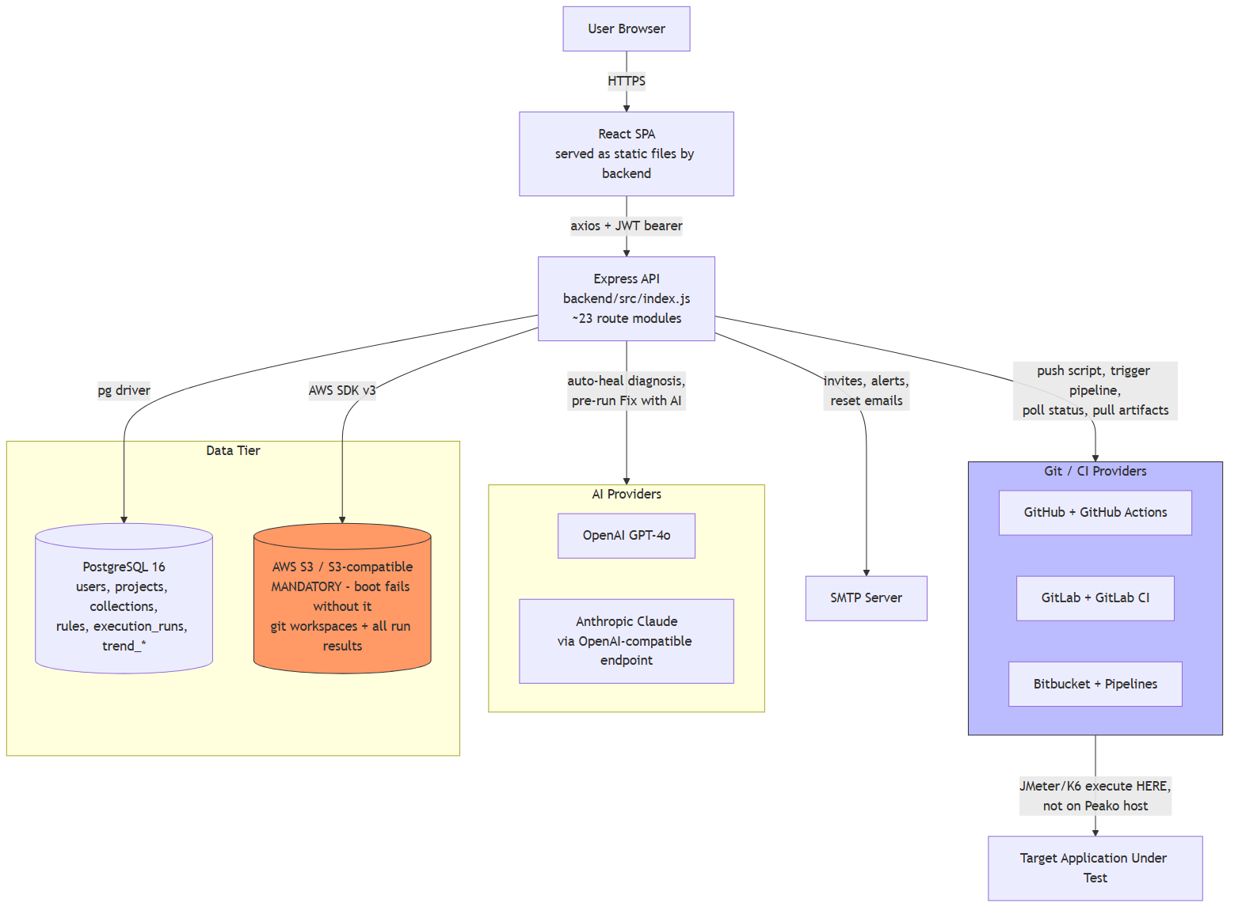
Figure 1 — Current-state system architecture. The Peako server never runs JMeter/K6 itself; it is an orchestrator — config, script generation, and result-ingestion — while a CI provider's own runners do the actual load generation.

5. End-to-End Data Flow (User Request)
Browser (React SPA) → axios request, JWT in Authorization header → Express API (backend/src/index.js).
- auth.js middleware: verify JWT → check user_sessions (jti, 30-min idle) → org license check
- ownsProject(): owner / assignment / org-admin / super-admin
Route handler (routes/*.js):
- PostgreSQL — read/write project data
- S3 — read/write workspace files or run results (via resultsStore.js / gitEngine.js)
- setImmediate-deferred background rewrite of config.json snapshot (non-blocking)
JSON response → Frontend renders. No session state is cached client-side beyond the JWT in localStorage; a 1-second heartbeat detects a session takeover from another tab/device.

6. Performance Testing Execution Flow
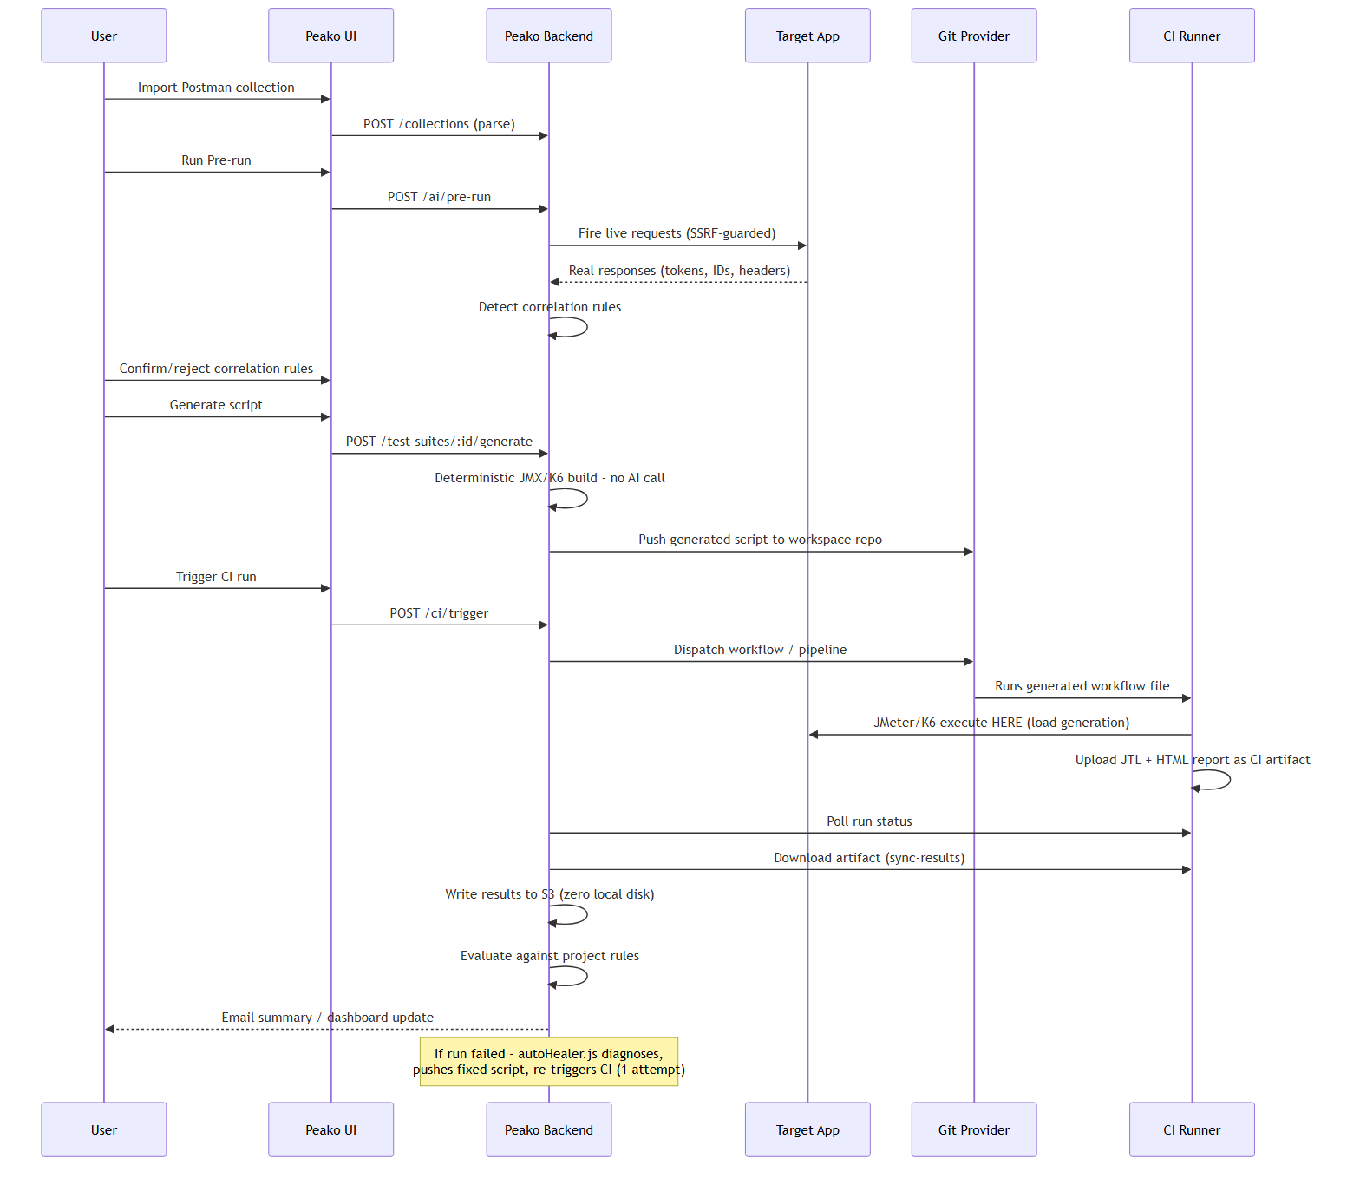
Figure 2 — Performance test execution flow. JMeter/K6 execute on the CI runner, never on the Peako server.
Not implemented / retired: local native execution, Docker-spawned execution, and the internal sequential-pipeline runner (pipelines.js) all now return HTTP 410 — “Local test execution has been retired. Run tests via the CI pipeline instead.” runner.js's POST /execute remains in the codebase but returns fully simulated/mocked metrics and is not the real execution path.

7. AI Integration Flow
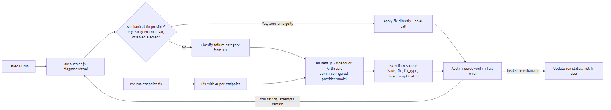
Figure 3 — AI is used only for auto-heal diagnosis and optional pre-run endpoint fixes — never for initial script generation.
- AI is never used for initial script generation — that path is fully deterministic (buildJmxTemplate()/buildK6Template()).
- AI is used for: (1) auto-heal diagnosis of an already-failing generated script, and (2) an optional per-endpoint AI-guided fix during pre-run.
- Provider/model/API key are configured per-org (ai_settings table), key stored AES-256-CBC encrypted, never returned raw over the API.
- Trend Analysis has one additional, optional AI touchpoint: a plain-English executive-summary rewording — the underlying scoring/regression/RCA/forecast logic is deterministic, not AI-generated.

8. Deployment Architecture
Deployment model: direct (bare-metal/VM), not Docker. The application runs as a plain Node.js process on the host, supervised by systemd — no container runtime is part of the documented architecture. Docker Compose/Dockerfiles still exist in the repository and still work, but are no longer the recommended or documented way to run Peako (see docs/DEPLOYMENT.md).

As documented in docs/DEPLOYMENT.md
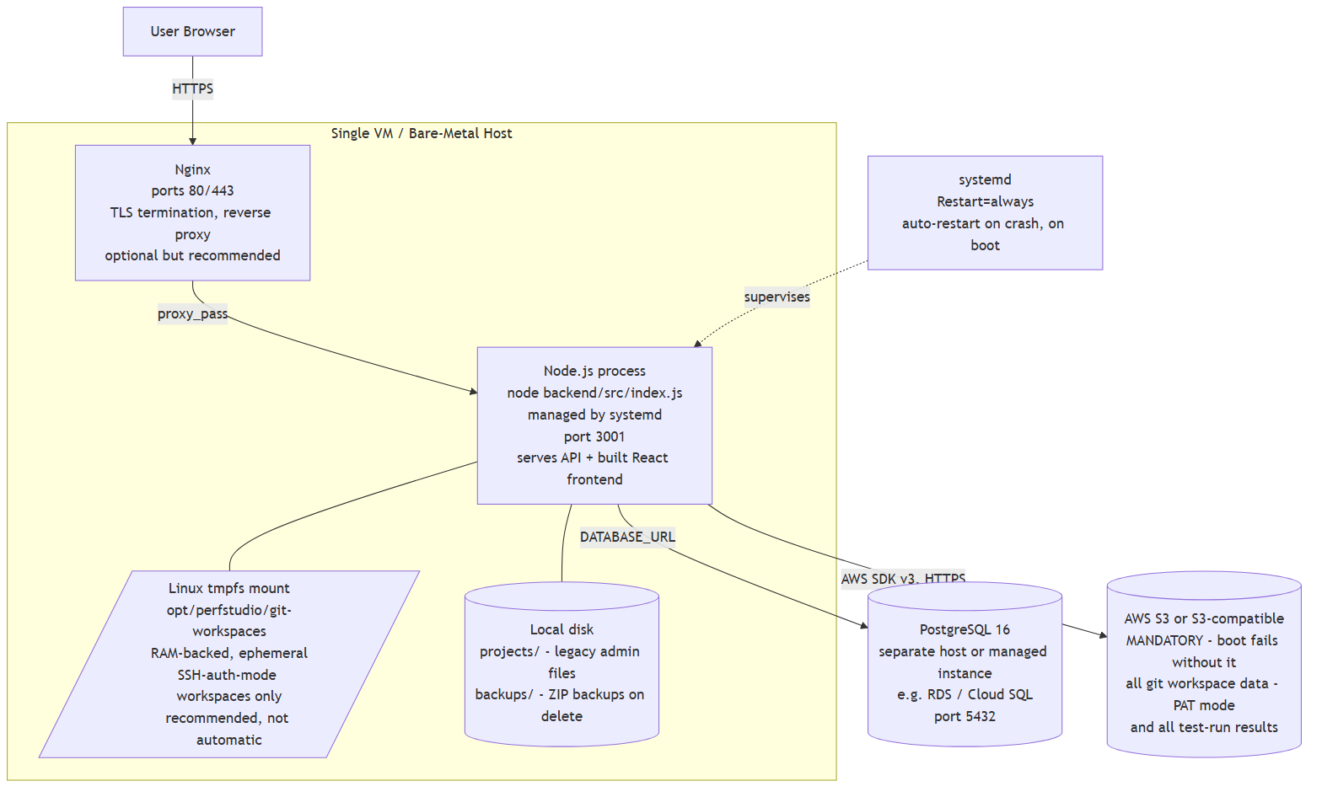
Figure 4 — Direct deployment topology: a single Node.js process, systemd-supervised, against external PostgreSQL and S3.
Item | Value
Process model | node backend/src/index.js — a single process serving both the API and the built React frontend static files, managed by systemd (Restart=always) in production.
Schema application | Manual, not automatic. node backend/src/db/migrate.js must be run once against a fresh Postgres database, and again after any pull that touches schema.sql. Idempotent (CREATE TABLE IF NOT EXISTS).
Default credentials | Super admin auto-seeded on first boot if none exists: admin@perfstudio.com / Admin@123. Must be rotated immediately post-deploy.
Kubernetes / containers | Not part of the documented deployment model.
Ephemeral git-workspaces | SSH-auth-mode git workspaces (the one thing still written to local disk) are recommended to be mounted as a real Linux tmpfs filesystem (via /etc/fstab) for the same zero-physical-disk property PAT-mode already gets from S3 — an OS-level configuration step, not automated by the app.
Ports | 3001 (app), 5432 (Postgres), 80/443 (Nginx, recommended), 22 (SSH, server admin).
Local dev | backend && npm run dev (nodemon, :3001), frontend && npm run dev (Vite, :5173) — two separate processes against a directly-installed PostgreSQL and S3/MinIO.

9. Infrastructure Requirements
Requirement | Details
Compute | Single VM or bare-metal host running the Node.js process directly under systemd; no horizontal scaling config exists (no load balancer, no multi-replica orchestration defined)
CPU/Memory | Minimum 2 vCPU / 4 GB RAM; recommended 4 vCPU / 8 GB RAM. Add RAM headroom if mounting the recommended tmpfs for git-workspaces (~6 GB planning figure)
Operating System | Ubuntu 20.04+/Debian 11+/RHEL 8+
Database | PostgreSQL 16 — separate host or managed instance (RDS, Cloud SQL, etc.); no SQLite fallback exists anywhere in the code
Storage | AWS S3 or S3-compatible object store — mandatory, boot-blocking. Local disk: projects/ and backups/ directories (legacy/admin files only) plus git-workspaces/ for SSH-auth mode (recommended as a real Linux tmpfs mount — PAT-mode git and all test results are S3-only, zero local disk)
Network/Ports | 3001 (app), 5432 (Postgres, can be internal-only), 80/443 (recommended Nginx reverse proxy), outbound HTTPS to: AWS S3, OpenAI/Anthropic, GitHub/GitLab/Bitbucket, SMTP host
External Services | AWS S3 (mandatory), one of GitHub/GitLab/Bitbucket (required for the platform's core function), SMTP provider (invites/alerts), OpenAI and/or Anthropic (optional — script generation itself is deterministic)
Secrets/Env Vars | JWT_SECRET, ENCRYPTION_KEY, DATABASE_URL, S3_SYNC_ENABLED/S3_BUCKET/S3_REGION/S3_ACCESS_KEY_ID/S3_SECRET_ACCESS_KEY (mandatory as a group), FRONTEND_URL, CORS_ORIGIN, SMTP_* (optional), org-level AI keys and git PATs (stored encrypted, not env vars)
Process supervision | systemd (Restart=always) supervises a single Node.js process. No queue/cache service required.
Monitoring/Logging | Not implemented as a dedicated system — console.log/console.error only, captured via journald/systemd. No Prometheus/Datadog/New Relic/OpenTelemetry. GET /api/health is liveness-only (no DB/S3 dependency check).
Backup Requirements | Postgres: pg_dump (documented cron example). S3 bucket versioning/backup is the customer's/DevOps's S3-side responsibility — not orchestrated by the app.

10. Security Architecture
Area | Current implementation | Notes
Authentication | JWT (HS256 by algorithm default, not explicitly pinned), 7-day expiry, single active session via jti in user_sessions, 30-min inactivity auto-expiry | JWT_SECRET has a hardcoded fallback if unset — must always be set explicitly in production
Authorization / RBAC | Three-tier project access (ownsProject.js): owner → project-assignment → org-admin (all projects in org) → super-admin (all orgs). 404s (not 403s) on denial to avoid existence-leak | Org-level licensing (org_licenses) additionally gates access/usage per org
API security | SSRF guard (isSafeUrl()) blocks localhost, 127.x, 0.x, 10.x, 192.168.x, 172.16-31.x, 169.254.x for pre-run's live outbound requests | No rate limiting, no Helmet/security-headers middleware detected
CORS | Currently permissive — the code's own comment states “allow all in current setup — restrict in production”; the callback returns true for any origin | Flagged directly in code as needing production hardening
Secrets at rest | AES-256-CBC (API keys, SMTP passwords, git PATs/SSH keys). Key = SHA-256 of ENCRYPTION_KEY, falling back to JWT_SECRET, falling back to a hardcoded default string if neither is set | ENCRYPTION_KEY must always be set explicitly. Decrypt failure silently falls back to plaintext — confirm intended behavior with dev team
Database security | Standard pg connection via DATABASE_URL; tenant isolation via org_id/user_id FKs and query-level scoping (no Postgres RLS observed) | TLS to Postgres depends on the DATABASE_URL's own sslmode
Network/TLS | The app terminates plain HTTP on :3001; TLS termination is a manual, external step (Nginx + Let's Encrypt/Certbot) | Documented as a setup step in docs/DEPLOYMENT.md, not automated
Org/user data isolation | Enforced at the query level (org_id/user_id filters) per route, not via DB-native row-level security | Confirmed consistent across licenses.js, summary.js, ownsProject.js
Default credentials | Auto-seeded super admin admin@perfstudio.com / Admin@123 on first boot if no super admin exists | Operational risk if not rotated immediately

11. Logging & Monitoring — Implemented vs. Missing

Implemented
- Console-based logging (prefixed tags like [Boot], [S3Sweep], [CI Trigger]) — text, unstructured, suitable for container stdout capture
- GET /api/health — liveness only ({status:'ok', ts}), does not check DB or S3 connectivity
- Ops alerting for infrastructure failures (S3 sync failures etc.) — webhook and/or email, rate-limited per failure kind (utils/opsAlert.js)
- Auto-heal audit trail: auto_heal_logs / ci_auto_heal_logs tables record every diagnosis/fix attempt

Missing (confirmed absent, not just “not configured”)
- No structured/JSON logging (no Winston/Pino/Bunyan)
- No metrics or APM (no Prometheus client, Datadog, New Relic, OpenTelemetry)
- No general user-action audit log (logins, deletions, config changes are not tracked beyond auto-heal-specific tables)
- Health check doesn't verify dependency reachability (DB, S3) — a healthy-looking container could still be unable to serve real requests if S3 is down mid-run

12. External Dependencies
Integration | Used for | Required?
AWS S3 (or compatible) | All git workspace + test-result storage | Mandatory — boot fails without it
GitHub / GitLab / Bitbucket | Script version control + CI-based test execution (the only real execution path) | Effectively mandatory — the core “run a test” feature depends on one of these
OpenAI and/or Anthropic | Auto-heal diagnosis, AI-assisted pre-run fixes, optional trend AI summary | Optional — degrades gracefully; script generation itself never depends on AI
SMTP provider | Invites, password reset, run alerts/summaries | Optional but expected in practice for multi-user orgs
Docker Hub | Distribution of PerfStudio's own published images | Only relevant to Peako's own release pipeline, not runtime

13. Architecture Gaps / Missing Infrastructure
These are concrete, code-confirmed items DevOps should plan around — not speculative:
- S3 is boot-mandatory but documented as optional. backend/src/index.js calls assertBucketReachable() and exits the process if S3 isn't configured/reachable, yet .env.example ships S3_SYNC_ENABLED=false as the default and describes it as an optional feature. A deployment following .env.example literally will not start.
- Vestigial local-execution infrastructure. EXECUTION_MODE, JMETER_BIN, K6_BIN env vars still exist and are still read by code, but every route that would use them returns HTTP 410 before reaching that code — confirmed dead code.
- The tmpfs mount for SSH-auth git workspaces isn't automated. docs/DEPLOYMENT.md documents an /etc/fstab entry as the recommended way to keep this directory RAM-backed/ephemeral, but nothing enforces it — a deployment that skips this step keeps SSH-auth workspace data on normal persistent disk, silently missing the zero-physical-disk property PAT-mode already gets for free.
- No provisioning automation. Deployment steps are manual shell commands (docs/DEPLOYMENT.md) — no Ansible/Terraform/config-management script exists for repeatable provisioning across multiple environments.
- No rate limiting, no Helmet, CORS currently permissive by the code's own admission. Straightforward to hire out to a reverse proxy/API gateway if not fixed in-app.
- No metrics/APM, no structured logging, health check doesn't probe dependencies. If SLOs/alerting are required, this needs to be built — currently there is nothing to scrape.
- No dedicated job queue/worker tier. Background work is in-process, setImmediate/interval-based — doesn't survive a process restart mid-cycle and won't scale across multiple app replicas without becoming a duplicate-work risk.
- Backups are only formally documented for Postgres. S3 bucket backup/versioning strategy is not orchestrated by the app and needs its own DevOps-side policy.

14. Open Questions for Development Team
Requires confirmation from the development team — not derivable from the code alone
- 1. Is a single VM/bare-metal host acceptable for the target environment, or is horizontal scaling (multiple app instances behind a load balancer) needed — none of the current tooling or in-process background-task model supports that yet?
- 2. Is CORS's current “allow all origins” behavior intentional for this deployment phase, or does it need to be locked down before any production rollout?
- 3. What is the intended SLA/monitoring stack? No APM/metrics exist today — need to know if DevOps is expected to supply this externally, or if it's on the dev roadmap.
- 4. Should the tmpfs mount for SSH-auth git workspaces be enforced via provisioning automation (Ansible/Terraform) rather than left as a manual, easy-to-skip step in docs/DEPLOYMENT.md?
- 5. Is there a target RPO/RTO for the S3-backed data, and does DevOps or the application team own S3 bucket versioning/backup policy?
- 6. Should .env.example (the legacy Docker path) be updated further or retired outright now that direct deployment is the documented model, given the current defaults would produce a non-booting deployment if followed literally?
- 7. Multiple app replicas (for HA) aren't tested/designed for given the in-process background-task model — is multi-replica deployment planned, and if so, does the dev team want to move this to a real queue first?

Sources reviewed: docker-compose.yml, Dockerfile, backend/Dockerfile, frontend/Dockerfile, .env.example, backend/.env.example, docs/DEPLOYMENT.md, docs/LOCAL_SETUP.md, backend/src/index.js, middleware/auth.js, utils/{encryption,ownsProject,s3Sync,gitEngine,resultsStore,opsAlert,preRunEngine}.js, routes/{execution,runner,pipelines,ciPipeline,ai,licenses}.js, db/{schema.sql,migrate.js,index.js}, package.json files, plus git log to confirm merge status of the S3 migration commits.

