Perf Studio (Peako)
Technical & Security Review Documentation Package
Product · Architecture · Backend · AI · Workflow · Security · Quality Engineering · Environment
Prepared: 2026-07-07
Compiled from source-code analysis of the perf-studio repository.

This package answers every item of the requested review checklist. Sections 1.3 (Product Roadmap), 7 (Quality Engineering), and 8 (Environment & Demo Access) are explicitly marked where they depend on business judgment, currently-absent tooling, or deployment-specific values that only the product/operations team can supply.

Table of Contents
Table of Contents 1
1. Product Documentation 1
1.1 Product Overview Document 1
Core Value Proposition 1
1.2 Feature List 1
1.3 Product Roadmap 1
Near-term / in-progress 1
Candidate future investments (not yet scheduled) 1
1.4 Business Use Cases 1
Primary use case — enterprise API performance testing at scale 1
Secondary use cases 1
1.5 Known Limitations 1
2. Architecture Documentation 1
2.1 High-Level Architecture Diagram 1
Multi-environment / multi-tenant isolation 1
2.2 Deployment Architecture Diagram 1
Application image composition (root Dockerfile, multi-stage) 1
Execution modes 1
Key environment variables 1
2.3 Sequence Diagrams — Requirement → Test Case → Automation → Execution → Reporting 1
2.4 Technology Stack Document 1
Frontend 1
Backend 1
AI, execution engines, integrations 1
2.5 CI/CD Pipeline Documentation 1
A. PerfStudio’s own build/release CI/CD (self-hosting) 1
B. Customer-facing CI/CD feature (external CI for generated test scripts) 1
3. Backend Documentation 1
3.1 API Documentation 1
Auth & Account (auth.js, passwordReset.js) — /api/auth 1
Admin & Organizations (admin.js, orgs.js, licenses.js) 1
Projects, Collections, Config (projects.js, collections.js, projectConfig.js, envConfig.js, config.js) 1
Rules, Scripts, Test Suites, Test Data (rules.js, scripts.js, testSuites.js, testData.js) 1
AI, Settings, Execution, Alerts (ai.js, settings.js, runner.js, execution.js, alerts.js) 1
Invites, Git, Pipelines, External CI (invites.js, git.js, pipelines.js, ciPipeline.js) 1
3.2 Database ER Diagram 1
3.3 Database Schema 1
Core tables 1
Supporting tables 1
Constraints, indexing, and data-type observations 1
4. AI Documentation 1
4.1 AI Architecture Document 1
4.2 Prompt Design / Prompt Templates 1
K6 script generation (the only AI-driven script generation path — JMeter generation is fully deterministic, see Section 5.3) 1
Auto-heal — full-script rewrite (last-resort tier) 1
Auto-heal — endpoint-scoped override patch (lower-cost tier) 1
Auto-heal — diff patch (surgical text edits) 1
Pre-run "Fix with AI" (single failing endpoint, outside the auto-heal pipeline) 1
4.3 Model Configuration & Supported LLMs 1
4.4 Token Usage & Cost Strategy 1
4.5 AI Workflow Diagram 1
Script generation (summarized) 1
Auto-heal cycle (summarized) 1
4.6 Auto-Healing Design 1
JTL error classification 1
Repair tiers, in order of preference 1
Verification and attempt policy 1
5. Workflow Documentation 1
5.1 Collection Import 1
Variable extraction and environment auto-population 1
5.2 Pre-run 1
5.3 Script Generation Design 1
Configuration merge order 1
JMeter generation — fully deterministic, no AI call 1
K6 generation — AI-driven 1
5.4 Correlation Strategy 1
5.5 Test Execution Workflow 1
Three execution paths 1
6. Security Documentation 1
6.1 Authentication Design 1
6.2 Authorization (RBAC) Design 1
6.3 Secret Management Strategy 1
6.4 Encryption Strategy 1
6.5 Audit Logging Design 1
6.6 Compliance Documentation (SOC 2 / ISO 27001 / GDPR) 1
Controls already present 1
Gaps to close before pursuing certification / attestation 1
6.7 SSRF Guard (Pre-Run outbound requests) 1
7. Quality Engineering 1
7.1 Code Coverage Report 1
What exists in place of automated testing today 1
Recommendation 1
7.2 Static Code Analysis Report 1
Recommendation 1
8. Environment & Demo Access 1
8.1 Demo Environment URL 1
8.2 Test User Credentials 1

1. Product Documentation

1.1 Product Overview Document
Product name: "Peako" (frontend/UI branding, e.g. <title>Peako | Quarks</title>) — Built by Quarks Technosoft PVT. LTD. (QTSolv).
Peako is an AI-powered, multi-environment API performance-testing platform. A user imports an API definition (Postman collection, Swagger/OpenAPI spec, cURL command, or raw JSON), the platform fires the endpoints live ("pre-run") to learn authentication tokens and response shapes, an AI model (OpenAI/Claude/Gemini etc) generates a JMeter or K6 load-test script from that data plus user-configured rules and test data, and the script is executed natively, in a spawned Docker container, or via an external CI provider (GitHub Actions / GitLab CI / Bitbucket Pipelines). Results are parsed, evaluated against pass/fail rules, emailed to stakeholders, and rendered as analytics dashboards and PDF reports. Failed runs can be automatically diagnosed and repaired by the built-in Auto-Healer.

Core Value Proposition
- AI Script Generation — converts imported API collections directly into runnable JMeter (.jmx) or K6 (.js) load-test scripts.
- Auto-Healer — diagnoses a failed run’s root cause and attempts an automatic fix + re-run.
- Multi-environment isolation — QA / Staging / UAT / Production each have independently-scoped test data, configuration, scripts, and results, enforced at the database layer (collection_id + env).
- Real-time analytics — response time, throughput, error rate, and P90/P95 percentile dashboards, live during a run and post-run.
- Git-native workflow — every project is a Git repository with a branch-per-user model, PR review, and GitHub/GitLab/Bitbucket sync.
- CI/CD integration — both an internal sequential pipeline runner and external CI (GitHub Actions, GitLab CI, Bitbucket Pipelines), including CI-context auto-heal.
- Org-based licensing — per-organization plan tiers with user/project limits and expiry, managed by a Super Admin console.

1.2 Feature List
Category | Features
Organizations & Teams | Org creation, license-tier assignment, org-admin invitation, role-based access (Super Admin / Org Admin / User), per-project user assignment.
Projects & Collections | Project CRUD; import API collections from Postman v2.1, Swagger/OpenAPI, cURL, or raw JSON; environment-scoped configuration; multiple collections per project.
Pre-Run (Live Validation) | Fires every collection endpoint live (SSRF-guarded, chunked concurrency), extracts auth tokens/cookies, resolves {{var}} templates, flags missing variables, supports AI-assisted per-endpoint "Fix with AI".
Test Data Management | CSV upload per collection/environment, in-app CSV viewer/editor, open-in-external-app, auto-copy across environments.
Performance Rules | Threshold rules on response time, error rate, throughput, P90/P95 with operators (>, >=, <, <=, ==, between) and severity (error/warn).
Test Suite / Script Generation | Named test plans; deterministic JMeter (.jmx) generation; AI-driven K6 (.js) generation; CSV/token correlation.
Execution — Native | Runs JMeter/K6 binaries directly on the host, streams logs live, patches runtime parameters (VUsers/ramp-up/duration/loops).
Execution — Docker | Spawns containerized JMeter/K6 (EXECUTION_MODE=docker), with dependency/Docker-daemon checks.
Auto-Healer | Tiered repair strategy (deterministic mechanical fix → endpoint-override patch → diff patch → full rewrite), 1 automatic attempt plus a user-guided "Heal Again".
Internal Pipelines | Sequential multi-suite execution with SSE-streamed progress and stop-on-failure.
External CI/CD | GitHub Actions / GitLab CI / Bitbucket Pipelines: YAML generation, trigger, status polling, CI-context auto-heal with fixed-script re-push.
Git Integration | Per-project repo, branch-per-user (admin → main, user → users/<name>), commit/push/pull, PR create/merge/close, identity config.
Analytics & Dashboards | Live and post-run dashboards: response time, throughput, error rate, P90/P95, per-API breakdown, trend/transaction views.
PDF Reporting | 6-page auto-generated report (Summary, Dashboard, Transactions, Trend, Resource Utilization, Errors) via Puppeteer + pdfkit.
Email Alerts | Post-run summary, mid-run rule-breach alert, violation summary; per-user/org/project SMTP + recipient configuration.
Licensing & Entitlements | Plan tiers (trial/starter/growth/business/enterprise) with user/project caps, expiry, and enable/disable — enforced at the auth-middleware layer.
Admin Consoles | Super Admin: organizations, licenses, org-admin invites. Org Admin: projects, users, AI/Git/SMTP config, PR merges.
Authentication | Email/password, JWT sessions, single-active-session enforcement, forgot/reset password, invite-based onboarding.
Security Controls | AES-256-CBC encrypted secrets at rest, bcrypt password hashing, role-based route guards, SSRF-guarded outbound requests.

1.3 Product Roadmap
Peako/PerfStudio has moved well beyond an MVP — the platform has shipped a full AI-driven testing lifecycle, multi-provider CI/CD, and an org-level licensing system. The items below reflect what has actually been delivered, followed by what's actively in progress and what's next.
Delivered — Core Testing Platform
- End-to-end workflow: API import (Postman/Swagger/cURL/JSON) → live Pre-Run validation → rules & environment configuration → AI script generation → execution → analytics → reporting, fully implemented and in use.
- Multi-environment isolation (QA/Staging/UAT/Production) with strict per-collection, per-environment data scoping — no cross-environment leakage by design.
- Pre-Run engine: live endpoint firing with bounded concurrency, automatic auth-token and cookie extraction, iterative {{var}} template resolution, 401 auto-retry, and SSRF-guarded outbound requests.
- Deterministic JMeter script generation, including multi-host support for collections spanning several API families (e.g. distinct subdomains resolved independently per endpoint) — removed the earlier one-host-per-collection limitation.
- AI-driven K6 script generation via OpenAI GPT-4o or Anthropic Claude, with per-purpose model selection (separate models for generation vs. healing).
- Correlation handling: automatic token/session extraction from login responses and propagation into subsequent requests, plus CSV test-data parameterization.
- Real-time and post-run analytics dashboards (response time, throughput, error rate, P90/P95, per-API breakdown) and 6-page auto-generated PDF reporting.

Delivered — Auto-Healing
- Tiered auto-heal strategy shipped end-to-end: deterministic mechanical fixes (zero AI cost) → endpoint-scoped AI patch → surgical diff-patch → full-script rewrite, each tier bounding AI cost to the size of the actual change rather than the whole script.
- Auto-heal now verified working in both local and CI execution contexts, including a critical fix to async handling that had silently prevented diagnosis from ever running correctly.
- Token-budget pre-flight checks prevent wasted AI calls on scripts too large for a provider's output ceiling.

Delivered — CI/CD & Git Integration
- External CI/CD integration for GitHub Actions, GitLab CI, and Bitbucket Pipelines: YAML generation, triggering, status sync, and CI-context auto-heal with automatic push of the fixed script back to the repository.
- Pipeline-level result validation (fails the CI job immediately on zero requests or 100% error rate) so provider status reflects real outcomes without waiting on a delayed sync.
- Git-native project workflow: branch-per-user model (org/admin → main, users → users/<name>), PR creation/review/merge, and a security hardening pass that removed plaintext credential persistence from .git/config.
- Internal sequential pipeline runner for multi-suite test execution as a lighter-weight alternative to external CI.

Delivered — Platform, Licensing & Security
- Org-level licensing system: plan tiers (trial/starter/growth/business/enterprise) with user/project limits, expiry, and status enforcement at the authentication layer.
- Redesigned Super Admin console consolidating organization, license, and admin management into a single workspace.
- Security hardening pass: AES-256-CBC encryption for stored secrets (AI keys, SMTP passwords, Git tokens), single-active-session enforcement, and closure of a data-leakage bug where a deleted collection's config could leak into a new one via ID reuse.

Near-term / in-progress
- Another tool Peako Recorder to record network traffic and covert to postman collection (.json).
- Custom helper for correlation in APIs. Currently there is no feature to provide directions to get, extract, apply correlations for APIs which are not covered automatically.
- CI status polling for runs already in progress when the CI Pipeline tab loads (currently only freshly-triggered runs auto-poll; older runs need a manual refresh).
- Job-log fetching for GitHub Actions / GitLab CI auto-heal diagnosis (only Bitbucket currently exposes pipeline logs to the heal routine).

Candidate future investments (not yet scheduled)
- Automated test suite and CI quality gates (see Section 7 — none currently exist).
- Self-service data export/deletion endpoints for GDPR data-subject requests (see Section 6.6).
- Comprehensive audit logging of administrative and data-mutating actions (see Section 6.5).
- Multi-factor authentication.
- Secondary database indexes on high-traffic foreign keys (projects.user_id, collections.project_id, test_suites.project_id, etc.).

1.4 Business Use Cases

Primary use case — enterprise API performance testing at scale
- 1. An org admin imports a multi-endpoint API collection (Postman export) into a project.
- 2. The team runs Pre-Run to validate connectivity, capture real response shapes, and extract auth tokens.
- 3. QA engineers upload CSV test data representing realistic load mixes / user scenarios.
- 4. The org admin defines SLA rules (e.g. average response time < 200ms, P95 < 500ms, error rate < 1%).
- 5. A test plan is created and a JMeter or K6 script is generated targeting the QA/Staging/UAT environment independently of the others.
- 6. The script runs via the Git-integrated CI pipeline (GitHub Actions / GitLab CI / Bitbucket Pipelines) or natively/in Docker.
- 7. On failure, the Auto-Healer diagnoses and attempts a fix (bad template variables, disabled elements, correlation issues) and re-runs.
- 8. Real-time dashboards show per-API response time, throughput, and error breakdown; a PDF report is emailed to stakeholders with pass/fail rule evaluations.
- 9. Results and generated scripts are committed to Git for audit/version history.
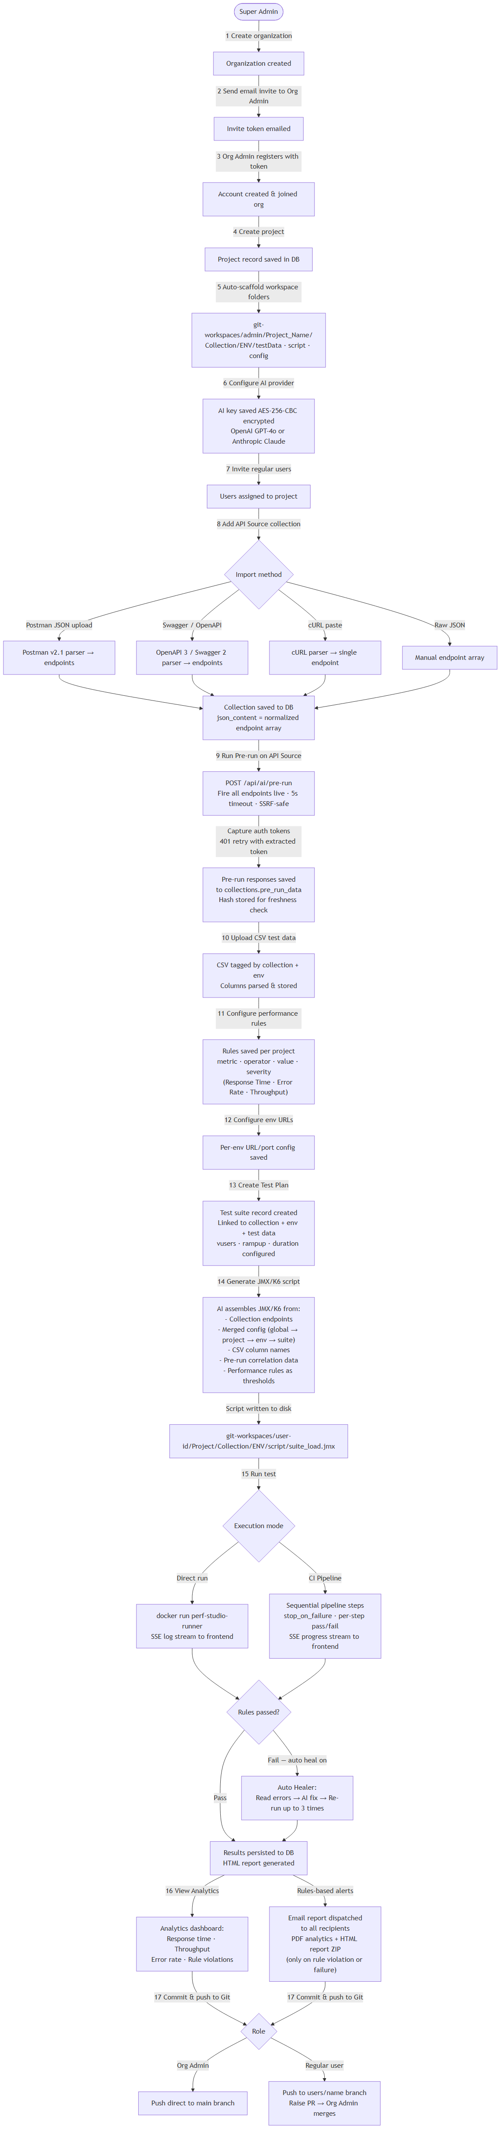
User journey: account/org setup through first successful test run.

1.5 Known Limitations
All items below are evidenced directly in code, schema, or committed documentation — none are speculative.
Limitation | Detail
No automated test suite | Zero unit/integration tests exist in backend/src or frontend/src; no test runner (Jest/Vitest/Mocha) is installed. See Section 7.1.
No linting / static analysis | No ESLint/Prettier configuration and no SonarQube (or equivalent) integration anywhere in the repo or CI. See Section 7.2.
Schema not auto-applied | schema.sql is never run automatically — a fresh Postgres volume requires a manual node backend/src/db/migrate.js before the app can serve real requests.
No secondary indexes on most foreign keys | Only one explicit index exists beyond primary/unique keys (a unique index on execution_runs.ci_run_id). High-traffic FK columns such as projects.user_id and test_suites.project_id are unindexed.
AI generation cost/latency is unmetered | Every K6 script generation and every auto-heal attempt is a live LLM call with no token counting, cost tracking, caching, or per-org rate limiting.
Large-script auto-heal can still exhaust the model’s output ceiling | Full-script rewrites are capped by the provider’s hard output-token limit (for example 16,384 GPT-4o / 8,192 Claude); a pre-flight guard now returns an honest "too large" result instead of a wasted call, but very large scripts may still get no automatic fix.
No user-facing data export/deletion (GDPR) | No endpoint allows a user to export or delete their own personal data; removal only happens when an admin deletes the user or project outright.
No comprehensive audit trail | Administrative and data-mutating actions (org/user/project changes) are not centrally logged with actor/timestamp; only session, invite, assignment, git-commit, and heal-attempt tables carry partial history.
Password policy is minimal | Minimum password length is 6–8 characters depending on the flow, with no complexity or history requirements — below typical enterprise policy (12+ characters).
No MFA | Authentication is single-factor (email + password) only.

2. Architecture Documentation

2.1 High-Level Architecture Diagram
Browser (React SPA) communicates over axios/JWT with the Express API, which is the single integration point for PostgreSQL, the filesystem-based Git workspaces, the AI providers, the JMeter/K6 execution layer, the configured Git provider, and SMTP.
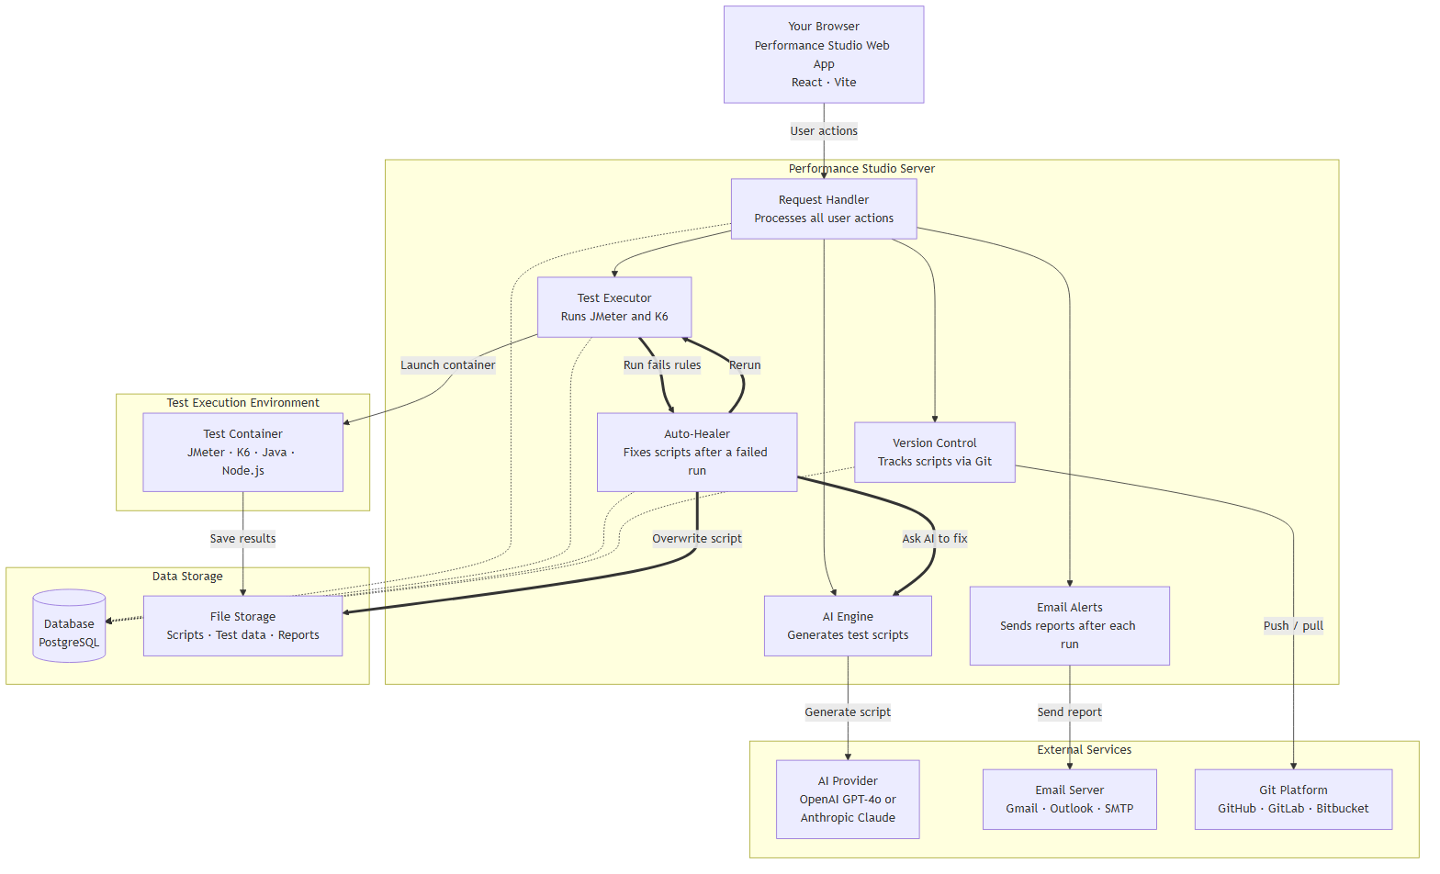
System architecture: request handler and its dependencies (docs/images/system-architecture.mmd).
Browser (React SPA) --axios/JWT--> Express API (backend/src/index.js, ~23 route modules)
|-- PostgreSQL: users, projects, collections, rules, test_suites, execution_runs, git_*, ci_*, ...
|-- Filesystem workspaces: git-workspaces/<Project>/<admin|user-N>/<Collection>/<Env>/{config,testData,script,results}
|-- AI provider (OpenAI / Anthropic): script generation + auto-heal diagnosis
|-- JMeter / K6 binaries (native) or Docker containers: test execution
|-- Git provider (GitHub / GitLab / Bitbucket): script versioning, PRs, CI triggers
|-- SMTP: alert emails, invites, password reset

Multi-environment / multi-tenant isolation
- Every project has one workspace folder per environment (QA / Staging / UAT / Production) and one per actor: an admin/ workspace (org admin, pushes to main) and one user-<id>/ workspace per regular user (pushes to users/<name>, merges via PR).
- Config, test data, scripts, and results are always scoped by collection_id + env at the database layer, so switching environment in the UI cannot leak another environment’s data.

2.2 Deployment Architecture Diagram
Recommended deployment is Docker Compose with two services: an all-in-one PerfStudio application container and a PostgreSQL container.
Service | Image | Ports | Volumes | Depends on | Healthcheck
postgres | postgres:16-alpine | 5432 (internal) | pg_data → /var/lib/postgresql/data | — | pg_isready -U postgres
PerfStudio | tasleemzaif/PerfStudio:latest (or build ./Dockerfile) | 3001 | PerfStudio_projects → /app/projects, PerfStudio_git → /app/git-workspaces, PerfStudio_backups → /app/backups | postgres: service_healthy | curl -f http://localhost:3001/api/health

Application image composition (root Dockerfile, multi-stage)
- Stage 1 (builder): node:22-slim builds the React/Vite frontend to static assets.
- Stage 2 (runtime): ubuntu:22.04 with Java 17 OpenJDK, Apache JMeter 5.6.3 (+ jpgc-casutg plugin), Grafana K6, Node.js 22, and Git; serves the built frontend as static files from the backend and runs node backend/src/index.js as a non-root user.
- Separate, lighter backend/Dockerfile (Node 18-alpine) and frontend/Dockerfile (nginx-served) are also published to Docker Hub by CI, but are not what docker-compose.yml runs by default.

Execution modes
Mode | JMeter / K6 location | When used
native (default) | Bundled inside the application image | Single-container deployment; simplest networking; used by docker-compose.yml
docker | Spawned containers (justb4/jmeter, grafana/k6) via the Docker socket | When backend needs isolated, disposable execution environments

Key environment variables
Variable | Required | Purpose
JWT_SECRET | Yes | JWT signing secret
ENCRYPTION_KEY | Recommended | AES-256-CBC key for encrypting stored API keys / SMTP passwords / Git tokens
DATABASE_URL | Yes | PostgreSQL connection string — the only DB config read; no SQLite fallback
FRONTEND_URL / CORS_ORIGIN | Yes | Invite/reset-password email links; allowed API origin
HOST_PROJECTS_ROOT / HOST_BACKUPS_ROOT | Yes (Docker) | Host paths for volume mounts
EXECUTION_MODE | Optional | "native" (bundled binaries) vs "docker" (spawn containers)
SMTP_* (HOST, PORT, USER, PASS, FROM) | Optional | Fallback SMTP if not configured per-user in-app
Note: The application’s own CI/CD pipeline is documented separately from the customer-facing CI/CD feature — see Section 2.5.

2.3 Sequence Diagrams — Requirement → Test Case → Automation → Execution → Reporting
The platform implements this lifecycle as one continuous, linear workflow (documented end-to-end in docs/USER_WORKFLOW.md):
Stage | Implementing files | What happens
1. Requirement (Collection Import) | routes/collections.js, utils/parseCollection.js | A Postman/Swagger/cURL/JSON API definition is imported and normalized into a flat endpoint list; this is the functional "requirement" the rest of the pipeline tests against.
2. Test Case Preparation (Pre-Run + Rules + Env Config) | routes/ai.js POST /pre-run, utils/preRunEngine.js, routes/rules.js, routes/envConfig.js | Endpoints are fired live to learn real auth tokens/response shapes; SLA rules and per-environment target URLs/variables are configured.
3. Automation (Script Generation) | routes/testSuites.js POST /:id/generate | A JMeter (.jmx, deterministic) or K6 (.js, AI-generated) script is produced from the endpoints, rules, test data, and pre-run results.
4. Execution | routes/execution.js, utils/testRunner.js, routes/pipelines.js, routes/ciPipeline.js | The script runs natively, in a spawned Docker container, as part of an internal sequential pipeline, or via external CI (GitHub Actions / GitLab CI / Bitbucket Pipelines).
5. Reporting | utils/ruleEvaluator.js, utils/generateAnalyticsPdf.js, utils/emailUtils.js | Results are parsed from the JTL/K6 summary, evaluated against rules, rendered as live/post-run dashboards, exported as a 6-page PDF, and emailed to configured recipients.
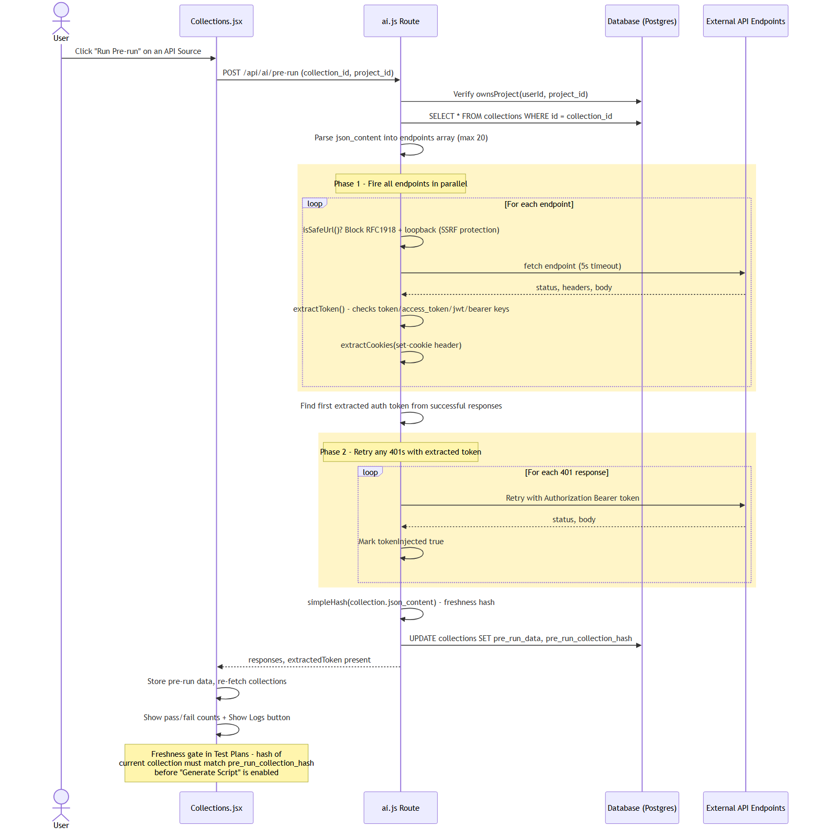
Pre-run sequence: bulk fire, token/cookie extraction, 401 retry, AI-assisted per-endpoint heal.
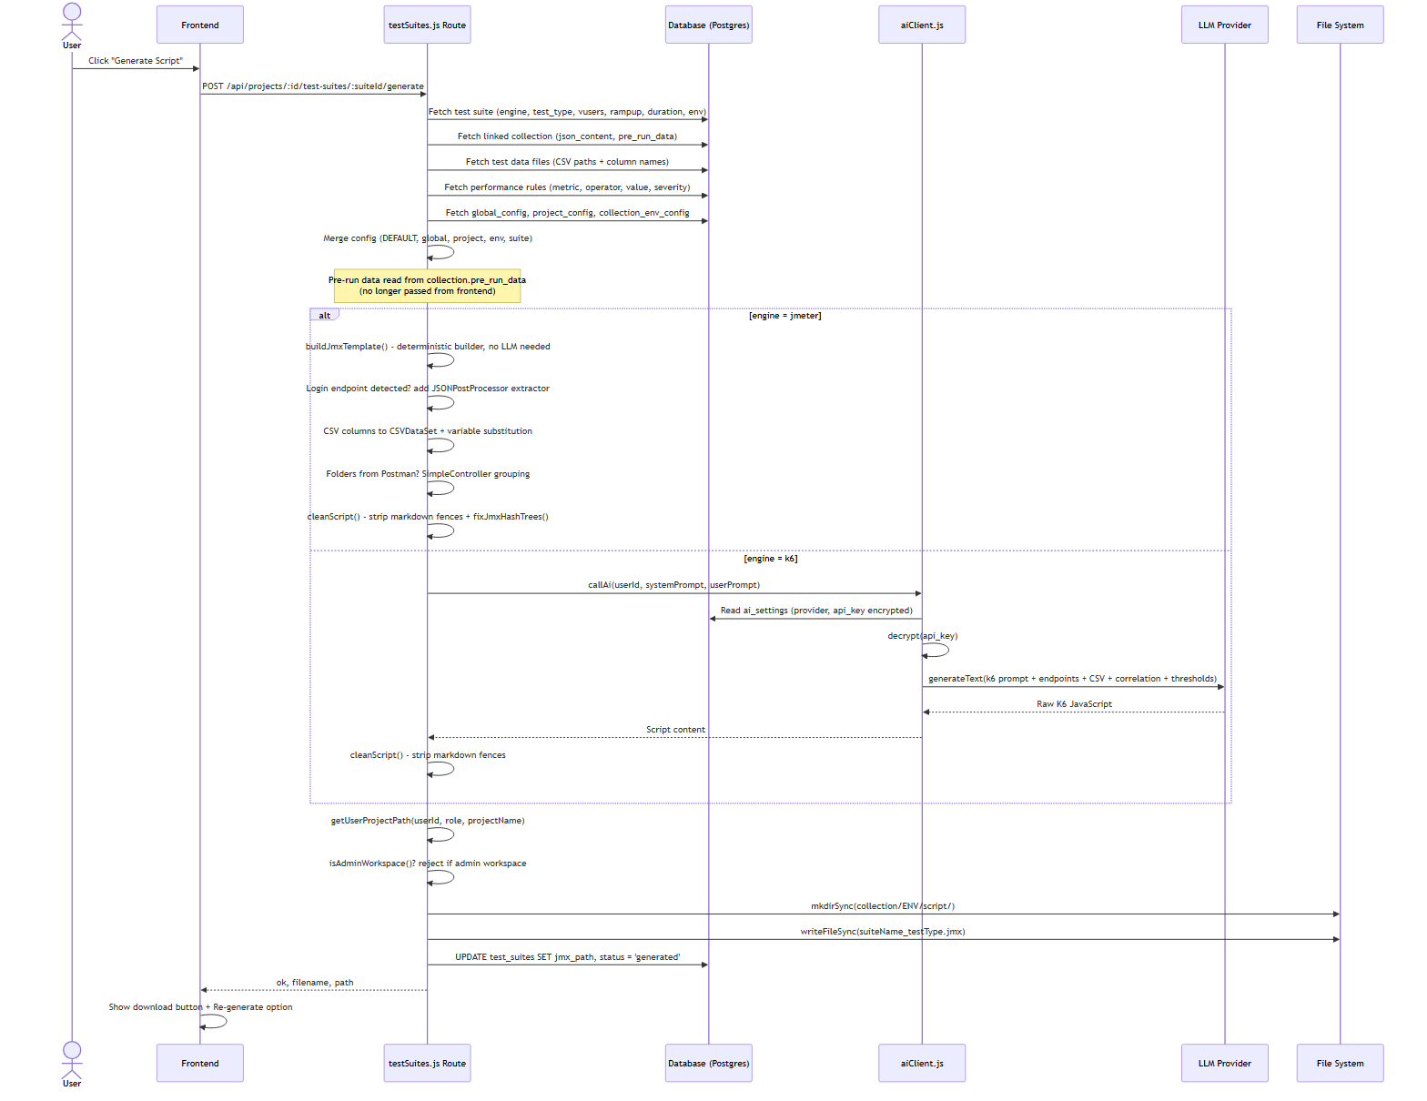
Script generation sequence: deterministic JMeter build vs AI-driven K6 generation.
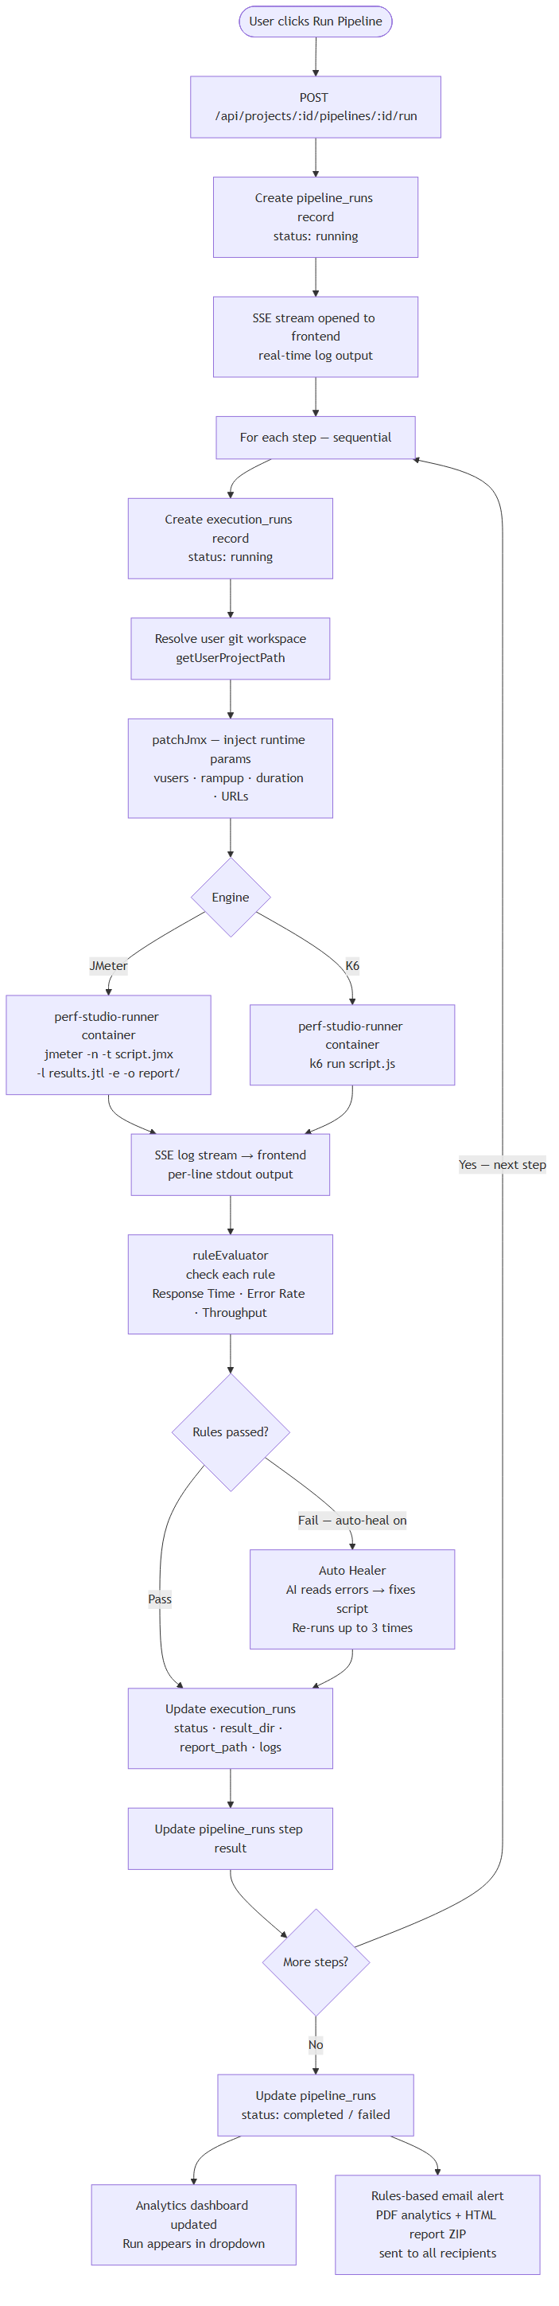
Test execution sequence: trigger → spawn JMeter/K6 → stream logs → parse JTL → evaluate rules → report.

2.4 Technology Stack Document

Frontend
Component | Technology / Version
Framework | React 18.2.0
Build tool / dev server | Vite 5.1.4 (port 5173)
HTTP client | axios 1.6.7 (JWT bearer interceptor)
Charting | Chart.js 4.5.1 + react-chartjs-2 5.3.1
PDF / screenshot (client-assisted) | html2canvas 1.4.1, jsPDF
Spreadsheet parsing | xlsx 0.18.5
Icons | @tabler/icons-webfont 3.44.0
State management | React hooks only (useState in App.jsx, prop-drilled) — no Redux/Zustand
Routing | Manual page-state + popstate listener — no react-router

Backend
Component | Technology / Version
Runtime | Node.js 22
Framework | Express 4.18.2 (port 3001)
Dev tooling | nodemon 3.1.0 (dev only)
Database | PostgreSQL 16, via pg 8.x (db/index.js entry point, db/pg.js compatibility shim, schema.sql applied by migrate.js)
Auth | jsonwebtoken 9.0.2 (HS256), bcryptjs 2.4.3 (10 rounds)
Encryption | Node.js built-in crypto — AES-256-CBC for secrets at rest
File uploads | multer
Backups | archiver (ZIP on project delete)

AI, execution engines, integrations
Component | Technology / Version
AI providers | OpenAI /Claude/Gemini/Azure OpenAI
Load-test engines | Apache JMeter 5.6.3 (+ jpgc-casutg plugin), Grafana K6 (native binaries or justb4/jmeter, grafana/k6 containers)
Git integration | simple-git (local ops), @octokit/rest (GitHub), raw REST calls (GitLab, Bitbucket)
Email | nodemailer (any SMTP provider)
PDF generation | Puppeteer (HTML → screenshot) + pdfkit (page stitching)
Containerization | Docker, Docker Compose

2.5 CI/CD Pipeline Documentation
There are two distinct, unrelated CI/CD systems in this product — they must not be confused.

A. PerfStudio’s own build/release CI/CD (self-hosting)
- File: .github/workflows/docker-publish.yml.
- Triggers: push to main, tag v*, and pull requests (PRs build but never push).
- Steps: checkout → Docker Buildx setup → Docker Hub login (non-PR only) → metadata extraction (branch/semver/latest tags) → build & push backend image → build & push frontend image → job summary.
- No test or lint gate exists in this pipeline (see Section 7).

B. Customer-facing CI/CD feature (external CI for generated test scripts)
- Files: routes/pipelines.js (internal sequential pipelines — not external CI) and routes/ciPipeline.js (external GitHub Actions / GitLab CI / Bitbucket Pipelines integration).
- User configures a provider’s auth (PAT / trigger token / app password), which is encrypted at rest.
- PerfStudio generates provider-specific YAML (.github/workflows/perf-test.yml, .gitlab-ci.yml, or bitbucket-pipelines.yml) embedding the script path, engine install steps, and a JTL validation step that fails the job immediately on 0 requests or a 100% error rate.
- The YAML is committed/pushed to the project’s Git repository (auto-push option available, with a verified-branch check to prevent landing on the wrong branch).
- PerfStudio triggers the pipeline (workflow_dispatch for GitHub, pipeline trigger API for GitLab, trigger API for Bitbucket) and polls status.
- On completion, PerfStudio downloads artifacts, evaluates rules, and — if auto_heal is enabled — diagnoses and repairs the script, pushes the fix back to the repository, and re-triggers the pipeline (maximum 1 automatic attempt; a "Heal Again" action allows a user-guided retry).
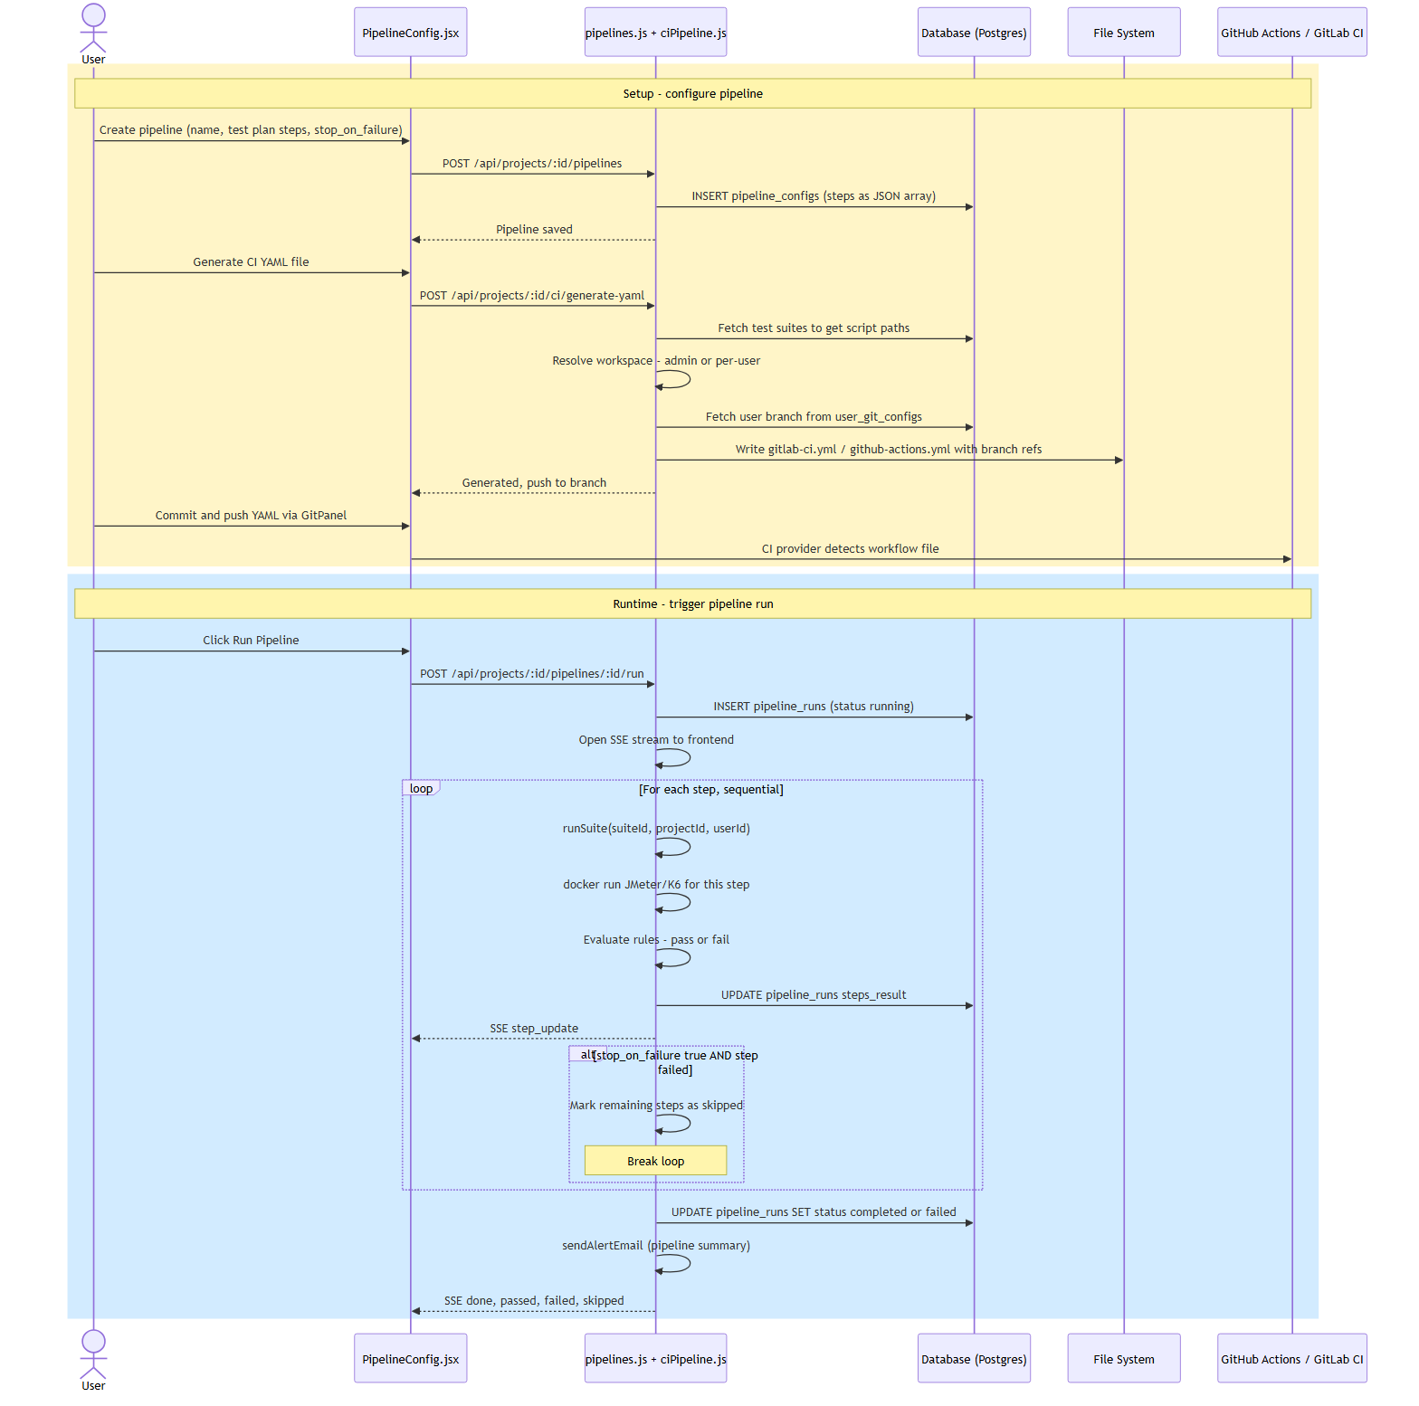
External CI/CD sequence: YAML generation → trigger → provider execution → results sync → optional auto-heal.
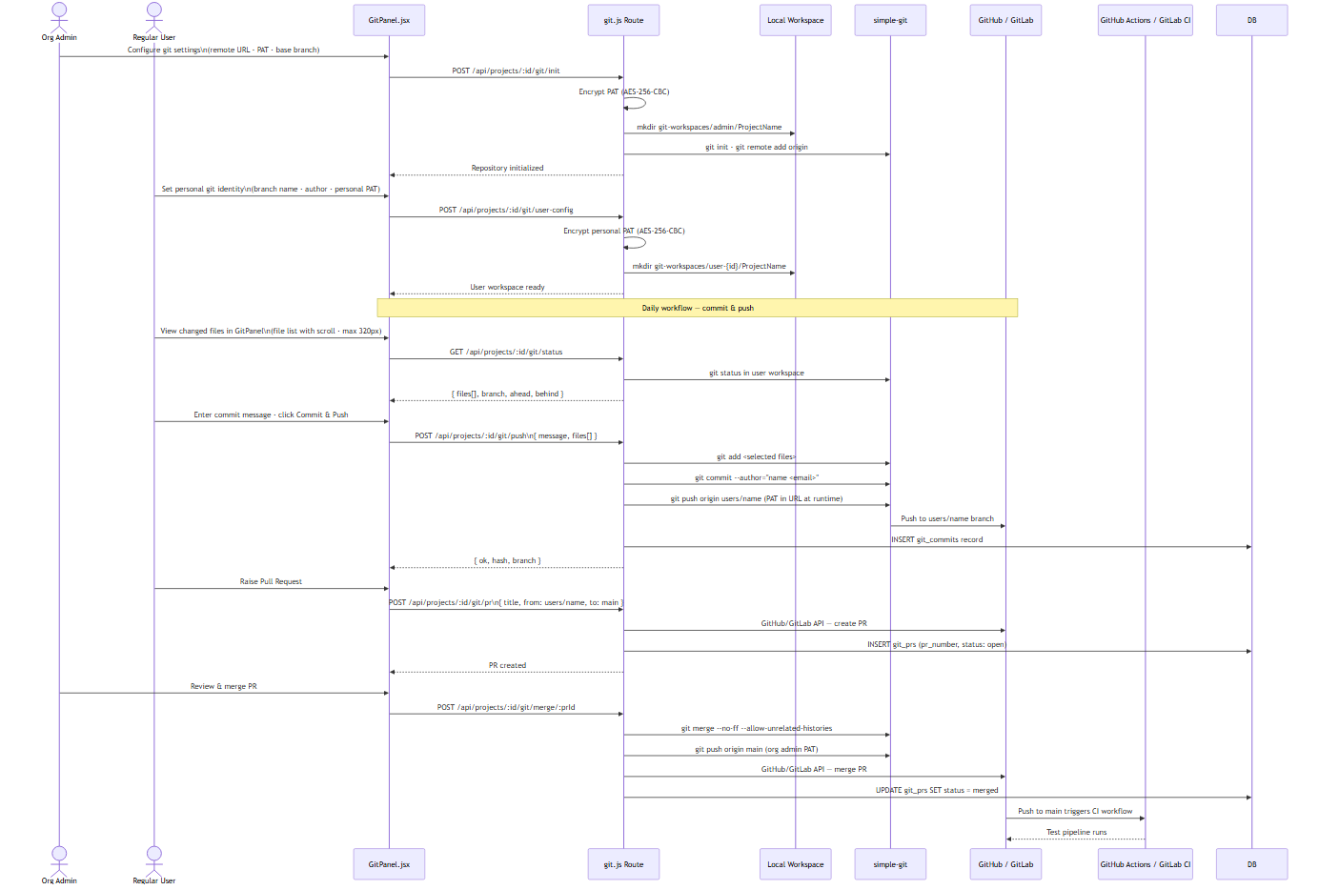
Git + CI integration: branch-per-user model, PR flow, and external CI trigger.

3. Backend Documentation

3.1 API Documentation
No machine-readable OpenAPI/Swagger spec is generated by the codebase; the tables below are a hand-compiled equivalent covering all ~25 route modules mounted under /api in backend/src/index.js. Nearly every router applies the auth middleware (JWT validation + license/session check); exceptions are noted. Project-scoped routers additionally call ownsProject(userId, projectId) and return 404 (never 403) on denial, to avoid leaking existence.

Auth & Account (auth.js, passwordReset.js) — /api/auth
Method & Path | Auth | Purpose
POST /register | Public | Role-based signup; creates org if needed; status stays "pending" until admin approval.
POST /login | Public | Validates credentials; blocks pending/rejected users; enforces single active session unless force:true.
POST /logout | Public (token in body/header) | Invalidates the session for the token’s user.
POST /heartbeat | JWT | Keep-alive / session validity check; also used for takeover detection.
GET /me, PUT /me | JWT | Fetch/update profile (name, email).
PUT /me/password | JWT | Change password (current password required).
GET /me/registry-token | JWT | Returns the org’s npm registry token for the Artifact Keeper integration.
POST /forgot-password | Public | Issues a 30-minute reset token by email; never reveals whether the email exists.
POST /reset-password | Public | Consumes a valid, unused, unexpired token to set a new password.
POST /admin/users/:id/reset-password | JWT + admin | Admin-forced password reset; org admin limited to own-org users.

Admin & Organizations (admin.js, orgs.js, licenses.js)
Method & Path | Auth | Purpose
GET /api/admin/users | admin | List users (super admin: all non-super; org admin: own org).
PUT /api/admin/users/:id/status | admin | Approve/reject a pending registration.
DELETE /api/admin/users/:id | admin | Cascading delete of a user’s invites, alerts, assignments, and git-commit references.
GET /api/orgs | Public | Organization list for signup/invite forms.
GET /api/orgs/managed | super_admin | All orgs with member/project counts and license metadata.
POST /api/orgs | super_admin | Create org, optionally invite its first org admin, provision a licence + npm registry token.
PUT /api/orgs/:id, DELETE /api/orgs/:id | super_admin | Update metadata; delete only if the org has no active members.
GET /:id/admins, GET/POST/DELETE /:id/npm-token | super_admin | Org-admin listing; Artifact Keeper registry token lifecycle (never returns the raw token after creation).
GET /api/licenses/plans, /mine | org_admin / super_admin | Plan-tier catalogue; the caller’s org’s live usage vs. limits.
GET/PUT /api/licenses/:orgId, PUT /:orgId/status | super_admin | Assign/upgrade a plan; enable/disable an org.

Projects, Collections, Config (projects.js, collections.js, projectConfig.js, envConfig.js, config.js)
Method & Path | Auth | Purpose
GET/POST/PUT/DELETE /api/projects | JWT (create/edit restricted to non-user roles) | Project CRUD; delete triggers async Git cleanup + ZIP backup + cascading deletes.
GET /api/projects/backups, /backups/:filename | org_admin / super_admin | List/download ZIP backups of deleted projects (path-traversal guarded).
GET/POST/PUT/DELETE /api/projects/:id/collections | JWT + ownsProject | Import (multipart: source file + optional Postman environment file), parse, update, delete a collection; auto-populates env config.
POST /collections/parse-curl | JWT | Parses a raw cURL string into an endpoint object.
GET/PUT /api/projects/:id/config | JWT + ownsProject | Project-wide reference configuration (display-only defaults).
GET/PUT /api/projects/:id/collections/:cid/env-config/:env | JWT + ownsProject | Per-collection-per-environment URLs/variables — strict isolation, unique on (collection_id, env).
GET/PUT /api/config | JWT | User-level global URL/port defaults.

Rules, Scripts, Test Suites, Test Data (rules.js, scripts.js, testSuites.js, testData.js)
Method & Path | Auth | Purpose
CRUD /api/projects/:id/rules | JWT + ownsProject | Performance thresholds (metric, operator, value(s), severity); writes trigger an async config.json refresh.
CRUD /api/projects/:id/scripts | JWT + ownsProject | Legacy script metadata templates.
CRUD /api/projects/:id/test-suites | JWT + ownsProject | Test-plan definitions (engine, VUsers, ramp-up, duration/loops, linked collection/environment).
POST /test-suites/:id/generate | JWT + ownsProject | Generates the JMeter/K6 script; blocked until pre-run is fresh; blocks generation from the admin workspace directly.
GET /test-suites/:id/download/:type | JWT + ownsProject | Downloads the generated .jmx or .js file.
GET/POST/PUT/DELETE /api/projects/:id/test-data | JWT + ownsProject (+ multer upload) | CSV/XLSX test-data management, scoped per collection/environment; flags stale files missing from disk.
GET/PUT /test-data/:id/content | JWT + ownsProject | Paginated CSV read/write.
POST /test-data/:id/open-external | JWT + ownsProject | Opens the file with the OS default application.

AI, Settings, Execution, Alerts (ai.js, settings.js, runner.js, execution.js, alerts.js)
Method & Path | Auth | Purpose
POST /api/ai/pre-run | JWT + ownsProject | Fires all endpoints live (SSRF-guarded, chunked), extracts auth tokens/cookies, retries 401s.
POST /api/ai/pre-run/heal | JWT + ownsProject | AI-diagnosed single-endpoint fix (header/body/URL override), verified by re-firing.
GET/PUT /api/settings/ai | JWT | AI provider/model selection; API key is write-only (never returned raw — only an api_key_set flag).
POST /api/runner/execute | JWT | Mock/simulated run for UI development — not real execution.
/api/execution/* (check-deps, check-docker, run, PDF export, etc.) | JWT | Real execution: dependency checks, Docker management, run lifecycle, live SSE log/metric streaming, PDF export.
GET/PUT /api/alerts/config, POST /test-smtp, /send-test | JWT | SMTP configuration and connectivity testing.
CRUD /api/alerts/recipients, /projects/:id/recipients | JWT | Global and per-project alert recipient lists.

Invites, Git, Pipelines, External CI (invites.js, git.js, pipelines.js, ciPipeline.js)
Method & Path | Auth | Purpose
POST /api/invites | admin | Creates a 72-hour invite; enforces org license/user-count limits.
GET /invites/validate/:token, POST /invites/accept/:token | Public | Invite validation and self-service acceptance (sets password, activates account, re-checks license at acceptance time).
GET/PUT /api/projects/:id/git/config, POST /init | JWT + ownsProject (config write: org_admin) | Remote/auth configuration and repository initialization.
GET /status, POST /commit, /push, /pull; GET /branches, /log; CRUD /prs | JWT + ownsProject | Standard Git operations plus PR create/merge (merge restricted to org_admin)/close.
CRUD /api/projects/:id/pipelines, POST /:id/run | JWT + ownsProject | Internal sequential multi-suite pipelines, SSE-streamed, with stop-on-failure.
GET/PUT /api/projects/:id/ci/config, POST /config/test, /generate-yaml, /trigger | JWT + ownsProject (YAML gen: org_admin) | External CI provider configuration, connectivity test, YAML generation/commit, and run triggering.
GET /ci/runs, /runs/:runId/status | JWT + ownsProject | CI run history and live status polling with results sync.
Note: runner.js (mock) vs. execution.js (real), and pipelines.js (internal sequencing) vs. ciPipeline.js (external CI) are deliberately separate subsystems that are easy to confuse by name.

3.2 Database ER Diagram
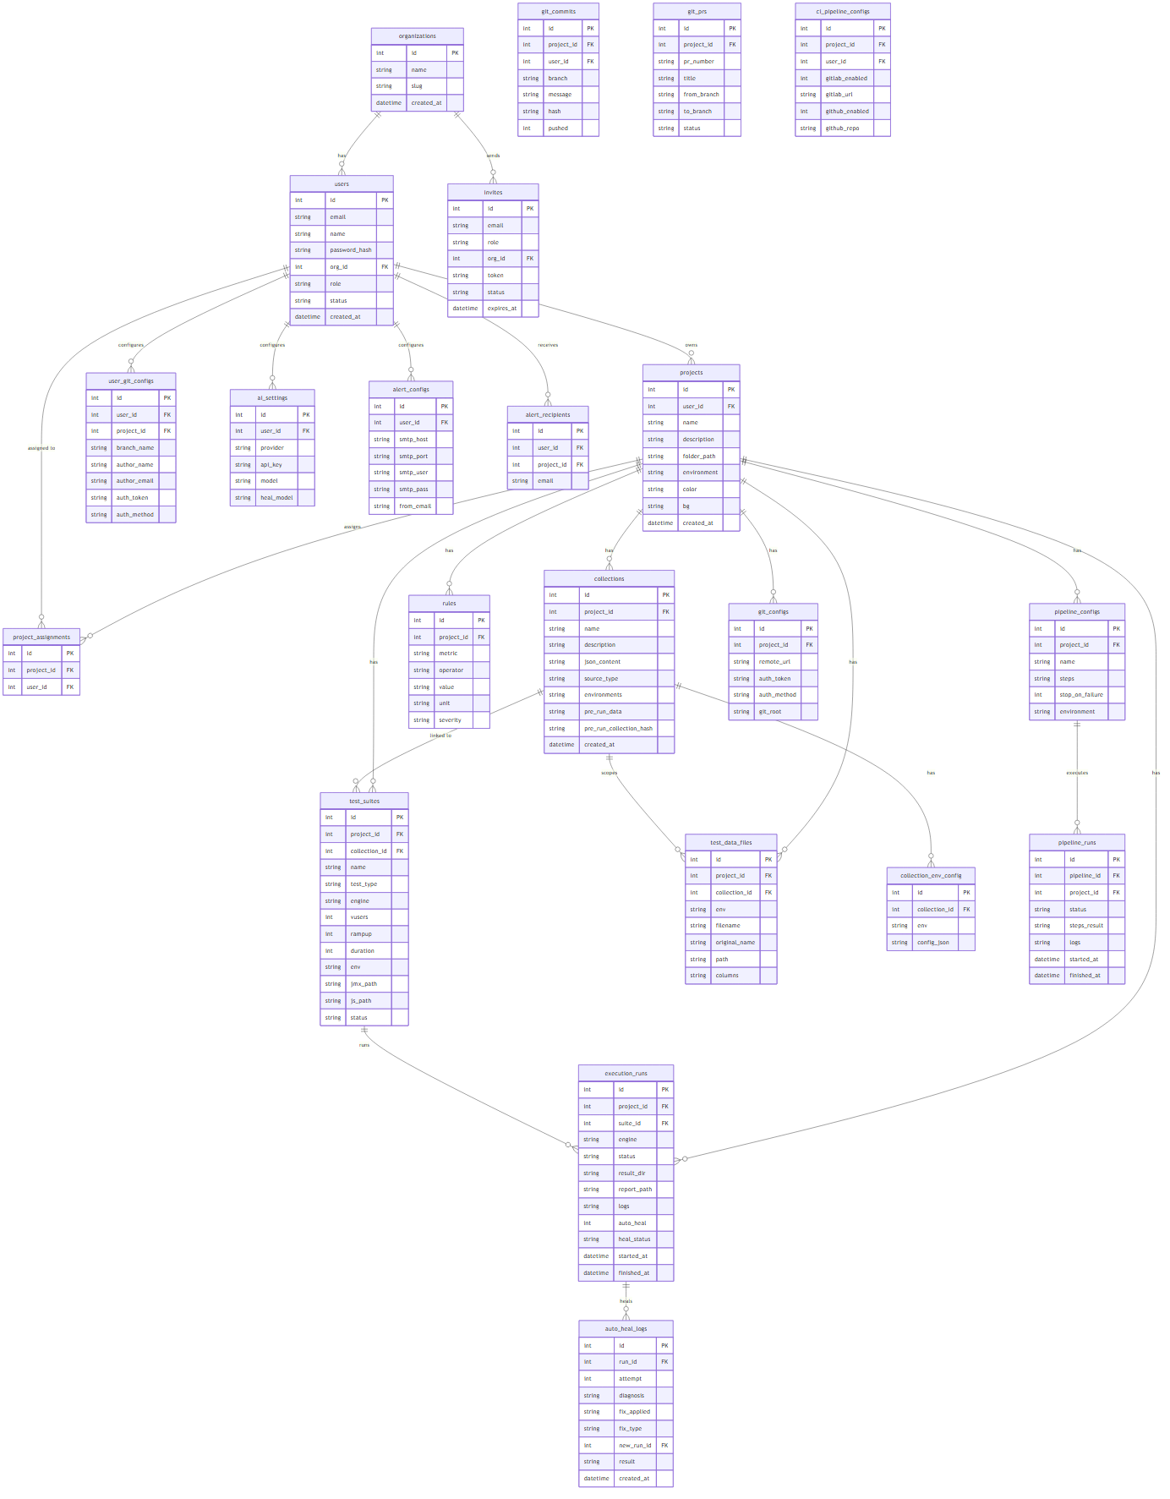
Entity-relationship model across 31 tables, grouped by domain.
Logical domains: (1) Authentication & Authorization — organizations, users, user_sessions, password_resets, invites, project_assignments, org_licenses; (2) Projects & Collections — projects, collections, collection_env_config, global_config, project_config; (3) Test Configuration & Rules — rules, scripts, test_data_files, test_suites, ai_settings; (4) Test Execution — execution_runs, auto_heal_logs; (5) Git Integration — git_configs, user_git_configs, git_commits, git_prs; (6) CI/CD — pipeline_configs, pipeline_runs, ci_pipeline_configs, ci_pipeline_runs, ci_auto_heal_logs; (7) Alerts — alert_configs, alert_recipients.

3.3 Database Schema
Schema: backend/src/db/schema.sql, applied by migrate.js as idempotent CREATE TABLE IF NOT EXISTS statements (not a data migrator — there was no prior production data). db/index.js seeds a super_admin user (admin@perfstudio.com) on first boot if none exists.

Core tables
Table | Key columns | Notable FKs
organizations | id, name (unique), slug (unique), description, website, industry, registry_token_enc/key/prefix/expires_at | —
org_licenses | id, org_id (unique), plan, max_users, max_projects (NULL = unlimited), status, expires_at | org_id → organizations, ON DELETE CASCADE
users | id, email (unique), name, password_hash, org_id, role, status | org_id → organizations (no cascade specified)
user_sessions | id, user_id, jti (unique), expires_at, last_used_at | user_id → users, CASCADE; UNIQUE(jti)
projects | id, user_id, name, description, color, folder_path, environment, uuid | user_id → users, CASCADE
collections | id, project_id, name, json_content, source_type, tool_target, generated_jmx/k6, pre_run_data, pre_run_collection_hash | project_id → projects, CASCADE
collection_env_config | id, collection_id, env, config_json | UNIQUE(collection_id, env); no FK on collection_id (see Section 1.5 known-limitation history)
rules | id, project_id, metric, operator, value, value_min, value_max, unit, severity | project_id → projects, CASCADE
test_suites | id, project_id, collection_id, test_data_id, engine, config_json, jmx_path/js_path, vusers, rampup, duration, env | collection_id → collections SET NULL; test_data_id → test_data_files SET NULL
execution_runs | id, project_id, suite_id, status, result_dir, report_data, ci_run_id, heal_status | suite_id → test_suites SET NULL; UNIQUE INDEX on ci_run_id WHERE NOT NULL
auto_heal_logs / ci_auto_heal_logs | id, run_id / ci_run_id, attempt, diagnosis, fix_applied, fix_type, result | No FK constraint on run_id / ci_run_id

Supporting tables
Table | Purpose
global_config / project_config / ai_settings | Per-user global config, per-project reference config, and per-user AI provider settings (encrypted API key).
test_data_files | CSV/XLSX metadata (filename, columns, collection_id, env).
git_configs / user_git_configs / git_commits / git_prs | Project-level and per-user Git remote/auth configuration, commit and PR history.
pipeline_configs / pipeline_runs | Internal sequential pipeline definitions and run history.
ci_pipeline_configs / ci_pipeline_runs | External CI provider configuration (unique per project+user) and run history.
alert_configs / alert_recipients | Per-user SMTP settings and global/per-project recipient lists.
password_resets / invites / project_assignments | Reset tokens, org invitations, and many-to-many user↔project assignment.

Constraints, indexing, and data-type observations
- One explicit secondary index exists: a unique partial index on execution_runs(ci_run_id) WHERE ci_run_id IS NOT NULL, added specifically to prevent a race condition producing duplicate rows during concurrent CI status polling.
- No other secondary indexes exist on foreign-key columns (e.g. projects.user_id, collections.project_id, test_suites.project_id) — a performance consideration at higher data volumes.
- JSON-shaped data (config_json, json_content, environments, logs, variables) is stored as TEXT rather than PostgreSQL JSONB, forgoing native JSON indexing/query operators.
- Boolean flags are stored as INTEGER (0/1), a holdover from the pre-migration SQLite schema.
- A handful of FKs have no ON DELETE clause (implicit NO ACTION) — e.g. git_prs.created_by, invites.invited_by — and auto_heal_logs.run_id / ci_auto_heal_logs.ci_run_id have no FK constraint at all.
- collection_env_config and test_data_files store collection_id as a plain integer with no foreign key — a documented, since-fixed data-leakage risk when a collection ID was reused after deletion (see Section 5.1 for the historical bug and fix).

4. AI Documentation

4.1 AI Architecture Document
AI calls are centralized behind a single function, callAi(userId, systemPrompt, userPrompt, purpose), in backend/src/utils/aiClient.js. The purpose argument ('script' or 'heal') selects which of two independently configurable models is used, so an organization can, for example, use a cheaper/faster model for script generation and a stronger model for auto-heal diagnosis.
Provider | Client shape | Endpoint
OpenAI | Standard OpenAI SDK client | api.openai.com
Anthropic (Claude) | Called through an OpenAI-compatible endpoint shape (same system/user message format) | api.anthropic.com/v1 with header anthropic-version: 2023-06-01
- Provider and model are selected per organization via the ai_settings table (settings.js GET/PUT /api/settings/ai).
- The API key is AES-256-CBC encrypted at save time and decrypted only at the moment of the AI call; the frontend only ever receives an api_key_set boolean, never the key.
- Temperature is fixed at 0.2 for both providers and both purposes, favoring deterministic, reproducible output over creativity.
- max_tokens is set explicitly per call to the provider’s real output ceiling (16,384 for GPT-4o, 8,192 for Claude by default) — this was a historical bug fix, since omitting it caused silent truncation on large responses.
- A response’s finish_reason is checked; finish_reason === "length" is surfaced as an explicit "response was cut off" error rather than being passed to JSON.parse and failing cryptically.

4.2 Prompt Design / Prompt Templates

K6 script generation (the only AI-driven script generation path — JMeter generation is fully deterministic, see Section 5.3)
System: "You are an expert k6 v0.50 JavaScript performance test script generator.
Output ONLY raw valid JavaScript. No markdown fences, no explanation."
- User prompt assembles: test type (load/stress/spike/endurance), runtime parameters as __ENV constants (THREADS, RAMP_UP, DURATION, PROTOCOL, URL, PORT), the k6 executor/thresholds derived from the project’s rules, the full endpoint collection as structured JSON (capped at 4,000 characters), CSV test-data guidance (SharedArray + column-name matching), a correlation section built from the first 2,000 characters of pre-run response data, and any previously AI-verified endpoint overrides.
- Prompt-injection mitigation: endpoint and variable data is JSON-stringified rather than interpolated as executable code; pre-run data and prior fixes are length-capped; nothing free-form from an end user is placed directly into the instruction text.

Auto-heal — full-script rewrite (last-resort tier)
System: "You are an expert {JMeter|k6} performance test auto-healer... ABSOLUTE RULES: (1) for ZERO_SAMPLES regenerate from scratch, otherwise the fixed script MUST retain every original sampler; (2) only modify elements responsible for the failure, preserve passing requests byte-for-byte; (3) maintain original sampler order; (4) place new extractors as post-processors on the correct response; (5) fix the root cause, never mask it; (6) output ONLY one JSON object."
Required JSON shape: {"issue", "fix", "fix_type": "script_rewrite"|"no_fix", "fixed_script"}. The user prompt supplies: engine and attempt number, the auto-detected failure categories with 2–5 paragraphs of category-specific fix guidance each, a FAILING vs. PASSING sampler inventory, DNS resolution status per host, referenced-vs-defined variable analysis, a JTL error summary grouped by label, the last 15 KB of the JMeter/K6 log, the last 80 console log lines, any rule violations, and the full current script. An optional user-supplied instruction (e.g. "use refreshToken instead of accessToken") is prepended and marked highest priority.

Auto-heal — endpoint-scoped override patch (lower-cost tier)
Used only for VARIABLE_REFERENCE / REQUEST_MALFUNCTION categories on JMeter suites with a linked collection. The AI is explicitly told not to rewrite the script — only to propose per-endpoint header/body/URL overrides, using {{captured:KEY}} for values captured from an earlier response and {{key}} for collection variables, with authorization/token values required to prefer {{captured:KEY}}. Capped at 8 endpoints per attempt.

Auto-heal — diff patch (surgical text edits)
For any remaining category, the AI is asked for a small list of {find, replace} edits instead of a full file. Each "find" must match the current script’s text exactly once — 0 or 2+ matches causes that edit to be rejected rather than guessed at. The result is checked for well-formed XML (JMeter) or balanced brackets (K6) before being accepted; a failure falls through to the full-rewrite tier.

Pre-run "Fix with AI" (single failing endpoint, outside the auto-heal pipeline)
routes/ai.js builds a small, tightly-scoped prompt containing only the one failing endpoint’s last request/response, the tokens captured so far, and the collection’s non-blank variables, plus any user instruction. Output is {"issue","fix","fix_type": "header_override"|"body_override"|"url_override"|"no_fix", "headers"?, "body"?, "url"?}. The proposed override is persisted (fingerprinted by method + name) and applied automatically on every future pre-run for that endpoint.

4.3 Model Configuration & Supported LLMs
Provider | Default model | Configurable heal model | Max output tokens | Temperature
OpenAI | gpt-4o | Independent (ai_settings.heal_model) | 16,384 (hard provider ceiling) | 0.2
Anthropic (Claude) | claude-sonnet-5 | Independent (ai_settings.heal_model) | 8,192 default (Anthropic’s extended-output beta is not enabled) | 0.2
The frontend’s model dropdown is a curated convenience list only, not a technical whitelist — settings.js stores whatever model string is submitted verbatim, and a "Custom (enter model ID)…" option exists for both providers so a newly released model can be used immediately without a code change.

4.4 Token Usage & Cost Strategy
There is no token-counting, cost-tracking, usage-quota, or response-caching layer anywhere in the codebase because It supports BYO AI (Bring your own AI). Each script-generation or auto-heal AI call is a fresh, unmetered request billed entirely at the underlying provider account.
- JMeter generation makes zero AI calls (fully deterministic template builder) — cost only applies to K6 generation.
- Auto-heal is capped at 1 automatic attempt per failed run (reduced from an earlier default of 3, specifically to avoid repeated, unguided, same-cost retries); a manual "Heal Again" with a user instruction is the intended path for a further attempt.
- The only token-related safeguard is a pre-flight size check before a full-script rewrite: the script’s size is estimated in tokens and compared against the provider’s ceiling minus a safety margin (600 tokens); if it can’t possibly fit, an honest "no_fix" is returned immediately instead of spending a guaranteed-to-truncate AI call.
- The tiered repair strategy (mechanical fix → endpoint-override patch → diff patch → full rewrite) is itself the primary cost-control mechanism: each tier’s AI output is bounded by the size of the change rather than the size of the whole script, which is what makes healing large (100KB+) scripts economically and technically feasible at all.

4.5 AI Workflow Diagram

K6 generation flow: assemble context → build prompt → call provider → validate/clean → write script.

Script generation (summarized)
Load suite + collection + test data + rules + merged config -> for JMeter: buildJmxTemplate() (no AI)
-> for K6: build system/user prompt -> callAi(purpose='script') -> strip markdown -> write .js

Auto-heal cycle (summarized)
Run fails -> buildContext() (parse JTL, classify errors, resolve DNS, diff vars) -> diagnoseWithAi():
1) tryFixTemplateVars() / tryFixDisabledElements() [deterministic, zero AI cost]
2) tryEndpointOverridePatch() [AI, endpoint-scoped, low cost]
3) tryDiffPatch() [AI, surgical edits, medium cost]
4) full-script rewrite [AI, last resort, token-budget-guarded]
-> apply fix -> Phase 1 quick verify (1 VUser/1 loop) -> Phase 2 full re-run -> healed | still_failing | infra_error

4.6 Auto-Healing Design
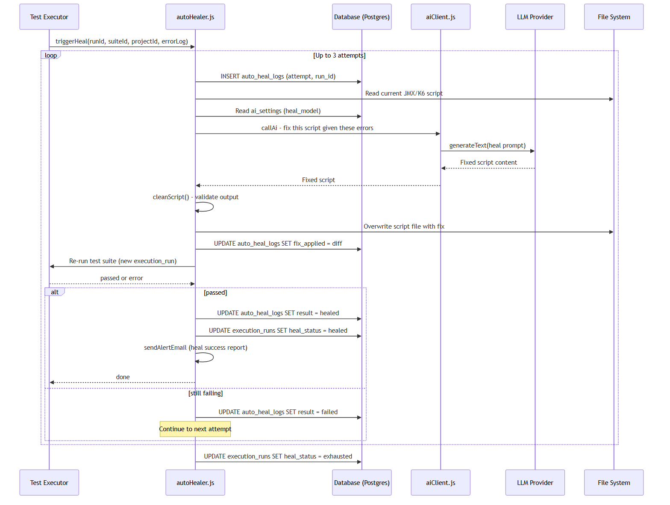
Auto-heal decision flow across both local execution and CI-triggered runs.

JTL error classification
Failures are grouped into categories before any AI call is made, so the diagnosis prompt is targeted rather than generic: DNS/Connection failures (no response, 0/500–505/429, connection-refused patterns), Correlation/Auth failures (401/403, invalid/expired token/session/CSRF), Assertion failures, Variable/Reference failures (unresolved ${…} or literal {{var}}), Request Malformation (400/404/405/422 and other 4xx), and Zero Samples (no requests recorded at all). If ≥70% of failures classify as infrastructure-level, the whole run is marked an infrastructure failure and auto-heal deliberately does not attempt a script fix.

Repair tiers, in order of preference
Tier | Trigger | AI cost | Mechanism
1. Mechanical fix | Literal {{var}} tokens present, or disabled ThreadGroup/Sampler/Controller elements | None | tryFixTemplateVars() resolves or converts to ${var}; tryFixDisabledElements() flips enabled="false" to "true".
2. Endpoint-override patch | VARIABLE_REFERENCE / REQUEST_MALFUNCTION, JMeter + linked collection | Low — output limited to a small overrides list | AI proposes per-endpoint header/body/URL overrides; script is deterministically regenerated (zero extra AI tokens) via the existing generator.
3. Diff patch | Any other category | Medium — output limited to the size of the change | AI proposes exact-match find/replace text edits; rejected if a "find" isn’t unique or the patched result is structurally malformed.
4. Full rewrite | All prior tiers unavailable/failed | Highest — output bounded by full script size | AI reproduces the entire corrected script; guarded by a pre-flight size check and a same-sampler-count / structural-validity check on the result.

Verification and attempt policy
- Phase 1 — quick verify: 1 VUser, 1-second ramp-up, 1 loop, no HTML report, to catch a broken/invalid fix cheaply before committing to a full re-run.
- Phase 2 — full run: original run parameters (VUsers/ramp-up/duration/loops), only attempted if Phase 1 passes.
- Maximum 1 fully automatic attempt (local: autoHealer.js MAX_ATTEMPTS; CI: ciPipeline.js HEAL_CI_MAX_ATTEMPTS) — a deliberate reduction from an earlier default of 3, since an unguided repeat of the same diagnosis produces the same result at the same cost. A user-supplied instruction via "Heal Again" is the intended next step.
- CI-context healing (ciPipeline.js healCycleCI()) shares the same diagnoseWithAi() logic as local healing, and additionally pushes the fixed script back to the Git repository before re-triggering the CI job.
- Every attempt, its diagnosis, the fix applied, and the outcome are persisted to auto_heal_logs (local) or ci_auto_heal_logs (CI).

5. Workflow Documentation

5.1 Collection Import
Supported formats: Postman v2.1, Swagger/OpenAPI (JSON or YAML), cURL, and raw JSON. parseCollection.js normalizes every format into the same flat internal shape: {name, folder, folderPath, method, url, headers, body, queryParams}.
- Postman parser: walks the nested folder structure (preserved as folder/folderPath for later JMeter grouping), extracts v2.1-style query params, and skips disabled headers/params.
- Swagger/OpenAPI parser: resolves the base URL from servers[0].url (or host+basePath+schemes), iterates every path × method, extracts query parameters and an example request body.
- cURL parser: delegates to a dedicated parseCurl() utility and wraps the single resulting endpoint in an array.
- What is explicitly not done: Postman pre-request scripts are never executed, and Postman collection/environment variables are not resolved at parse time — the raw {{var}} text is preserved as-is for later stages to handle.

Variable extraction and environment auto-population
- Collection-level variables (a Postman collection’s own top-level variable array) are extracted as a fallback default.
- An optional second upload — a Postman .postman_environment.json export — provides real values that take precedence over the collection’s own defaults; re-uploading a collection never overwrites a value the user already has stored for an environment.
- On import, each endpoint’s URL is resolved against the variable map to {protocol, url, port} and merged into project_config (project-wide reference) and collection_env_config (per-environment, authoritative for script generation) — without ever overwriting a value the user has already set manually.
- A dedicated per-collection Git-workspace folder tree is created per environment: testData/, script/, results/, and a config.json snapshot; the original source file and any uploaded environment file are stored alongside it for reference.

5.2 Pre-run

Pre-run: bulk fire → token/cookie capture → 401 retry → optional AI-assisted per-endpoint fix.
- Purpose: fire every collection endpoint live, exactly as it will be called, to learn real authentication tokens and response shapes before any script is generated — script generation is blocked until a fresh pre-run exists (hash-matched to the current collection).
- Concurrency: endpoints are fired in chunks of 20 with a 250ms pause between chunks (removed a prior hard cap of the first 20 endpoints only — every endpoint in the collection is now fired).
- Variable substitution (preRunEngine.js substituteVars/findMissingVars): resolves {{var}} iteratively up to 5 passes (to handle nested templates like {{protocol}}://{{host}}); an unresolved token is left in place and reported to the caller rather than silently sent as literal text.
- Token/cookie extraction: scans response bodies for common auth field names (token, access_token, jwt, bearer, sessionToken, refreshToken, etc., including inside nested wrapper objects) and Set-Cookie headers; every match is retained, not just the first.
- 401 retry: if a default token (access-token-shaped fields only — refresh tokens are deliberately excluded from this default) exists from an earlier response, a 401 is retried once with it injected as an Authorization header plus any captured cookies.
- SSRF guard: requests are blocked to localhost, 127.x, 0.x, 10.x, 192.168.x, 172.16–31.x, and 169.254.x, and must be http/https — enforced before any request is fired (see Section 6.7 for a full gap analysis).
- AI-assisted per-endpoint heal ("Fix with AI"): lets a user fix a single still-failing endpoint without re-running the whole collection; the fix is persisted as a fingerprinted override and applied automatically on every future pre-run of that endpoint.

5.3 Script Generation Design

Script generation: deterministic JMeter template builder vs. AI-driven K6 generation.

Configuration merge order
{ ...DEFAULT_CONFIG, ...global_config, ...project_config, ...collection_env_config, ...suite.config_json }
For a suite scoped to a collection, URL/protocol/port fields are stripped from the global/project layers before merging, so a collection-scoped suite’s target can only ever come from its own environment config or its own suite override — this closes a historical cross-collection URL leak (see Section 5.1 of the security findings summary in Section 6).

JMeter generation — fully deterministic, no AI call
- buildJmxTemplate() constructs the entire .jmx XML from the resolved endpoints, CSV columns, and correlation rules: User Defined Variables (protocol/server/port, thread/ramp-up/duration or loop-count, CSV path/file, and collection variables — all overridable at runtime via -J flags), one CSVDataSet element per test-data file, one HTTPSamplerProxy per endpoint with header/body/query substitution, and a JSONPathExtractor for every field captured from a detected login endpoint.
- Multi-host support: a single collection spanning multiple API families (each behind its own {{var}}-templated base URL) resolves each endpoint’s own host independently and, when more than one distinct host is found, emits indexed UDVs (PROTOCOL_1/SERVER_1/PORT_1, _2, …) instead of forcing every sampler onto one host.
- CSV correlation: request body/query values are matched against actual CSV column values (case-insensitive, by value or by key name) and rewritten to ${columnName} references.
- Postman folder structure is preserved as JMeter Simple Controllers when present.

K6 generation — AI-driven
There is no deterministic K6 template; the script is produced by an LLM call using the prompt described in Section 4.2, with determinism coming from a low temperature (0.2) and a consistent, structured prompt rather than a fixed template.
Output artifacts: the generated .jmx or .js file is written to <workspace>/<Collection>/<Env>/script/<SuiteName>.<ext>, and its path is recorded on the test_suites row for later execution and download.

5.4 Correlation Strategy
- Login/token extraction: when a login endpoint is detected, every captured response field (accessToken, refreshToken, sessionId, etc.) is extracted via a JMeter JSONPathExtractor into a same-named JMeter variable.
- Propagation: subsequent (non-login) requests automatically receive an Authorization: Bearer ${accessToken} header; a per-endpoint override (from a pre-run "Fix with AI" fix) can substitute a different captured field, e.g. ${refreshToken}, via the {{captured:KEY}} placeholder convention translated to ${KEY} at generation time.
- CSV data and captured tokens are kept in separate variable namespaces and can be combined freely in the same request body, e.g. {"username": "${username}", "authorization": "Bearer ${accessToken}"}.
- Multi-host correlation: tokens remain global JMeter variables regardless of which host issued them, so a login on API family A can authenticate calls to API family B within the same script.
- Explicit non-goals: no conditional branching on response content (e.g. "if 404, use a fallback token"), no cross-response extraction from non-JSON bodies (HTML/regex extraction is not implemented), and no dynamic construction of a request URL from a prior response’s field — any of these would require bespoke AI-authored logic on the K6 path only, since the JMeter path is template-driven.

5.5 Test Execution Workflow

Execution paths: single run, native runner utility, and sequential internal pipeline.

Three execution paths
Path | File | Characteristics
Single run | routes/execution.js | Immediate, SSE-streamed logs; native or Docker; live per-second rule monitoring during the run; JMX runtime-parameter patching; PDF export.
Native runner utility | utils/testRunner.js | Shared binary-discovery + spawn logic reused by single runs and pipelines; falls back through bundled path → common install paths → PATH.
Sequential pipeline | routes/pipelines.js | Runs multiple test suites back-to-back, SSE-streamed, optional stop-on-failure, one execution_runs record per step plus an aggregate pipeline_runs record.
- Binary discovery: JMeter/K6 binaries are located via a fallback chain (bundled install → common install paths → PATH lookup) and the runner returns a clear error if none is found, rather than failing opaquely.
- Runtime parameters (VUsers, ramp-up, duration/loops) are patched into the JMX as -J overrides (JMeter) or environment variables (K6) at run time, without needing to regenerate the script.
- Live monitoring: partial JTL output is parsed roughly every second during a run so that rule breaches (error rate, response time, throughput) can trigger a mid-run alert email as soon as they occur, not only at the end.
- Result parsing (utils/ruleEvaluator.js): computes total/pass/fail counts, error rate, average response time, P90/P95, and throughput from the JTL, then evaluates each configured rule with its operator (>, >=, <, <=, ==, between). Rules with severity=error must all pass for the run to pass; severity=warn rules are logged only. If no rules are configured, the run falls back to raw fail-count pass/fail.
- Docker-mode execution mounts the script/results/test-data directories into justb4/jmeter or grafana/k6 containers and translates host↔container paths as needed.
- Difference from pipelines: a single run evaluates rules once at the end (plus live monitoring during); a pipeline evaluates and persists a result per step and can stop remaining steps immediately on the first failure.

6. Security Documentation
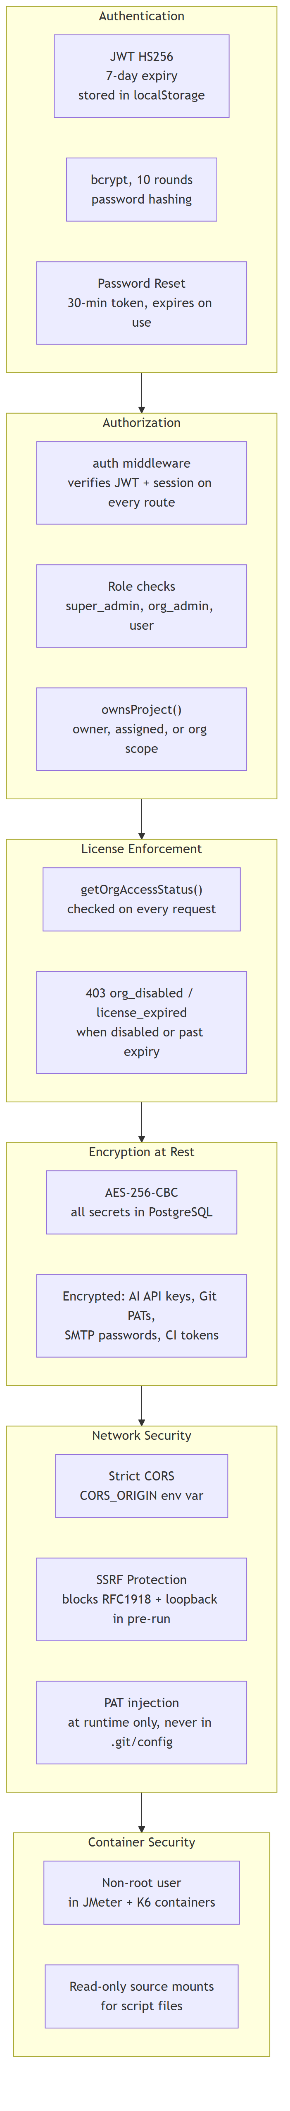
Security layering: authentication → authorization → license enforcement → encryption at rest → network security → container security.

6.1 Authentication Design
- JWT scheme: HS256, signed with JWT_SECRET, 7-day expiry, carrying a jti (session ID) and userId. The code falls back to a hardcoded default secret if JWT_SECRET is unset — this must always be set explicitly in production.
- Password hashing: bcrypt, 10 rounds.
- Session management: each login creates a user_sessions row keyed by jti; only one active session per user is allowed (a new login invalidates the previous session unless force:true is passed); sessions expire after 30 minutes of inactivity, tracked via last_used_at and refreshed on every authenticated request (including a client heartbeat).
- Login flow: credentials validated, pending/rejected accounts rejected with 403, an existing active session blocks a second login (409 SESSION_ACTIVE) unless forced, and session replacement is atomic (old session deleted, new one created in one transaction).
- Logout: deletes all sessions for the token’s user.
- Password reset: a 32-byte random token valid for 30 minutes; the forgot-password endpoint never reveals whether an email exists; all prior reset tokens for the user are invalidated when a new one is issued.
- Invite-based onboarding: a 72-hour random token; acceptance re-checks the org’s license status (can fail between invite-send and acceptance if the org is disabled or at its user limit) and issues a JWT immediately for first login.

6.2 Authorization (RBAC) Design
Role | Scope
super_admin | All organizations; manages orgs, licenses, and org-admin invitations. Has no project-scoped UI of its own.
org_admin | Own organization only; manages users, projects, AI/Git/SMTP configuration, and merges PRs.
user | Only projects explicitly assigned via project_assignments; cannot create projects or invite org admins.
- License gate: every authenticated request from a non-super-admin user with an org checks getOrgAccessStatus() and returns 403 (org_disabled or license_expired) if the org’s license is invalid.
- Project-level authorization: ownsProject(userId, projectId) grants access if the user owns the project, is explicitly assigned to it, or is an org_admin/super_admin over the owner’s organization; denial returns 404, never 403, to avoid leaking project existence.
- Admin-only routes (admin.js) additionally scope org_admin visibility/actions to their own organization and to the "user"/"org_admin" roles only — they cannot see or act on another org or on a super_admin.
Note: The invite-revocation endpoint (DELETE /api/invites/:id) does not carry an explicit role check in the reviewed code path — this should be verified and, if confirmed, restricted to admin roles only.

6.3 Secret Management Strategy
Secret | Storage | Protection
AI provider API keys | ai_settings.api_key | AES-256-CBC encrypted at rest; never returned to the frontend (only an api_key_set flag).
SMTP password | alert_configs.smtp_pass | AES-256-CBC encrypted at rest; masked in API responses.
npm/Artifact Keeper registry token | organizations.registry_token_enc | AES-256-CBC encrypted; only metadata (prefix, created/expires) returned after creation, not the raw token.
Git PATs / SSH keys | git_configs.auth_token, user_git_configs.auth_token/ssh_key | Column exists as TEXT; encryption coverage for this specific field should be explicitly re-verified against the current commit before relying on it.
JWT_SECRET, ENCRYPTION_KEY, DATABASE_URL | Environment variables | Not stored in the database; must be set per-deployment and never committed.
- A previously-fixed issue is worth noting for audit history: Git PATs used to be persisted into .git/config on disk via git remote set-url, making them readable in plaintext to anyone with filesystem access to a workspace; this was fixed by passing authenticated URLs only as one-off command arguments (never persisted to disk) for every fetch/push/pull.
- No secrets-rotation mechanism exists for JWT_SECRET or ENCRYPTION_KEY beyond a manual redeploy with a new value.

6.4 Encryption Strategy
- At rest: AES-256-CBC with a random 16-byte IV per value, stored as <iv_hex>:<ciphertext_hex>; the key is derived via SHA-256 of ENCRYPTION_KEY (falls back to JWT_SECRET, then a hardcoded default if neither is set — ENCRYPTION_KEY should always be set explicitly and kept distinct from JWT_SECRET in production).
- Passwords are hashed (bcrypt), not encrypted — irreversible by design.
- In transit: the application itself does not terminate TLS; HTTPS is expected to be provided by a reverse proxy or the deployment platform in front of port 3001. The Docker Compose reference topology does not include a TLS-terminating proxy by default — this must be added at deployment time (e.g. Nginx + a certificate) for any non-local deployment.
- The Postgres connection in the reference docker-compose.yml is unencrypted (internal Docker network, no sslmode=require) — acceptable for a single-host deployment where Postgres is not exposed, but should use TLS if the database is ever reachable across an untrusted network.
- Graceful-degradation caveat: the encrypt/decrypt helpers return plaintext unchanged if a crypto operation fails, which avoids a hard outage but means an encryption misconfiguration would fail silently rather than loudly — recommended to add explicit alerting on this fallback path.

6.5 Audit Logging Design
There is no dedicated, comprehensive audit-log table recording "who changed what, when" across administrative and data-mutating actions. The following tables provide partial, purpose-specific history:
Table | What it records
user_sessions | Login/session creation and last-activity time (not a full login-history log — old sessions are deleted, not archived).
auto_heal_logs / ci_auto_heal_logs | Every auto-heal attempt, diagnosis, fix applied, and result.
git_commits | Commit author, branch, message, and push status.
invites / project_assignments | Creation time and who created the invite/assignment; no record of later revocation.
execution_runs | Test run history, status, and timing.
Gap: there is no record of who approved/rejected a user, who changed an organization’s license plan or status, who edited a project’s configuration, or failed authentication/authorization attempts. For any compliance program requiring a full activity trail, a dedicated audit_log table (actor, action, target, before/after, timestamp, IP) would need to be added.

6.6 Compliance Documentation (SOC 2 / ISO 27001 / GDPR)
PerfStudio holds no third-party compliance certification today; this section is a factual gap analysis of relevant controls already present versus what a formal program would additionally require — it is not a claim of compliance.

Controls already present
- Role-based access control with three tiers, enforced in middleware and per-route.
- Encryption at rest for the highest-sensitivity fields (AI keys, SMTP password, registry tokens).
- Session expiry (30-minute inactivity) and single-active-session enforcement.
- Data isolation between organizations (org_id scoping) and between environments (collection_id + env scoping).
- SSRF protections on outbound pre-run requests.

6.7 SSRF Guard (Pre-Run outbound requests)
preRunEngine.js blocks any URL matching localhost, 127.x.x.x, 0.x.x.x, 10.x.x.x, 192.168.x.x, 172.16–31.x.x, or 169.254.x.x, and requires an explicit http:// or https:// scheme; anything else is rejected before a request is ever fired.
Residual gaps to track: IPv6 loopback/link-local/unique-local ranges (::1, fe80::/10, fc00::/7) are not explicitly matched by the current regex list; there is no DNS-rebinding protection (a hostname could resolve to a public IP at check time and a private IP at request time); and there is no outbound rate limiting beyond the existing 20-per-chunk/250ms pacing, which is a performance control rather than an abuse control.

7. Quality Engineering
No automated test runner, linter, or static-analysis integration currently exists in this repository, confirmed by inspecting both package.json files, searching the full source tree for test/spec files, and reviewing the only CI workflow present.

7.1 Code Coverage Report
Check performed | Result
Test runner in backend/package.json devDependencies | Not present (only nodemon).
Test runner in frontend/package.json devDependencies | Not present (only @vitejs/plugin-react, vite).
Test/coverage step in .github/workflows/docker-publish.yml | None — the workflow only builds and pushes Docker images.
Automated coverage percentage | 0% as tool is in phase 1 or development.

What exists in place of automated testing today
Quality assurance is currently manual, following the 15-step end-to-end flow documented in docs/USER_WORKFLOW.md: import a collection → run Pre-Run against live endpoints → configure rules/environment → generate a script → execute it (locally, in Docker, or via CI) → inspect the resulting analytics dashboard and PDF report. This provides real functional coverage of the happy path on every manual pass.

7.2 Static Code Analysis Report
Check performed | Result
ESLint configuration (.eslintrc*) at repo root or per-package | Not present.
Prettier configuration | Not present.
SonarQube (or equivalent) configuration or CI step | Not present.
Pre-commit hooks enforcing style/lint | Not present.

8. Environment & Demo Access
This section requires values specific to your actual deployment, which are not derivable from the source code. Placeholders are provided below for your team to complete.

8.1 Demo Environment URL
Field | Value
Environment URL | https://peako.qtsolvdev.com/sign-in

8.2 Test User Credentials
The application ships with one seeded account out of the box; all other roles need to be created for the reviewer.
Role | Email | Password | Notes
Super Admin (seeded by default) | admin@perfstudio.com | Admin@123 | Auto-created on first backend boot if no super_admin exists (backend/src/db/index.js). Change this password before exposing any non-local environment.
Owner / Org Admin (for review) | tasleema85@gmail.com | Admin@123 | Create via the Super Admin console (Organizations → invite an org admin) ahead of the review.
Regular User (for review) | tasleemzaif@hotmail.com | Admin@123 | Create via the Org Admin’s invite flow, or note the license plan’s user limit if creating additional accounts.
Note: The seeded super-admin password is publicly documented (in this codebase’s own README) — it must be rotated on any environment that is reachable outside a trusted network, including this demo environment.

