Tuition Finder: User manual

* 1. Introduction

Implementation refers to a critical software development process when engineers create the executable version and a user guide, also commonly known as manual, is a technical communication document intended to give assistance to people using a particular system.

This report covers ten sections. In these sections i have discussed the activity and views of our system.

* 1. Main Page

When user click on our system, the system show the home page which contain 2 button and 2 edit text. Button for sign up and login and two edit text field get the sign up data. After filling up sign up field user click on signup button then our system stores the signup data into backend database. For backend database we used firebase database. If the data stored successfully then our system shows the message “ signup successful “. Below, this is our system home page,

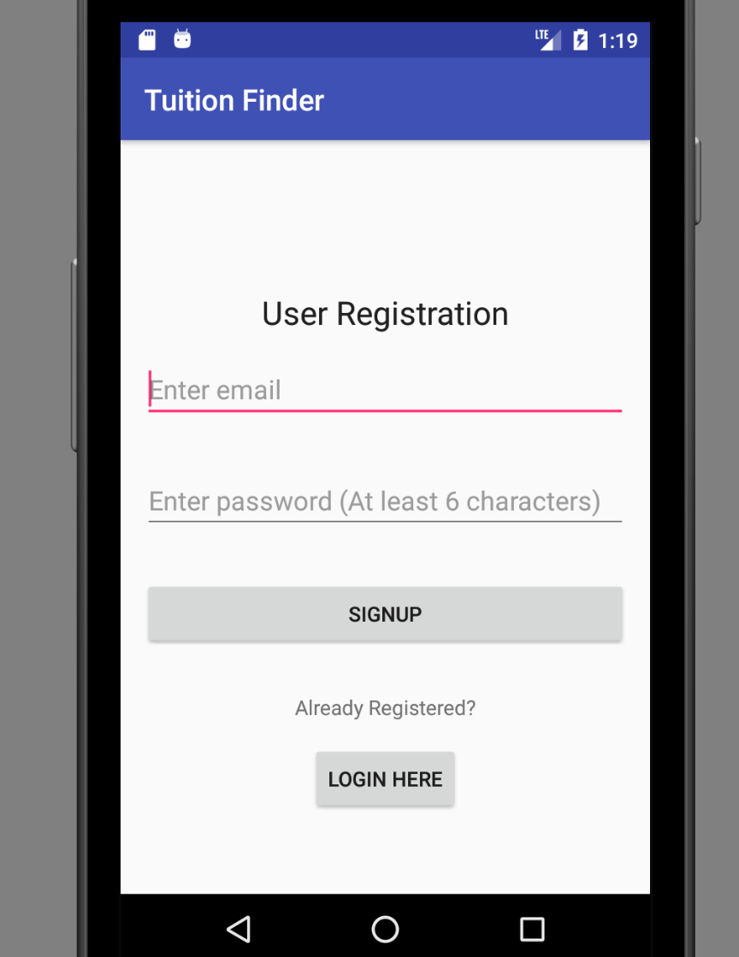

Fig-4.2.1: For Home Page

If user click on login button then our system show login page.

* 1. Login Page

When user click on login button, the system show the login page which contain 1 button and 2 edit text field. Button for login and two edit text field get the login data. After fill up edit text field user click on login button then our system get the email and password from backend database and check if those data match then system show the message as “ signup successfully “ this is our system login page,

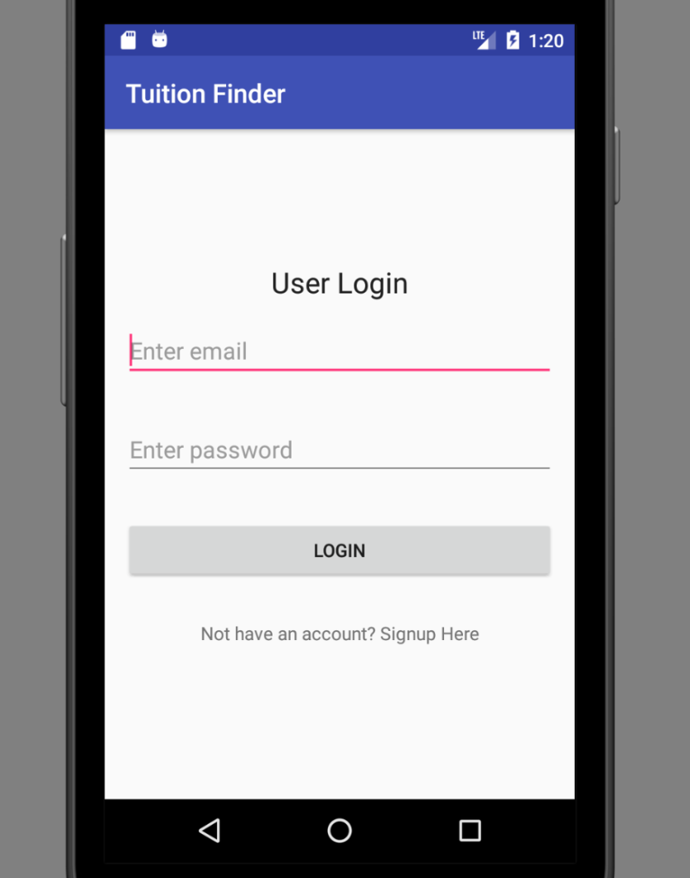

Fig-4.3.1: for login page

If logged in successfully then system show main page of our system.

* 1. Common Interface page

After login successfully system show common interface page with message “Welcome to our app” . Main page contain 3 button. Button 1 for search tuition. Button 2 for post tuition. Button 3 for logout. User can choose one of them at a time.

This is our main page,

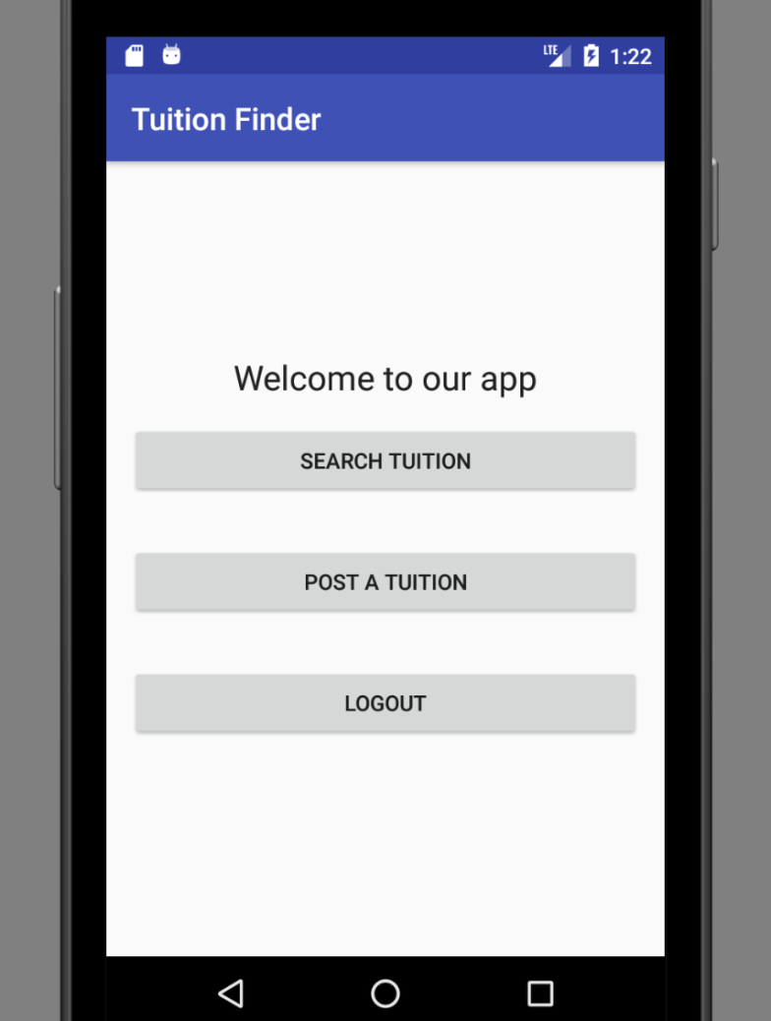

Fig-4.4.1: for main page

* 1. Post Page

If user clicked on post button in main page then system show post page, where user can post for tuition. There are several text field in post page and two button. Text field contain description of the tuition such as location, class, salary, days, subject and contact. Button one for submit and another for logout. If user click on submit button then system store data into backend database from text field.

This is post page,

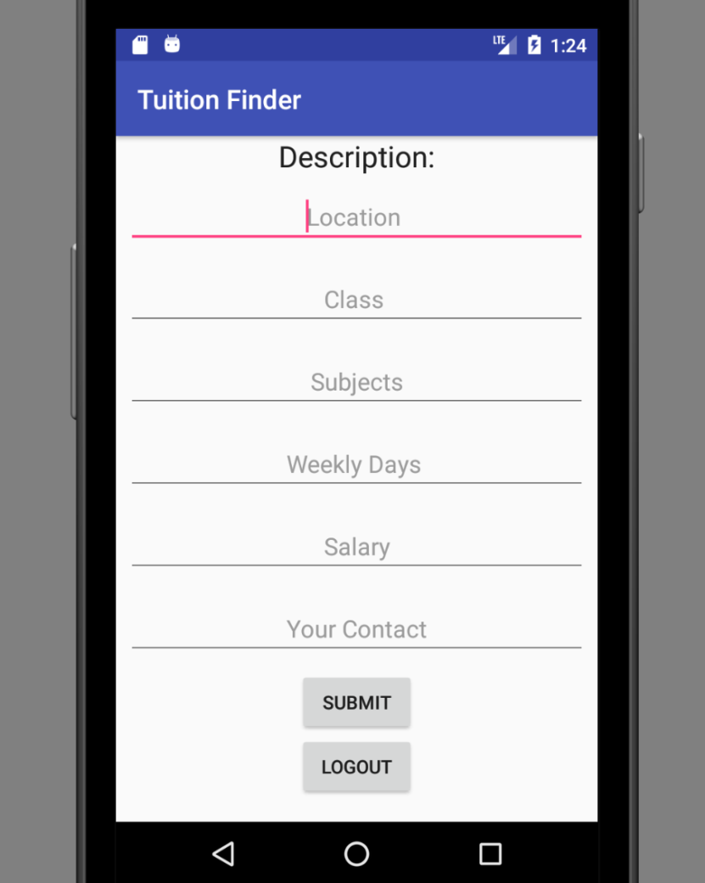

Fig-4.5.1: for post page

* 1. Search Page

If user clicked on search button in main page then system show search page, where user can search for tuition according to location

This is our search page

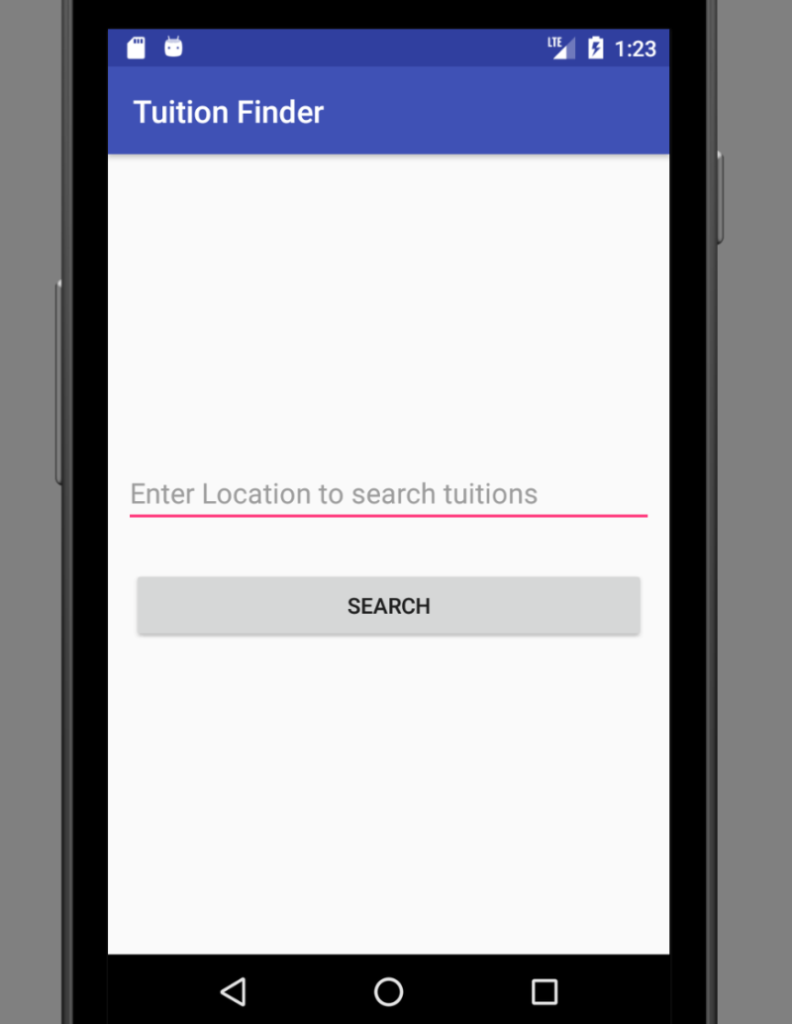

Fig-4.6.1: for search page

If user fill up edit text field with location then system show the tuition list according to location.

* 1. Tuition List Page

When User clicked on search button in search page then system show tuition list page.

This is tuition list page

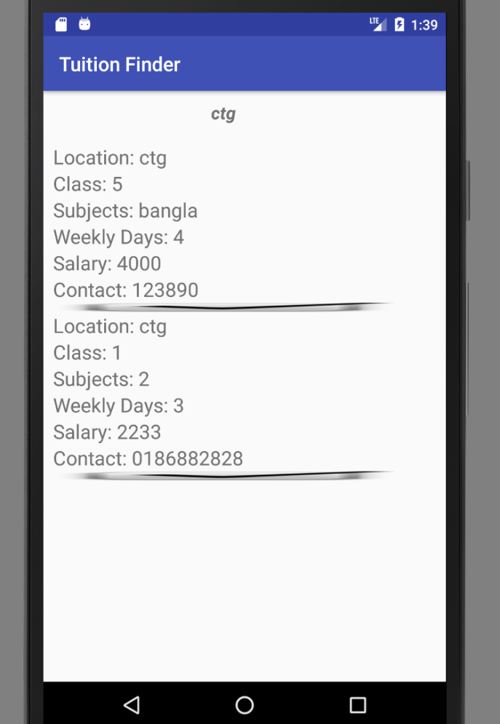

Fig-4.7.1: for tuition list

If user push on specific tuition for some moment system show update and delete window.

* 1. Update & Delete Window

When user pushed for some moment on specific tuition then system show this page where user can update and delete tuition information. This window contain 2 button. Button 1 for update and button 2 for delete. Here only a user who posted the tuition the corresponding advertisement can update/delete the tuition post. This restriction is strictly maintained to counter unauthorized manipulation of data.

This is update and delete window,

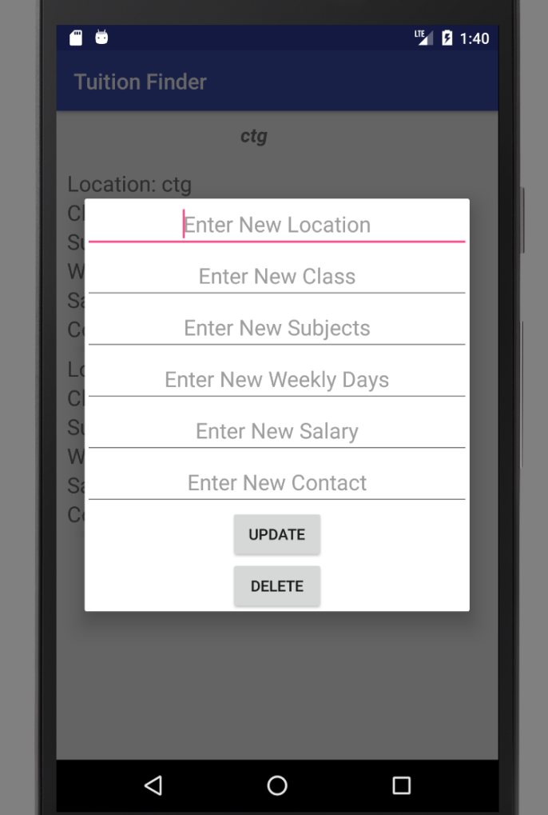

Fig-4.8.1: for update and delete.

* 1. Future Work

I have tried our best to help people who are searching for tuition, but we have found some limitations in our system such as using GPS. Fake tuition post etc. In future we will try to solve the limitations in our system.

* 1. Conclusion

This report provide all the information about the whole project management. The information got from the previous report is combined here. All these report helped us to build our app more efficiently.

­­­­­