Taslima Begum

Ex6768

CSC 4996

To Do List Application

Functional Requirements

1. Required: can add additional tasks
2. Required: can view the tasks in their to do list
3. Required: can delete the tasks in their to do list
4. Required: can see the status of the tasks; i.e. started, pending, completed, late
5. Desired: can use this website to make a to do list.
6. Desired: can edit the tasks in their to do list.

Non-functional Requirements

1. Required: User friendly and easy to use. It must be easy and simple for people
2. Required: Availability: the application must be available at any time
3. Required: Repeating: must avoid repetition of users or tasks
4. Desired: Storage: want to fit a lot of tasks in the web application
5. Desired: Recovery: if the website goes down, must be a solution to get it running again
6. Desired: Performance: works efficient enough to not crash

System Architecture Diagram

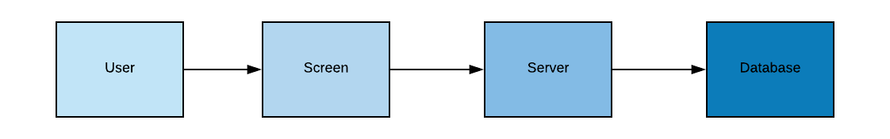

Data-Flow Diagram

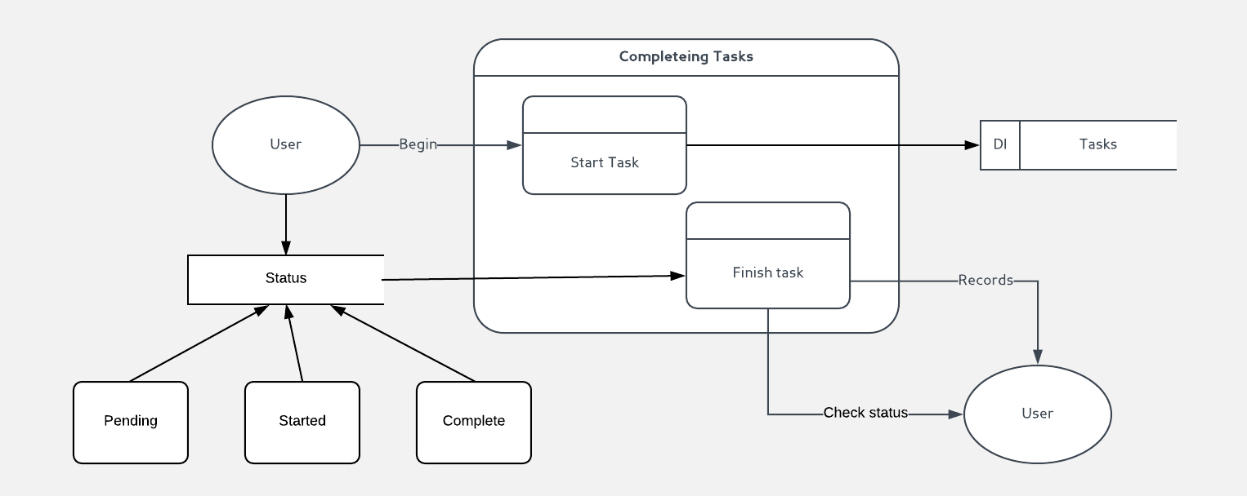

Use cases

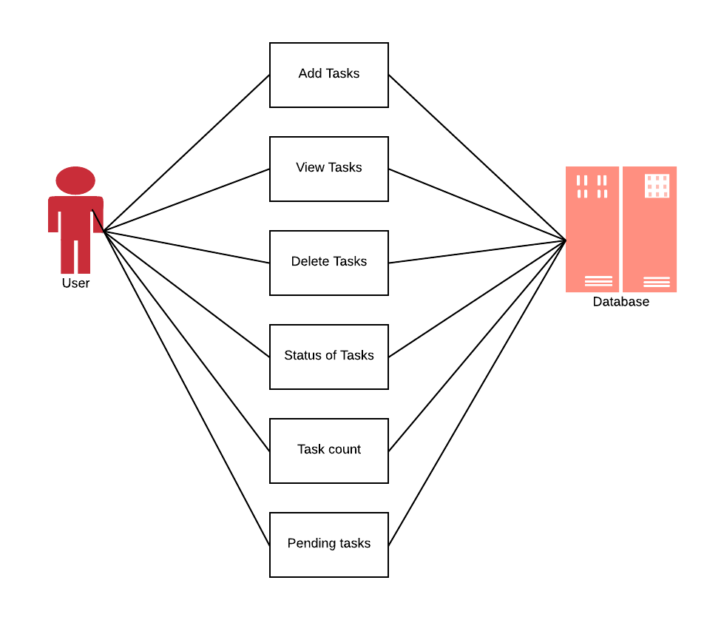

Database design

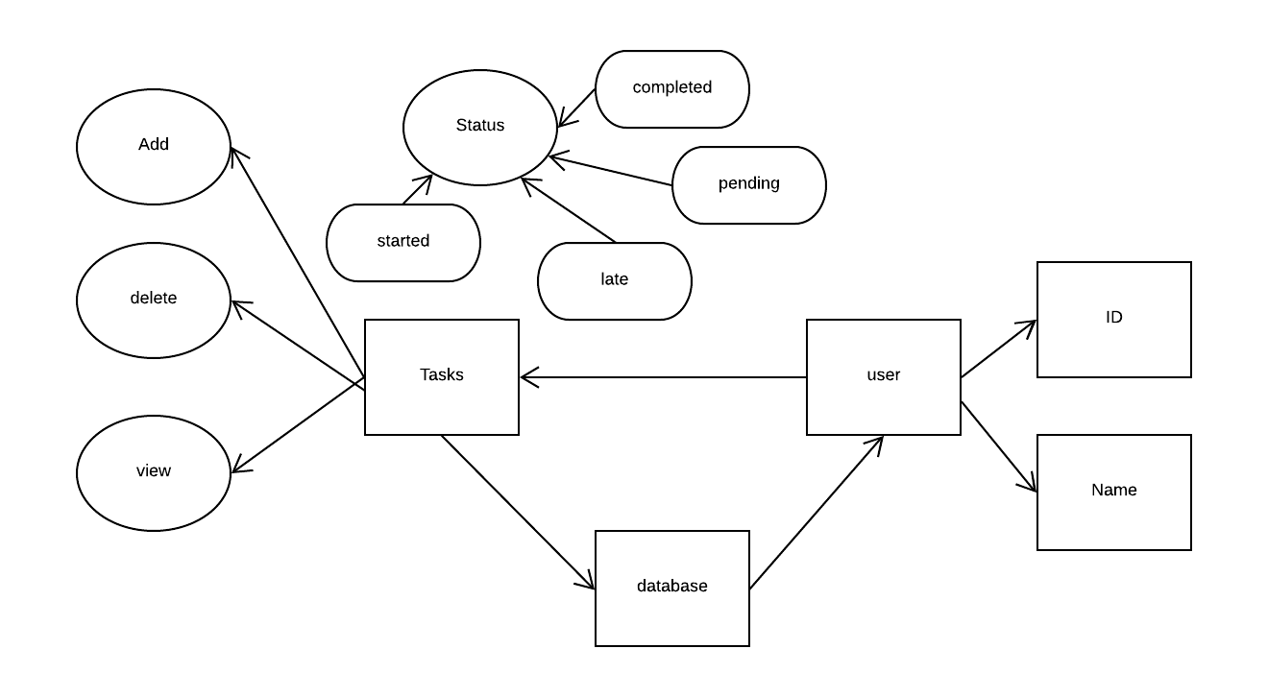

Class Diagram

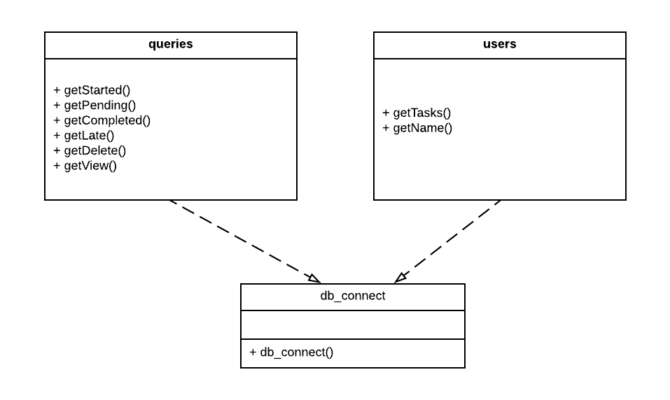

Test cases:

1. Test to make sure the “add task” works
2. Test to make sure the “delete” works
3. Test to make sure the status “started” works
4. Test to make sure the status “pending” works
5. Test to make sure the status “completed” works
6. Test to make sure the status “late” works