Question Paper Generation Using LLM
Project Report | Individual Industry Project | 2025–26
  - Prepared with reference to the supplied Project Brief and Project Synopsis Template. Learner details are left for the learner to complete.

1. Executive Summary
This project implements a local browser-based assessment drafting tool for educators. It converts educator-provided learning notes into a structured paper with questions, marks, source context, and a separate suggested answer key. The user can select an offline extractive mode or connect an OpenAI-compatible chat-completions model. The educator reviews and edits the generated material before download.
The motivation is to reduce repetitive drafting while retaining subject-matter judgment. The system is not an autonomous examiner and does not claim to measure learning. Its core contribution is a practical, low-friction workflow that keeps source material visible, makes marks configurable, and allows a local mode that sends no notes to a model provider.
The supplied dataset contains 500 synthetic document-retrieval metadata rows and seven fields. It is not a question-generation dataset: it has no passage, question, answer, or validated label. It has been cleaned and analyzed independently, and its synthetic score averages are reported only as dataset descriptions. They do not measure this application.

2. Problem Statement and Objectives
Educators preparing practice tests and examinations often convert lecture notes, handouts, or learning objectives into questions under time constraints. Repeated authoring can create uneven topic coverage, inconsistent marks, or difficulty that does not fit the intended learners. Generative AI can draft material quickly, but can also hallucinate, omit important concepts, or produce ambiguous questions and incorrect answer keys.
The system is designed for teachers and trainers who need editable first drafts from materials they are authorized to use. Its goals are to accept familiar note formats, expose understandable assessment controls, support offline and hosted generation, provide answers and note references for review, and export a student-facing paper separately from the teacher key.
The prototype is a single-user local application. It does not include automated student grading, authentication, persistent storage, institution-specific policy enforcement, or a validated question bank. Its intended use is assisted drafting followed by educator review. It should not be used as the only control in a high-stakes assessment.

3. Requirements and User Workflow
The educator enters a subject and learner level, chooses an assessment type and difficulty, selects question formats, and specifies the number of items and total marks. Notes can be pasted into the interface or uploaded as TXT, PDF, or DOCX. The application extracts text from the uploaded file, then uses the configured generation path. Questions and answer text are editable in the result view.
The generator aims to return the requested number of questions with the requested total marks. API responses are parsed as JSON and checked for item count, summed marks, and required question and answer fields before they are shown. Offline mode drafts prompts from note sentences and retains source excerpts as answer anchors. The teacher can download the student paper, the answer key, or the editable JSON record.
Usability requirements include a clear settings panel, progress feedback, source visibility, and an explicit review reminder. The API key is entered as a password field and held in session state rather than written into project files. No question bank or uploaded material is persisted by the app. Streamlit may impose upload limits; very large documents should be split into smaller authorized excerpts.

4. System Architecture and Technology
The interface is built in Streamlit and the core logic is Python. TXT decoding uses the standard library. PDF text extraction uses pypdf, and DOCX paragraphs use python-docx. The optional hosted mode calls a configured OpenAI-compatible `/chat/completions` endpoint through Python’s standard HTTP client. The user selects a model name and provides an API key at runtime.
The offline path requires no model credentials and performs sentence-based transformations against the submitted notes. It is intentionally conservative and offers a workflow baseline, not language-model reasoning. The online path requests strict JSON and includes instructions to stay within supplied notes, but provider output is still untrusted until reviewed. A structural check cannot establish correctness or educational quality.
The system has no database. Results are held in Streamlit session state until the session ends. A separate pandas analysis script cleans the supplied reference metadata and regenerates three SVG visualizations. The architecture diagram shows the two generation paths and downstream review/export stage. Hosted mode transmits the notes to the selected provider; the provider’s terms, retention settings, and billing apply.
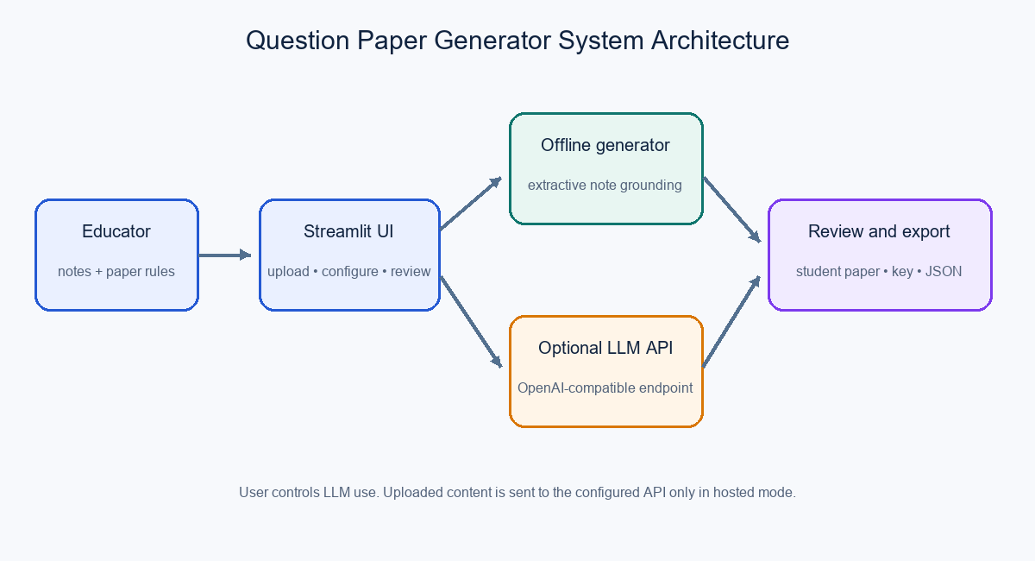

5. Implementation Details
The app presents the source material and paper settings together so that the educator can check what will inform the generation request. The file reader extracts text from supported document types and reports a clear error when parsing fails. The note input remains editable after upload so the educator can remove irrelevant material and correct extraction artifacts before generation.
For API mode, the application builds a prompt containing the assessment parameters and a bounded excerpt of source notes. The response is decoded as JSON, then checked for the requested item count, the exact mark total, and required fields. A failed check is shown to the user, who can retry or reduce the request. API communication uses a timeout and displays generation failures instead of silently returning an empty paper.
The result view includes question text, marks, source phrases, and expandable answers. Exports are plain text for convenient printing and JSON for subsequent editing. The implementation avoids a hidden training step: the supplied synthetic CSV is not loaded into the app, and course notes remain the only generation context. The project can be started on Windows by running the included batch script, which creates a virtual environment and installs the listed dependencies.

6. Dataset and Exploratory Analysis
The supplied `dataset.csv` has 500 rows and seven columns: `doc_id`, `doc_type`, `chunk_id`, `word_count`, `retrieval_score`, `query_type`, and `answer_quality_score`. The cleaning routine trims string values, normalizes case, converts numeric fields, removes exact duplicates and incomplete records, clips both score columns to the documented 0–1 interval, and saves a clean CSV. The observed input had no duplicates and no missing cells, so the cleaned file retains 500 rows and seven columns.
The observed mean retrieval score is 0.7466. The synthetic answer-quality score averages 0.8029 and ranges from 0.600 to 1.000. Intent categories count as follows: summarization 118, procedural 106, factual 94, comparative 92, and analytical 90. The project includes charts for retrieval-score distribution, query intent counts, and word count against the synthetic quality score.
These fields are generic retrieval metadata, not educational responses. In particular, the answer-quality field has no supplied annotation protocol, evaluator identity, or evidence that it was assessed by people. The metrics cannot support a claim about this generator’s accuracy or validity. The accompanying data dictionary fills in each column description and explains these limitations.

7. Evaluation, Limitations, and Ethics
The project verifies simple structural properties during API generation: returned item count, presence of question/answer fields, and total marks. These checks support reliable formatting but are not an empirical model evaluation. The project has no suitable question-and-answer benchmark, annotated syllabus coverage, provider credentials, or recorded timing trials. Consequently it reports no model accuracy, response-time, F1, or uptime figure.
A future evaluation should sample multiple subjects and learner levels, then ask educators to rate alignment, correctness, clarity, ambiguity, accessibility, difficulty, and rubric quality. Report both the rate of questions answerable from notes and the rate of answer keys judged correct. Latency should be measured over repeated runs for each mode and endpoint. The evaluation should describe the sample, rating guide, agreement process, model settings, and failure cases.
Risks include factual errors, ambiguous distractors, bias, inaccessible wording, poor topic balance, and unauthorized sharing of copyrighted or confidential course material. The interface displays source context and calls for review, but these safeguards do not guarantee safety or quality. In hosted mode notes leave the local process. Educators must follow institutional rules and provider data terms, avoid personal data, and retain responsibility for the final paper.

8. Deployment, Conclusion, and References
For Windows, install Python 3.10 or newer and run `run_windows.bat`. The script creates `.venv`, installs `requirements.txt`, and starts Streamlit locally. Initial dependency installation requires package access. Offline generation works without an API connection after setup. Hosted mode requires a compatible endpoint, model identifier, and API key; provider charges may apply. Secrets and the virtual environment should not be committed or shared.
The deliverable provides educators with a configurable, reviewable first-draft process and makes the distinction between provided notes and unrelated metadata explicit. The next useful improvements are a representative human-reviewed benchmark, explicit topic coverage controls, marking rubrics, better PDF/DOCX exports, accessibility review, and an educator usability study. These should be added only with clear evaluation evidence and institutional review.
References: Streamlit documentation, https://docs.streamlit.io/ ; Python documentation, https://docs.python.org/3/ ; OpenAI API text-generation documentation, https://platform.openai.com/docs/guides/text-generation ; HCLTech Career Shaper Programme Project Brief and Project Synopsis Template supplied with this project (2025–26).

