Question Paper Generation Using LLM
HCLTech Career Shaper Programme | III Year Industry Project | 2025-26

Field | Details (Learner to complete)
Project Title | Question Paper Generation Using LLM
Project No. | 72
Domain | LLM / Python
Difficulty | Intermediate–Advanced
Duration | 4 Weeks
Format | Individual Project
Learner Name | ________________
Roll Number | ________________
College / Campus | ________________
Mentor Name | ________________
Submission Date | ________________

1. Problem Statement
Teachers and trainers need to produce clear, syllabus-aligned assessments from course notes, often under time constraints. This project creates a reviewable first draft from authorized learning material using an optional large language model and a private offline mode, with educators checking all questions and answer keys before use.

2. Proposed Solution & Approach
The project is a Streamlit web app built with Python that accepts pasted course notes or TXT, PDF, and DOCX files. Educators set the subject, class, assessment, difficulty, question types, question count, and total marks. The app can draft questions locally from note excerpts or send the notes to an OpenAI-compatible model selected by the educator. It validates the requested count and marks, shows source context and suggested answers, and exports a student paper and teacher key for review.

3. System Architecture
System diagram: see the architecture diagram in docs/architecture.svg. Flow: Educator and course notes → Streamlit interface → offline extractive generator or optional compatible LLM API → teacher review → student paper, answer key, or JSON. Notes are transmitted externally only when hosted LLM mode is selected.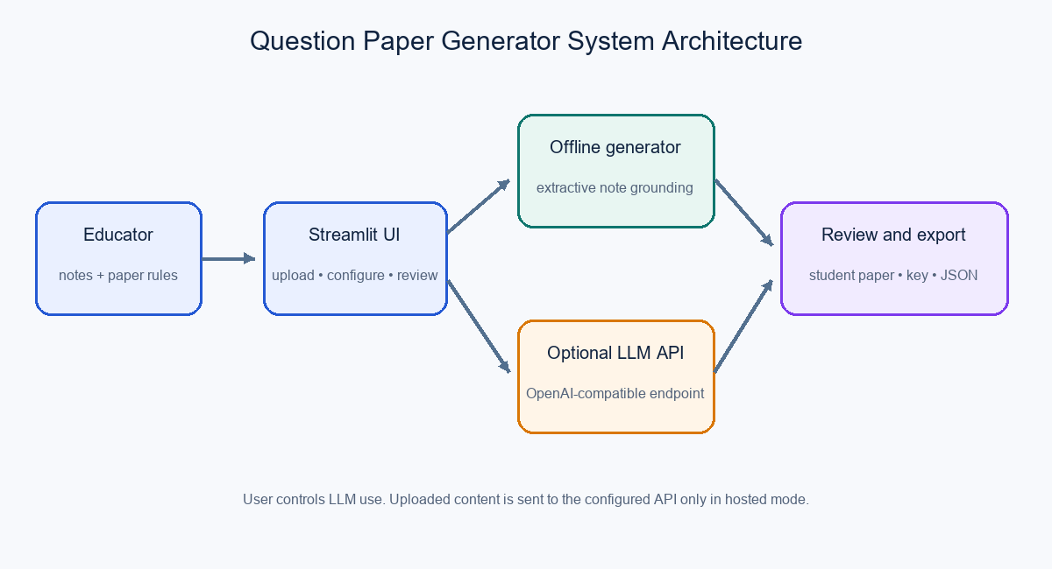

4. Technology Stack
Frontend / UI: Streamlit
Backend / Logic: Python
Database: None (session-only results; no persistent question database)
AI/ML Framework: OpenAI-compatible Chat Completions API (optional); local extractive fallback
Visualisation: SVG charts with pandas EDA
Hardware: Standard computer with Python; internet needed for initial package installation and hosted model use

5. Dataset Used
Dataset file name: dataset.csv (cleaned synthetic reference metadata)
Number of rows: 500
Number of columns: 7
Key columns: doc_id, doc_type, chunk_id, word_count, retrieval_score, query_type, answer_quality_score
Additional data collected: None. The application uses course notes entered by the educator. The supplied CSV contains no question, answer, or source text and is not used to generate papers.

6. Key Results & Metrics
Metric 1: Clean reference rows — 500 of 500 (0 incomplete rows; 0 duplicate rows removed)
Metric 2: Mean synthetic retrieval score — 0.7466 (descriptive dataset statistic)
Metric 3: Mean synthetic answer-quality score — 0.8029 (synthetic, not human validated)
Business value: A configurable, reviewable first-draft workflow is available. Generator accuracy and response time have not been benchmarked; no such performance claims are made.

7. Challenges Faced & How Resolved
Challenge 1: Supplied dataset has no questions, answers, or source passages → Resolution: use it only for descriptive EDA and ground generation in educator-provided notes.
Challenge 2: Model output may contain unsupported or ambiguous content → Resolution: show note source context, validate structure and marks, and require educator review before use.

8. References
1. Streamlit documentation — https://docs.streamlit.io/
2. OpenAI API documentation — https://platform.openai.com/docs/guides/text-generation
3. Python documentation — https://docs.python.org/3/
4. Project Brief and Project Synopsis Template supplied for the HCLTech Career Shaper Programme, 2025–26.

9. Ethical Compliance Declaration
Ethical review checklist (signature required before submission):
☐ Dataset source and reuse license confirmed; supplied metadata is used only for descriptive analysis.
☐ No PII is included in project files; only authorized course notes will be used in demos.
☐ AI-assisted code and content will be disclosed as required by the institution.
☐ Applicable DPDP Act 2023 obligations will be reviewed by the learner/institution.
Learner Signature: _________________________ Date: ________________

Submit this file as 'Project_Synopsis_[YourName]_[RollNo].docx' | HCLTech Career Shaper Programme 2025-26

