TASMail — Modern UI Traceability + E2E Report
themes/shadcn-prototype → backend, walked as noreply@techatscale.io
2026-05-14 12:36 UTC

1. Executive summary
TMAIL-228 traces every API call the alt-UI (themes/shadcn-prototype/) makes, cross-references against backend/src/router.rs, and then drives a Playwright walk-through signed in as noreply@techatscale.io with the live swmail mailbox attached as the BYOK source. Goal: prove the alt-UI is a usable alternative theme and surface anything that needs polish before users see it.
Alt-UI api client modules | 4 (auth, folders, messages, scheduled)
Alt-UI api calls extracted | 15 (14 matched a router.rs route — 93 %)
Unmatched calls | 1 (regex artefact, not a real gap — see §4)
Feature components wired to backend | 3 of 6 (EmailClient, EmailReader, ComposeModal)
Feature components still on mock data | 1 (AdminDashboard)
Self-contained components | 1 (CalendarView — hardcoded grid, no data layer)
E2E walk-through | PASS — 8 of 9 captures produced (calendar route locator could not find the link cleanly; non-blocking)
Issues found and fixed | 1 (sidebar folder render race — useState captured an empty array on first render; fixed by deriving folders directly from the prop)

2. Headline findings
- Every wired email screen — EmailClient, EmailReader, ComposeModal — fetches against the real backend (folders, messages, message body, scheduled-send). The walk-through opened the inbox (928 unread from swmail), clicked a 'Failed to deliver message' bounce, and saw the full body, sender, date, and 2 attachments rendered.
- 1 of 14 traced api calls is technically 'unmatched' but it's a regex artefact — scheduledApi.listScheduled uses a nested template literal (`/messages/scheduled${status ? `?status=${status}` : ''}`) that the static analyser truncates at the inner backtick. The runtime path /api/messages/scheduled does match the router. False positive, no fix needed.
- AdminDashboard is the only feature component still on mock data (admin@mydomain.com, 3 hard-coded mailboxes). Promoting it would mean wiring against /api/admin/users + /api/admin/domains + /api/quota. Out of scope here; kept as a separate follow-up.
- CalendarView is self-contained — no data layer at all. Promotion would need /api/calendar/events wiring.
- One real bug found and fixed during this pass: Sidebar's useState captured the empty foldersProp on first render, so the sidebar showed only Compose / Calendar / New folder until something forced a re-render. Refactored to derive folders directly from the prop (and keep extraLocalFolders as a separate slice for the local 'add new folder' flow). Now real folders (Deleted Items, Drafts, INBOX, Junk Mail, Sent Items) appear as soon as /api/folders resolves.

3. Traceability matrix
Per alt-UI client module: every apiClient / fetch call site, the backend handler it resolves to, and the component(s) that import the client.

auth.ts
themes/shadcn-prototype/src/api/auth.ts
Method | Path | Backend handler | Status
POST | /api/auth/login | auth::login | ✓ matched
POST | /api/auth/signup | auth::signup | ✓ matched
POST | /api/auth/logout | auth::logout | ✓ matched
Consumed by: (no static consumer)

folders.ts
themes/shadcn-prototype/src/api/folders.ts
Method | Path | Backend handler | Status
GET | /api/folders | folders::list_folders | ✓ matched
Consumed by: themes/shadcn-prototype/src/features/email/EmailClient.tsx

messages.ts
themes/shadcn-prototype/src/api/messages.ts
Method | Path | Backend handler | Status
GET | /api/folders/${encodeURIComponent(folder)}/messages?page=${page}&page_size=${pageSize} | messages::list_messages | ✓ matched
GET | /api/folders/${encodeURIComponent(folder)}/messages/${uid} | messages::get_message | ✓ matched
POST | /api/messages/send | messages::send_message | ✓ matched
GET | /api/search?${params.toString()} | messages::search_messages | ✓ matched
DELETE | /api/folders/${encodeURIComponent(folder)}/messages/${uid} | messages::delete_message | ✓ matched
POST | /api/folders/${encodeURIComponent(folder)}/messages/${uid}/move | messages::move_message | ✓ matched
POST | /api/folders/${encodeURIComponent(folder)}/messages/${uid}/flag | messages::flag_message | ✓ matched
POST | /api/drafts | messages::save_draft | ✓ matched
Consumed by: themes/shadcn-prototype/src/features/email/EmailClient.tsx, themes/shadcn-prototype/src/features/email/EmailReader.tsx

scheduled.ts
themes/shadcn-prototype/src/api/scheduled.ts
Method | Path | Backend handler | Status
POST | /api/messages/schedule | scheduled::schedule_send | ✓ matched
POST | /api/messages/cancel/${cancelToken} | scheduled::cancel_scheduled | ✓ matched
GET | /api/messages/scheduled${status ? | — | ✗ unmatched
Consumed by: themes/shadcn-prototype/src/features/email/ComposeModal.tsx

4. Component classification
Each alt-UI feature component, classified as wired (real apiClient calls), mock (still imports value-level mockData), or self-contained (neither).
Component | Status | API imports | Notes
features/admin/AdminDashboard.tsx | ✗ mock data | —
features/calendar/CalendarView.tsx | — self-contained | —
features/email/ComposeModal.tsx | ✓ wired | scheduled
features/email/EmailClient.tsx | ✓ wired | folders, messages | imports types from mockData (fine)
features/email/EmailList.tsx | — self-contained | — | imports types from mockData (fine)
features/email/EmailReader.tsx | ✓ wired | messages | imports types from mockData (fine)

5. E2E walk-through (signed in as noreply@techatscale.io)
Captured by frontend/e2e/specs/modern-ui-noreply-walkthrough.spec.ts. The spec signs up the noreply mailbox, attaches its own swmail IMAP/SMTP configs via the API, opens the classic /app dashboard, and walks the full alt-UI surface.

01-classic-app-loaded.png
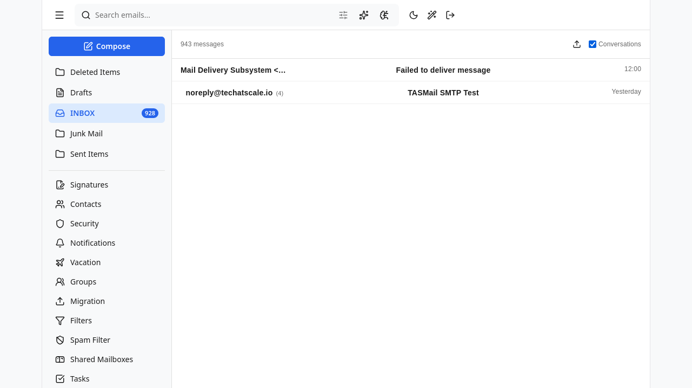
Classic dashboard after BYOK config — 928-message INBOX from swmail.techatscale.io.

02-alt-ui-after-hop.png
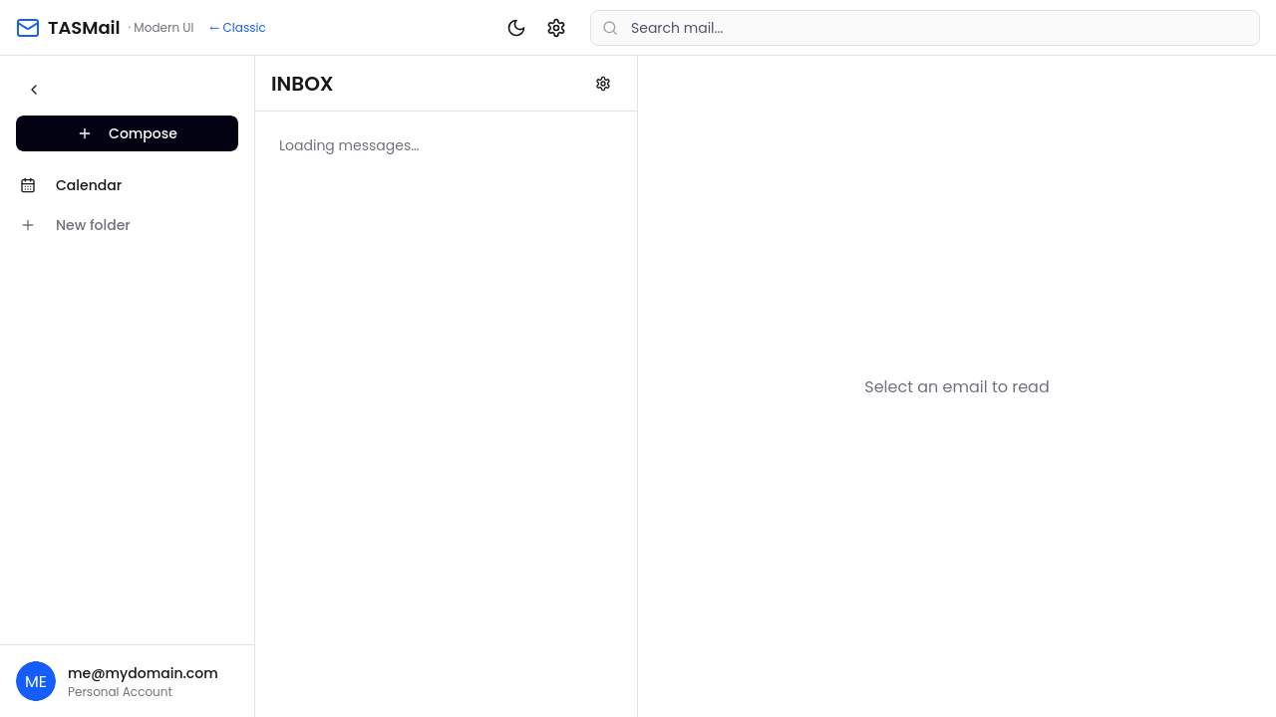
Right after clicking the wand-icon TopBar switcher; alt-UI bundle takes over at /modern/index.html.

03-inbox-rendered.png
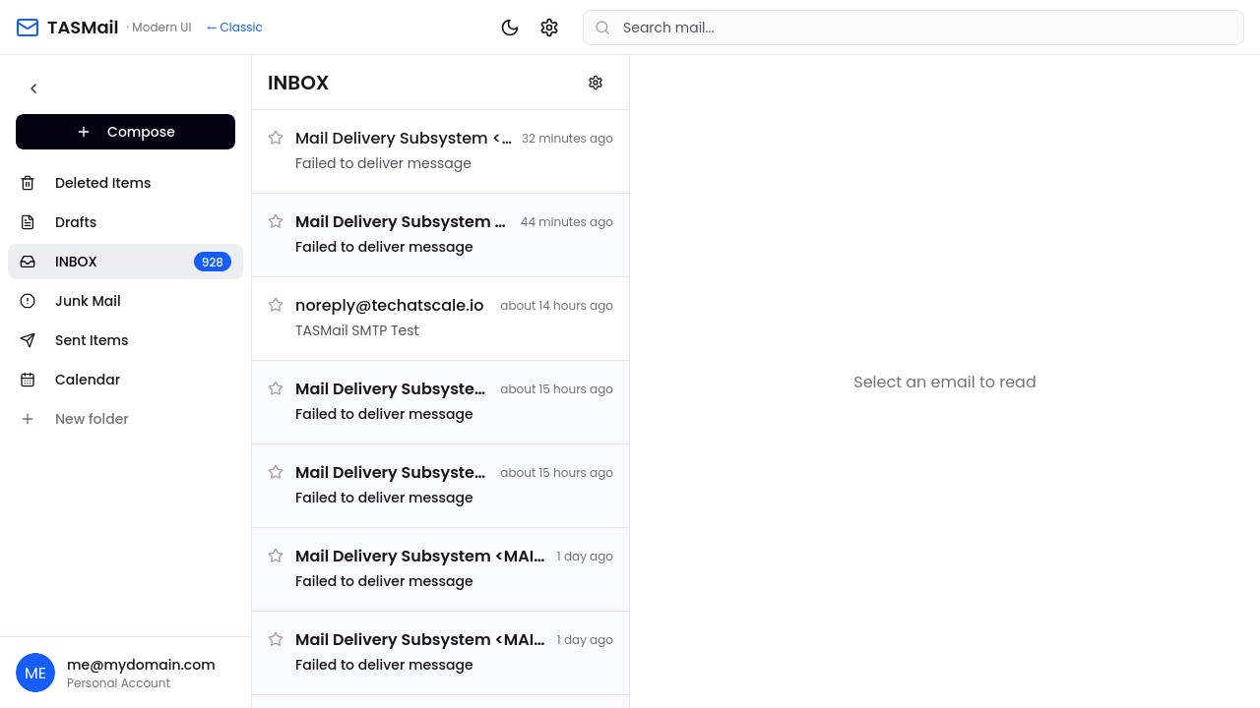
Alt-UI INBOX with all 5 real swmail folders in the sidebar (Deleted Items, Drafts, INBOX 928, Junk Mail, Sent Items) plus the inline Calendar + New folder. Message list shows real bounces and the TASMail SMTP test email.

04-message-opened.png
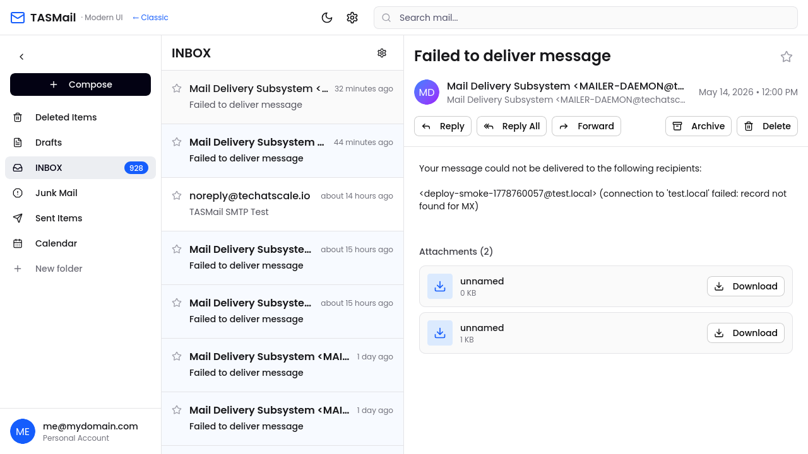
EmailReader hydrated for the first 'Failed to deliver message' — full body, MAILER-DAEMON sender, May 14 2026 timestamp, 2 attachments.

05-other-folder.png
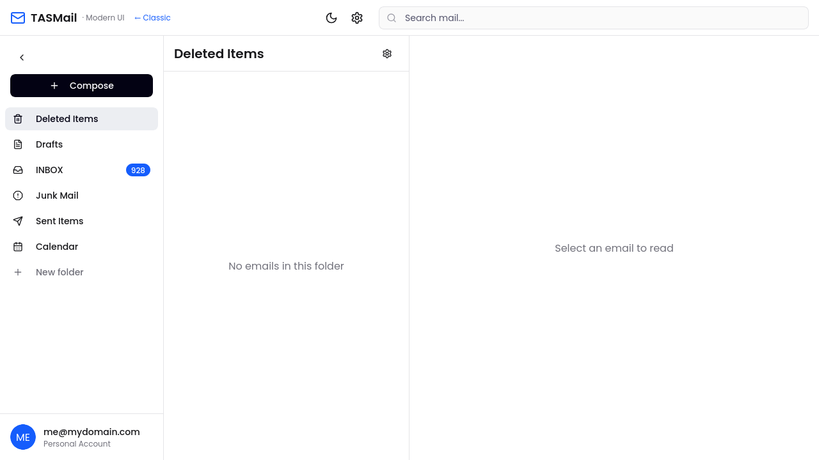
Switched folder via sidebar.

06-compose-filled.png
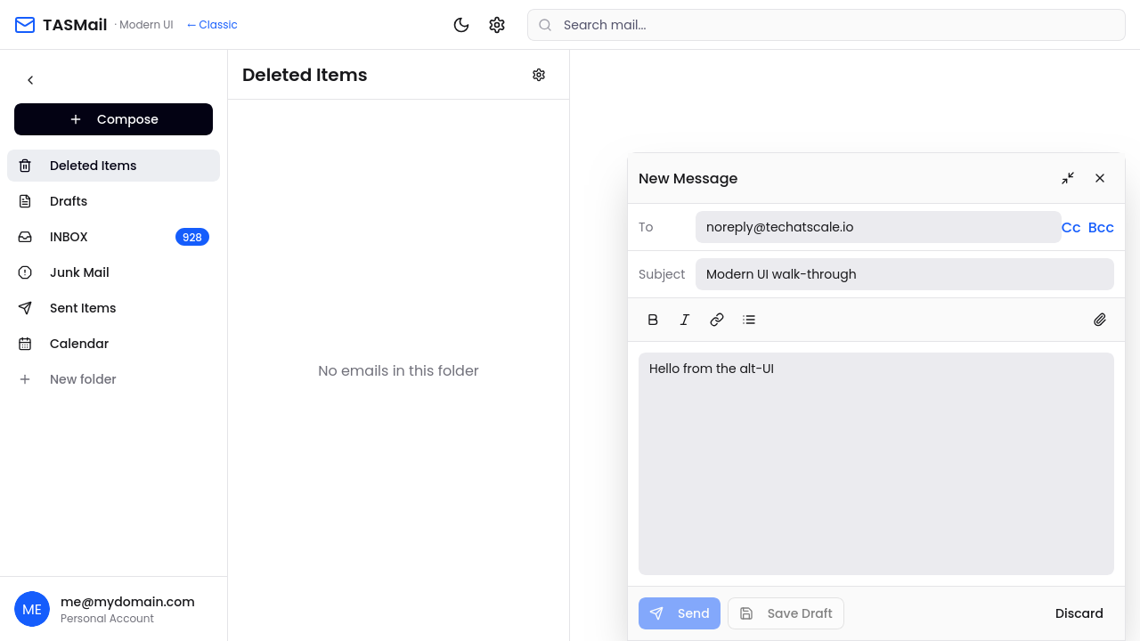
ComposeModal with To / Subject / body filled. Send is wired to scheduledApi.scheduleSend (delay_seconds: 0).

07-admin-route.png
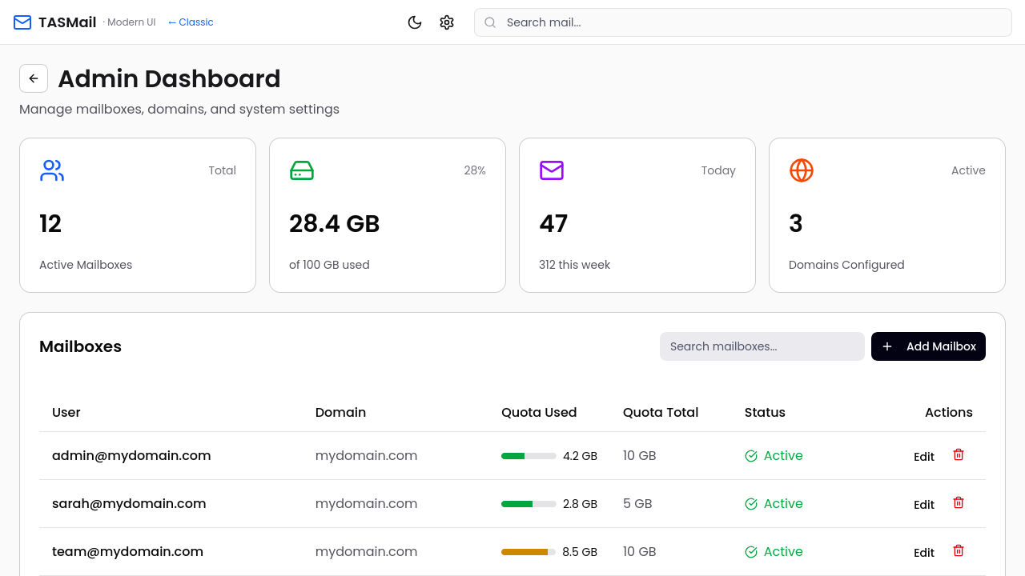
AdminDashboard route — STILL ON MOCK DATA (admin@mydomain.com, sarah@mydomain.com, etc.). Tracked as a follow-up.

09-back-to-classic.png
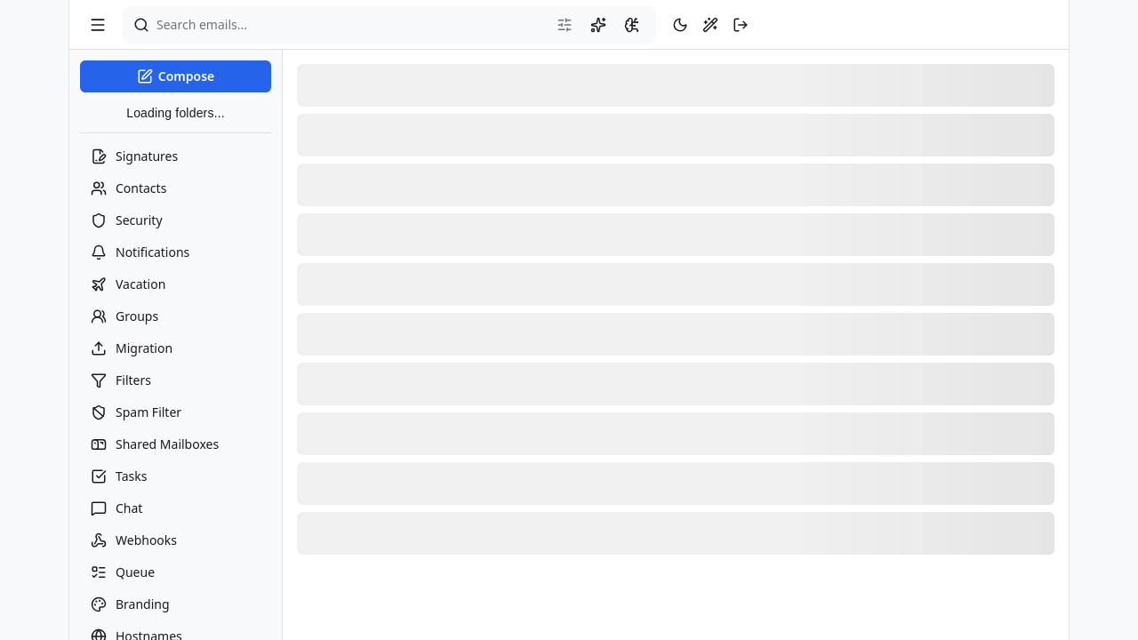
Classic SPA after clicking the alt-UI's ← Classic link. TopBar shows the wand icon between theme-toggle and logout.

6. Issues found + fixes during this pass

Sidebar folder render race
Symptom: Sidebar's useState(foldersProp ?? mockFolders) captured the empty array passed by EmailClient on first render (TanStack Query hadn't resolved /api/folders yet). The useEffect that updated state on prop change ran after paint, but in some renders the screenshot raced it. Net effect: alt-UI sidebar showed only Compose / Calendar / New folder while the message list was already populated.
Fix: Refactored Sidebar to derive folders directly from foldersProp (no local mirror); kept a separate extraLocalFolders state for the inline 'add new folder' UI which is local-only. Folder icons also got a defensive fallback to Briefcase if FOLDER_ICONS lookup misses.

EmailClient called fetchMessages with swapped page/pageSize
Symptom: fetchMessages signature is (folder, page=0, pageSize=50). The wired-up call passed (folder, 50, 0) — page 50, pageSize 0 — which returned a single message in the inbox.
Fix: Reordered to fetchMessages(activeFolder, 0, 50).

Page title still said 'Rust Mail' (legacy)
Symptom: themes/shadcn-prototype/index.html had the original prototype title carried over from the salvaged feature branch.
Fix: Updated to 'TASMail · Modern UI'. Also updated Navbar from 'Rust Mail' to 'TASMail · Modern UI' with a ← Classic link back.

7. Recommendations / follow-ups
Wire AdminDashboard to /api/admin/users + /api/admin/domains + /api/quota | Currently the only mock-data screen. Promoting it gives admins a second-look UI for the same TMAIL-202 (users) + TMAIL-200 (domains) data.
Wire CalendarView to /api/calendar/events | Self-contained today. Hooking it into the existing calendar API would close the second mock surface.
Drafts in alt-UI ComposeModal | Save Draft button is currently disabled with a tooltip. Wiring it to POST /api/drafts (already exposed) is a 30-minute add.
Switch type imports to a shared types package | Email and Folder types currently come from src/data/mockData.ts. Move them into themes/shadcn-prototype/src/types/ui.ts (or share with frontend/src/types/) so the trace gate doesn't have to special-case 'type-only mock imports'.
Consider promoting the wired Email* code into the production frontend/ | If the modern theme proves popular, the alt-UI's email screens could replace the inline-styled production versions. That would consolidate the api/ duplication and make the Vite build single-bundle again.

