**CSE 5382 Secure web tool**

**Tasmeen Kaur Kathuria**

**1001150823**

**Tools used:**

1. PMD
2. Flawfindr
3. Pylint

**Link to the website:**

http://lowcost-env.24ci25cswa.us-west-2.elasticbeanstalk.com/

**Snapshots:**

1. Register

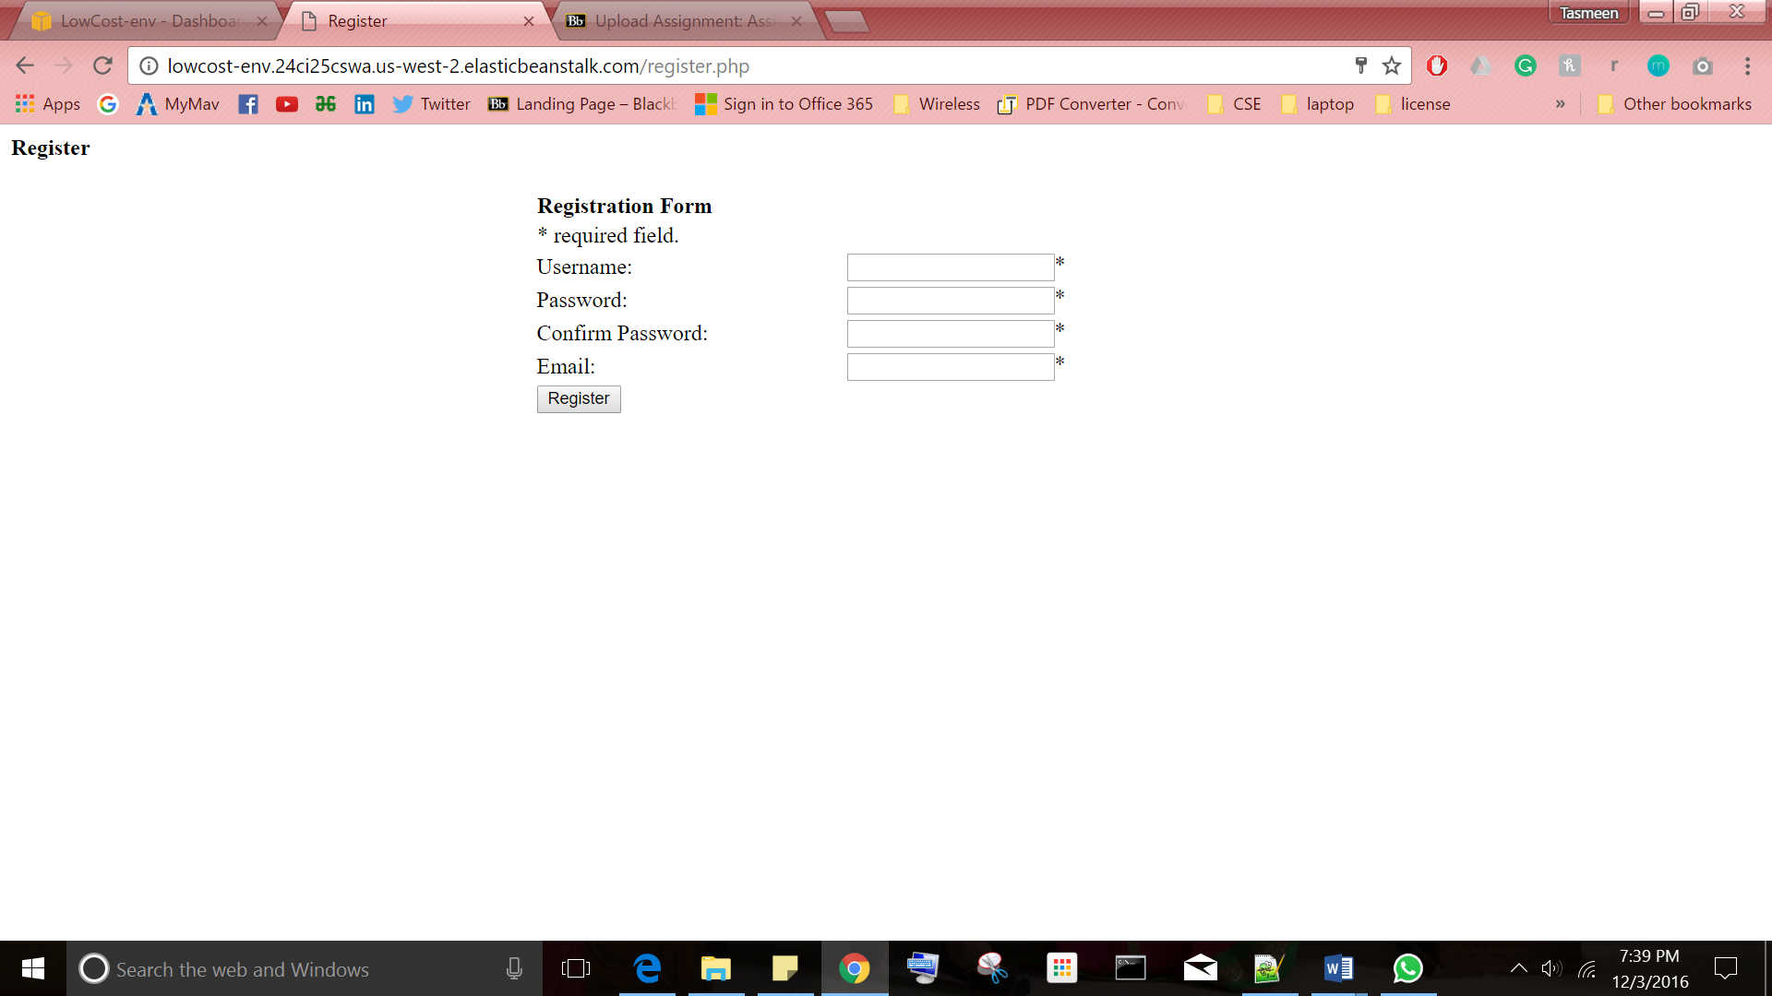

1. Login

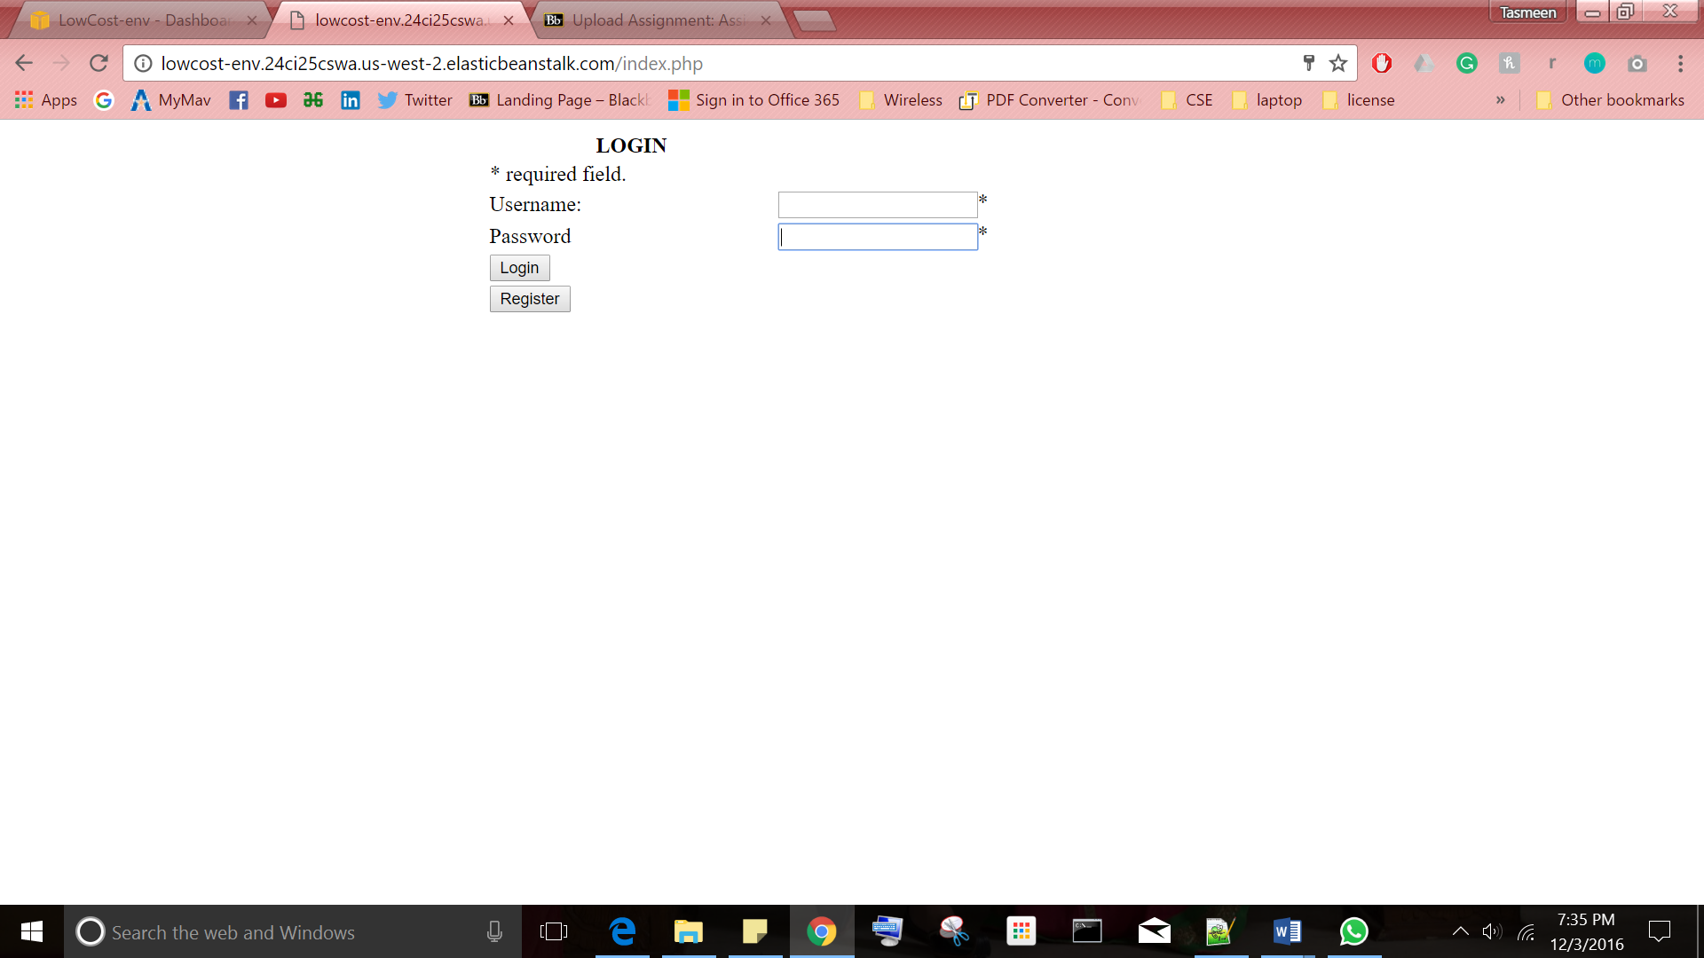

1. Upload

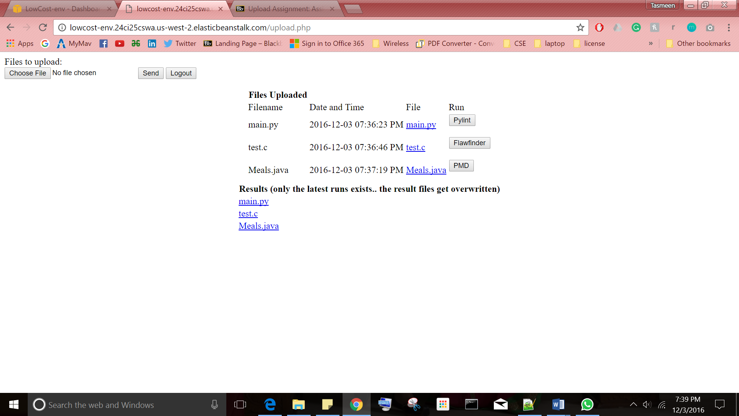

**References:**

1. <http://stackoverflow.com/questions/3512507/proper-way-to-logout-from-a-session-in-php>
2. <http://stackoverflow.com/questions/23116108/running-all-pmd-ruleset-from-command-line>
3. <http://stackoverflow.com/questions/7563658/php-check-file-extension>
4. <http://php.net/manual/en/function.uniqid.php>
5. <http://www.9lessons.info/2012/08/upload-files-to-amazon-s3-php.html>
6. <http://php.net/manual/en/function.file-get-contents.php>
7. <https://code.tutsplus.com/tutorials/how-to-use-amazon-s3-php-to-dynamically-store-and-manage-files-with-ease--net-31>
8. <http://www.w3schools.com/php/php_form_complete.asp>
9. http://www.w3schools.com/php/php_form_required.asp