DATA ANALYSIS PROJECT REPORT
Template for Student Submission
Project Title | Alzheimer Disease Data Analysis Using Pandas, NumPy, and Matplotlib
Student Name | Taibun Sayed ,Sheikh Nusrat Jahan Raufa,Tashmiah Haque
Student ID | 24-58839-2,24-58929-2,24-59834-3
Course / Section | [C]
Instructor | MD. Tanzeem Rahat
Date of Submission | 02-05-2026

1. Executive Summary
This project analyzes an Alzheimer disease dataset using Python libraries including Pandas, NumPy, and Matplotlib. The main objective was to identify patterns, trends, and relationships within Alzheimer-related health indicators. The dataset contains demographic and health-related information such as confidence limits, age categories, location, and data values. Data preprocessing techniques were applied to clean missing values, remove inconsistencies, and improve data quality. Feature engineering was performed by creating new columns such as ConfidenceGap and ValueCategory. Multiple analytical methods including grouping, correlation analysis, trend analysis, and outlier detection were conducted. Visualizations such as bar charts, histograms, scatter plots, line charts, and boxplots were used to present findings. The analysis revealed that Alzheimer-related values tend to vary across age groups and years, while confidence limits maintain a strong relationship. The project demonstrates how data analysis can support understanding of healthcare-related trends.

2. Introduction and Project Objectives
Alzheimer’s disease is a neurological disorder that affects memory, thinking, and behavior. It is one of the most common diseases among older adults and has become a growing public health concern worldwide. Analyzing Alzheimer-related datasets can help researchers understand patterns and identify risk-related indicators.
This project uses an Alzheimer dataset to explore relationships between demographic variables, time-based trends, and confidence limits. Python libraries such as Pandas, NumPy, and Matplotlib were used to perform data cleaning, feature engineering, statistical analysis, and visualization.
Item | Your Content
Dataset name | Alzheimer Disease and Healthy Aging Data
Dataset source | CDC Alzheimer Dataset / Kaggle Alzheimer Health Dataset
Main project goal | To analyze Alzheimer-related health data and identify meaningful trends and relationships using Python data analysis tools.
Research Question 1 | Does Alzheimer-related data vary across age groups?
Research Question 2 | How does Alzheimer data change over time?
Research Question 3 | Is there a relationship between confidence limits?

3. Dataset Description
The dataset contains Alzheimer-related health information collected from multiple states and years. Each row represents a health-related observation including demographic categories and measured data values.
The dataset contains both categorical and numerical variables which make it suitable for meaningful analysis.

3.1 Basic Dataset Information
Property | Value
Number of rows | 284,142
Number of columns | Approximately 30+
Data types present | Numerical, Categorical ,Text
Target or key variable(s) | Data_Value, Confidence Limits, State, Year
Potential issues observed at first glance | Data_Value, Confidence Limits, State, Year

3.2 Initial Observations
Initial inspection showed missing values in multiple columns such as confidence limits and geolocation fields. Some numerical columns contained invalid negative values. The dataset also contained categorical columns representing demographic and regional information. Data cleaning was necessary before performing analysis

4. Data Cleaning and Preparation

Issue Found | Action Taken | Reason / Justification
Missing values | Filled numeric missing values using mean | Prevent data loss
Missing categorical values | Filled with “unknown” | Maintain dataset completeness
Negative values in confidence limits | Replaced using clip(lower=0) | Negative health measurements are invalid
Column readability issue | Renamed columns | Easier analysis
Duplicate records | Removed duplicates | Prevent repeated observations

5. Feature Engineering

New Feature | How It Was Created | Why It Is Useful
ConfidenceGap | High_Confidence_Limit − Low_Confidence_Limit | Measures uncertainty range
ValueCategory | Categorized Data_Value into ranges | Helps compare low/high value groups
ZScore | NumPy statistical formula | Detects unusual observations

6. Analysis Methodology
- Pandas was used for data loading, cleaning, grouping, filtering, and aggregation.
- NumPy was used for z-score computation and statistical calculations.
- Matplotlib was used to create charts and visualizations.
The project followed a structured workflow:
- Data Understanding
- Cleaning
- Feature Engineering
- Analysis
- Visualization
- Findings

7. Analysis and Visualizations
[This is the main body of the report. Organize it by research question, not by code order. For each subsection, include the analysis, the relevant plot or table, and a short interpretation.]

7.1 Research Question 1
Does Alzheimer-related data vary across age groups?
A bar chart was used to compare average Alzheimer values across age groups.

Interpretation
The chart shows that the 65 years or older category has a slightly higher average Alzheimer value compared to the 50–64 years group. This indicates that Alzheimer-related measurements may increase with age.

Figure 1: Average Alzheimer Value by Age Group

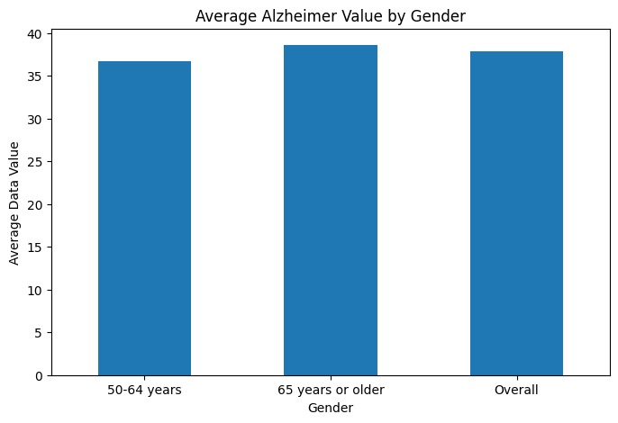

7.2 Research Question 2

How does Alzheimer data change over time?
A line chart was created to observe yearly trends.

Interpretation
The line chart shows slight fluctuations across years but an overall increasing trend. Alzheimer-related values increase gradually toward 2022.

Figure 2: Year-wise Alzheimer Trend
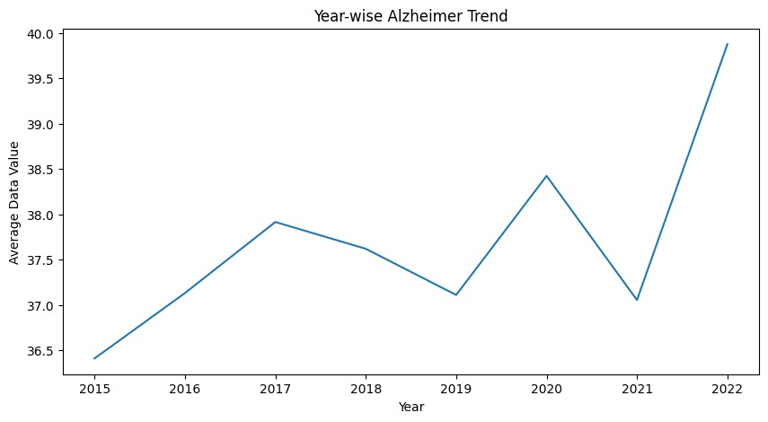

7.3 Research Question 3

Is there a relationship between confidence limits?
A scatter plot was used to analyze the relationship.

Interpretation
The scatter plot shows a positive relationship between low and high confidence limits. As low confidence values increase, high confidence values also tend to increase.

Figure 3: Relationship Between Confidence Limits
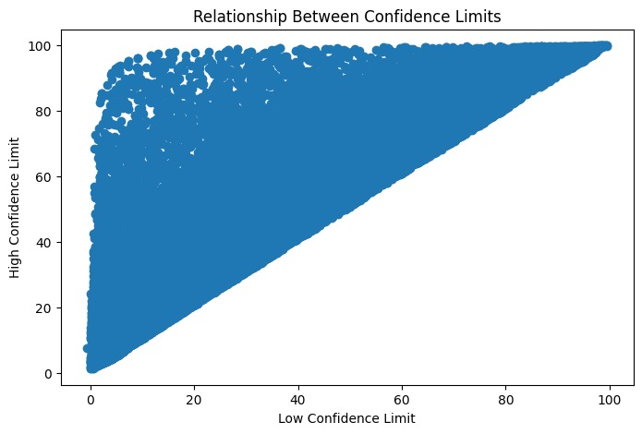

8. NumPy-Based Custom Computation
Component | Description
Computation Used | Z-Score Calculation
Purpose | Detect abnormal values
Formula | (Value − Mean) / Standard Deviation
Result | Identified statistical spread and unusual observations

Explanation
NumPy was used to compute Z-scores for Data_Value. This helps measure how far each value is from the dataset mean.

9. Key Findings
- Older age groups show higher Alzheimer-related values.
- Alzheimer values fluctuate slightly over years.
- Confidence limits have a strong positive relationship.
- Most data values fall between low-to-medium ranges.
- The dataset contains few extreme outliers.

10. Limitations
- Missing values may affect precision.
- Dataset may not represent all populations equally.
- Some variables may lack contextual information.
- Correlation does not imply causation.

11. Conclusion
This project successfully analyzed Alzheimer-related health data using Pandas, NumPy, and Matplotlib. Multiple analytical techniques were applied to understand patterns, trends, and relationships. Results suggest that age and time may influence Alzheimer-related indicators. The project demonstrates the usefulness of Python-based data analysis in healthcare research.

12. References / Dataset Source

- CDC Alzheimer Disease Dataset
- Kaggle Alzheimer Health Dataset
- Pandas Documentation
- NumPy Documentation
- Matplotlib Documentation

Final Submission Checklist
- √ I included my GitHub repository link or Google Colab notebook link in the Google Sheet provided by the instructor.
- √ I attached the project report as a separate file.
- √ My report includes dataset source, project objective, cleaning steps, feature engineering, analysis, visualizations, findings, limitations, and conclusion.
- √ My code uses Pandas, NumPy, and Matplotlib meaningfully.
- √ All bracketed placeholder text and helper notes were replaced or deleted before submission.

