|  |
| --- |
|  |

|  |
| --- |
| Name: Miss Tasleem Akhter |
| Course Date: Data Analytics |
|  |

**Table of contents**

Day 1: Task 1 3

Day 1: Task 2 3

Day 1: Task 3 4

Day 2: Task 1 5

Day 3: Task 1 9

Day 3: Task 2 10

Day 3: Task 3 11

Day 4: Task 1 12

Day 4: Task 2 13

1. Scenario Background 13

2. Data Laws and Regulations 14

3. Azure Service Recommendations 14

4. Data Types and Data Modelling 14

5. Data Storage Formats and Structures in Azure 14

6. Additional Considerations 15

Submission Guidelines: 15

Course Notes 17

Additional Information 17

# Day 1: Task 1

Please research and complete the below questions relating to key concepts of cloud.

Be prepared to discuss the below in the group following this task.

|  |  |
| --- | --- |
| What can cloud computing do for us in the real-world? | Cloud computing is like a superpower for modern technology which has changed businesses, individuals, and even how governments operate in the real world. For example cloud computing can enable us to work remotely and collaborte with ideas and enable us to complete projects remotely which reduces reliance on office spaces. And we do not have to investe in expensice infrastructure because cloud computing can be flexible and scalable to our computign and business needs. Most importantly, cloud computing allows us to secure our data from anywhere in the work instead of relying on hard drives which makes the system reliable and cost efficient too. |
| How can it benefit a business? | Business can benefit in lots of ways from the cloud computing like enhance business performance, scalabiliy, reduce expenses of hardware and software infrastructure, collaborate with each other from anywhere in the world, increase income, provide back up solution and protect critical business information by enabling automatic updates.  Business can benefit in lots of ways from the cloud computing like |
| What’s the alternative to cloud computing? | Alternative to cloud computing is, hybrid solutions, and on premises infrastructure, edge computing and data centres where businesses rent space for their data from their party data-centres. |
| What cloud providers can we use, what are their features and functions? | There are several major cloud providers offering a variety of features and functions tailored to different business needs which are AWS that offer secure features like scalability, security and global infrastructure. Another one is Microsoft Azure which  wide range of cloud solutions, including AI, machine learning, hybrid cloud capabilities, and enterprise-grade security. The Google Cloud Platform offers powerful data analytics like AI, and machine learning tools, along with scalable cloud computing and storage solutions. |

# Day 1: Task 2

Please research the below cloud offerings, explain what they are and examples of use cases.

|  |  |  |  |
| --- | --- | --- | --- |
| Cloud Offerings | Explain what it is | When / how might you use this service in the real-world? | |
| IaaS (Infrastructure as a service) | IaaS provides virtualized computing resources over the internet, including servers, storage, and networking. It's a scalable and flexible option where users can manage and control infrastructure without maintaining physical hardware. | | AWS |
| PaaS (Platform as a service) | PaaS offers a development environment with tools and frameworks needed to build, test, and deploy applications. It abstracts infrastructure management and lets developers focus on coding rather than handling servers or system updates. | Goggle App Engine | |
| SaaS (Software as a service) | SaaS delivers ready-to-use applications over the internet, eliminating the need for installation or maintenance. Users access the software through a web browser, typically via a subscription model. | Microsoft 365 | |

# Cloud computing offers three primary service models, each catering to different needs in the real world:

# **1. IaaS (Infrastructure as a Service)**

# Day 1: Task 3

Please research the below terms and explain what they are, when they would be appropriate and a real-world example of where it could be implemented (i.e. what type of organisation).

|  |  |
| --- | --- |
| Public Cloud | This is a cloud computing model where IT resource such as servers, storage, and networking are provided by a third-party vendor and made accessible over the internet and shared among multiple users and organizations, making them highly scalable and cost-effective like the NHS. |
| Private Cloud | This a cloud computing environment dedicated to a single organization. Unlike public clouds, where resources are shared among multiple users, a private cloud provides a more secure and controlled infrastructure, typically hosted on-premises or in a third-party data centre like a bank. |
| Hybrid Cloud | This is a computing environment that combines elements of both public and private clouds, allowing organizations to leverage the benefits of both. This setup enables businesses to store sensitive data in a private cloud while utilizing the scalability and cost-effectiveness of public cloud resources for less critical workloads and used for organisations like dentists and GP surgeries. |
| Community Cloud | This type is a cloud computing model where multiple organizations with shared interests, regulatory requirements, or operational needs collaborate on a common cloud infrastructure. It provides a balance between the security of private clouds and the cost-effectiveness of public clouds and used by hospitals and industrial and manufacturing organisations. |

# Day 2: Task 1

Describe, with examples, the **three** major areas that the Computer Misuse Act deals with.

|  |  |  |
| --- | --- | --- |
| Area | Description | Example |
| Unauthorised access to computer material | This is accessing the computer system without permission. | Logging into someone`s account without permission. |
| Unauthorised access with intent to commit further offences | This means altering or deleting data without permission, including spreading malware or viruses. | A hacker breaking into a bank's system to steal customer financial details. |
| Unauthorized Modification of Computer Material | This means altering or deleting data without permission, including spreading malware or viruses. | A cybercriminal deploying ransomware to encrypt files and demand payment for decryption. |

The computer misuse act 1990 is an act where an individual can be criminalised because of computer related offense. Describe three extra powers that the Police and Justice Act 2006 (Computer Misuse) has added.

|  |
| --- |
| Description |
| **Increased Penalties for Hacking** |
| **Criminalization of Denial-of-Service (DoS) Attacks** |
| **Ban on the Creation and Distribution of Hacking Tools** |

Look at the below website to answer the questions:

<https://www.gov.uk/personal-data-my-employer-can-keep-about-me>

|  |
| --- |
| Write down three items of data which a company can store about an employee. |
| **Personal information like name and address** |
| **Employment records like work history** |
| **Bank details and tax information** |

|  |
| --- |
| Give three more examples of data that an employer can only store if they first get the employee’s permission. |
| **Medical records** |
| **Biometric data** |
| **Criminal records information** |

Conduct further research to answer the below questions.

|  |  |
| --- | --- |
| Question | Answer |
| Provide one example of: Copyright infringement | British Telecommunications (BT) vs. British Sky Broadcasting (BSkyB). BT accused BSkyB of using its patented technology for digital video recording without permission. The dispute centred around software used in Sky+ boxes, which BT claimed infringed on its intellectual property. The case was settled, highlighting the importance of respecting software patents and copyright laws in the UK. |
| Provide one example of: Plagiarism | The case of **Apple vs. Samsung**. Apple accused Samsung of copying design elements and user interface features from the iPhone for its Galaxy smartphones. The legal battle lasted for years, with Apple arguing that Samsung had plagiarized key aspects of its technology. The case resulted in significant financial penalties for Samsung and reinforced the importance of originality in tech development. |
| What are two consequences of copyright infringement and software piracy? | Legal penalties and security risks |
| Give three possible consequences for individuals when using pirated software | Fines and legal action, security risks like cyber attacks and lack of support and updates leading  to compatibility issues and system failures. Also a person using a pirated operating system may experience frequent crashes and be unable to access new features.  These risks highlight the importance of using legally lice |

Listed below are some laws which we have covered today:

1. Computer Misuse Act 1990

2. Police and Justice Act 2006 (Computer Misuse)

3. Copyright, Designs and Patents Act 1988

4. Copyright (Computer Programs) Regulations 1992

5. The Health and Safety (Display Screen Equipment) Regulations 1992

6. Data Protection Act 2018

7. Consumer Rights Act 2015

* Insert a number in the first column of each row to match each of the statements with one of the above Acts.
* One of statements is incorrect and not illegal. For this statement, write ‘Not illegal’.

|  |  |
| --- | --- |
|  | **Clause** |
| 3 | With some exceptions, it is illegal to use unlicensed software |
| 7 | Any product, digital or otherwise, must be fit for the purpose it is supplied for |
| 1 | Unauthorised modification of computer material is illegal |
| 4 | It is illegal to create or use a hacking tool for penetration testing |
| 6 | Personal data may only be used for specified, explicit purposes |
| 5 | Employers must provide their computer users with adequate health and safety training for any workstation they work at |
| 1 | It is illegal to distribute hacking tools for criminal purposes |
| Not illegal | It is illegal to distribute an illicit recording |
| 6 | Personal data may not be kept longer than necessary |
| 1 | Gaining unauthorised access to a computer system is illegal |
| 5 | Employers must ensure that employees take regular and adequate breaks from looking at their screens |
| 1 | It is illegal to prevent or hinder access (e.g. by a denial-of-service attack) to any program or data held in any computer |
| 6 | Personal data must be accurate and where necessary kept up to date |

# Day 3: Task 1

Please complete the below lab (3) *‘Explore relational data in Azure’* and paste evidence of the completed lab in the box provided.

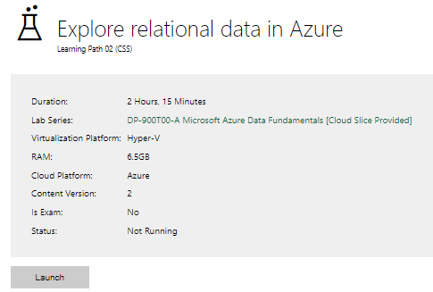

|  |  |
| --- | --- |
| Completed lab |  |

# Day 3: Task 2

Please complete the below lab (4) *‘Explore non-relational data in Azure’* and paste evidence of the completed lab in the box provided.

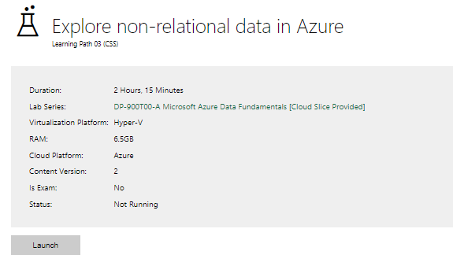

|  |  |
| --- | --- |
| Completed lab |  |

# Day 3: Task 3

Please complete the below lab (5) ‘Explore data analytics in Azure’ and paste evidence of the completed lab in the box provided.

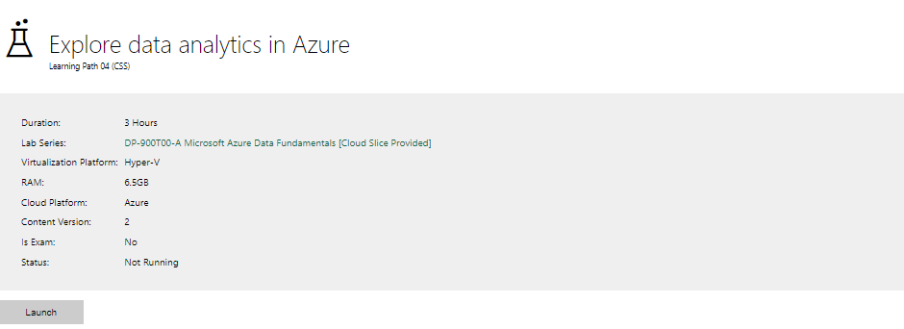

|  |  |
| --- | --- |
| Completed lab | Unfortunately, I was unable to complete lab because of login issues and I have attempted to do this several times. |

# Day 4: Task 1

In your teams, complete the Azure DP-900 practice exam and paste your result below – this is open book and please research and discuss your answers as a team.

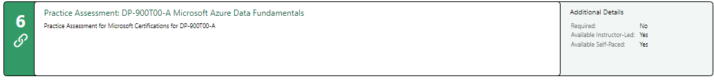

|  |  |
| --- | --- |
| Result |  |

# Day 4: Task 2

#### **1. Scenario Background**

"Paws & Whiskers" is a growing pet shop that aims to improve its business by analysing sales, customer information, and inventory data. Currently, the data is collected manually or stored in spreadsheets. Management is interested in transitioning to Microsoft Azure to streamline data storage, analysis, and reporting, enabling them to make data-driven decisions.

#### **2. Data Laws and Regulations**

Identify and explain the data laws and regulations relevant to handling customer data within the proposal. Ensure you cover the following points:

* **GDPR Compliance**: Highlight the importance of adhering to the General Data Protection Regulation (GDPR), particularly as it relates to storing and processing customer information.
* **Data Protection Act (DPA) 2018**: Outline how the DPA 2018 may affect the way "Paws & Whiskers" collects and stores data, ensuring compliance with UK laws on data privacy.
* **Other Industry Standards**: Research any additional data protection standards or regulations that may apply to pet shop data, particularly if they involve sensitive or payment information.

#### **3. Azure Service Recommendations**

Recommend Microsoft Azure services that would suit the company’s data analysis needs and explain why these services are suitable. Your recommendations should include:

* **Data Storage**: Identify suitable storage options, such as **Azure Blob Storage** or **Azure SQL Database**, and discuss the benefits of each for storing large datasets, including inventory, sales transactions, and customer details.
* **Data Analysis Tools**: Recommend tools such as **Azure Machine Learning** for customer behaviour analysis or **Azure Synapse Analytics** for analysing sales trends.
* **Data Integration and Automation**: Explain how services like **Azure Data Factory** could automate data collection and integration processes, improving efficiency.

#### **4. Data Types and Data Modelling**

Define the types of data "Paws & Whiskers" will need to work with and describe your approach to data modelling:

* **Data Categories**: Identify key data types, such as customer demographics, transaction history, pet inventory, and product categories.
* **Data Modelling Approach**: Outline how you would structure this data using a relational model or a data warehouse approach, considering factors like tables, entities, relationships, and primary keys.

#### **5. Data Storage Formats and Structures in Azure**

Discuss how you would store data within Azure and the formats you would recommend:

* **Data Formats**: Specify recommended formats (e.g., CSV for raw data imports, JSON for structured data, Parquet for analytics) and explain why these formats are suitable for specific data types.
* **Data Security and Encryption**: Include recommendations for securing data using Azure’s built-in encryption features and access controls to ensure compliance with data privacy regulations.

#### **6. Additional Considerations**

Provide any other considerations that might enhance data handling and efficiency in Azure, such as:

* **Backup and Disaster Recovery**: Outline a backup plan using **Azure Backup** or **Azure Site Recovery** to safeguard against data loss.
* **Data Visualisation**: Discuss potential use of **Power BI** within Azure for creating dashboards that provide management with real-time insights into sales and customer trends.
* **Future Scalability**: Comment on how Azure services can scale as the business grows, accommodating larger datasets and more complex analyses.

### **Submission Guidelines:**

1. **Structure**: Ensure your report is well-organised, with sections for each task (e.g., Data Laws, Azure Services, Data Types, etc.).
2. **Formatting**: Include headings, bullet points where appropriate, and any visuals or diagrams that support your explanations.
3. **References**: Cite any resources or regulations referenced in the report.
4. **Length**: Aim for 1500-2000 words.

|  |
| --- |
|  |

|  |
| --- |
| **Course Notes** |

It is recommended to take notes from the course, use the space below to do so, or use the revision guide shared with the class:

|  |
| --- |
| **Additional Information** |

We have included a range of additional links to further resources and information that you may find useful, these can be found within your revision guide.

**END OF WORKBOOK**

**Please check through your work thoroughly before submitting and update the table of contents if required.**

**Please send your completed work booklet to your trainer.**