TASK 4 REPORT
Design for Testability (DFT), Scan Chain Insertion and Conceptual LVS/DRC
Student Name: Tasmiya Firdose
Department: Electronics and Communication Engineering

Table of Contents
- 1. Objective
- 2. Introduction
- 3. Task Requirements
- 4. Design for Testability (DFT)
- 5. Scan Chain Insertion
- 6. Simulation Environment
- 7. RTL Design and Simulation
- 8. Timing Constraints (SDC)
- 9. EPWave Results
- 10. LVS and DRC
- 11. Test Coverage and Stuck-at Faults
- 12. DFT Plan
- 13. Deliverables
- 14. Observations
- 15. Conclusion
- 16. References

Objective
To introduce Design for Testability (DFT), implement a scan-enabled 4-bit ALU using SystemVerilog, verify scan chain functionality, prepare timing constraints for Static Timing Analysis (STA), and conceptually explain LVS/DRC.

Introduction
Design for Testability improves chip testing by inserting scan flip-flops into sequential circuits. Scan chains allow internal registers to be observed and controlled, improving fault detection.

Task Requirements
• Apply scan chain insertion manually.
• Explain LVS and DRC.
• Discuss test coverage and stuck-at faults.
• Prepare DFT plan and STA constraints.

Design for Testability (DFT)
DFT adds hardware features to simplify testing. In this task, a scan D flip-flop replaces a normal flip-flop and is controlled using scan_en, scan_in and scan_clk.

Scan Chain Insertion
A manual scan chain approach was used. During scan mode, serial data is shifted through the flip-flops. During functional mode, the ALU performs logical operations normally.

Simulation Environment
Language: SystemVerilog
Simulator: EDA Playground (Icarus Verilog)
Waveform Viewer: EPWave

Timing Constraints (SDC)
The SDC file defines clock period, uncertainty, transition, input delay and output delay. These constraints are used for Static Timing Analysis.

LVS and DRC
LVS compares the layout netlist with the schematic to verify connectivity. DRC checks whether the layout satisfies manufacturing design rules such as spacing, width and enclosure.

Test Coverage and Stuck-at Faults
Functional tests verified AND and XOR operations. Scan shifting validated scan operation. Stuck-at-0 and Stuck-at-1 faults are detected by shifting known patterns through the scan chain.

DFT Plan
1. Insert scan flip-flops.
2. Apply reset.
3. Shift test patterns.
4. Capture functional response.
5. Shift out captured data.
6. Compare with expected output.

Deliverables
• SystemVerilog Design
• Testbench
• Constraints.sdc
• EPWave waveform
• DFT Report

Observations
Reset, scan shift and functional operations executed successfully. Timing constraints were prepared successfully.

Conclusion
The scan-enabled 4-bit ALU was successfully simulated. The waveform verified scan functionality and ALU operation. Conceptual LVS/DRC and DFT methodology were documented.

Figure 1: RTL Design, Testbench and Simulation Output
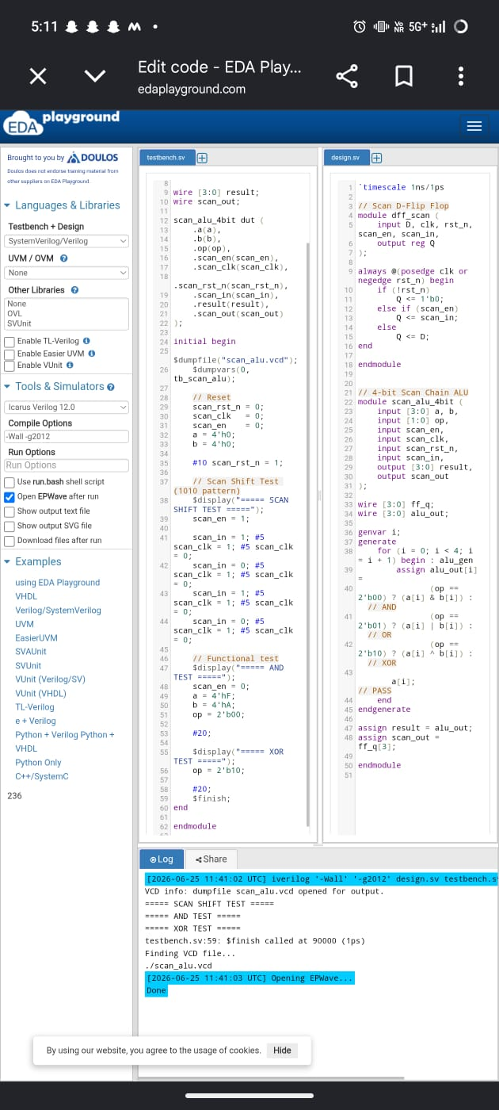
Figure 1: RTL Design, Testbench and Simulation Output

Figure 2: Timing Constraints (Constraints.sdc)
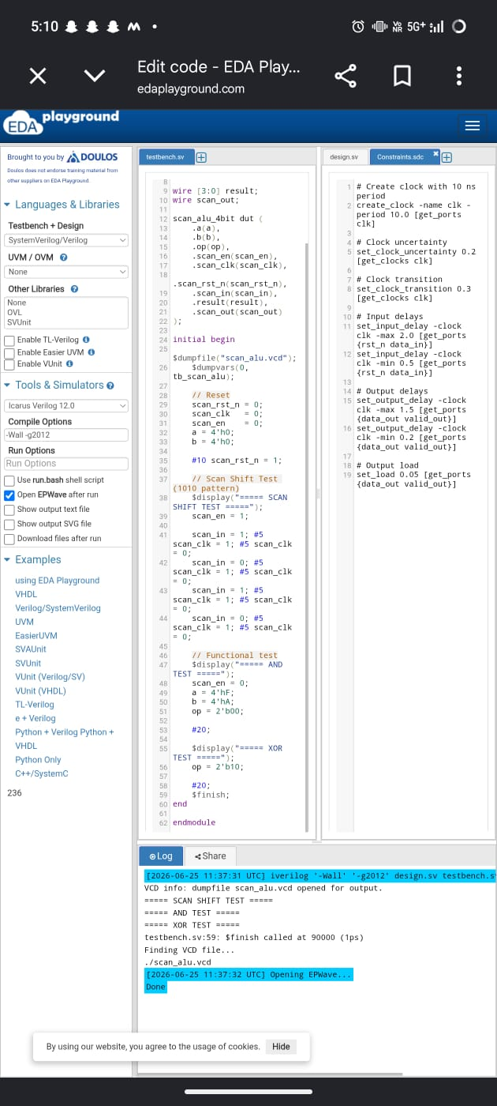
Figure 2: Timing Constraints (Constraints.sdc)

Figure 3: EPWave Simulation Waveform
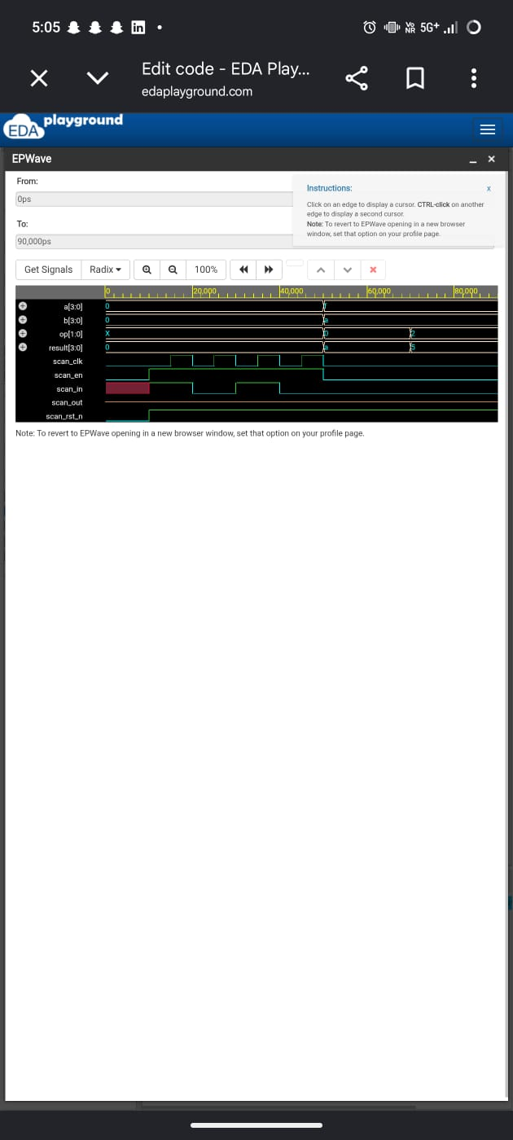
Figure 3: EPWave Simulation Waveform

References
1. EDA Playground
2. Icarus Verilog
3. SystemVerilog IEEE 1800 Standard
4. Basic DFT and STA Concepts

