**2 rounds of load testing with minimum 20 users, on OrangeHrm application using JMETER.**

JMeter Home Page

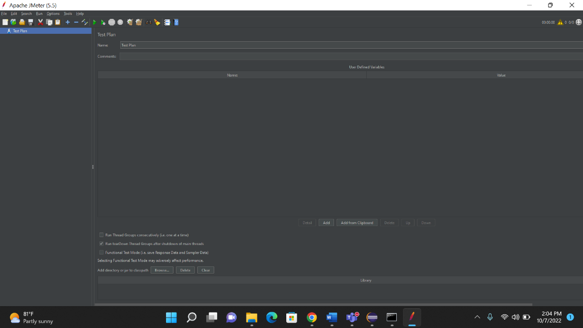

Creating Thread group in JMeter

* To add Threads right click on project -> Add -> Threads -> Thread group.

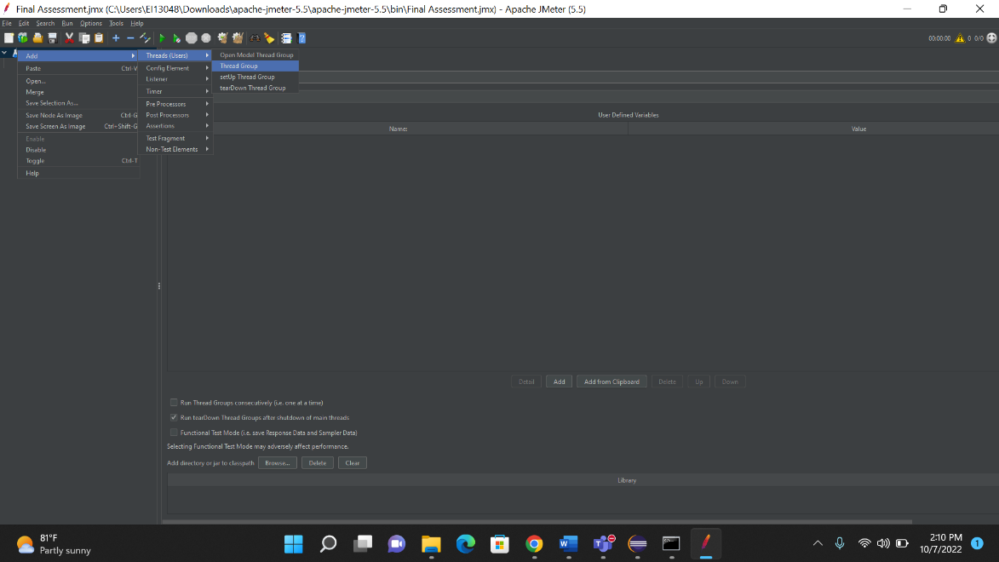

Thread Group Specifies the number of Users the application at a time, here we are load testing the functionality Orange HRM with 20 users

**Creating Different listeners inside Thread Group**

To add sampler to your thread right click on your thread -> Add -> sampler -> select request. Here I took HTTP request as many web pages send HTTP request.

**HRM Login:** The sampler named login is used to check the login function of orange HRM Login.

**PIM Page:** The sampler named login is used to check the login function of orange HRM PIM Page.

**Admin:** The sampler named login is used to check the login function of orange HRM Admin Page.

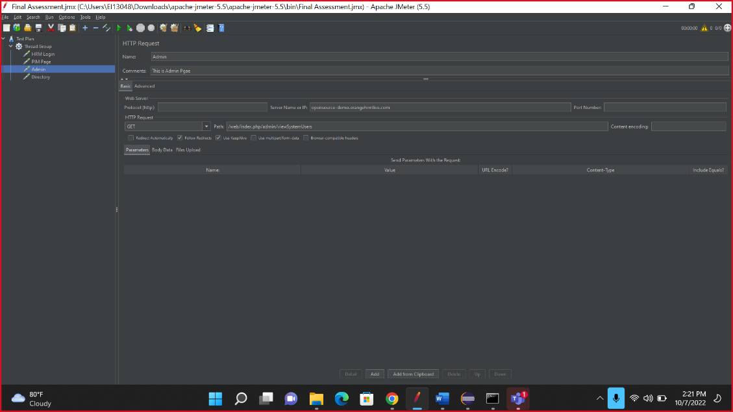

**Directory:** The sampler named login is used to check the login function of orange HRM Directory.

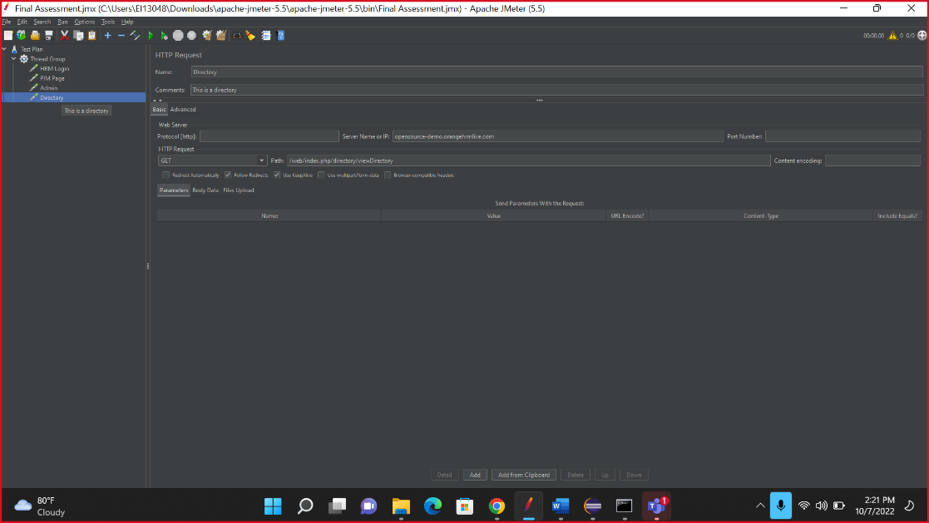

**Adding Listeners**

Listener View Results Tree is used to view the Result of number of users logging in to the website (25). To check the Total count of users logging in Checking the My info functionality we used a listener Aggregate Report. To add Listeners right click on project -> Add -> Listener -> View Results Tree or any others. We are Checking the Load performance for 25 users with throughput for My info page we get My info total count as 2 in the Aggregate report.

1. **Aggregate Report**

1. **View Result in Table**

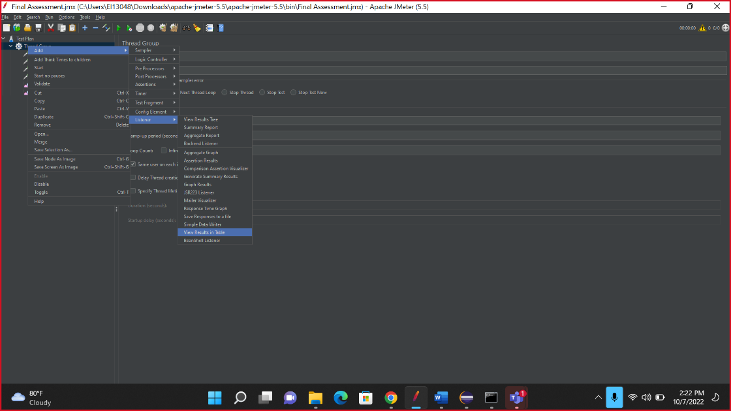

1. **View Result in Tree**

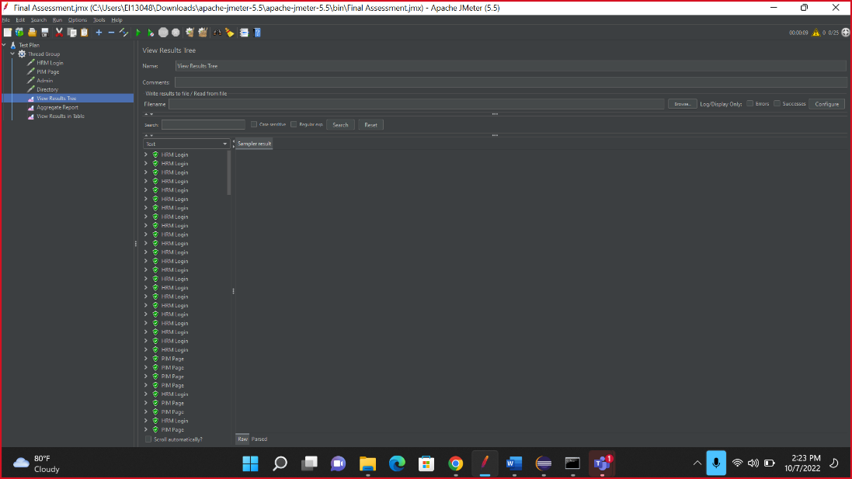

**Adding Assertions**

In this we are adding Response assertion. To add assertion right click on Thread-> Add -> Assertion -> Take assertion that you want. The Response Assertion is selected and named as Validate Login for My info page. Here we can verify and validate the data of requests that we have sent to the server. Using assertions, we can compare the expected result with the actual result.

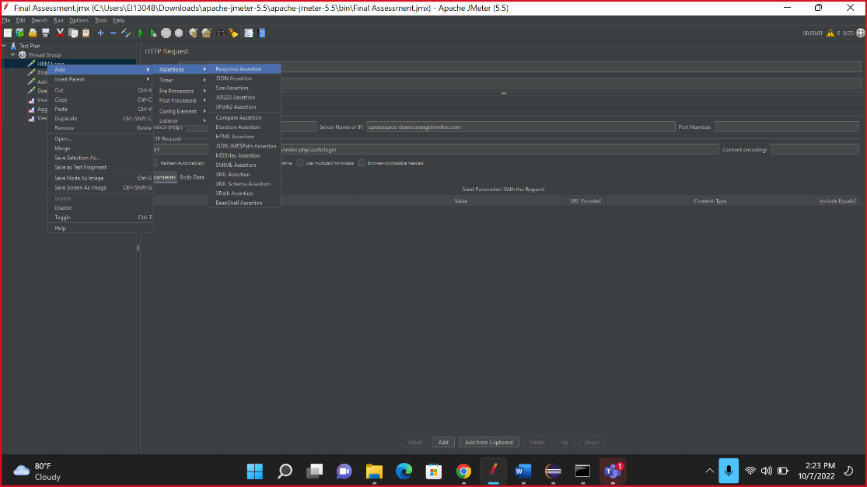

In this we entered a response mesagge “OK” hence all the cases must pass.

If we entered a invalid response message like “OKK” then it will show error. The test case will fail.

