**1-DNS**

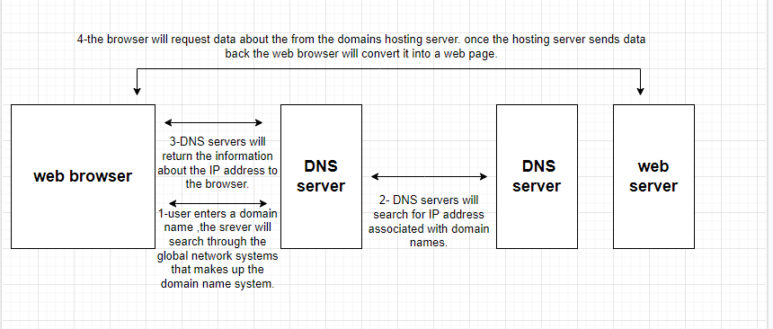

**2-http request cycle**

