
MODERN ACADEMY
FOR ENGINEERING & TECHNOLOGY
Electronics and CommunicationsDepartment
Spring Semester - Academic Year 2025/2026
JAN 2026


Computer vision
A. Prof. Dr.
Presented by:

- Yousef Hossam Id:10 Enginner
- 0
- 11
- 22
- 33
- 44
- 55
- 66

Twsela — Full System Report (v1.0)
Comprehensive system briefing for product managers and technical stakeholders working on courier and logistics platforms across the MENA region. This report summarises architecture, feature set, operational metrics, integrations, and roadmap items — focused on actionable insights for prioritisation, engineering planning, and go-to-market decisions.

- Introduction & Market Analysis
Logistics is the backbone of the global economy, and in the MENA region, it is a $50 billion industry. However, the lack of localized technology hinders growth. Twsela is introduced as a central hub for courier operations, specifically designed to handle the complexity of "Cash on Delivery" (COD) and fragmented address systems. It aims to provide small and medium-sized logistics providers with the tools previously only available to industry giants like Aramex or DHL.

- Executive Summary
- Platform Vision
Twsela is an Arabic-first, enterprise-grade courier management platform tailored for MENA.
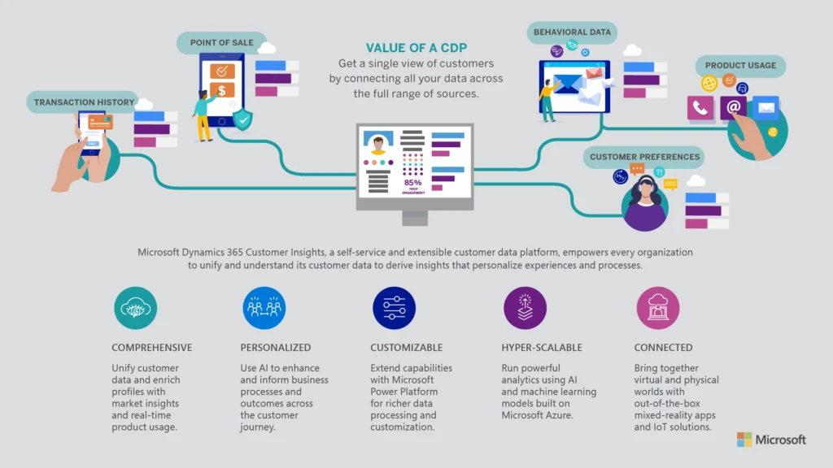 It orchestrates the end-to-end shipment lifecycle across Owner, Admin, Merchant, Courier and Warehouse roles, providing traceability, zone-based pricing and observability out of the box.
- Market Focus
Primary focus on GCC (KSA, UAE, Kuwait, Qatar), with regional expansion into Egypt, Morocco, Jordan and Lebanon. Differentiators: RTL UX, integrated MENA payment/SMS providers, zone pricing and optimized manifests.
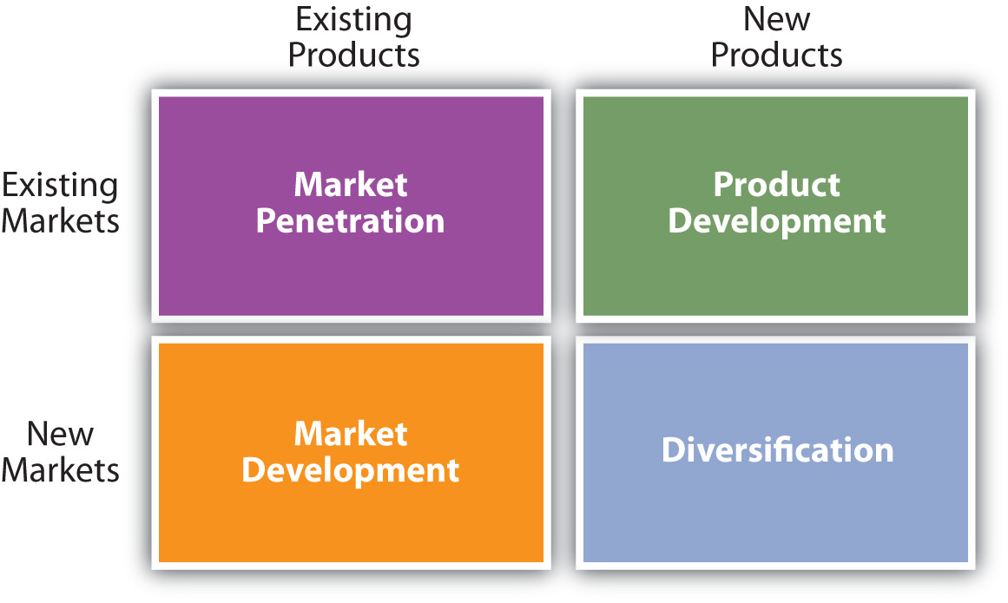
- Operational Highlights
174 domain models, 88 REST controllers, 176 DB tables, 59 Flyway migrations and 938+ unit tests. Production-ready stack includes Redis caching, Prometheus/Grafana, Docker and Nginx with TLS termination.

- Business Model & Go-to-Market

Customer Segments & Value
- Owner/Admin — End-to-end visibility, SLA & pricing controls.
- Merchant — Fast shipment creation, tracking, reconciliation.
- Courier — Clear manifests, route guidance, earnings tracking.
- Warehouse — Intake, pick waves, throughput optimization.
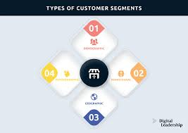
Competitive advantages include Arabic-first UX, integrated MENA provider support, and an observability-first infrastructure to reduce operational cost and improve SLA compliance.

Revenue Streams
Subscription tiers (Starter $99, Growth $299, Enterprise custom), per-shipment usage fees ($0.10–$0.50), SMS billing, premium analytics & route optimisation add-ons, and optional transaction fees (1.5%–2.5%).
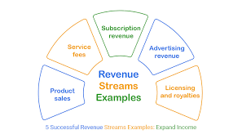

- System Architecture — High Level
The system is built for high availability and zero downtime:
- Core: Java 17 with Spring Boot 3.3.3 for robust business logic.

- Persistence: MySQL 9.4.0 with 176 tables, designed using 3rd Normal Form (3NF).

- Scaling: Dockerized micro-services approach, allowing each part of the system (e.g., the pricing engine) to scale independently.

- Observability: Using Prometheus for metrics and Grafana for monitoring system health and server CPU/Memory usage.
The stack is layered: Presentation (Vite, RTL-first pages), API (Spring Boot Java 17), Business Services, Data Access (Spring Data JPA), and Infrastructure (Redis, MySQL, Prometheus/Grafana). Key design patterns: event-driven workflows, transactional outbox, and domain-driven modelling across 174 entities.
Security & Auth

JWT auth, RBAC, BCrypt, CSRF cookies, rate limiting and IP blacklisting.

Scalability
Dockerised services, Redis caching, and planned Kubernetes migration for multi-region scale.


Geo & Zones
Google Maps polygon zones, distance-based pricing and courier territory assignment.

- User Roles & Dashboards
Role-specific experiences are first-class: Owner (full oversight), Admin (operations), Merchant (self-service), Courier (manifest-driven), Warehouse (fulfilment workflows). Each role has tailored pages, APIs and analytics to reduce noise and improve task completion rates.
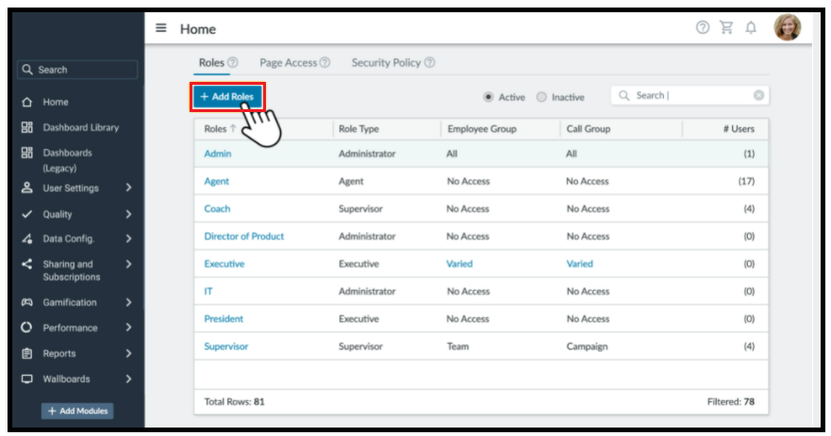
Owner
Revenue and SLA KPIs, tenant controls, payouts, branding and advanced analytics.
Merchant
Fast create, bulk upload, label printing, invoices, returns and integration with e-commerce platforms.
Courier & Warehouse
Optimised manifests, offline-capable mobile flows, pick waves and throughput dashboards.

- Feature Catalog — Highlights & Implementation Notes
The platform contains a broad feature set across the shipment lifecycle. Below are the highest-impact capabilities with brief implementation notes for product and engineering alignment.
- Authentication & Security
JWT (24h), OTP verification, rate limiting (Bucket4j + Redis), API key management and audit logging.

Prioritise token revocation and security event dashboards for SOC workflows.

- Smart Assignment & Route Optimization
Assignment scoring blends distance, capacity and past performance. Route optimisation is offered as paid add-on; prepare for heavier compute (batch or microservice) and potential third-party solver integration. 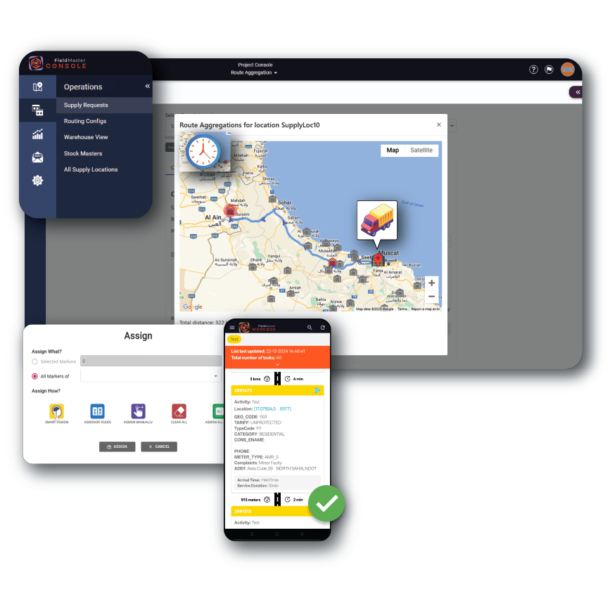
- Warehouse Operations

Full receiving, put-away, pick waves and inventory movement tracking. Important to instrument cycle counts and discrepancy workflows for SLA and auditability.

- Financial Management & Wallets
Multi-currency, COD reconciliation, settlement batches and invoice generation (Arabic PDF support). Ensure reconciliation jobs and audit trails are idempotent and observable.

Data Model & API
The domain model spans 174 entities across 176 tables. Core domains: Shipments, Users, Zones, Pricing, Warehouse, Finance, Notifications, Integrations and PlatformOps. The API surface (88 controllers) provides around 400+ endpoints grouped by domain; OpenAPI docs are exposed via SpringDoc.

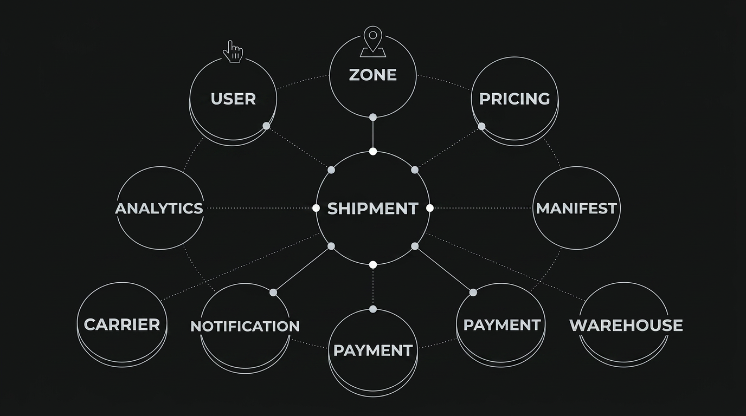
Recommendation: maintain a prioritized API contract backlog for the top 20 endpoints used by merchants and couriers to ensure stability during refactors and to enable mobile SDK adoption.

Infrastructure, Observability & DevOps
Production architecture uses Nginx (TLS), Spring Boot app (Tomcat), MySQL (utf8mb4), Redis and Prometheus/Grafana. Backups run daily with 30-day retention. Logging is structured JSON with 30-day retention and 100MB file rotation. Health endpoints and alerts are pre-configured.

Monitoring
Prometheus metrics (JVM, DB, HTTP, custom business metrics) and Grafana dashboards for system and business observability.

CI/CD
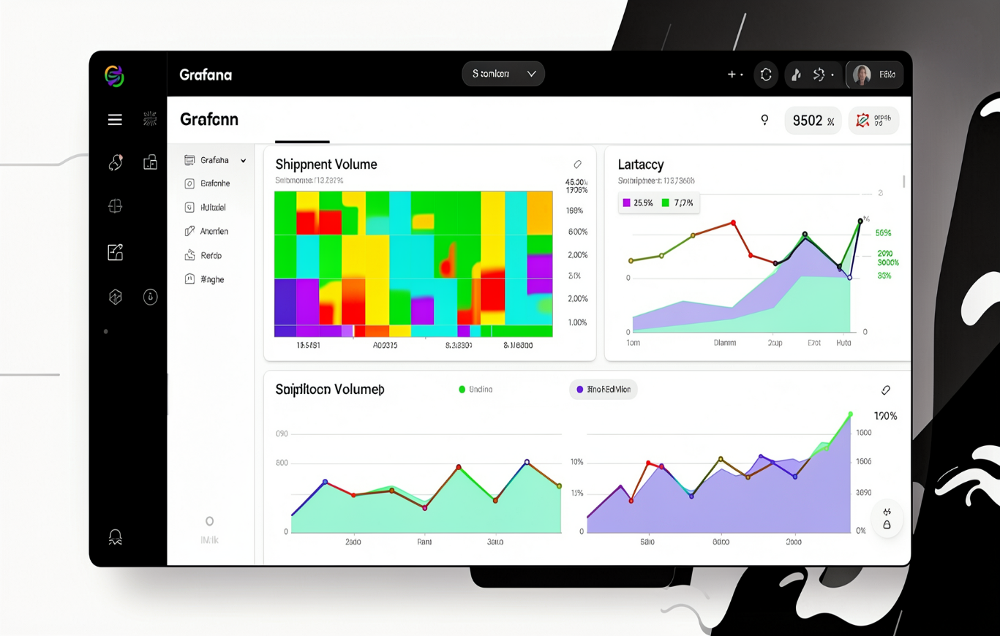
Maven build, container images, Docker Compose for local stacks and planned Kubernetes migration for Q2 2026.

Resilience
Rate limiting, dead-letter queues, and async job monitoring for operational stability under load.
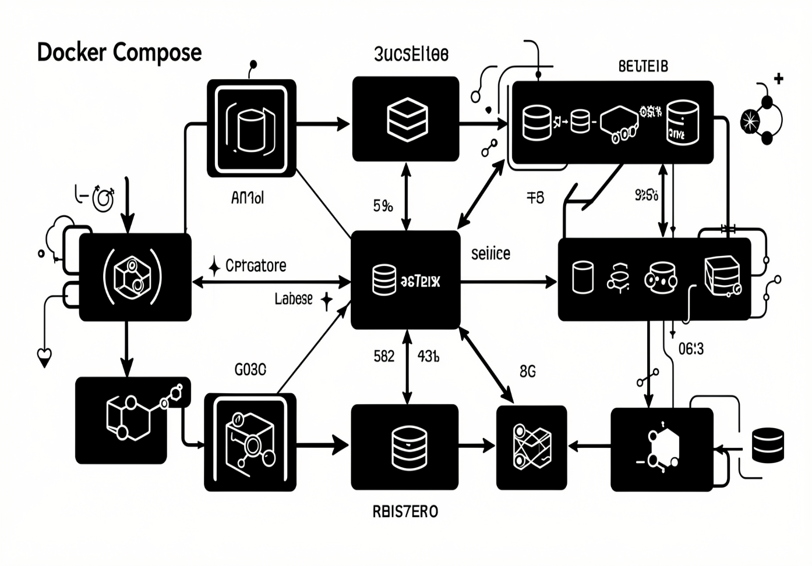

Security & Compliance
Security model enforces RBAC, method-level checks (@PreAuthorize), JWT authentication, CSRF protection and extensive audit logging. Additional protections include IP blacklists, input sanitisation filters and account lockout policies. Compliance features allow regional policy definition and audit exports.
Ensure security event dashboards and automated alerts are integrated with on-call channels before any public tenant onboarding. Token revocation and API key rotation should be included in initial enterprise onboarding checklist.

Roadmap & Recommendations
Short-term roadmap (Sprints 49–57) focuses on admin operations, owner features, merchant and courier advances, platform admin tools, notification centre and financial enhancements. Mid-term (Q2 2026) priorities: mobile apps, AI route optimisation, Kubernetes deployment and predictive analytics. Longer term: public API marketplace, white-labeling and IoT tracking.

Sprints 49–57
Admin and owner pages, notification centre, settlements, BI dashboards and integration hub.

Q2 2026
Mobile apps, AI route optimiser, Kubernetes migration and multi-region deployment.

Q3–Q4 2026
API marketplace, white-label, mobile SDKs, blockchain POD experiments and carbon-tracking features.
Key recommendations for product & engineering stakeholders:
- Prioritise mobile offline flows and manifest performance for courier reliability.
- Harden security observability and enterprise onboarding (SAML/SSO, token revocation, audit exports).
- Productise route optimisation as an add-on service with clear SLAs and compute cost modelling.
- Stabilise top 20 merchant and courier API endpoints and publish a lightweight API SDK for integrations.
- Prepare a staged Kubernetes migration plan with blue/green deploys and database failover strategy.
For follow-up, I can produce a prioritized engineering backlog, a migration plan for Kubernetes, or detailed API stability SLAs — tell me which you want next.

