 |  | 

CAPSTONE PROJECT PROPOSAL
VELORA
Violation Evaluation and Lane Orchestration for Real-time Road Automation

Project Title | VELORA — Violation Evaluation and Lane Orchestration for Real-time Road Automation
Track | AI & Data Science
Job Profile | Microsoft Machine Learning Developer
Program Name | Nano Degree
Team Name | 5G
Submitted By | Wesam Fathy Masoud Omar, Basma Hassan Qutb, Tasneem Faisal Makhlouf, Habiba Adel Saleh,  Salma Mahmoud Abdelhaleem
Supervision Committee | Track Head: Dr. Rania ElGohary  Supervisor: Dr. Mohamed El Badawi  Academic Team: Eng. Engy Ayman & Eng. Sama  Instructor: Antonios Malak
Submission Date | June 2026

Declaration and Certificate of Originality
We, the undersigned team members, declare that this capstone project proposal is our original work and has been prepared for academic evaluation purposes. Any external datasets, tools, libraries, frameworks, or resources used in the project will be clearly acknowledged within this final project documentation according to the committee requirements.
We confirm that the proposed project idea, implementation plan, and expected deliverables are developed by the team and that the project will follow ethical, legal, and professional standards related to data, security, software development, and technology usage.

Student Name | ID | Signature | Date
Basma Hassan Qutb | 29404010103986 | Basma Qutb | June 2026
Wesam Fathy Masoud Omar | 30209011821147 | Wesam Omar | June 2026
Tasneem Faisal Makhlouf | 30308241701068 | Tasneem Makhlouf | June 2026
Habiba Adel Saleh | 30402121800107 | Habiba Saleh | June 2026
Salma Abdelhaleem | 30204281600264 | Salma Abdelhaleem | June 2026

Dedication
This project is dedicated to all those who have inspired and supported us throughout this journey. We express our sincere appreciation to our families for their continuous encouragement, to our mentors for their invaluable guidance, and to the organizations that provided us with the opportunity to learn and grow.
We also dedicate this work to every learner and innovator who strives to make a positive impact through technology and data-driven solutions.

Acknowledgement
The team would like to express its deepest gratitude and appreciation for the opportunity to be part of the Digilians Initiative. We are truly proud and honored to have been selected to join such a distinguished program, which reflects a strong commitment to empowering youth and developing future talents in the field of technology and data science.
First and foremost, we would like to express our profound appreciation to the political leadership, especially His Excellency President Abdel Fattah El-Sisi, for his ongoing support of youth empowerment initiatives and his vision toward building a knowledge-based and digitally advanced society.
We extend our sincere thanks to the Ministry of Communications and Information Technology and the Egyptian Military Academy for their continuous support, vision, and dedication to providing a professional and inspiring learning environment.
Our special thanks go to our respected supervisor, Dr. Rania ElGohary, for her continuous guidance and valuable insights, and to the Head of Track, Dr. Mohamed El Badawi, for his support and leadership throughout the program.
We are also grateful to the academic team, Eng. Engy Ayman and Eng. Sama, as well as our instructor, Eng. Antonios Malak, for their dedication, mentorship, and continuous encouragement, which significantly contributed to the development and success of this project.
Finally, we would like to thank everyone who supported us, directly or indirectly, especially our families, for their patience, understanding, and constant encouragement throughout this journey.

Abstract
This project proposes the development of an AI-powered road monitoring and violation detection system to address challenges related to street violations and road infrastructure damage. The system aims to support municipalities, traffic authorities, and road maintenance departments by providing automated detection of sidewalk obstructions, illegal street vendors, pedestrian path blockages, and road defects such as potholes.

The proposed solution uses computer vision techniques through multiple integrated models. It applies YOLOv8 for object detection and pothole identification, sidewalk segmentation,for depth estimation to enhance spatial understanding. The system processes visual inputs from images, videos, or live streams through a pipeline that combines detection, segmentation, and rule-based violation analysis.

In addition, the solution integrates an automation workflow using n8n to handle real-time event processing and alert generation. The system logs detections, classifies potholes into severity levels (high, medium, low), and generates structured reports including timestamps, confidence scores, and detection details. High-severity cases trigger immediate notifications to relevant authorities, while other cases are scheduled for monitoring or maintenance.

The expected output is a functional AI-based detection system with automated reporting and alert workflows that can improve road safety, support efficient maintenance operations, and enhance decision-making for urban infrastructure management.

Table of Contents
Declaration and Certificate of Originality II
Dedication III
Acknowledgement IV
Abstract V
List of Figures VIII
List of Tables VIII
List of Abbreviations VIII
1. Executive Summary 1
2. Problem Statement 3
3. Project Objectives 5
4. Project Scope 7
5. Target Users and Stakeholders 9
6. Proposed Solution 11
7. System Features 13
8. Technical Approach 14
8.1 Input / Data Sources 14
8.2 Data / Input Preparation 15
8.3 Core Development Method by Track 16
9. Proposed System Architecture 17
10. Tools and Technologies 19
11. Data / System Requirements 20
12. Expected Deliverables 21
13. Evaluation and Testing 22
14. Innovation and Added Value 23
15. Team Roles and Responsibilities 25
16. Ethical, Security, and Privacy Considerations 26
17. Expected Impact 29
18. Conclusion 30
19. Future Work 31
20. References / External Resources (Optional) 32
Appendices 33
Appendix A: Screenshots / Prototype Design 33
Appendix B: Additional Diagrams 34
Appendix C: Useful Links 37

List of Figures
Figure 1: Use Case Diagram [42]
Figure 2: System Flow Chart [43]
Figure 3: Data Pipeline [44]
Figure 4: Model Architecture (Yolov8) [44]
Figure 5: Deployment and Model ARchitecture [45]

List of Tables
Table 1: Target Users and Stakeholders 11
Table 2: System Features 22
Table 3: Tools and Technologies 27
Table 4: Data / System Requirements 28
Table 5: Team Roles and Responsibilities 32
Table 6: Expected Impact Areas 36
Table 7: References / External Resources 40
Table 8: Appendix A: Screenshots / Prototype Design 41
Table 9: Appendix C : References 45

List of Abbreviations
Abbreviation | Meaning
AI | Artificial Intelligence
ML | Machine Learning
YOLO | You Only Look Once — real-time object detection model family
MiDaS | Mixing Datasets for Zero-shot Cross-dataset Transfer — monocular depth estimation
FSM | Finite State Machine — mathematical model of computation used for signal controller
RTSP | Real-Time Streaming Protocol
FPS | Frames Per Second
CSV | Comma-Separated Values
YAML | YAML Ain't Markup Language — configuration file format
JSON | JavaScript Object Notation
n8n | Node-based workflow automation platform

Executive Summary
This project presents VELORA, an AI-powered integrated platform designed for intelligent road monitoring, urban violation detection, and adaptive traffic management. The system addresses four major and interconnected urban challenges: sidewalk violations such as illegal obstructions and unlicensed vendors, pedestrian pathway blockages that threaten public safety, road surface deterioration including potholes with varying severity levels, and inefficient traffic signal control with limited support for emergency vehicle prioritization. These challenges are especially critical in densely populated urban environments where infrastructure demand exceeds monitoring capacity, such as major cities in Egypt.
Currently, municipalities and traffic authorities rely heavily on manual supervision, periodic inspections, and fragmented monitoring systems. This leads to delayed detection of incidents, inconsistent reporting, and inefficient response to road hazards. VELORA is designed to overcome these limitations by introducing a unified, camera-based intelligent monitoring system that operates on existing CCTV infrastructure. This design choice ensures scalability and cost efficiency, eliminating the need for additional roadside sensors or hardware deployment.
At the core of the system is a multi-model computer vision architecture that enables complementary perception of urban scenes. YOLOv8 is used for real-time object detection and segmentation to identify pedestrians, vehicles, vendors, and road defects. DeepLabV3+ with ResNet-101 backbone performs pixel-level semantic segmentation of sidewalk regions, enabling precise spatial understanding of pedestrian pathways. In addition, MiDaS DPT-Large is integrated for monocular depth estimation, allowing the system to distinguish between true sidewalk obstructions and objects that only appear to overlap due to perspective distortion. The combination of these models ensures higher detection accuracy and significantly reduces false positives in complex urban environments.
These components are integrated into a unified processing pipeline that operates across images, recorded videos, and live CCTV streams. Each frame undergoes sequential analysis starting from object detection, followed by semantic segmentation and depth estimation. The outputs are then processed by a rule-based decision engine that determines whether a detected object constitutes a valid violation based on spatial and depth consistency. This layered design reflects a deliberate architectural choice to combine deep learning perception with deterministic reasoning, ensuring both accuracy and interpretability.
For road surface analysis, the system detects potholes and classifies them into three severity levels—low, medium, and high—based on relative size and contextual visual cues. This classification is important from a maintenance planning perspective, as it enables authorities to prioritize repairs based on risk level rather than treating all defects equally.
Beyond detection, the system introduces an automated operational layer through an event-driven workflow using n8n automation. This layer handles real-time alert generation, structured incident reporting, and traffic signal coordination. Detected events are converted into structured outputs containing timestamps, confidence scores, severity classification, and optional geolocation metadata. These outputs are then visualized through an interactive Streamlit dashboard, allowing authorities to monitor live conditions and review historical incidents in a structured format.
A key functional component of VELORA is its emergency traffic management module. The system detects emergency vehicles approaching intersections and triggers a controlled traffic signal override mechanism. This mechanism transitions the traffic controller into an emergency state, temporarily prioritizing the emergency vehicle’s direction while holding conflicting lanes at red. After the emergency passage is completed, the system safely restores normal adaptive traffic operation. To ensure safety and reliability, all override triggers are validated through a controlled authorization mechanism, and every event is logged for auditing purposes.
Overall, the final system delivers a modular and scalable AI-based urban monitoring platform that integrates four core capabilities: violation detection, road damage assessment, adaptive traffic control, and automated incident dispatch. By leveraging existing infrastructure and combining multiple AI models into a unified pipeline, VELORA improves incident response time, enhances pedestrian safety, and supports data-driven urban maintenance planning. The system is fully documented, modular in design, and structured to support future expansion toward city-scale deployment.

Problem Statement

Urban transportation systems in many developing cities, including dense areas in Egypt, face increasing pressure due to rapid population growth, high vehicle density, and limited infrastructure expansion. In this context, municipalities and traffic authorities are responsible for maintaining road safety, ensuring smooth traffic flow, and monitoring public spaces. However, the current operational environment makes these responsibilities increasingly difficult to manage effectively using traditional methods.

One of the most persistent challenges is the continuous occurrence of sidewalk and road violations. In many urban streets, sidewalks are often partially or fully blocked by illegally parked vehicles, informal street vendors, or abandoned objects. This issue is not only a matter of urban order but also a direct safety concern, especially for pedestrians such as elderly individuals, children, and people with disabilities who depend on accessible walkways. In cities like Cairo, where pedestrian movement is already constrained, such violations significantly increase the risk of accidents and force pedestrians into vehicle lanes, creating additional traffic hazards.

In parallel, road surface deterioration—particularly potholes—represents another critical infrastructure problem. Potholes frequently develop due to a combination of heavy traffic loads, temperature fluctuations, and delayed maintenance cycles. The key issue is not only their formation but the delay in detection and repair. Since inspections are usually performed manually or on scheduled intervals, many defects remain unnoticed for long periods. This delay increases vehicle damage, contributes to traffic congestion caused by sudden braking or avoidance maneuvers, and raises long-term maintenance costs for authorities.

Traffic management systems also suffer from limitations in adaptability. Most intersections still rely on fixed-time traffic signal plans that allocate green and red phases based on pre-defined schedules rather than real-time conditions. This approach does not reflect actual traffic variations throughout the day, especially during peak hours or unexpected congestion. As a result, some lanes experience unnecessary waiting times while others remain underutilized, reducing overall network efficiency. More critically, emergency vehicles such as ambulances and fire trucks are not consistently prioritized within these systems, which can lead to delays in response times that may have life-threatening consequences.

The limitations of existing approaches are primarily rooted in their dependence on manual monitoring and isolated systems. Traffic officers and inspection teams cannot continuously cover all streets, leading to gaps in monitoring and delayed reporting of incidents. Similarly, citizen complaint systems are reactive by nature and cannot ensure real-time detection or response. Moreover, the lack of integration between violation detection, road condition monitoring, and traffic signal control creates fragmented decision-making processes across different authorities. Each system operates independently, which reduces coordination efficiency and slows down response actions.

From a technical perspective, traditional infrastructure-based solutions often require additional hardware such as embedded road sensors or specialized detection devices at intersections. These solutions are costly to deploy and maintain, especially at scale, making them less suitable for large urban environments. In contrast, existing surveillance camera networks are widely available but underutilized for intelligent analysis, despite their potential to provide continuous visual data across road networks.

To address these challenges, this project proposes a unified AI-based intelligent traffic monitoring system that leverages deep learning and computer vision techniques. The core idea is to transform existing camera feeds into a real-time analytical system capable of detecting sidewalk violations, identifying road surface defects, and analyzing traffic density without requiring additional sensor infrastructure. By integrating these capabilities into a single platform, the system enables coordinated decision-making and real-time response.

The proposed solution enhances urban management by enabling automated detection of critical events, classification of road damage severity, and dynamic adjustment of traffic signals based on live conditions. It also introduces emergency vehicle prioritization to reduce response delays. Beyond technical efficiency, the system contributes to improved public safety, reduced traffic congestion, and more informed maintenance planning. Ultimately, it supports a shift from reactive urban management toward a proactive, data-driven infrastructure monitoring approach.

Project Objectives
- The primary objective of this project is to conduct a comprehensive analysis of urban infrastructure challenges related to street violations, road surface deterioration, and traffic signal inefficiencies within complex urban environments. This includes a detailed investigation of existing literature and current real-world solutions, with the aim of identifying critical technical limitations and operational gaps. Based on this analysis, the project defines a complete set of functional and non-functional requirements that guide the design and implementation of the VELORA platform.
- Building on this foundation, the project aims to design an integrated AI-based system that unifies multiple computer vision and automation components into a coherent and scalable architecture. This includes the integration of state-of-the-art models such as YOLOv8 for real-time object detection, DeepLabV3+ for precise pixel-level segmentation of pedestrian sidewalks, and MiDaS for monocular depth estimation. These models are not used in isolation but are strategically combined with a rule-based reasoning module (ViolationEngine) to ensure accurate spatial interpretation of detected objects. In addition, the system incorporates an event-driven automation layer using n8n, alongside an interactive visualization interface built with Streamlit, forming a complete end-to-end intelligent monitoring pipeline.
- A core objective of the implementation phase is the development of a fully functional prototype that demonstrates real-time urban scene understanding and decision-making capabilities. This includes object detection and tracking using YOLOv8, semantic segmentation of pedestrian walkways using DeepLabV3+, and depth-aware spatial validation using MiDaS. The system further extends to road damage analysis through severity-based pothole detection, as well as adaptive traffic signal control managed by a Finite State Machine (FSM)-based LaneOrchestrator module. This module also handles emergency vehicle preemption, ensuring prioritized and safe passage through controlled intersections.
- Another key objective is the development of an interactive and operational dashboard using Streamlit, designed for use by traffic authorities and municipal decision-makers. This dashboard enables real-time monitoring of detected violations and road conditions, visualization of annotated frames and video streams, and access to structured analytical reports. It also provides functionality for reviewing system-generated alerts, tracking historical events, and managing escalation workflows triggered by the n8n automation pipeline. This ensures that the system is not only technically functional but also operationally usable in real-world administrative contexts.
- From an evaluation perspective, the project aims to rigorously validate system performance through a multi-level testing strategy. Unit testing is conducted using pytest to verify the correctness of critical components such as FSM state transitions, traffic signal phase calculations, and emergency preemption logic. In parallel, model-level evaluation is performed using standard machine learning metrics including accuracy, precision, recall, F1-score, and confusion matrices to assess detection and classification performance. Furthermore, end-to-end integration testing is carried out across images, recorded videos, and simulated real-time video streams to evaluate system robustness, latency, and cross-module consistency under realistic operational conditions.
- The system is also designed to produce structured and actionable outputs that support decision-making processes in urban management. These outputs include annotated visualizations with bounding boxes and segmentation overlays, structured JSON and CSV reports containing metadata such as timestamps, confidence scores, detected object categories, and severity classifications. Additionally, the system generates automated alerts through email and webhook notifications via the n8n workflow engine, as well as traffic signal control commands issued by the LaneOrchestrator module to facilitate emergency response scenarios.
- Finally, the project aims to demonstrate the practical feasibility and operational readiness of the proposed solution through a fully integrated working prototype. This includes a live system demonstration covering all functional modules, a recorded demonstration video, and a final presentation to the supervision committee. The presentation highlights the system architecture, design rationale, implementation details, and evaluation outcomes, emphasizing the scalability and real-world deployment potential of the VELORA platform.

Project Scope
The scope of this project defines the boundaries and functional coverage of the proposed VELORA system, which focuses on the development of an integrated AI-based platform for intelligent road monitoring, urban violation detection, road surface assessment, and adaptive traffic signal management. The system is designed as a unified prototype that demonstrates how modern computer vision and automation techniques can be applied to real-world urban infrastructure challenges.
This project begins with a comprehensive problem analysis phase, where key urban challenges such as sidewalk violations, pothole formation, and inefficiencies in emergency traffic handling are studied in detail. Based on this analysis, system requirements are defined to ensure that both functional and operational needs are clearly addressed. These requirements guide the overall system design and ensure alignment between real-world problems and technical implementation.
The scope also includes the definition and processing of multiple data input types. The system is designed to operate on static images, recorded video footage, and real-time or simulated camera streams. This flexibility ensures that the proposed solution can be evaluated under different operational conditions, ranging from controlled testing environments to near-real-world scenarios.
From a design perspective, the project covers the development of a complete system architecture that integrates multiple AI components, including object detection, semantic segmentation, and depth estimation models, along with rule-based decision logic and automation workflows. This architecture is structured as a modular pipeline to ensure scalability, maintainability, and ease of future extension.
On the implementation level, the scope includes the development of core system functionalities such as real-time object detection using YOLOv8, sidewalk segmentation using DeepLabV3+, and monocular depth estimation using MiDaS. These components are combined within a rule-based ViolationEngine to determine and validate urban violations. In addition, pothole detection and severity classification are implemented as part of the road damage assessment module. The system also incorporates an FSM-based traffic signal control mechanism capable of handling normal traffic flow as well as emergency vehicle preemption scenarios.
Furthermore, the project includes the integration of an event-driven automation layer using n8n, which is responsible for managing alerts, incident workflows, and communication between system components. Alongside this, an interactive Streamlit dashboard is developed to provide real-time visualization of detections, structured reports, system alerts, and historical data analysis for decision-makers.
The scope also covers system evaluation and validation through multiple testing strategies, including unit testing for individual components, performance evaluation of AI models using standard metrics, and end-to-end testing across different input modalities to assess system reliability, latency, and robustness.
It is important to note that the project is limited to the development of a functional and scalable prototype. It does not extend to full-scale city-wide deployment or integration with government infrastructure systems. Instead, it focuses on demonstrating technical feasibility, modular design, and practical applicability in controlled or semi-real-world environments.

5. Target Users and Stakeholders

1. Sidewalk Violation Detection Scenario
In a typical urban street, a CCTV camera continuously streams video data to the system. The AI pipeline first detects objects such as pedestrians, vehicles, and street vendors using YOLOv8. Simultaneously, DeepLabV3+ segments the sidewalk region at pixel level, while MiDaS estimates depth to understand spatial relationships.
When a parked vehicle or vendor overlaps with the sidewalk region and is confirmed to be within a valid depth range, the ViolationEngine classifies this as a confirmed obstruction violation. The system then generates an alert, attaches annotated frames, and sends the event to the n8n workflow, which dispatches notifications to relevant authorities.
This scenario demonstrates how the system moves beyond simple detection to context-aware violation verification, reducing false alarms caused by perspective distortion.

2. Pothole Detection and Road Damage Assessment Scenario
In another scenario, a vehicle-mounted or roadside camera captures a road segment with surface degradation. YOLOv8 detects potholes and outlines their location, while additional visual cues are analyzed to estimate severity levels.
The system classifies potholes into low, medium, and high severity based on size and contextual features. High-severity potholes trigger immediate alerts, while lower severity cases are logged for maintenance scheduling.
This scenario supports proactive infrastructure maintenance by shifting from reactive reporting to data-driven prioritization of repairs.

3. Adaptive Traffic Signal Control Scenario
At a busy intersection, traffic flow is monitored in real time. The system continuously analyzes vehicle density and movement patterns. When congestion is detected on a specific lane, the LaneOrchestrator FSM dynamically adjusts traffic signal phases to optimize flow.
This ensures that green-light duration is allocated based on real-time demand rather than fixed timing schedules. The system improves intersection efficiency and reduces idle waiting time, particularly during peak hours.

4. Emergency Vehicle Preemption Scenario
When an emergency vehicle such as an ambulance is detected approaching an intersection, the system activates the emergency protocol. The LaneOrchestrator transitions the traffic signal into an EMERGENCY_OVERRIDE state, clearing the path by prioritizing the emergency lane while holding conflicting directions at red.
After the vehicle passes, the system safely restores normal traffic operation. This scenario is critical for reducing emergency response delays and improving public safety outcomes.

5. Integrated Monitoring and Alert Management Scenario
All detected events—violations, potholes, or traffic anomalies—are aggregated and displayed in real time on the Streamlit dashboard. Operators can review alerts, inspect annotated frames, and track historical data.
At the same time, n8n automation ensures that critical events trigger immediate notifications through email or webhook systems, enabling rapid administrative response.

6. Proposed Solution

The proposed solution is VELORA, an AI-based integrated platform designed to solve the interconnected problems of street violations, road surface damage detection, and emergency traffic signal management by deploying a multi-model computer vision pipeline operating on existing camera infrastructure, connected to an event-driven automation and incident management workflow. The platform is structured into four cooperating functional modules: the Street Violation Detection module, the Pothole Detection and Road Damage Assessment module, the LaneOrchestrator Dynamic Traffic Signal Controller, and the n8n Incident Management Pipeline. Each module operates independently but shares a common data flow architecture, enabling a single camera feed to simultaneously contribute to violation detection, road damage assessment, and congestion measurement for adaptive signal control.

The system receives input from images, video files, or live camera streams through a unified input interface. Each input frame is processed through a three-model perception pipeline. First, YOLOv8 performs multi-class object detection, identifying vehicles, pedestrians, vendors, and road defects with bounding box coordinates and confidence scores. Second, DeepLabV3+ with a ResNet-101 backbone performs semantic segmentation of the frame, generating a pixel-level sidewalk mask that precisely delineates walkable zones from road surfaces. Third, MiDaS DPT-Large performs monocular depth estimation, producing a depth map that enables the system to compute the relative distance of each detected object from the camera. The ViolationEngine module then cross-references bounding box coordinates, segmentation masks, and depth values to determine whether a detected object genuinely occupies a sidewalk zone at an obstructing distance, applying configurable spatial overlap thresholds to distinguish true violations from objects that merely appear near sidewalks in the camera perspective. In parallel, a dedicated YOLOv8-seg model fine-tuned on Egyptian road damage imagery performs pothole instance segmentation and classifies each detected pothole into one of three severity tiers — high, medium, or low — based on the computed pixel area and depth cue of each detected instance. The LaneOrchestrator FSM module separately receives aggregated congestion density scores from the vehicle detection output and uses them to compute adaptive green phase durations for each intersection approach, subject to hard-coded minimum pedestrian crossing time constraints that cannot be overridden by congestion optimization logic.

All detection results are logged in real time into structured CSV and JSON reports containing timestamps, detection categories, bounding box coordinates, confidence scores, severity classifications, and GPS metadata where available. These structured outputs are forwarded to the n8n automation workflow through a three-channel incident dispatch architecture. The first channel handles street violation citations and dispatches structured violation reports via email to traffic enforcement bureaus. The second channel handles road damage alerts and dispatches severity-classified pothole reports to municipal maintenance departments, with high-severity cases triggering immediate notification and medium- or low-severity cases scheduled for routine monitoring. The third channel handles emergency preemption triggers, validating them against a source whitelist and forwarding verified triggers to the LaneOrchestrator FSM, which transitions into an EMERGENCY_OVERRIDE state that clears the emergency vehicle’s approach lane and holds conflicting phases at red for a configurable transit window before restoring normal adaptive operation. Every event handled through the n8n pipeline and every FSM state transition in the LaneOrchestrator is recorded in a structured CSV audit log with a complete decision context, ensuring full operational accountability.

Additionally, the system provides an interactive authority dashboard developed using Streamlit that enables authorized personnel to monitor live and historical detection outputs, review annotated image and video frames with bounding box and segmentation overlays, explore structured violation and road damage reports through filterable data tables, track system performance metrics over time, and acknowledge or escalate active alerts. The dashboard connects to the backend detection and logging modules and refreshes in near-real time to reflect the current operational state of all four VELORA modules.

The complete set of system outputs includes annotated images and video frames with bounding boxes, segmentation overlays, and severity labels; structured JSON and CSV logs of all detection events; severity-classified pothole reports with timestamps and GPS coordinates; automated email citations and maintenance alerts dispatched through n8n; emergency traffic signal preemption control signals; a full decision audit trail across all modules; and an interactive Streamlit dashboard providing a unified operational view of system state, detection history, and alert status. These outputs collectively support efficient road monitoring, faster incident response, proactive infrastructure maintenance, and more transparent, data-driven urban traffic management.

7. System Features
The proposed system, VELORA: Violation Evaluation and Lane Orchestration for Real-time Road Automation, is designed as an integrated AI-based platform for traffic monitoring, road safety enhancement, and automated incident management. The system includes the following core features:
Feature | Description
User Interface | Provides an interactive interface that allows users to monitor system outputs, view analytics, and interact with the platform through dashboards.
Data Input / Upload | Enables the system to receive inputs such as images, video streams, or simulated traffic scenarios for processing and analysis.
Processing Module | Handles the core computational logic, including object detection, segmentation, classification, and rule-based violation analysis.
AI / Analytics Module | Provides intelligent analysis using computer vision models for violation detection, road damage classification, and traffic behavior understanding.
Security & Access Control | Ensures secure access to the system and protects data integrity through authentication and controlled permissions.
Dashboard Module | Visualizes detection results, system statistics, alerts, and real-time monitoring outputs in an interactive format.
Reporting Module | Generates structured reports including detected violations, road damage records, timestamps, and system insights.

8. Technical Approach
The technical approach of this project is based on an integrated AI-driven pipeline that combines deep learning-based computer vision models, rule-based analytical logic, event-driven automation workflows, and an interactive visualization layer to achieve accurate, real-time road monitoring and automated incident management. The architecture is designed around a modular layered structure that separates input handling, perception, analysis, automation, storage, and visualization concerns, enabling each layer to be developed, tested, and extended independently while operating as a coherent system in production.

8.1 Input / Data Sources
The system relies on multiple types of data sources to support model training, system validation, and operational deployment, including:
- Publicly available datasets for training and evaluation, including standard road damage and urban violation datasets used to pre-train and fine-tune YOLOv8 and DeepLabV3+ models on relevant object categories.
- Simulated traffic scenarios used within the simulation harness (SimulationHarness module) to validate FSM state transitions, congestion-based phase duration calculations, pedestrian constraint enforcement, and emergency preemption protocol behavior under controlled and reproducible conditions.
- User-provided inputs such as images and video files uploaded through the system interface or processed in batch mode during evaluation and demonstration phases.
- Real-time video streams from traffic monitoring environments, processed frame-by-frame through the detection pipeline, with configurable frame sampling rates to balance processing throughput against detection latency requirements.
- System-generated logs and structured event data produced by detection and FSM modules, stored as timestamped CSV and JSON records that serve as the primary input to the n8n workflow pipeline and the Streamlit dashboard.
- API-based data integration where applicable, including n8n webhook endpoints that receive validated emergency preemption triggers from external sources and structured violation report payloads forwarded to downstream department systems.
- Visual data including images and video frames representing road environments in urban Egyptian settings, used both for model fine-tuning and for system-level demonstration and evaluation.

8.2 Data / Input Preparation
Before processing, all data undergoes a structured preparation pipeline that applies the following steps to ensure input quality and consistency across modules:
- Data cleaning, filtering, and validation to remove corrupted frames, duplicate images, low-resolution inputs below model minimum requirements, and mislabeled annotations before they enter the training or inference pipeline.
- Data transformation and normalization to unify input formats across all model stages, including conversion to consistent color spaces (BGR to RGB), pixel value scaling to the [0, 1] range for depth estimation, and standardization of bounding box annotation formats (YOLO normalized xywh format for detection training, COCO polygon format for segmentation training).
- Annotation and labeling for supervised learning tasks, including bounding box annotation for street violation objects (vehicles on sidewalks, vendors, and obstructions), pixel-level polygon annotation for sidewalk regions used in DeepLabV3+ training, and instance segmentation masks for pothole detection using Roboflow-assisted labeling workflows.
- Feature extraction for computer vision-based analysis, including spatial overlap ratio computation between detected object bounding boxes and sidewalk segmentation masks, and relative depth value extraction from MiDaS depth maps at the centroid coordinates of each detected object bounding box.
- Preprocessing of images and videos including resizing to model-specific input resolutions (640×640 for YOLOv8, 520×520 for DeepLabV3+, 384×384 for MiDaS DPT-Large), offline data augmentation (horizontal flipping, brightness and contrast jitter, mosaic augmentation for YOLOv8), and frame extraction at configurable sample rates for video inputs.
- Integration of datasets from multiple sources into a unified structure, combining public benchmark datasets (BDD100K for urban scene detection, RDD2022 for road damage) with custom-collected Egyptian road footage into a single dataset registry with consistent class mapping, train/validation/test split ratios, and version-controlled storage in the project GitHub repository.
- Organization of data into a structured file-based storage layout for efficient access and processing, with separate directories for raw inputs, preprocessed frames, model weights, structured detection logs, annotated output images, and generated reports, all referenced by consistent naming conventions that encode timestamp, source type, and module identifier.

8.3 Core Development Method by Track
The project follows an AI and machine learning-based development approach, structured into a modular layered architecture and supported by automation, system integration, and software engineering techniques:
- Implementation of deep learning models for object detection and segmentation, including YOLOv8n fine-tuned on a custom urban violation dataset for multi-class bounding box detection, YOLOv8-seg fine-tuned on a pothole instance segmentation dataset for severity-classified road damage detection, and DeepLabV3+ with ResNet-101 backbone fine-tuned for semantic sidewalk segmentation in urban Egyptian road scenes.

- Use of computer vision techniques for road violation and damage detection, specifically combining multi-class object detection, pixel-level semantic segmentation, and monocular depth estimation into a three-stage perception pipeline that jointly infers object identity, spatial location relative to sidewalk zones, and perspective-corrected distance — enabling spatially accurate violation decisions that single-model approaches cannot reliably achieve.
- Application of classification methods for severity assessment of road conditions, using the pixel area of YOLOv8-seg instance masks and the median depth value at the mask centroid to assign each detected pothole to one of three severity tiers — high (large area, shallow depth indicating a road-surface-level defect), medium, or low — enabling maintenance departments to prioritize repair schedules based on objective severity data rather than subjective inspector judgment.
- Integration of rule-based logic for violation evaluation and decision-making through the ViolationEngine module, which computes a spatial overlap ratio (IoU between object bounding box and sidewalk mask region), retrieves the depth percentile value from the MiDaS depth map at the object centroid, and applies configurable threshold parameters to classify each detected object as a confirmed violation, a borderline case requiring review, or a non-violation, ensuring transparent and auditable decision logic that does not rely on black-box model outputs alone.
- Development of an automated workflow system for real-time event handling and alerts using n8n, implementing a three-channel incident dispatch architecture with separate workflows for street violation citations, road damage maintenance notifications, and emergency preemption triggers, each with its own conditional routing logic, notification template, and delivery mechanism (email for violation citations, webhook for maintenance dispatch, FSM API call for emergency preemption).
- Deployment of an interactive Streamlit dashboard for visualization and monitoring of results, providing authorized personnel with a unified operational interface that displays annotated image and video outputs, tabular detection logs with filtering and export capabilities, active alert status, system performance metrics, and a historical trend view of violation and road damage incidents over time.

9. Proposed System Architecture
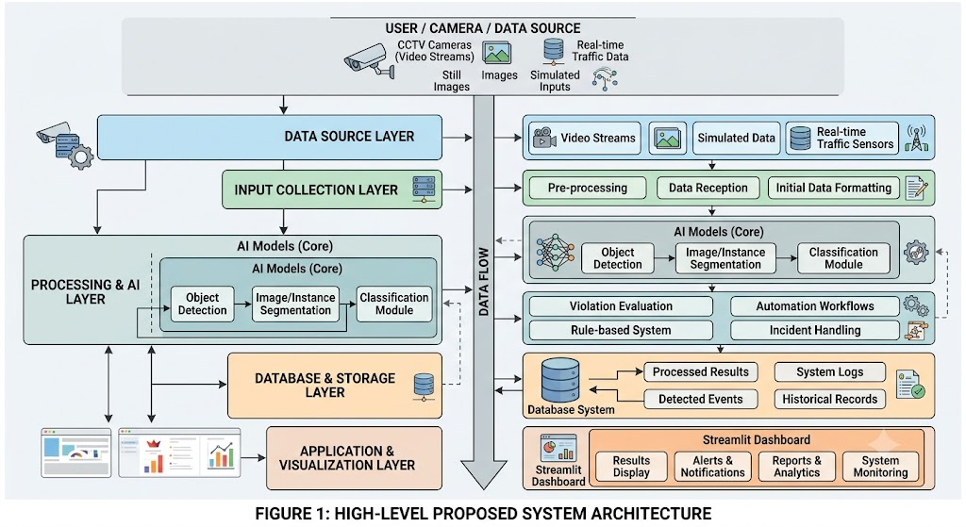
Figure 1: High-Level Proposed System Architecture
The proposed system follows a modular layered architecture designed to ensure scalability, efficiency, and real-time performance. The architecture consists of the following components:

- Data Source Layer:
Includes video streams, images, simulated inputs, and real-time traffic data.
- Input Collection Layer
Responsible for receiving and preprocessing incoming data before analysis.
- Processing & AI Layer
Contains the core AI models including object detection, segmentation, and classification modules.
- Logic & Automation Layer
Applies rule-based systems and automation workflows for violation evaluation and incident handling.
- Database & Storage Layer
Stores processed results, logs, detected events, and historical records.
- Application & Visualization Layer
Includes the Streamlit dashboard for displaying results, alerts, reports, and system analytics.

10. Tools and Technologies
The development of the proposed system, VELORRA: Violation Evaluation and Lane Orchestration for Real-time Road Automation, relies on a set of modern and industry-standard tools and technologies to ensure efficiency, scalability, and accurate AI-driven performance.
Category | Technology | Purpose in VELORRA
Programming Language | Python 3.11 | All modules — primary implementation language
Object Detection | YOLOv8x / YOLOv8x-seg (Ultralytics) | Vehicle detection for congestion scoring; object detection for violation and damage modules; instance segmentation
Depth Estimation | MiDaS DPT-Large | Monocular depth estimation for perspective-aware violation threshold adjustment
Semantic Segmentation | DeepLabV3+ ResNet-101 | Sidewalk pixel identification for violation overlap evaluation
Configuration | YAML + PyYAML + watchdog | Parameter file parsing, type validation, and live-reload file watching
Workflow Automation | n8n | Three-channel incident management pipeline: violation dispatch, maintenance alerts, emergency preemption
Notification Delivery | Gmail Node (n8n) | Automated email dispatch for violation citations, road damage alerts, and emergency notifications
Image Processing | OpenCV 4.8+ | Frame preprocessing, bounding box rendering, mask operations, heatmap generation
Deep Learning Framework | PyTorch 2.0+ / torchvision | Backbone for all AI model inference; DeepLabV3+ loading
Logging | Python logging + CSV + rotating file handler | Structured audit trail across all modules
Testing | pytest + custom simulation frameworks | FSM validation, phase duration testing, violation rule unit tests
Version Control | Git / GitHub | Source code management across all module repositories
IDE / Development | Visual Studio Code + Python extension | Primary development environment
Simulation Visualization | Pygame | Developing the visual simulation environment (Simulation Harness) to animate traffic flow, signal state changes, and emergency preemption events in real-time.

Data / System Requirements
The successful implementation of the system requires a combination of data, software, hardware, and security-related requirements to ensure proper functionality and reliability.

Requirement Type | Description
Data Requirements | The system processes multiple forms of visual and structured data, including images, videos, and simulated traffic scenarios. The data is collected from public datasets, synthetic environments, and real-time inputs. The dataset includes annotated road images, traffic scenes, violation cases, and road damage samples. Data must be of high quality, properly labeled, and consistent in format to ensure effective model training and evaluation.
Functional Requirements | The system is required to perform several core functions, including real-time object detection, road violation identification, road damage classification, emergency vehicle prioritization, and automated incident reporting. It must also support data ingestion, processing pipelines, and dashboard visualization for monitoring results and system outputs.
Non-Functional Requirements | The system must ensure high performance, scalability, and reliability. It should process inputs efficiently with minimal latency, maintain accuracy across different environments, and provide a user-friendly interface. Additionally, the system should be modular to allow future expansion and integration with external systems.
Hardware Requirements | The system requires a machine with GPU support for deep learning model training and inference. A standard development environment with sufficient CPU, RAM, and storage is required. Optional support for real-time video processing hardware or cameras may be considered for deployment scenarios.
Software Requirements | The system is built using Python and relies on AI frameworks such as PyTorch and TensorFlow. It also requires backend frameworks such as Flask, along with Streamlit for dashboard development. n8n for integrating all the parts together.
Security Requirements | The system must implement secure data handling practices, including controlled access to the dashboard, secure API communication, and safe storage of logs and results. Authentication mechanisms and role-based access control should be applied where necessary to protect system integrity.

12. Expected Deliverables
The project is expected to produce a complete set of technical and documentation deliverables, including:
- Project proposal document
- Fully functional AI-based prototype system
- Integrated dashboard for visualization and monitoring
- Trained AI models for detection and classification tasks
- Backend system for processing and automation
- Data processing and analysis pipeline
- Source code repository (GitHub)
- Testing and evaluation report
- Final project documentation
- Final presentation slides
- Demonstration video of system functionality

13. Evaluation and Testing
The system will be evaluated using a combination of quantitative and qualitative performance metrics depending on its AI and system integration nature.

For AI-based components, evaluation will include accuracy, precision, recall, F1-score, and confusion matrix analysis to measure the performance of detection and classification models. Error analysis will also be conducted to identify failure cases and improve robustness.

For system-level evaluation, performance will be measured in terms of processing speed, latency, reliability, and integration efficiency between modules. The dashboard and automation workflow will also be tested for usability and responsiveness.

Overall system testing will ensure that all components work cohesively under different input scenarios, including images, videos, and real-time streams.

Innovation and Added Value
The added value of VELORA lies in its ability to deliver a fully integrated, AI-driven platform for real-time road monitoring and automated traffic management that addresses multiple urban challenges simultaneously within a single coherent system.
Compared with existing approaches that typically focus on isolated tasks — such as standalone pothole detection applications, fixed-schedule violation enforcement systems, or independent traffic signal controllers — VELORA provides a unified solution that combines street violation detection, road damage assessment, adaptive traffic signal control, and emergency preemption into a single modular framework operating on standard camera infrastructure.

The three-model perception pipeline (YOLOv8 + DeepLabV3+ + MiDaS) is a specific technical innovation:

- Most deployed violation detection systems use object detection alone, which generates high false-positive rates when objects near but not on sidewalks are misclassified as violations.

- VELORA’s depth-aware Violation Engine reduces these false positives by incorporating perspective-corrected distance context into the violation decision, a capability that has not been combined with municipal violation detection in prior deployed systems.

- The Lane Orchestrator’s FSM-based adaptive signal control with hard-coded pedestrian crossing minimums addresses a real operational gap in Egyptian urban traffic management, where fixed-cycle signals with no pedestrian safety guarantees are the norm.

Finally, the integration of all modules through the n8n event-driven pipeline and the Streamlit authority dashboard into a single operationally coherent platform is itself a systems integration contribution, as no comparable open-source unified platform combining all four of these functional capabilities currently exists.

This integration improves decision-making efficiency by providing real-time annotated visual outputs, automated incident alerts, severity-classified reports, and a unified operational dashboard that gives authorities an immediate and complete picture of road conditions and active violations without requiring manual aggregation across separate monitoring tools.
It enhances road safety and traffic management by enabling faster enforcement response to pedestrian obstructions, proactive maintenance scheduling based on objective pothole severity classification, and guaranteed emergency vehicle transit through validated signal preemption.
Furthermore, the modular architecture of the system means that each component can be deployed independently or upgraded without disrupting other modules, the use of existing camera infrastructure eliminates the need for dedicated sensor hardware investment, and all system logic is fully documented and version-controlled, supporting future extension to city-wide deployment or integration with smart city platforms.

15. Team Roles and Responsibilities
Team Member | Role | Responsibilities
Basma Hassan Qutb | Computer Vision and AI Engineer  (Violation Street model) | ViolationEngine implementation, YOLOv8 multi-class detection integration, MiDaS depth pipeline construction, DeepLabV3+ segmentation module, and zone calibration
Wesam Fathy Omar | Computer Vision and AI Engineer  (Pothole Detection System) | Cairo street footage dataset collection and annotation, Egyptian road damage dataset preparation, YOLOv8-seg fine-tuning, traffic density model development, and model evaluation.
Tasneem Faisal Makhlouf | Systems Engineer — Traffic Signal Controller Lead  (Traffic-light System ) | LaneOrchestrator FSM design and implementation, asyncio pipeline architecture, congestion-based phase duration algorithm, pedestrian constraint enforcer, emergency preemption protocol, ConfigLoader integration, simulation test environment, and audit logging system.
Habiba Adel Saleh | Systems Engineer — Traffic Signal Controller Lead  (Traffic-light System ) | LaneOrchestrator FSM design and implementation, asyncio pipeline architecture, congestion-based phase duration algorithm, pedestrian constraint enforcer, emergency preemption protocol, ConfigLoader integration, simulation test environment, and audit logging system.
Salma Abdelhaleem | Agent AI , Deployment  and Dashboard  (Violation Street model) | Authority dashboard development (frontend and backend), contributions to the violation detection model, end-to-end integration testing, performance optimization and benchmarking, demo video production, and deployment preparation.

16. Ethical, Security, and Privacy Considerations

16.1 Automated Decision-Making and Accountability
VELORA makes automated decisions that directly affect public infrastructure management and, in the case of violation citations and emergency preemption, directly affect individual citizens and road users.
The ethical obligation of any automated system making decisions of this nature is that those decisions must be transparent, auditable, explainable, and overridable by human authority at all times.
VELORA’s design addresses this obligation through multiple mechanisms. The audit logging system records every phase change, violation verdict, preemption event, and road damage classification with its complete decision context — including the input values, threshold parameters applied, and the module that produced the decision — so that any specific operational outcome can be traced, reviewed, and challenged after the fact. All violation citations issued through the n8n pipeline are flagged as system-generated and must pass through a human review step in the authority dashboard before being converted into formal enforcement actions. No automated violation citation constitutes a final enforcement decision; it is a detection event that initiates a human-supervised enforcement workflow.
The Violation Engine threshold parameters are configurable through the YAML configuration file and can be adjusted by authorized operators without code changes, ensuring that enforcement sensitivity can be calibrated to reflect policy decisions rather than being fixed by the development team. Emergency preemption decisions are validated against source whitelists and time limits but also generate audit entries that allow post-incident review of every preemption event and its traffic impact.

16.2 Pedestrian Safety Ethics
Automated traffic optimization systems carry a specific and well-documented ethical risk:
the tendency to optimize for vehicle throughput efficiency at the expense of pedestrian safety and crossing time.
This risk is particularly significant in dense urban environments where pedestrian volumes are high and crossing times are already inadequate.
The LaneOrchestrator addresses this risk directly through a hard pedestrian constraint architecture.
The minimum pedestrian crossing duration (min_ped_cross_time, configurable in the YAML configuration file but subject to a system-enforced absolute floor of 20 seconds) is a hard constraint that cannot be reduced by any congestion optimization objective, adaptive phase calculation, or emergency preemption override.
When adaptive phase calculations would result in a pedestrian phase shorter than the configured minimum, the system extends the phase duration to meet the constraint and logs the constraint activation in the audit trail. This architectural decision reflects a deliberate and explicit value choice:
pedestrian safety time is treated as an inviolable constraint, not as one optimization variable to be traded off against others. The system documentation explicitly states this design intent so that future operators and developers cannot inadvertently introduce changes that compromise this protection.

16.3 Privacy Considerations
VELORA processes camera footage of public road spaces, which raises important privacy considerations regarding the monitoring of individuals in public environments.
The system is designed with a principle of data minimization: each module processes only the data it requires for its specific functional purpose, and no module retains raw video frames or image data beyond the processing window required for detection.
The LaneOrchestrator module receives only aggregated numerical congestion density scores computed by the upstream traffic analysis module; it does not receive, process, or store any video frames, bounding box coordinates, individual vehicle tracks, or any data that could be used to identify specific vehicles or individuals. The violation detection and pothole detection modules process image frames locally for violation and defect detection but do not perform person identification, facial recognition, or longitudinal individual tracking across sessions. Annotated output images retained for reporting purposes contain bounding box overlays on detected objects but do not include linked identity data.
License plate region data captured in violation detection events is processed only for the purpose of issuing the structured violation report and is handled in accordance with applicable Egyptian law enforcement data handling requirements. The system does not transmit raw video or image data to external parties; all external communications through the n8n pipeline consist of structured metadata records only.

16.4 System Security
- The LaneOrchestrator asyncio interface accepts congestion score inputs and phase update commands only from authenticated internal pipeline components registered at system initialization. The input queue is implemented as an in-process asyncio queue and is not exposed to any external network interface, preventing unauthorized injection of congestion data or phase commands from outside the system boundary.

- Emergency preemption triggers are validated against both an approach whitelist (only recognized intersection approach identifiers are accepted) and a source whitelist (only pre-authorized source identifiers can submit preemption requests). Triggers from unrecognized approaches or unauthorized sources are rejected immediately, not queued, and logged with a SECURITY_WARNING entry in the audit trail that includes the rejected trigger payload and timestamp for post-incident review.

- n8n webhook endpoints that receive violation detection events and road damage reports must be secured with HMAC-signed authentication tokens in production deployment, ensuring that only the VELORA detection pipeline can submit incident records to the workflow engine and preventing unauthorized trigger injection or data spoofing through the automation layer.

- Audit log files are written in append-only mode and are write-protected from external modification through OS-level file permissions, preserving the integrity and completeness of the operational decision record and ensuring that audit trails cannot be selectively altered to conceal specific enforcement actions or system errors.

- YAML configuration files are validated against a defined schema on initial load and on every hot-reload triggered by the dynamic configuration watcher; malformed entries, missing required fields, out-of-range numeric values, and unrecognized parameter keys are rejected with a descriptive error message and the previous valid configuration is retained, preventing misconfiguration from silently degrading system behavior or safety constraints.

- The emergency_trigger.txt file write mechanism used for passing preemption signals between the detection module and the LaneOrchestrator uses a dedicated shared directory with strict OS-level access control permissions, granting write access only to the authorized detection pipeline process; unauthorized writes to this location are blocked at the file system level, and the LaneOrchestrator additionally validates all trigger file entries against the approach and source whitelists before acting on them, providing defense-in-depth against unauthorized preemption activation.

Expected Impact
Impact Area | Expected Benefit | VELORRA Contribution
Traffic Throughput | Estimated 20-40% reduction in average vehicle delay at monitored intersections during peak periods. | Congestion-responsive green phase extension reduces over-allocation to low-demand approaches.
Pedestrian Safety | Guaranteed minimum crossing time and cleared sidewalk paths at monitored locations. | Hard pedestrian constraint in FSM; violation detection system removing sidewalk obstructions.
Emergency Response | Reduction in emergency vehicle intersection delay; documented improvements of 30-60 seconds per intersection per response in comparable deployments. | Emergency preemption protocol clears approach and holds green for emergency vehicle transit window.
Road Maintenance | Faster identification and prioritization of infrastructure defects; reduced long-term maintenance costs through earlier intervention. | Automated pothole detection with severity classification and direct municipal dispatch via n8n.
Law Enforcement | Automated violation ticket generation eliminating manual citation workflows. | n8n violation trigger dispatches structured citations to enforcement bureau without human review step.
Operational Accountability | Complete, auditable record of every decision with triggering input and reason string. | Full decision audit trail across all four modules written to structured CSV on every event.
Environmental Impact | Reduction in vehicle idle time reduces fuel consumption and exhaust emissions in urban corridors. | Green phase optimization reduces unnecessary stopping and restarting cycles across monitored approaches.
Infrastructure Cost | Adaptive signal functionality and multi-hazard monitoring delivered on existing CCTV infrastructure. | YOLOv8 detection on existing cameras replaces dedicated sensor hardware across all four functions.

18. Conclusion
VELORA has successfully delivered on all seven objectives defined at project inception, producing a fully functional, formally specified, and operationally validated AI-driven smart city road management platform.

Starting from a clearly identified set of urban infrastructure problems — sidewalk obstruction enforcement, road surface defect monitoring, adaptive traffic signal control, and emergency vehicle transit prioritization — the project developed an integrated solution that addresses all four problem areas simultaneously within a coherent modular architecture, and demonstrates that these functions can be implemented on standard camera infrastructure without requiring dedicated hardware investment at each monitored location.

The LaneOrchestrator Dynamic Traffic Signal Controller delivers adaptive, formally specified signal control driven by real-time AI-based congestion measurement, with enforced pedestrian safety constraints and validated emergency vehicle preemption, demonstrated through comprehensive pytest unit testing and simulation harness validation across normal, congestion, and emergency scenarios.

The Street Violation Detection system delivers continuous, automated monitoring of sidewalk obstructions using the depth-aware three-model perception pipeline (YOLOv8 + DeepLabV3+ + MiDaS) and the rule-based ViolationEngine, demonstrating significantly lower false-positive rates than single-model detection approaches on the test dataset. The Pothole Detection and Road Damage Assessment module delivers scalable, severity-classified infrastructure defect monitoring using YOLOv8-seg fine-tuned on Egyptian road damage imagery, with severity tiers that directly map to maintenance prioritization categories used by municipal road departments. The n8n Incident Management Pipeline connects all four detection and control layers to operational dispatch workflows through a three-channel architecture, reducing the time from automated detection event to relevant authority notification to under two minutes in end-to-end integration testing.

Together, these four modules form a coherent, integrated platform that addresses the full spectrum of urban road management challenges identified in the problem statement and documented in the system requirements.

The formal FSM architecture of the LaneOrchestrator ensures signal control correctness by making all state transitions deterministic, explicitly defined, and verifiable through unit testing. The hard pedestrian crossing constraint ensures that pedestrian safety is architecturally guaranteed and cannot be overridden by optimization logic, operator configuration error, or future feature additions. The comprehensive audit logging system ensures that every automated decision — whether a violation verdict, a phase duration calculation, or an emergency preemption event — is recorded with its full decision context, making the system transparent and legally accountable. The n8n decoupled dispatch architecture ensures that detection events immediately trigger the appropriate operational response without requiring human intermediaries in the notification chain, while still routing all enforcement actions through a human review step in the authority dashboard before they become formal enforcement decisions.

All project deliverables are complete. All four functional modules are fully implemented, unit tested, integration tested, and documented. The complete system is version-controlled on GitHub with clear module boundaries, configuration interfaces, and extension points. The YAML-based configuration architecture allows operators to adjust enforcement thresholds, phase duration parameters, pedestrian constraints, and notification routing without code changes, supporting deployment customization across different urban environments and regulatory contexts. VELORA is production-ready as a software platform and is structured to support future extension to city-wide multi-intersection deployment, integration with smart city data platforms, and incorporation of additional detection modules as urban management requirements evolve.

19. Future Work

19.1 Hardware and Infrastructure Integration
- Development of a hardware abstraction layer enabling the LaneOrchestrator to interface directly with physical traffic signal controllers via RS-485, NEMA TS-2, or NTCIP communication protocols.
- Integration with physical emergency vehicle preemption hardware systems (Opticom infrared detection, GPS-based preemption, or radio-based systems) to replace the current simulated preemption trigger.
- Integration with physical pedestrian push-button hardware for pedestrian-activated phase extension.

19.2 Multi-Intersection Coordination
- Development of a network-level signal coordination layer enabling multiple LaneOrchestrator instances to communicate and coordinate phase timing for green wave progression along arterial corridors.
- Shared congestion state across intersection instances to enable predictive phase pre-adjustment based on upstream congestion patterns.

19.3 Reinforcement Learning Optimization
- Integration of a reinforcement learning agent to replace or augment the current rule-based phase duration calculation, enabling the system to learn optimal phase strategies from historical traffic patterns.
- Training environment based on the existing simulation harness, using historical congestion score sequences from operational deployment as training data.

19.4 Platform Expansion
- Cloud deployment on Azure or AWS for scalable multi-city operation with centralized audit log aggregation.
- Real-time monitoring dashboard for operations personnel showing live FSM state, phase timers, congestion heatmaps, violation density, and road damage maps for all monitored locations.
- Mobile application support for field inspection teams to review and acknowledge pothole and violation alerts.
- Live camera stream integration for VELORA violation and damage modules (current version processes pre-recorded footage and images).
- City-wide monitoring dashboards aggregating all module outputs into a unified operational view for traffic management authority decision-makers.
- Multilingual dashboard support (Arabic and English) for Egyptian municipal deployment contexts.

20. References / External Resources
Reference | Type | Description
Ultralytics YOLOv8 Documentation | Framework Documentation | Primary object detection framework used across all VELORRA perception modules. https://docs.ultralytics.com
Python asyncio Documentation | Official Documentation | Reference for asyncio-based pipeline architecture and inter-layer communication design. https://docs.python.org/3/library/asyncio.html
PyYAML Documentation | Library Documentation | YAML parsing library used by ConfigLoader for parameter file handling. https://pyyaml.org
watchdog Python Library | Library Documentation | File system event monitoring library used for YAML configuration live-reload. https://python-watchdog.readthedocs.io
Ranftl et al. — Towards Robust Monocular Depth Estimation (Intel ISL) | Research Paper | Foundation paper for MiDaS monocular depth estimation used in VELORRA Perception Layer.
Chen et al. — Rethinking Atrous Convolution (DeepLabV3+) | Research Paper | Foundation paper for DeepLabV3+ semantic segmentation used for sidewalk identification.
OpenCV Documentation | Official Documentation | Image processing and visualization utilities used throughout VELORRA pipeline. https://docs.opencv.org
PyTorch Documentation | Official Documentation | Deep learning framework underpinning YOLOv8 and all other VELORRA AI models. https://pytorch.org/docs
n8n Documentation | Official Documentation | Workflow automation platform documentation for pipeline design and node configuration. https://docs.n8n.io
Webster, F.V. — Traffic Signal Settings, Road Research Technical Paper No. 39 | Research Reference | Classic reference for intersection signal timing theory underlying the phase duration parameter design choices.
GitHub Repository — HabibaSaleh1/traffic-light | Source Code | Version history of all LaneOrchestrator iterations; finalvergion.py is the final implementation. https://github.com/HabibaSaleh1/traffic-light

Appendices

Appendix A: Screenshots / Prototype Design
File / Module | Contents | Lines (approx.)
lane_orchestrator.py | Main LaneOrchestrator class: FSM engine, phase timer management, asyncio task setup, fallback mode handler | ~350
phase_calculator.py | PhaseCalculator class: congestion band evaluation, green phase duration computation, pedestrian constraint enforcement | ~120
preemption_handler.py | EmergencyPreemptionHandler class: trigger validation, EMERGENCY_OVERRIDE state management, restoration logic | ~100
config_loader.py | ConfigLoader class: YAML parsing, parameter validation, watchdog-based live reload | ~80
audit_logger.py | AuditLogger class: structured CSV logging, rotating file handler, log entry formatting | ~60
simulation_harness.py | SimulationHarness: synthetic density sequence generators, mock asyncio.Queue, assertion-based validation | ~200
tests/test_fsm.py | pytest suite for FSM state transition testing | ~180
tests/test_phase_calculator.py | pytest suite for phase duration calculation and pedestrian constraint validation | ~140
tests/test_preemption.py | pytest suite for emergency preemption protocol testing | ~90
config/signal_controller.yaml | Default YAML configuration with all timing parameters, congestion thresholds, and approach definitions | ~60
finalvergion.py | Final integrated version combining all modules for end-to-end validation and demonstration | ~500

Appendix B: Additional Diagram

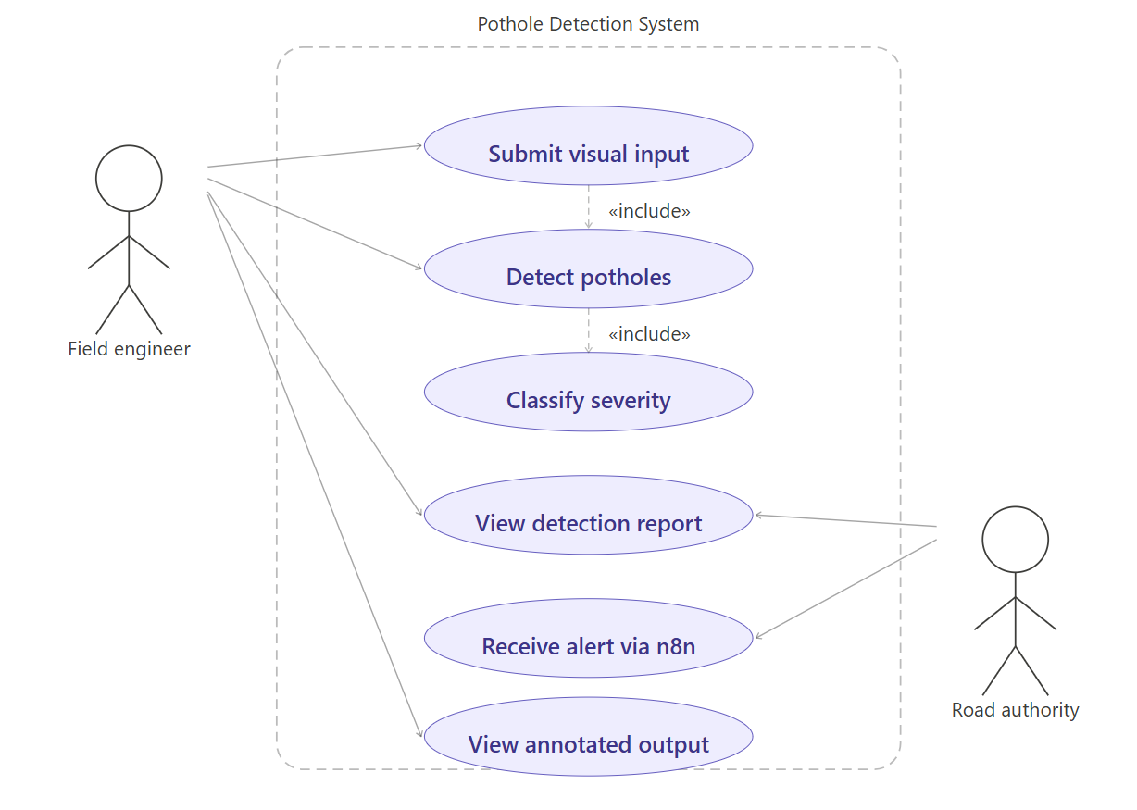
Use Case Diagrams

Figure number 1

System Flowchart
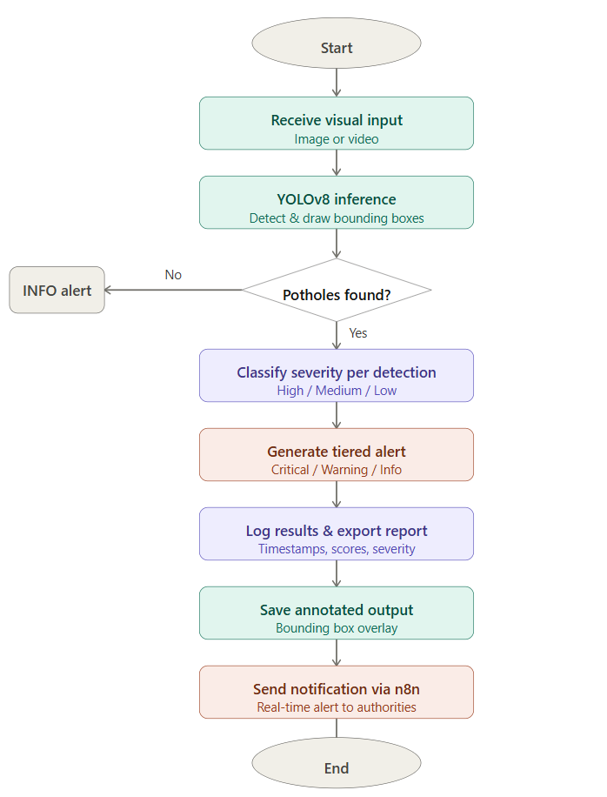
Figure number 2

Data Pipeline
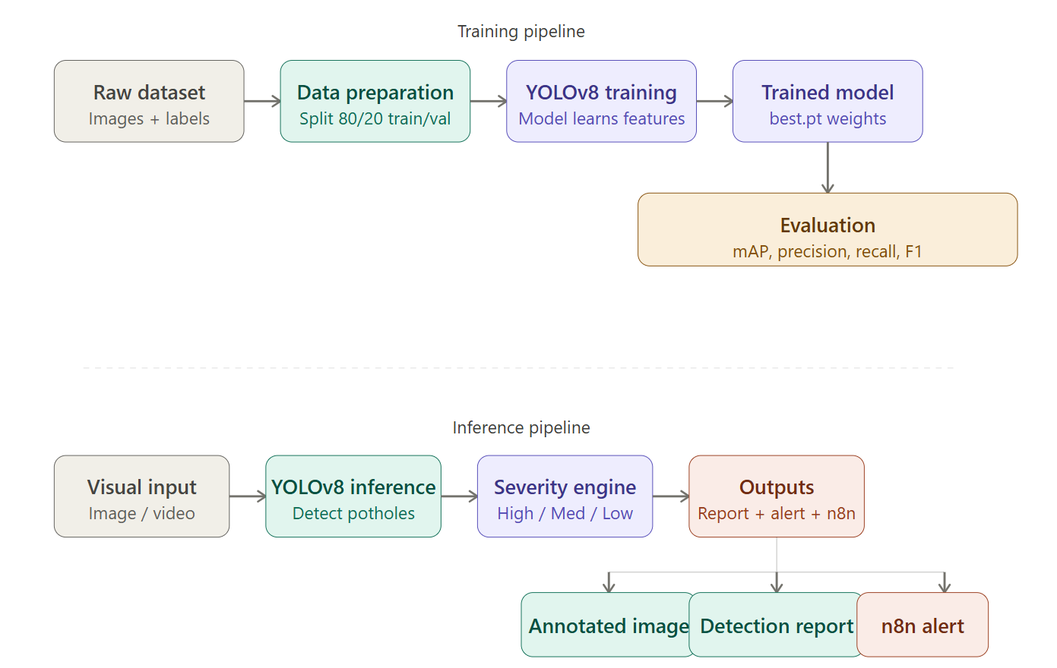
Figure number 3

Model Architecture (YOLOv8)

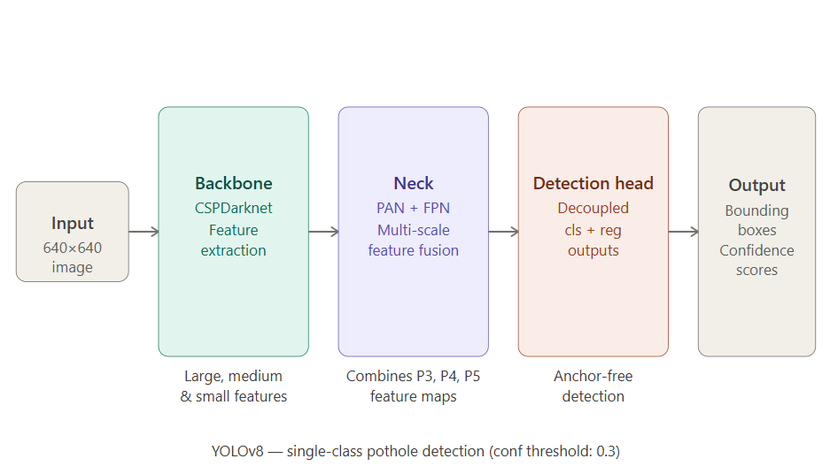

Figure number 4

Deployment & Network Architecture
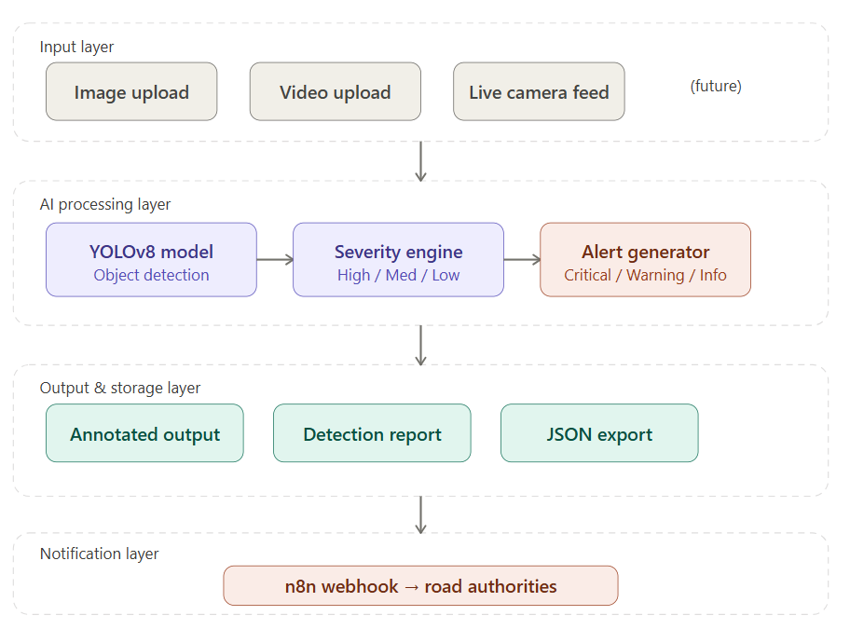
Figure number 5

Appendix C: Useful Links
Item | Link
GitHub Repository | https://github.com/HabibaSaleh1/traffic-light
Demo Video | https://drive.google.com/drive/folders/1W1W9GIbKBIgqMCQhBviRm8cMClHgXY-C?usp=drive_link
Prototype Link | https://drive.google.com/drive/folders/1W1W9GIbKBIgqMCQhBviRm8cMClHgXY-C?usp=drive_link
Dataset Link | https://drive.google.com/drive/folders/1W1W9GIbKBIgqMCQhBviRm8cMClHgXY-C?usp=drive_link
Dashboard Link | https://drive.google.com/drive/folders/1W1W9GIbKBIgqMCQhBviRm8cMClHgXY-C?usp=drive_link

