
Data mining project report
Instructor : Dr. Ashraf saeed
TA : Eng. Rowan

Student name : Tasneem Ibrahim Hassan
Rana Ehab Mahmoud sakr
Marc Ehab Edourd
Mortada Mohamed Mortada
Student’s ID : 22101382
22100784
22100908
Faculty : Computer science and engineering (CSE)
Level : Three Semester : Fall 2025
Course name : Data Mining Course code : AIE323

- Dimensions tables steps
- Customer :
For The Customer table we noticed that this table doesn’t need to drop or generate any table we just needed to split the null instances that found in the excel sheet so we first create a table in the database SSMS and we connected it to the vs and take the source excel in vs and we chose the product file from it and map the attributes in it to the attributes in the DB table then take it to a split function to remove null instances then map it to the data warehouse (OLAB).
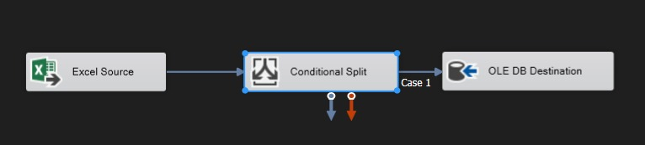
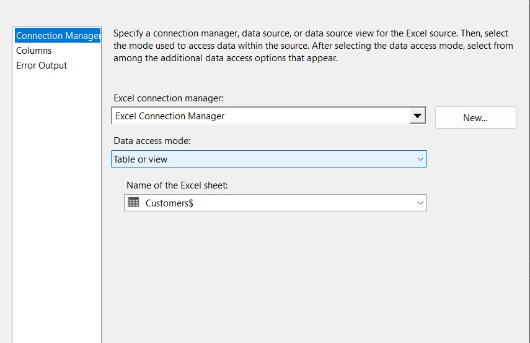
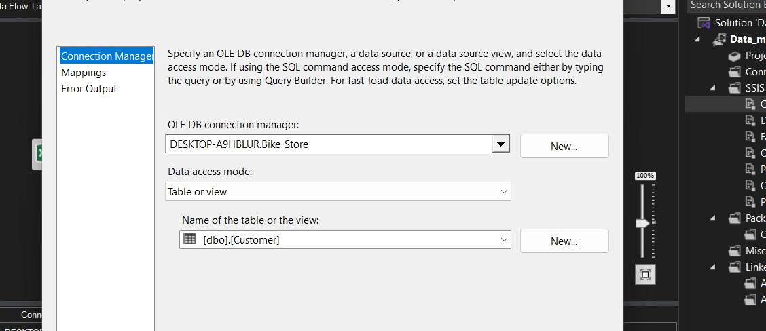
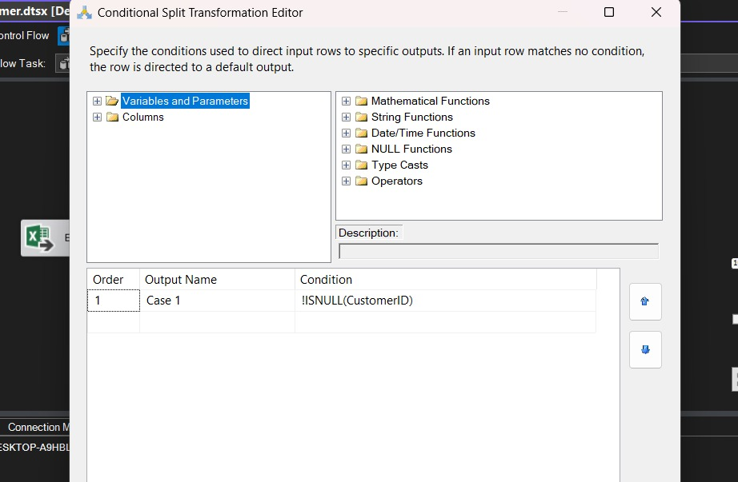
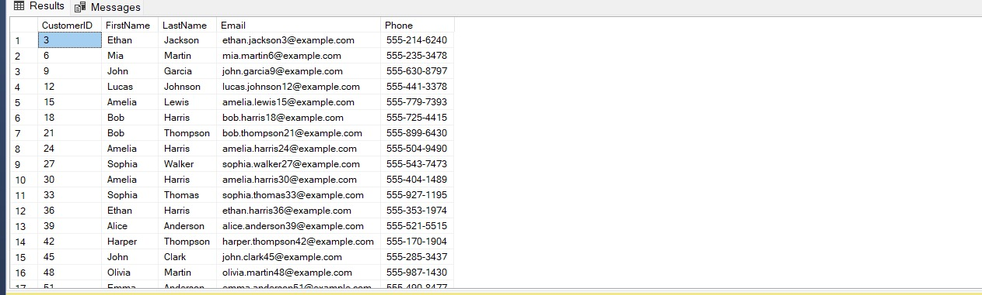

- Product :
For The product table we noticed that this table doesn’t need to drop or generate any table we just needed to split the null instances that found in the excel sheet so we first create a table in the database SSMS and we connected it to the vs and take the source excel in vs and we chose the product file from it and map the attributes in it to the attributes in the DB table then take it to a split function to remove null instances then map it to the data warehouse (OLAB).
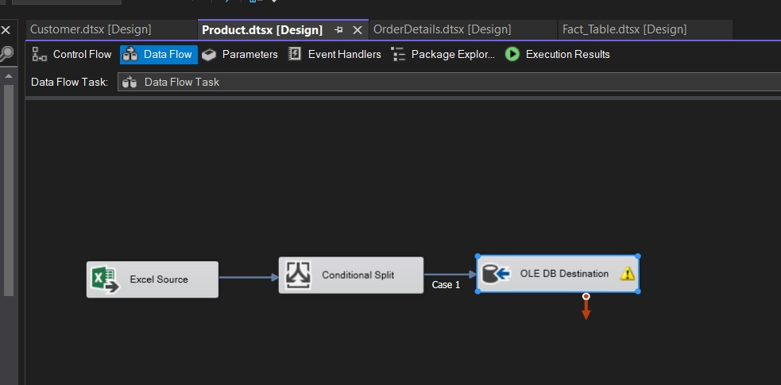
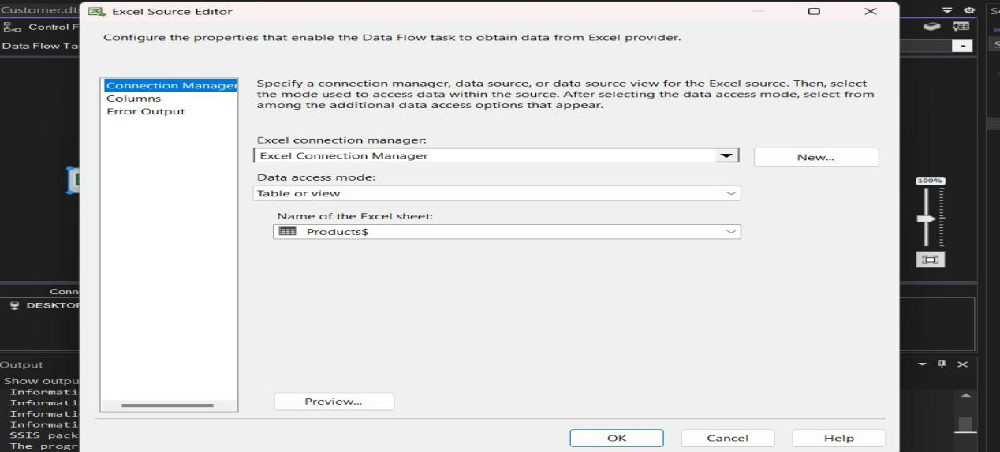
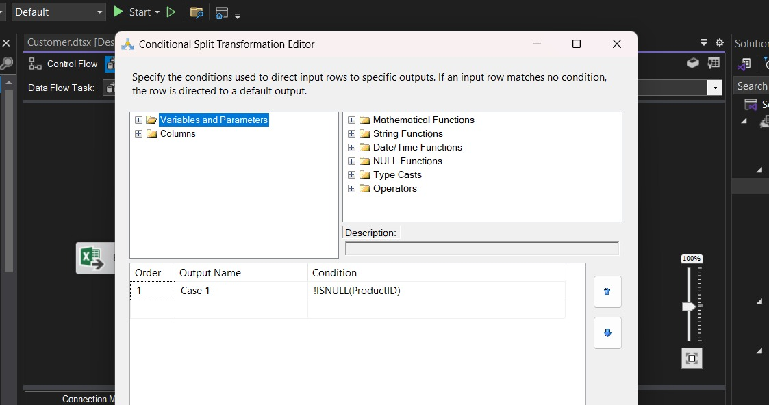
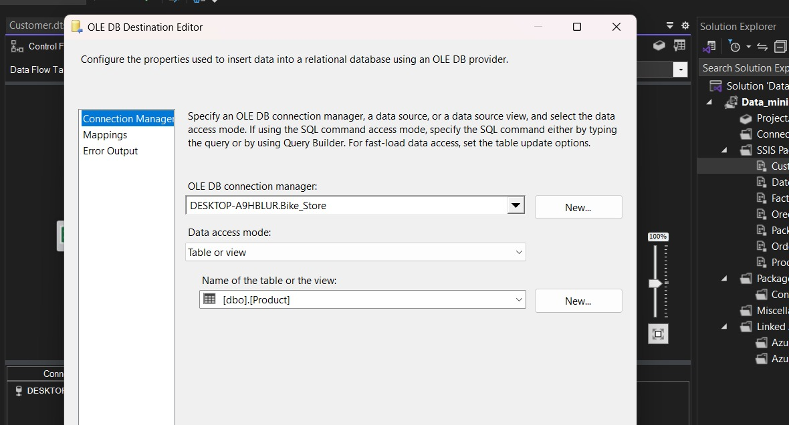
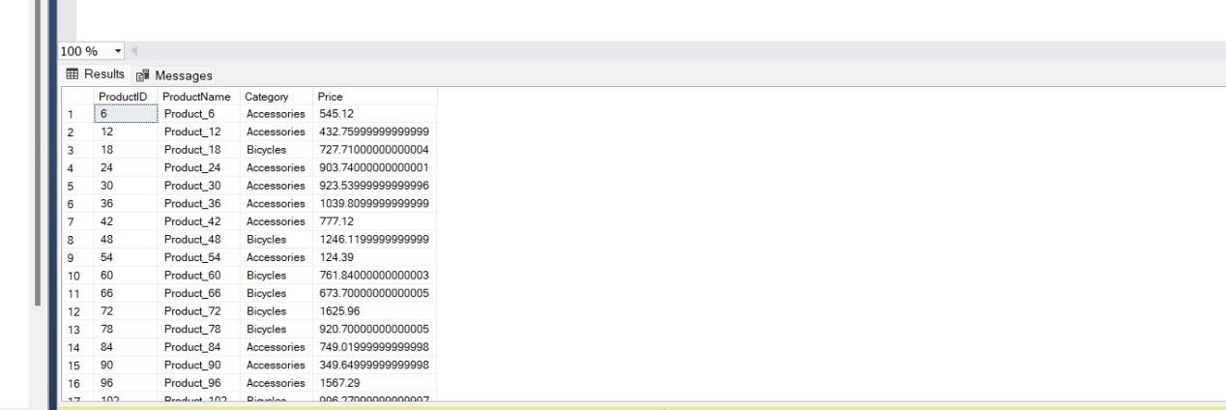

- Date :
in the table date we take order date column from orders table then we introduce it a split function that removes the instances that is null from our column and we removed the duplicate from it using the sort method that also sort the dates then we used the script component and we write a small code in it that just increment the variable we previously created that refers to the date_id then we mapped those 2 columns to a destination warehouse.
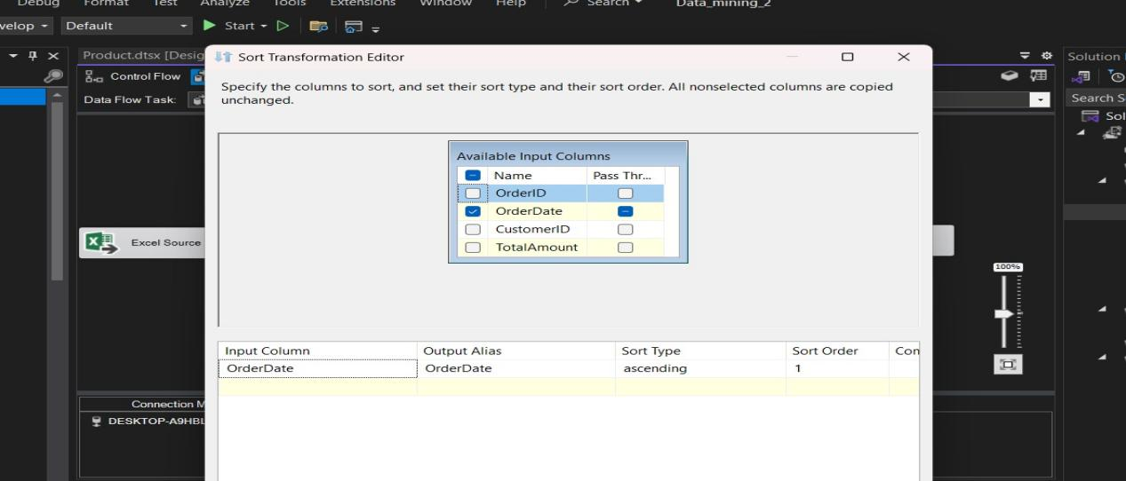
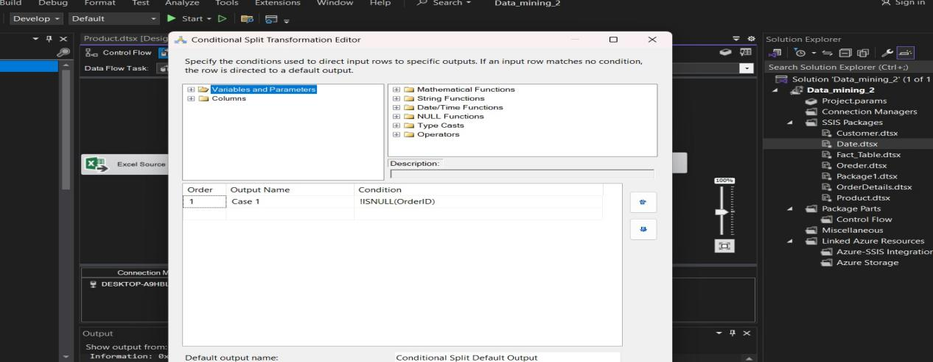
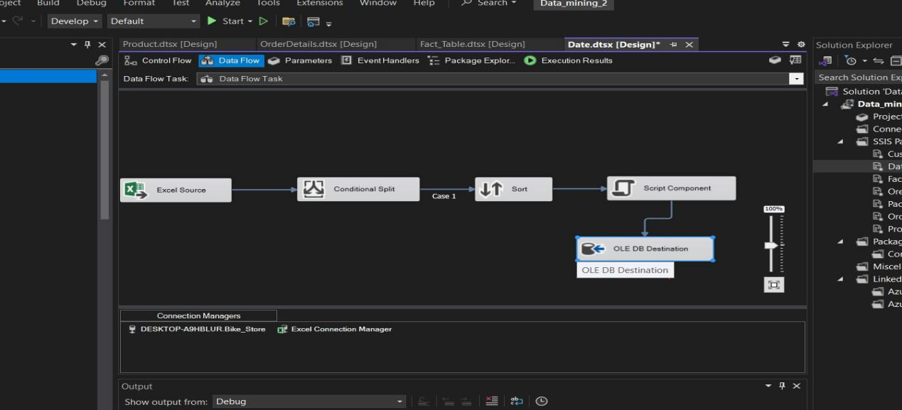
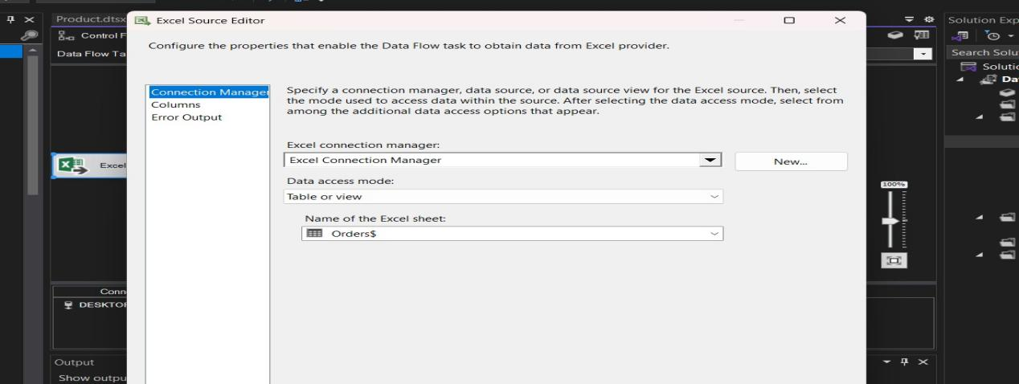
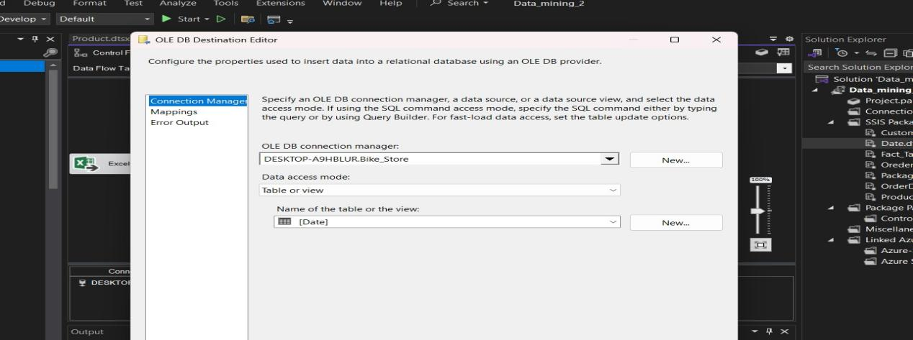
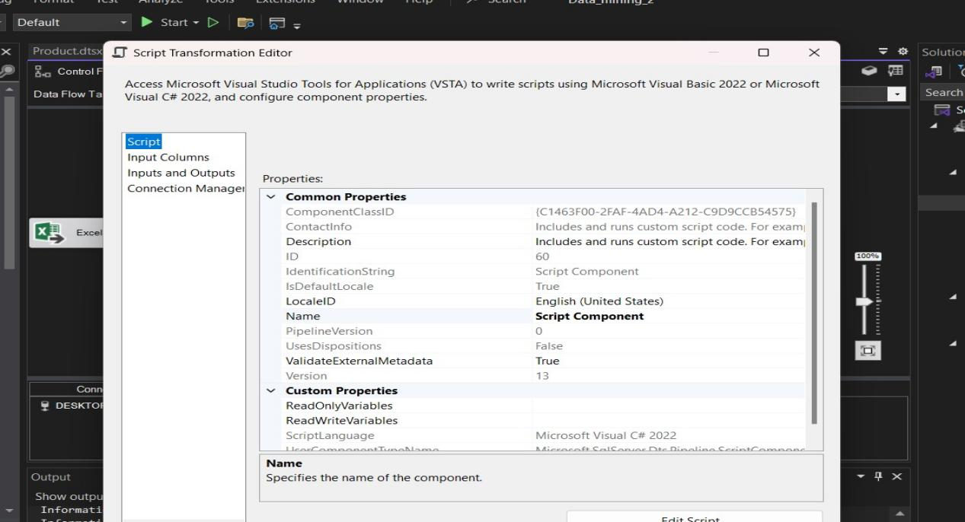
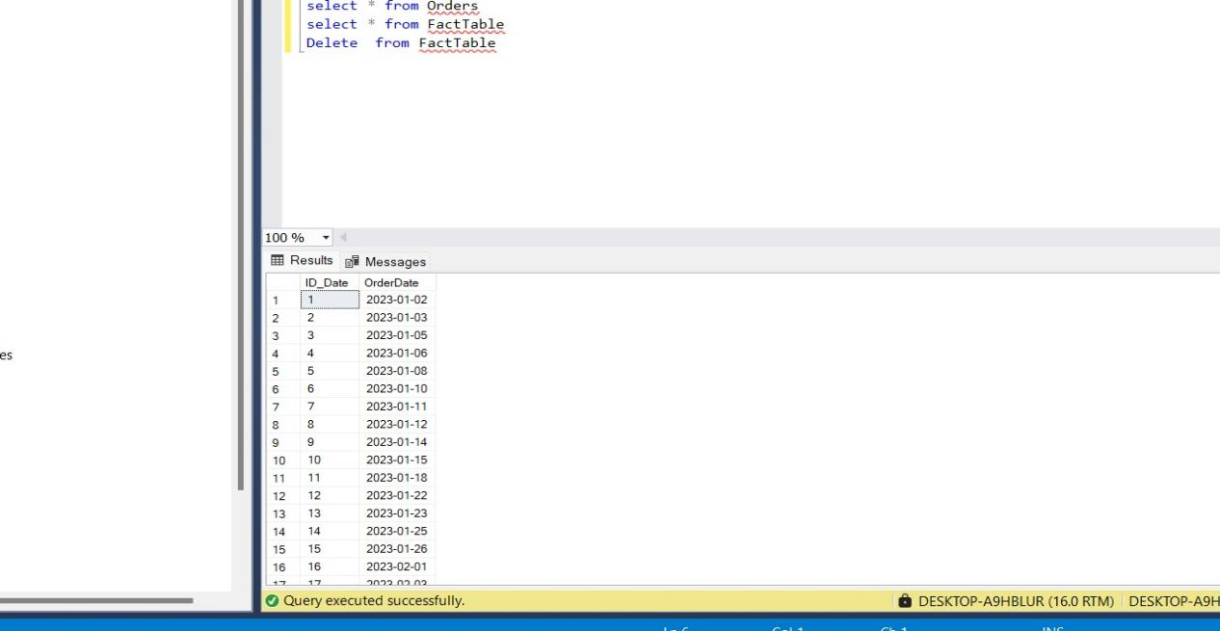

- Orders :
For The Orders table we noticed that from this table we need to only select customer id and remove the duplicates from it before mapping it to the warehouse so we start to create the table in the data base SSMS but just added the column we needed (order date) then at the vs we take a source excel sheet and map the attribute we take to the order date then we take the function split to split the nulls of the excel sheet then we take a function sort that sort the dates and remove the duplication then we create an variable Id_date then we write code script in the component script to auto increment this id then we map the output to the warehouse.

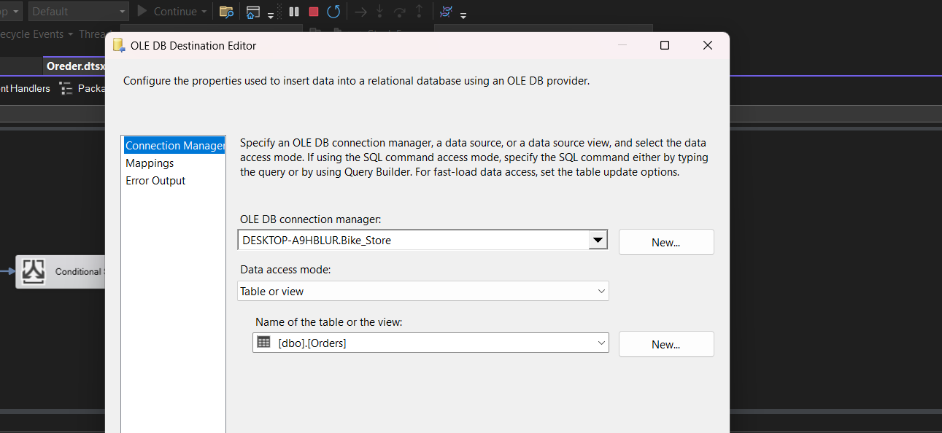
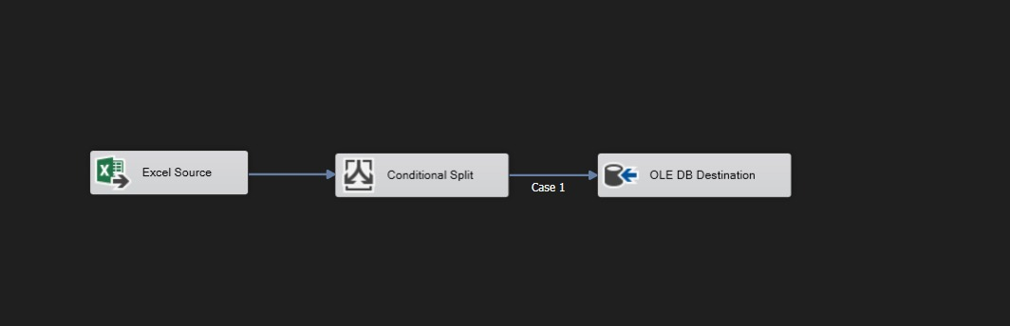
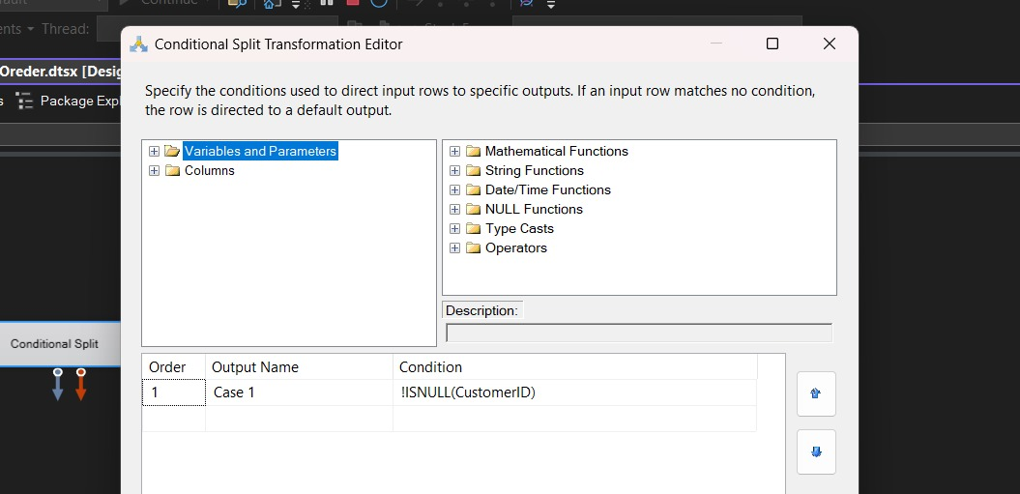
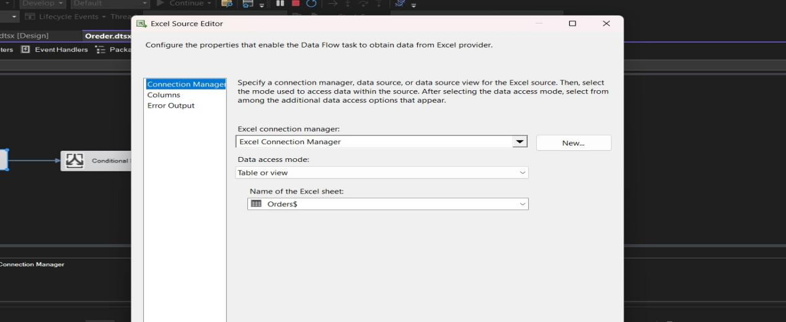

- OrderDetails :

- Fact table :
At first we took 2 warehouses that we previously created one of orders and the other is order details then we sort them using function sort and merge them using function merge join then map the output to the warehouse destination fact table
