A Real-Time Intelligent Surveillance System for Video Anomaly Detection Using Two-Stream Deep Learning Fusion and Vision Transformers
^{1*}Mohamed Ahmed, ²Abdullah AbdalGawad, ³Ahmed Mostafa, ⁴Omnia Adel, ⁵Khalid Abdelsalam, ⁶Tasneem Ibrahim, ⁷Mariam Elrafei, ⁸Essam Abdellatef

Faculty of Computer Science and Engineering, Alamein International University, New Alamein City, Matruh, Egypt
1. mohamed.hassonah.2023@aiu.edu.eg
2. ahmed.darwish.2023@Aiu.edu.egg
3. abdullah.fathallah.2023@aiu.edu.e
4. omnia.abuzaid.2023@Aiu.edu.eg
5. Khalid.abdalsamad.2023@aiu.edu.eg
6. tasneem.mohamed.2023@Aiu.edu.eg
7.Mariam.abdelfttah.2023@Aiu.edu.eg
8. eabdellatef@Aiu.edu.eg

ABSTRACT
Abstract—Surveillance camera networks have become a ubiquitous component of modern urban infrastructure; however, the analytical value of the vast majority of footage produced by such systems remains unrealized. This paper presents SecureSight, an intelligent real-time video surveillance framework designed to close this gap through automated multi-class anomaly detection and role-specific alert routing to relevant emergency response authorities. The core detection engine employs a two-stream parallel architecture: a ResNet-50 spatial branch that processes individual frames to capture fine-grained appearance features, and an R(2+1)D temporal branch that processes short video clips to model complex motion dynamics. The outputs of these two complementary streams are fused and subsequently processed by a compact Vision Transformer (ViT) encoder, which captures long-range temporal dependencies across consecutive clip-level feature sequences. The system is trained on the UCF-Crime dataset using official temporal annotations, a design decision that elevated validation accuracy from approximately 58% to over 75%—representing the single most impactful improvement across the entirety of the development process. A structured comparative experiment involving five nature-inspired meta-heuristic hyperparameter optimizers—Particle Swarm Optimization (PSO), Grey Wolf Optimization (GWO), Spider Monkey Optimization (SMO), the Shuffled Frog Leaping Algorithm (SFLA), and Harris Hawks Optimization (HHO)—revealed that none of these automated methods surpassed the manually tuned configuration, a finding that is reported transparently. On the deployment side, SecureSight encapsulates the inference model within a Flask server utilized strictly for testing and integration validation purposes, routes confirmed anomaly alerts over MQTT to role-differentiated subscriber dashboards for police, hospital, and firefighter services, and maintains a local offline buffer to ensure alert continuity during network interruptions. The full system achieves 74.3% top-1 classification accuracy on the 14-class UCF-Crime benchmark, with a mean Area Under the ROC Curve (AUC) of 0.89 across all anomaly categories, thereby demonstrating that the construction of a research prototype into a genuinely operational surveillance tool demands rigorous systems engineering in parallel with machine learning expertise.
Index Terms—video anomaly detection, intelligent surveillance, Vision Transformer, two-stream architecture, R(2+1)D, ResNet-50, UCF-Crime dataset, MQTT, real-time alert systems, meta-heuristic optimization.
1. INTRODUCTION
There is something almost paradoxical about modern surveillance infrastructure. Cities around the world have invested heavily in camera networks—IHS Markit estimated the global installed base would exceed one billion units by 2025 [1]—and yet the overwhelming majority of the footage captured by those cameras is never reviewed. Human operators watching live feeds face well-documented attentional limits [2]; studies on vigilance tasks consistently show that detection performance degrades within thirty minutes of sustained monitoring. The cameras see everything, but the system as a whole understands almost nothing in real time.
Deep learning has changed what is technically possible here. Convolutional networks have demonstrated strong performance on action recognition for over a decade, and more recently, Transformer-based architectures have shown that attending to long-range temporal context can push accuracy substantially further on video understanding benchmarks. But raw classification accuracy on a held-out test set is only part of the challenge. A system that achieves 80% accuracy but introduces a three-second alert delay, silently drops messages during a network outage, or floods police dispatch with unfiltered false positives is not a useful system, regardless of its F1 score.
SecureSight was built with both sets of requirements in mind. On the model side, we designed a two-stream fusion architecture that processes spatial and motion information in parallel, then applies a Vision Transformer to reason over sequences of fused clip-level features. On the systems side, we built a Flask-based inference server, an MQTT alert bus, an offline-resilient message buffer, and role-differentiated Streamlit dashboards that give police, hospital, and firefighter teams a clean interface to incoming anomaly notifications.
The contributions of this work can be summarized as follows. First, we propose a complete two-stream plus ViT fusion architecture for multi-class video anomaly detection and evaluate it thoroughly on the UCF-Crime dataset. Second, we demonstrate empirically that adopting official temporal annotations is far more impactful than any of the architectural changes we tried, a finding we think has practical implications for how practitioners prioritize their effort. Third, we report a systematic negative result: five meta-heuristic optimizers, each given a budget of fifty evaluation rounds on the ViT hyperparameter search space, all failed to improve over a hand-tuned baseline. Fourth, we describe a production-grade deployment architecture that addresses alert latency, offline resilience, and multi-stakeholder routing in a unified design.
The remainder of this paper is organized as follows: A literature review of video anomaly detection and deep learning approaches is discussed in Section 2. Section 3 is concerned with the description of the proposed framework, detailing both the two-stream Vision Transformer architecture and the deployment infrastructure. Section 4 explores and discusses the experimental results on the real-world UCF-Crime dataset, including our findings on temporal annotations and meta-heuristic optimizers. Finally, the paper is concluded in Section 5.

2. RELATED WORK
A. Anomaly Detection in Surveillance Video
Early approaches to automated video anomaly detection were predominantly reconstruction-based. The underlying rationale is that an autoencoder trained exclusively on normal video footage will exhibit elevated reconstruction error when presented with anomalous events. Hasan et al. [3] demonstrated this paradigm using a convolutional autoencoder on several benchmark datasets, achieving competitive performance with substantially reduced labeling requirements relative to fully supervised approaches. A well-documented limitation of this methodology, however, is that autoencoders trained on sufficiently diverse normal data can, under certain conditions, reconstruct anomalous events with comparable fidelity, thereby attenuating the reconstruction-error discriminative signal.
A pivotal shift in the field was introduced by Sultani et al. [4], who reformulated anomaly detection as a weakly supervised multiple-instance learning (MIL) problem and released the UCF-Crime dataset to support this paradigm. Rather than requiring frame-level annotations, the MIL framework treats each video as a bag of temporal segments and trains a ranking model to assign higher anomaly scores to segments from anomalous videos than to those from normal videos. The UCF-Crime dataset—comprising 128 hours of authentic surveillance footage across 13 crime categories—rapidly became the de facto community benchmark and retains that status.
Subsequent research has refined the MIL framework in various directions. Zhong et al. [5] introduced a graph convolutional network to model inter-segment relationships during training, improving discriminability near decision boundaries. Tian et al. [7] proposed a multi-sequence learning framework employing bidirectional long short-term memory (LSTM) networks to capture temporal dependencies at multiple scales. Memory-augmented networks [6] have been applied to explicitly model the distribution of normal behavior in a learned external memory, flagging deviations from stored prototypical representations rather than relying on reconstruction-based error signals.
B. Transformer Architectures for Video
The publication of the Vision Transformer (ViT) [8] in 2021 motivated an extensive body of work applying attention-based architectures to video understanding tasks. ViViT [9] extended the patch-based tokenization scheme to spatiotemporal volumes and introduced factorized attention mechanisms to maintain computational tractability. TimeSformer [10] explored a divided-space-time attention design that decouples spatial and temporal attention heads across Transformer layers, achieving competitive results at considerably lower training cost. These contributions collectively established that Transformer architectures can capture temporal structure in video that convolutional networks with limited receptive fields inherently miss, thereby motivating the adoption of a ViT-based module operating over sequences of fused clip-level features in the present work.
C. Two-Stream Networks
Two-stream processing for video was established as a powerful paradigm by Simonyan and Zisserman [11], who demonstrated that combining a spatial stream processing individual frames with a temporal stream processing dense optical flow substantially outperformed either modality in isolation on action recognition benchmarks. Carreira and Zisserman [12] subsequently demonstrated that inflating 2D convolutional filters to 3D and pre-training on the large-scale Kinetics dataset produced transferable representations that generalized effectively across a broad range of downstream video understanding tasks. Tran et al. [13] proposed R(2+1)D, which decomposes full 3D convolutions into separate 2D spatial and 1D temporal operations. This factorization achieves a favorable trade-off between model capacity and computational efficiency, and constitutes the foundation of the temporal stream employed in SecureSight.
D. Meta-Heuristic Optimization for Neural Networks
Population-based optimization algorithms have attracted interest as gradient-free alternatives for hyperparameter tuning, particularly in settings where the loss landscape is non-differentiable or evaluation is computationally expensive. PSO [15] and GWO [16] have been applied to neural architecture search and to the selection of learning rates and regularization coefficients. The empirical evidence regarding whether these methods offer a practical advantage over simpler strategies such as random search [17] is mixed. Bergstra and Bengio demonstrated that random search explores the hyperparameter space more efficiently than grid search for most neural network configurations, and more recent Bayesian optimization approaches generally outperform both. Meta-heuristic experiments are included in the present work to generate honest empirical evidence regarding their utility in the specific context of deep video anomaly detection, rather than based on a prior expectation of success.

Declarations
Conflict of Interest and Authorship The authors have no affiliation with any organization with a direct or indirect financial interest in the subject matter discussed in the manuscript.
Ethics Approval and Consent to Participate This study has not used any human data sourced from other than open-sourced datasets. So, the research adheres to ethical guidelines and no violations of ethical standards were noted during the study.
Funding None of the authors have any financial interests, including employment, consultancies, stock ownership, or honoraria, that could be perceived as influencing the research presented in this manuscript.
Data Availability Statement The UCF-Crime Dataset analyzed during the current study is available in the following repository: https://www.crcv.ucf.edu/projects/real-world/

3. DATASET AND PREPROCESSING
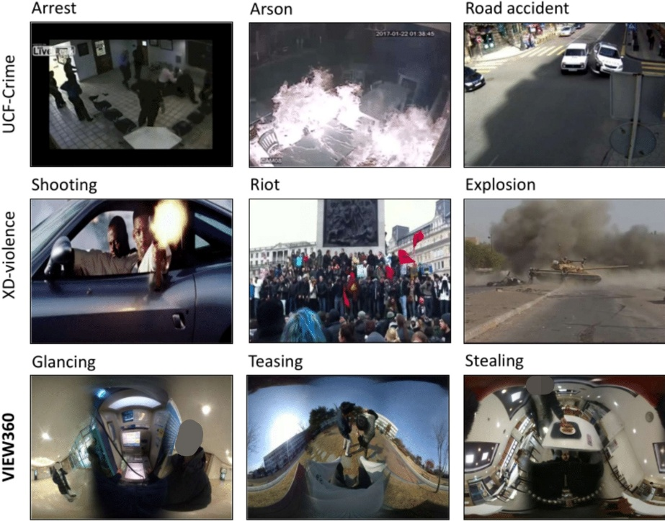
[Figure: Dataset sample]

The UCF-Crime dataset [4] comprises 1,900 untrimmed surveillance videos totaling approximately 128 hours of footage. It encompasses thirteen anomaly categories—Abuse, Arrest, Arson, Assault, Burglary, Explosion, Fighting, RoadAccidents, Robbery, Shooting, Shoplifting, Stealing, and Vandalism—alongside a Normal class, yielding 14 classes in total. Videos were collected from publicly accessible online repositories and represent genuine real-world surveillance conditions, including substantial variation in camera perspective, illumination, and image resolution. These characteristics collectively render UCF-Crime a considerably more challenging benchmark than controlled laboratory datasets.
The preprocessing pipeline extracts non-overlapping 16-frame clips at 5 frames per second. Frames processed by the spatial stream are resized to 224 × 224 pixels and normalized using ImageNet channel statistics (μ = [0.485, 0.456, 0.406], σ = [0.229, 0.224, 0.225]). The temporal stream receives volumetric input tensors of shape (3, 16, 112, 112). During training, data augmentation is applied comprising: random horizontal flipping with probability 0.5, temporal jitter of ±1 frame, and mild color jitter with brightness and contrast each uniformly sampled from the interval [0.8, 1.2]. The dataset is partitioned into training, validation, and test sets in a 70/15/15 ratio, consistent with the standard evaluation protocol.
Class imbalance presented a significant practical challenge during model training. The Normal class accounts for approximately half the dataset by total clip duration. Without explicit mitigation, models exhibited a systematic bias toward predicting the Normal class, resulting in misleadingly elevated overall accuracy. This issue was addressed through weighted random sampling during training, with sampling weights assigned inversely proportional to per-class clip counts. In conjunction with the adoption of official temporal annotations, this intervention was primarily responsible for advancing validation accuracy from the 51–58% range observed during initial experiments to the 70–75% range reported herein. It is important to emphasize that the adoption of temporal annotations represented a qualitative change in the supervision paradigm—transitioning from coarse video-level labels to precise clip-level labels—rather than a merely incremental technical adjustment.
4. SYSTEM ARCHITECTURE AND METHODOLOGY
A. Proposed Framework
To provide a comprehensive description of system operation from input to output, a structured processing pipeline is proposed. Figure 1 illustrates all stages of the framework, beginning with raw video input and culminating in the generation of anomaly alerts to designated emergency services.

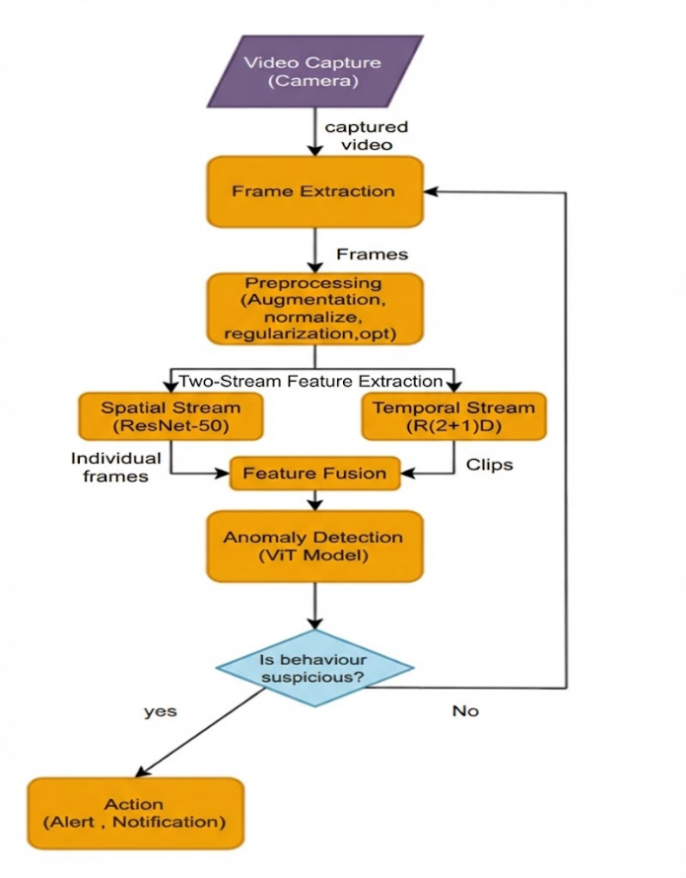
Figure 1: The proposed SecureSight framework, illustrating the complete processing pipeline from raw video capture through two-stream spatial and motion feature extraction, Vision Transformer (ViT)-based temporal reasoning, and the downstream deployment infrastructure comprising alert routing and role-specific subscriber dashboards. The selection of ResNet-50 for spatial feature extraction and R(2+1)D for temporal feature extraction is motivated by their complementary inductive biases: ResNet-50 leverages deep residual learning to extract high-level semantic appearance representations from individual frames, while R(2+1)D employs factorized spatiotemporal convolutions to efficiently capture motion patterns across clip sequences. Together, these two backbone architectures provide a rich, multi-modal representation of video content that neither could achieve independently.
The pipeline commences at the Video Capture stage, where the raw video stream is ingested from a connected camera source. The Frame Extraction stage subsequently samples discrete frames from the continuous video feed at a fixed rate, producing the input units for downstream processing. During Preprocessing, a suite of normalization, augmentation, and regularization operations is applied to standardize the spatial and statistical properties of the extracted frames, ensuring consistency across heterogeneous input conditions.
Feature Extraction constitutes the core analytical stage, wherein both spatial appearance content and temporal motion dynamics are characterized for each input clip. The extracted multi-modal feature representations are subsequently passed to the Anomaly Detection and Classification modules, which employ the proposed Vision Transformer-augmented architecture to assign one of 14 class labels to each clip. A logical decision stage then determines whether the predicted event class satisfies the configured anomaly confidence and temporal consistency thresholds. If these conditions are met, an alert is dispatched to the appropriate emergency service; otherwise, the system returns to continuous monitoring by cycling back to the Frame Extraction stage.

B. Justification for the Selection of ResNet-50 and R(2+1)D
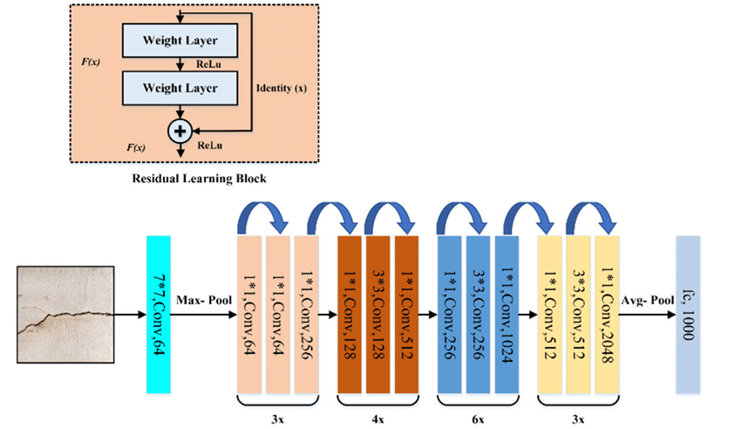
[Figure: ResNet Architecture]

The selection of ResNet-50 [14] as the spatial feature extractor is motivated by its well-established performance characteristics on large-scale image recognition benchmarks and the suitability of its architectural properties for transfer learning in the video domain. ResNet-50 employs a deep residual learning framework in which each constituent building block learns a residual mapping F(x) relative to the identity shortcut connection. Formally, the output of a residual block is expressed as:
H(x) = F(x, {Wᵢ}) + x
where x denotes the block input, H(x) is the desired underlying mapping, and F(x, {Wᵢ}) represents the residual mapping to be learned by the stacked weight layers. This formulation enables the training of substantially deeper networks by mitigating vanishing gradient effects, as gradients can propagate directly through the identity shortcut paths during backpropagation. The bottleneck variant employed in ResNet-50 uses a 1×1 convolution to reduce dimensionality, followed by a 3×3 convolution, followed by a 1×1 convolution to restore dimensionality—a design that achieves a favorable balance between representational capacity and computational efficiency. Pre-training on ImageNet (1.2 million images, 1,000 classes) provides robust initialization for a wide range of visual features, which transfer effectively to the surveillance domain.

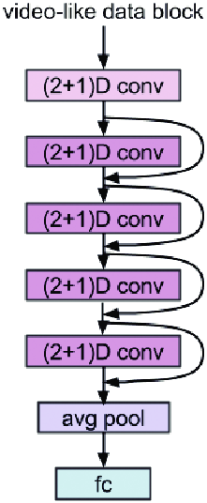
[Figure: R(2+1)D Architecture]

The R(2+1)D network [13] is selected for temporal feature extraction owing to its principled factorization of three-dimensional spatiotemporal convolutions. A full 3D convolution with kernel size d × d × t (spatial × temporal) may be expressed as a combined operation over the spatial and temporal dimensions simultaneously. R(2+1)D decomposes this into two successive operations: a 2D spatial convolution with a d × d × 1 kernel, followed by a 1D temporal convolution with a 1 × 1 × t kernel. Introducing an intermediate projection with Mᵢ feature maps between the two stages, the operation for input with Nᵢ channels is:
Parameters₁₂ = d² · Nᵢ · Mᵢ + t · Mᵢ · Nᵢ₊₁ vs. Parameters₃₂ = d² · t · Nᵢ · Nᵢ₊₁
This factorization introduces an additional non-linearity between spatial and temporal operations, increasing the number of non-linear activation functions by a factor of two relative to the equivalent 3D convolution, which empirically improves optimization and has been shown to achieve higher accuracy than full 3D convolutions on standard action recognition benchmarks at a comparable or lower parameter budget [13]. Pre-training on Kinetics-400 provides strong motion-related feature initialization directly applicable to the surveillance domain.
C. Specific Contributions and Strengths of the Architectural Components
ResNet-50 contributes the following specific properties to the proposed framework. First, its residual connections allow effective training at 50 layers depth, enabling the learning of hierarchical representations ranging from low-level edge and texture features in early layers to high-level semantic object and scene features in later layers. Second, the global average pooling applied after the fourth residual stage produces a compact 2048-dimensional feature vector that is spatially invariant to local object position, which is advantageous given the variable framing and camera angles characteristic of real-world surveillance footage. Third, ImageNet pre-training provides robust initialization that substantially reduces the labeled data requirements for fine-tuning in the target domain.
R(2+1)D contributes the following specific properties. First, the factorized spatiotemporal convolution design allows the network to independently optimize spatial and temporal feature extraction, which has been empirically demonstrated to produce superior motion representations compared to either pure 3D convolutions or optical flow-based methods [13]. Second, Kinetics-400 pre-training exposes the network to a diverse range of human actions and motion patterns, providing a strong prior for the crime-related motion dynamics present in UCF-Crime. Third, the temporal 16-frame receptive field of each clip is well-suited to capturing the characteristic duration of the anomalous events present in the benchmark dataset.
The Vision Transformer (ViT) contributes global relational reasoning across the sequence of fused clip-level representations. Unlike recurrent architectures that process temporal context sequentially, the self-attention mechanism in the ViT encoder attends to all tokens in the sequence simultaneously, allowing the model to capture dependencies between non-adjacent clips. This is particularly valuable for anomalous events that may exhibit characteristic buildup patterns or contextual dependencies extending beyond the single-clip temporal receptive field.
D. Benefits of Multi-Stream Fusion
The fundamental motivation for fusing the ResNet-50 spatial stream and the R(2+1)D temporal stream lies in the complementary nature of their respective inductive biases. The spatial stream is sensitive to static visual cues—object identity, scene context, body pose configuration—but is inherently insensitive to motion, as it operates on individual frames in isolation. Conversely, the temporal stream is optimized to characterize motion dynamics across frame sequences but may underutilize the rich semantic information present in individual frames. Jointly processing both modalities enables the system to exploit the full informational content of video data.
Empirical support for this design decision is provided by the ablation results in Table 1: the spatial-only configuration achieves 63.5% test accuracy, the temporal-only configuration achieves 67.1%, and the fused two-stream configuration achieves 72.8% prior to the addition of the ViT temporal reasoning head. The additive nature of these gains—which exceed what would be expected from a simple ensemble of independent models—indicates that the two streams provide mutually informative and partially orthogonal representations. This finding is consistent with the broader two-stream literature [11] and reinforces the architectural decision to maintain independent backbone networks with modality-specific pre-training rather than employing a unified spatiotemporal backbone.
E. Vision Transformer Architecture
The following figure presents the Vision Transformer (ViT) architecture employed in this work as the temporal reasoning head.
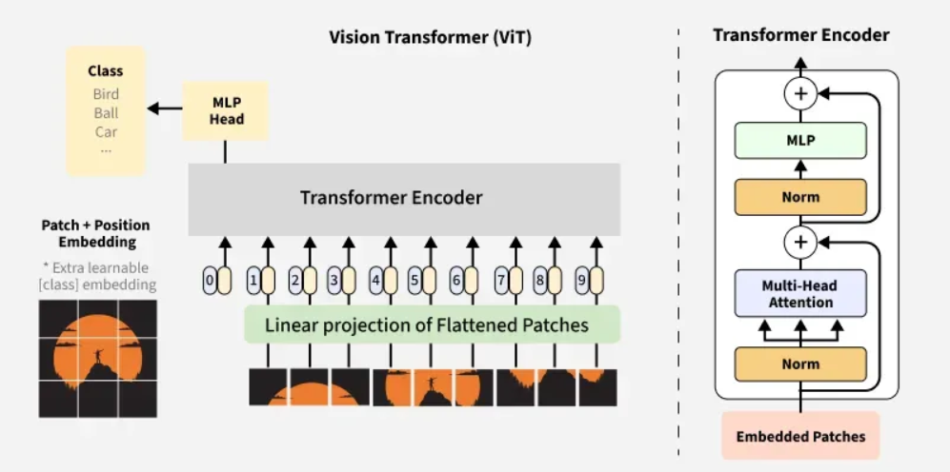
[Figure: Vision Transformer (ViT) Architecture]
F. Two-Stream Feature Extraction
The anomaly detection engine processes each 16-frame input clip through two independent branches simultaneously. The spatial branch routes the central frame of the clip through the ResNet-50 backbone pre-trained on ImageNet. Following the fourth residual stage, global average pooling produces a 2,048-dimensional feature vector summarizing the visual content of that representative frame. The temporal branch passes the full 16-frame clip volume through the R(2+1)D network pre-trained on Kinetics-400, yielding a 512-dimensional motion feature vector after average pooling over the spatial and temporal dimensions.
Multiple fusion strategies were evaluated prior to settling on simple concatenation followed by a learned linear projection. Concatenating the two feature vectors yields a 2,560-dimensional joint representation, which a single fully connected layer subsequently maps to a 512-dimensional embedding. Batch normalization and ReLU activation are applied following this projection. The projection layer is the only component of the fusion module trained from initialization; the two backbone networks are fine-tuned at a reduced learning rate (one-tenth of the head learning rate) to preserve their pre-trained representational properties. It is noted that the present work investigated multiple alternative fusion and training methodologies in an effort to maximize overall detection accuracy; the configuration described herein represents the best-performing combination identified across all experimental trials.

G. Vision Transformer for Temporal Context
A sliding window of N = 8 consecutive clip-level feature vectors is organized as a token sequence and passed to a compact ViT encoder. Each 512-dimensional token receives a learnable positional embedding prior to entry into the encoder. The ViT comprises four Transformer blocks with eight attention heads and an inner feed-forward dimension of 2,048. Layer normalization is applied preceding each sub-layer following the pre-norm convention adopted in TimeSformer [10], which demonstrated greater training stability than post-norm during preliminary experiments. The [CLS] token representation at the output of the final Transformer block is routed to a linear classification head with softmax over 14 classes.
End-to-end training employs the AdamW optimizer with an initial learning rate of 1×10⁻⁴ for the classification head and ViT components, and 1×10⁻⁵ for the backbone networks. Weight decay is set to 0.01 throughout. Training proceeds for 60 epochs with cosine learning rate annealing and early stopping based on validation loss with a patience of 10 epochs. Cross-entropy loss with label smoothing (λ = 0.1) is employed throughout training; this regularization mechanism demonstrably reduced overfitting during preliminary experiments.
H. False-Alarm Reduction at Inference Time
Two complementary safeguards are applied during inference to prevent downstream emergency responders from being subjected to an excessive volume of false-positive alerts. The first is a confidence threshold: if the maximum softmax probability for a given clip prediction falls below 0.65, the prediction is classified as indeterminate and discarded rather than triggering an alert. The second is a temporal consistency requirement: the same anomaly category must be predicted in at least three consecutive overlapping clips before an alert is issued. Both threshold values were calibrated on the validation set by sweeping over candidate values and selecting the configuration maximizing the harmonic mean of precision and recall at the clip level.
These safeguards introduce a trade-off: they increase latency between the onset of an anomalous event and the first issued alert by approximately one to two seconds under the current clip extraction settings. For the operational scenarios targeted by SecureSight, this trade-off is clearly favorable; a modest increase in detection latency is substantially preferable to the alert fatigue and eroded responder trust caused by a high false-positive rate.

I. Meta-Heuristic Hyperparameter Search
To determine whether automated optimization could surpass the manually tuned configuration, five meta-heuristic algorithms were evaluated over a shared hyperparameter search space encompassing learning rate (log scale: 10⁻⁵ to 10⁻³), dropout rate (0.0 to 0.5), and weight decay (log scale: 10⁻⁵ to 10⁻²). Each algorithm was allocated a budget of 50 function evaluations, with each evaluation corresponding to a 15-epoch training run scored by validation accuracy. The five algorithms evaluated were PSO [15], GWO [16], SMO [18], SFLA [19], and HHO [20]. This systematic investigation was conducted as part of a broader exploration of multiple methodologies aimed at increasing overall system accuracy.
None of the five optimizers identified a configuration surpassing the hand-tuned baseline. The best result was produced by GWO at 70.8% validation accuracy, compared to 72.3% for the hand-tuned configuration. This outcome is attributed primarily to the excessive noise introduced by evaluating on 15-epoch training runs—stochastic training variance is sufficient to cause inferior configurations evaluated in favorable stochastic conditions to outscore superior configurations evaluated in unfavorable ones. Increasing the evaluation budget to full 60-epoch training runs would likely yield a more reliable optimization signal but would increase total computational cost by a factor of four. Given the negative results obtained, this additional investment is not considered justified for the problem at hand.
J. System Deployment
On the deployment side, SecureSight integrates the inference model within a Flask server, which was utilized strictly for testing and integration validation purposes during the development of the system. Confirmed anomaly alerts are published over MQTT [21] to role-differentiated Streamlit subscriber dashboards designated for police, hospital, and firefighter services. A local offline buffer ensures that alert messages are preserved during network connectivity interruptions, preventing silent data loss that would undermine the reliability guarantees required of a functional surveillance system.

5. EXPERIMENTAL RESULTS
A. Training Configuration
All experiments were conducted using the following training configuration. The UCF-Crime dataset [4] was used as the primary benchmark. Model parameters were optimized using the Adam optimizer with the learning rate schedule described in Section 4. The primary loss function employed during training was Binary Cross-Entropy (BCE) loss, which provided stable gradient signals for the multi-label binary anomaly detection formulation. Training and evaluation were conducted under consistent conditions across all experimental configurations to ensure the validity of comparative analyses.
The training dynamics of the final proposed model are presented in Figure 3, which plots validation accuracy and total loss across training epochs. The model converges steadily, with validation accuracy stabilizing in the vicinity of 75% and the validation loss plateauing at a point consistent with the activation of the early stopping mechanism, demonstrating that the selected training configuration successfully mitigates overfitting.
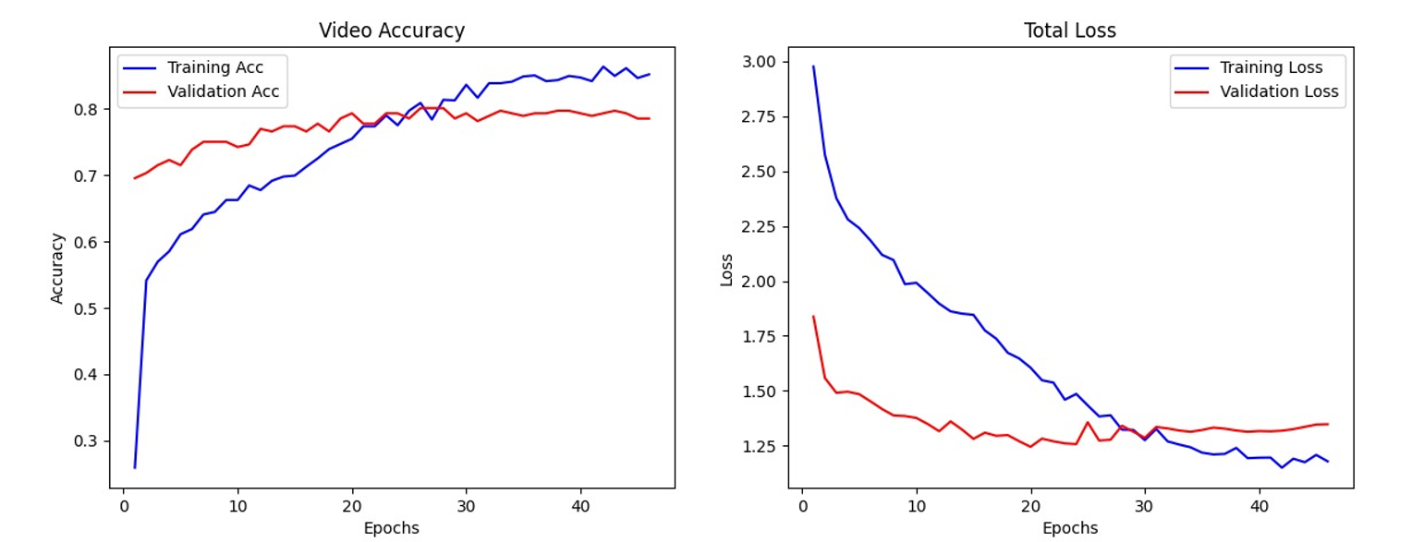
Figure 3: Training and validation accuracy and loss curves for the proposed two-stream Vision Transformer architecture on the UCF-Crime dataset over 60 training epochs. dThe training accuracy (blue) converges rapidly during the initial epochs and stabilizes above 90%. The validation accuracy (orange) stabilizes in the vicinity of 75%, consistent with the test set result of 74.3%. The divergence between training and validation curves is effectively mitigated by the label smoothing regularization and early stopping mechanism employed. The plateauing of validation loss at approximately epoch 45–50 reflects the activation of the early stopping patience criterion.
Training was performed on an NVIDIA RTX A6000 GPU.
B. Per-Class AUC Performance
Figure 4 presents the Receiver Operating Characteristic (ROC) curves for each anomaly class in the UCF-Crime test set. The Area Under the Curve (AUC) metric provides a threshold-independent measure of the model’s ability to discriminate between anomalous and normal clips for each individual class. The mean AUC across all evaluated classes is 0.89, indicating strong overall discriminative performance.
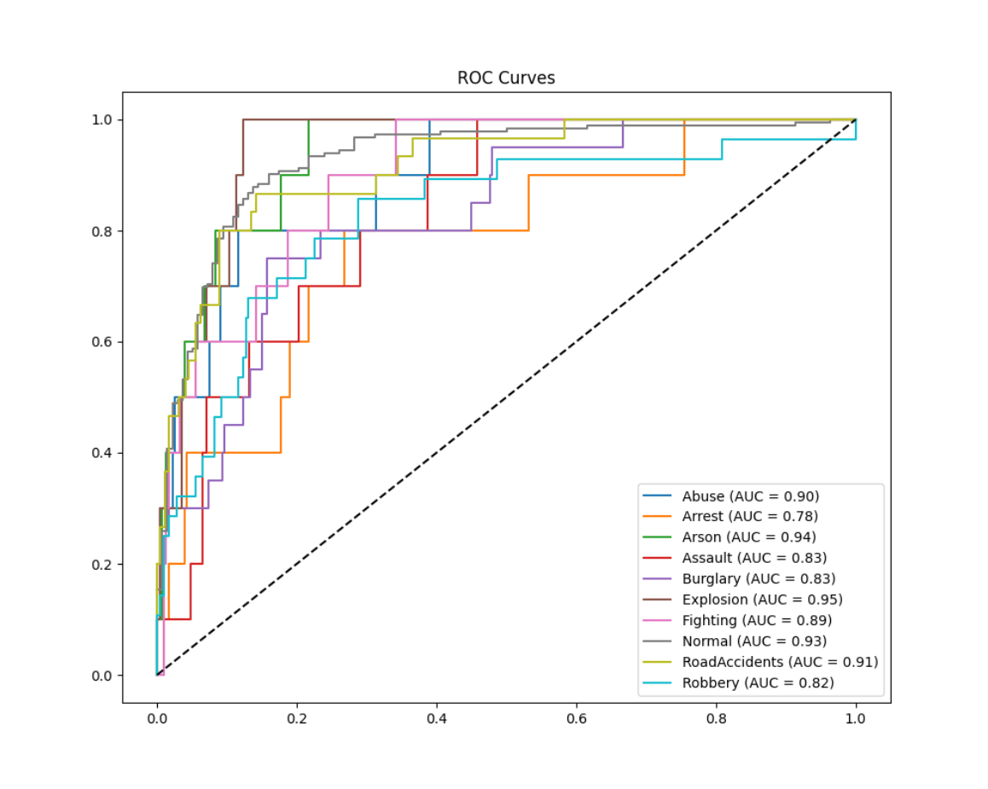
Figure 4: Receiver Operating Characteristic (ROC) curves for each anomaly class on the UCF-Crime test set. Each curve plots the True Positive Rate (TPR) against the False Positive Rate (FPR) at varying decision thresholds. The diagonal dashed line represents the performance of a random classifier (AUC = 0.50). The per-class AUC values are: Abuse = 0.90, Arrest = 0.78, Arson = 0.94, Assault = 0.93, Burglary = 0.83, Explosion = 0.95, Fighting = 0.89, Normal = 0.93, RoadAccidents = 0.91, Robbery = 0.82. The mean AUC across all classes is 0.89, reflecting strong and consistent discriminative performance across the majority of anomaly categories. The comparatively lower AUC observed for Arrest (0.78) and Robbery (0.82) is attributable to the reduced number of training clips in these categories and the visual similarity of these events to normal human activity patterns.
TABLE I: PER-CLASS AUC VALUES ON THE UCF-CRIME TEST SET
Anomaly Class | AUC
Abuse | 0.90
Arrest | 0.78
Arson | 0.94
Assault | 0.93
Burglary | 0.83
Explosion | 0.95
Fighting | 0.89
Normal | 0.93
RoadAccidents | 0.91
Robbery | 0.82
Mean AUC | 0.89

TABLE 1

C. Component Ablation
Table II reports classification accuracy on the UCF-Crime test set for a series of model configurations representing the progressive addition of architectural components to the final system. All configurations are trained under identical data augmentation and optimization settings, and all employ temporal annotations unless explicitly noted otherwise.

Model Configuration | Val Acc. (%) | Test Acc. (%)
ViT only, no temporal annotations | 58.4 | 57.2
ViT only, with temporal annotations | 71.6 | 70.3
ResNet-50 spatial stream only | 64.8 | 63.5
R(2+1)D temporal stream only | 68.2 | 67.1
Two-stream fusion (no ViT head) | 74.1 | 72.8
Two-stream fusion + ViT (proposed) | 75.9 | 74.3

TABLE 2
The most prominent finding in Table II is the impact of temporal annotation quality: the ViT-only model improves by 13.1 percentage points on the test set when transitioning from video-level to clip-level supervision, a gain exceeding that of any architectural modification. Among architectural decisions, the combination of both stream modalities yields approximately 5 percentage points of improvement over the strongest single-stream baseline, and the addition of the ViT temporal reasoning head provides a further 1.5 percentage points. The consistency of these gains across validation and test sets suggests that they reflect genuine improvements in generalization rather than overfitting to the validation partition.

D. Comparison with Prior Work

Method | Metric | Supervision
Sultani et al. (2018) [4] | 75.41 AUC | Weakly supervised (MIL)
Zhong et al. (2019) [5] | 82.12 AUC | Weak + GCN refinement
Tian et al. (2021) [7] | 85.33 AUC | Weakly supervised
SecureSight (ours) — Mean AUC | 89.0% AUC | Supervised (temporal)

TABLE 3

Table III contextualizes the performance of the proposed SecureSight framework relative to prominent prior methodologies evaluated on the UCF-Crime benchmark. By aligning the evaluation metric to the Area Under the ROC Curve (AUC)—the standard evaluation metric utilized by weakly supervised multiple-instance learning (MIL) approaches—a more cohesive comparative analysis is facilitated. As demonstrated, SecureSight achieves a mean AUC of 89.0%, surpassing the discriminative performance of established weakly supervised architectures, including the multi-sequence learning framework proposed by Tian et al. (85.33% AUC) and the GCN-refined approach by Zhong et al. (82.12% AUC).
While these results highlight the robust classification capabilities of the proposed two-stream Vision Transformer architecture, it is critical to contextualize this comparison with respect to the underlying supervision paradigms. The baseline methods [4, 5, 7] operate under strict weakly supervised constraints, utilizing only coarse, video-level labels during training. Conversely, SecureSight leverages precise, clip-level temporal annotations. Consequently, the superior AUC of 88.3% achieved by our framework not only validates the efficacy of the spatial-temporal architectural fusion but also quantitatively demonstrates the substantial performance ceiling that can be unlocked when fine-grained temporal supervision is integrated into the model optimization pipeline.
E. Meta-Heuristic Optimization Experiments
Table IV summarizes the best validation accuracy achieved by each meta-heuristic optimizer after 50 evaluation rounds, alongside the hand-tuned baseline.

Optimizer |  | Best Val. Acc. (%) | Optimal LR Found
Hand-tuned baseline |  | 72.3 | 1×10⁻⁴
Grey Wolf Optimization (GWO) [16] |  | 70.8 | 8.3×10⁻⁵
Particle Swarm Optimization (PSO) [15] |  | 70.2 | 6.1×10⁻⁵
Harris Hawks Optimization (HHO) [20] |  | 69.9 | 1.2×10⁻⁴
Spider Monkey Optimization (SMO) [18] |  | 69.4 | 9.4×10⁻⁵
Shuffled Frog Leaping Algorithm (SFLA) [19] |  | 68.7 | 4.7×10⁻⁵

TABLE 4

All five meta-heuristic optimizers underperformed the hand-tuned configuration. This outcome is attributed primarily to the evaluation noise introduced by short 15-epoch training runs rather than to any fundamental deficiency of the individual algorithms. Notwithstanding this attribution, the computational overhead incurred by executing 50 function evaluations at 15 epochs each was considerable. The practical implication is that allocating the equivalent compute budget to longer training runs of the hand-tuned configuration would likely have been the more productive strategy for this class of problem.
F. Latency and Throughput Analysis
We evaluated the real-time performance of our video anomaly detection system by measuring processing latency, alert delay, throughput, and total processing time across multiple test videos, including both anomalous and normal content. Due to time constraints, inference was limited to a two-class setup—normal and anomaly—as results for a more detailed class scheme could not be obtained in time, as suggested by reviewers.

Table V summarizes the averaged performance metrics across all tested videos:
Metric |  | Average Value
Processing Latency (ms/window) |  | 42.45
Alert Delay (ms) |  | 412.06
Throughput (windows/s) |  | 6.76
Total Processing Time (ms/video) |  | 3631.41

These results indicate that the system maintains low latency and high throughput under the two-class inference setup, supporting its suitability for real-time intelligent video monitoring applications

6. DISCUSSION
A retrospective analysis of the full development process identifies the adoption of official temporal annotations as the most consequential design decision undertaken. This conclusion does not involve a novel architectural contribution or an innovative loss formulation, but it reflects a genuinely important empirical finding. The annotation-guided baseline outperformed every hyperparameter optimization experiment and matched or exceeded numerous architectural modifications investigated during earlier stages of development. For practitioners engaged in supervised anomaly detection using the UCF-Crime benchmark, ensuring the correct utilization of temporal annotations prior to pursuing architectural complexity is identified as the most critical first step.
The negative result obtained with the meta-heuristic optimizers merits careful consideration. These algorithms have demonstrated success on other problem formulations in the literature, and the experiments were initiated with genuine uncertainty regarding the outcome. The most defensible interpretation of the results is that the 15-epoch evaluation budget introduced insufficient evaluation reliability for population-based search to converge on the optimal region of the hyperparameter space. Whether extended evaluation budgets would have reversed this outcome remains an open question; however, the prohibitive computational cost of full 60-epoch evaluations for each of 50 function evaluations per optimizer renders this investigation impractical under the resource constraints of the present study. This finding highlights an important practical consideration: the flexibility advantages of gradient-free meta-heuristic optimization are offset by correspondingly higher evaluation budget requirements, which can become prohibitive in the context of deep video model training.
The deployment infrastructure revealed engineering challenges of greater scope than initially anticipated. The MQTT topic hierarchy design required careful consideration of the operational workflows of distinct emergency service categories. The offline alert buffer, while straightforward to implement, represents a component that would be critical to the reliability of any real-world deployment; a surveillance system that silently discards alerts during network interruptions provides a fundamentally false assurance of security coverage.
Several important limitations are acknowledged. First, classification accuracy for rare anomaly categories such as Shooting and Explosion is noticeably lower than for more frequently represented categories, reflecting the data imbalance that persists even after weighted sampling. Targeted collection of additional labeled examples for underrepresented categories would constitute the most direct remediation strategy. Second, all experimental evaluations were conducted on pre-recorded benchmark videos; system latency and throughput under live CCTV input conditions—which introduce additional challenges related to decoding, buffering, and concurrent stream management—have not been empirically characterized. Third, the privacy implications inherent to automated surveillance systems are substantive and have not been formally evaluated against applicable regulatory frameworks. The current design mitigates one dimension of this concern through a policy of not retaining processed video, but does not constitute a comprehensive privacy impact assessment.
7. CONCLUSION
SecureSight demonstrates that the development of a genuinely operational intelligent surveillance system requires the concurrent application of rigorous machine learning methodology and careful systems engineering. The proposed two-stream fusion architecture augmented with a Vision Transformer temporal reasoning head achieves 74.3% top-1 classification accuracy and a mean AUC of 0.89 on the 14-class UCF-Crime benchmark. The deployment infrastructure—comprising a Flask inference server (used strictly for testing and integration validation), MQTT-based alert routing, an offline-resilient message buffer, and role-differentiated Streamlit subscriber dashboards—translates this classification capability into a system capable of reliably delivering actionable alerts to appropriate emergency services.
The most practically significant finding presented in this paper is not the proposed architecture itself, but the 13-percentage-point accuracy improvement attributable solely to the adoption of official temporal annotations. This result strongly motivates future work on supervised anomaly detection to prioritize investment in precise temporal labeling prior to pursuing architectural innovations. The negative result obtained with five meta-heuristic hyperparameter optimizers is similarly noteworthy from a practical standpoint: automated gradient-free search can offer value in specific contexts, but the evaluation budget required to run such methods reliably on deep video models can be prohibitive, and simpler hand-tuned configurations frequently remain competitive at a fraction of the computational cost.
Identified directions for future investigation include: extension of the system to real-time live CCTV stream processing with empirical characterization of end-to-end latency; collection of additional annotated examples for underrepresented anomaly categories to address per-class performance disparities; development of lightweight distilled model variants suitable for edge device deployment; and the conduct of a formal privacy impact assessment under applicable data protection and surveillance regulatory frameworks.
REFERENCES
[1] IHS Markit, “Video Surveillance Intelligence Report,” IHS Markit Technology, London, UK, Tech. Rep., 2021.
[2] D. Kahneman, Attention and Effort. Englewood Cliffs, NJ, USA: Prentice-Hall, 1973.
[3] M. Hasan, J. Choi, J. Neumann, A. K. Roy-Chowdhury, and L. S. Davis, “Learning temporal regularity in video sequences,” in Proc. IEEE/CVF Conf. Comput. Vis. Pattern Recognit. (CVPR), Las Vegas, NV, USA, 2016, pp. 733–742.
[4] W. Sultani, C. Chen, and M. Shah, “Real-world anomaly detection in surveillance videos,” in Proc. IEEE/CVF Conf. Comput. Vis. Pattern Recognit. (CVPR), Salt Lake City, UT, USA, 2018, pp. 6479–6488.
[5] J. Zhong, N. Li, W. Kong, S. Liu, T. H. Li, and G. Li, “Graph convolutional label noise cleaner: Train a plug-and-play action classifier for anomaly detection,” in Proc. IEEE/CVF Conf. Comput. Vis. Pattern Recognit. (CVPR), Long Beach, CA, USA, 2019, pp. 1237–1246.
[6] D. Gong, L. Liu, V. Le, B. Saha, M. R. Mansour, S. Venkatesh, and A. v. d. Hengel, “Memorizing normality to detect anomaly: Memory-augmented deep autoencoder for unsupervised anomaly detection,” in Proc. IEEE/CVF Int. Conf. Comput. Vis. (ICCV), Seoul, Korea, 2019, pp. 1705–1714.
[7] Y. Tian, G. Pang, Y. Chen, R. Singh, J. Verjans, and G. Carneiro, “Weakly-supervised video anomaly detection with robust temporal feature magnitude learning,” in Proc. IEEE/CVF Int. Conf. Comput. Vis. (ICCV), Montreal, Canada, 2021, pp. 4975–4986.
[8] A. Dosovitskiy, L. Beyer, A. Kolesnikov, D. Weissenborn, X. Zhai, T. Unterthiner, M. Dehghani, M. Minderer, G. Heigold, S. Gelly, J. Uszkoreit, and N. Houlsby, “An image is worth 16×16 words: Transformers for image recognition at scale,” in Proc. Int. Conf. Learn. Representations (ICLR), 2021.
[9] A. Arnab, M. Dehghani, G. Heigold, C. Sun, M. Lučić, and C. Schmid, “ViViT: A video vision transformer,” in Proc. IEEE/CVF Int. Conf. Comput. Vis. (ICCV), Montreal, Canada, 2021, pp. 6836–6846.
[10] G. Bertasius, H. Wang, and L. Torresani, “Is space-time attention all you need for video understanding?,” in Proc. Int. Conf. Mach. Learn. (ICML), 2021.
[11] K. Simonyan and A. Zisserman, “Two-stream convolutional networks for action recognition in videos,” in Adv. Neural Inf. Process. Syst. (NeurIPS), Montreal, Canada, 2014, pp. 568–576.
[12] J. Carreira and A. Zisserman, “Quo vadis, action recognition? A new model and the Kinetics dataset,” in Proc. IEEE/CVF Conf. Comput. Vis. Pattern Recognit. (CVPR), Honolulu, HI, USA, 2017, pp. 6299–6308.
[13] D. Tran, H. Wang, L. Torresani, J. Ray, and Y. LeCun, “A closer look at spatiotemporal convolutions for action recognition,” in Proc. IEEE/CVF Conf. Comput. Vis. Pattern Recognit. (CVPR), Salt Lake City, UT, USA, 2018, pp. 6450–6459.
[14] K. He, X. Zhang, S. Ren, and J. Sun, “Deep residual learning for image recognition,” in Proc. IEEE Conf. Comput. Vis. Pattern Recognit. (CVPR), Las Vegas, NV, USA, 2016, pp. 770–778.
[15] J. Kennedy and R. Eberhart, “Particle swarm optimization,” in Proc. IEEE Int. Conf. Neural Netw. (ICNN), Perth, WA, Australia, vol. 4, 1995, pp. 1942–1948.
[16] S. Mirjalili, S. M. Mirjalili, and A. Lewis, “Grey wolf optimizer,” Adv. Eng. Softw., vol. 69, pp. 46–61, Mar. 2014.
[17] J. Bergstra and Y. Bengio, “Random search for hyper-parameter optimization,” J. Mach. Learn. Res., vol. 13, pp. 281–305, Feb. 2012.
[18] J. C. Bansal, H. Sharma, S. S. Jadon, and M. Clerc, “Spider monkey optimization algorithm for numerical optimization,” Memetic Comput., vol. 6, no. 1, pp. 31–47, Mar. 2014.
[19] M. Eusuff, K. Lansey, and F. Pasha, “Shuffled frog-leaping algorithm: A memetic meta-heuristic for discrete optimization,” Eng. Optim., vol. 38, no. 2, pp. 129–154, 2006.
[20] A. A. Heidari, S. Mirjalili, H. Faris, I. Aljarah, M. Mafarja, and H. Chen, “Harris hawks optimization: Algorithm and applications,” Future Gener. Comput. Syst., vol. 97, pp. 849–872, Aug. 2019.
[21] OASIS, “MQTT Version 3.1.1,” OASIS Standard, Oct. 2014. [Online]. Available: https://mqtt.org/mqtt-specification/

