

Report in

Probability project

Instructor : Dr. Mervat Mikhael

Student name : Tasneem Ibrahim Hassan Mohamed

Student’s ID : 22101382
Faculty : Computer science and engineering (CSE)
Level : Two
Semester : Spring 2024
Course name : Probability

What is the problem statement that you see in this dataset?
The problem statement that can be identified from this dataset is to understand the perceptions and attitudes of students towards the integration of AI technologies in education. Specifically, the dataset aims to identify students' familiarity with AI, their opinions on the potential benefits and drawbacks of AI in education, and their expectations regarding the role of AI in their academic and professional lives.

Summary the data of the dataset that you will download it. Find the mean, median, standard deviation and mode for the specific column you will take a decision for it.
this project shows a dataset contains survey data collected from undergraduate students enrolled in the 2nd and 3rd year of the study of the faculty of cybernetics, statistics and Economic informatics from various universities and colleges worldwide
The survey aimed to understand students' perceptions of artificial intelligence (AI technologies) in education.
The dataset includes demographic information, such as age, gender, and educational level, as well as questions related to students' perceptions of AI in education.
By analyzing this dataset, we can gain valuable insights into students' perceptions of AI in education and identify areas
Specific column Q1=c(8,7,5,5,4,5,7,6,6,4,4,6,9,9,7,6,1,8,7,6,6,7,7,5,4,5,7,3,6,5,5,6,5,7,6,8,10,8,7,7,7,5,8,5,6,3,8,7,9,7,3,4,7,5,5,6,5,8,4,5,6,4,8,6,7,5,8,1,6,4,9,10,8,6,5,4,7,4,4,8,8,3,7,5,6,1,8,6,9,2,2)
Mean
5.912088
Median
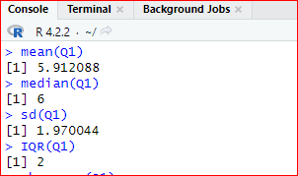
6
Standard deviation
1.970044
Mode
7
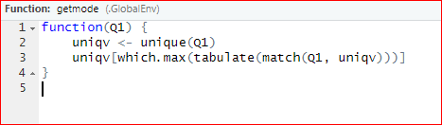

Calculate the interquartile range and skewness
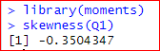
interquartile range
2
Skewness
-0.3504347

Histograms and box plot of the specific column that you will take a decision for it.
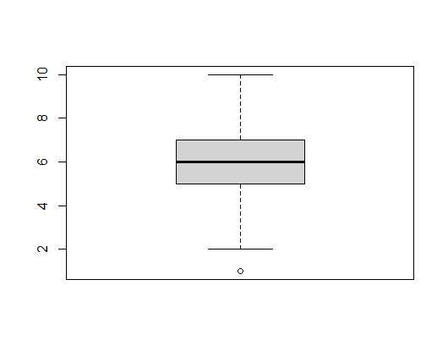
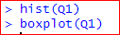

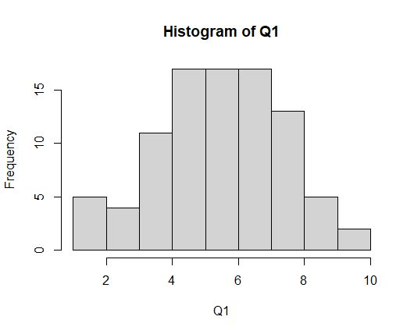

The largest number of students belong to a certain area do you think AI would have a big impact?

Education | Medicine | Agriculture | Constructions
Min. :0.0000 | Min. :0.0000 | Min. :0.0000 | Min. :0.0000
1st Qu.:0.0000 | 1st Qu.:1.0000 | 1st Qu.:0.0000 | 1st Qu.:0.0000
Median :1.0000 | Median :1.0000 | Median :1.0000 | Median :1.0000
Mean :0.6703 | Mean :0.8022 | Mean :0.5055 | Mean :0.5495
3rd Qu.:1.0000 | 3rd Qu.:1.0000 | 3rd Qu.:1.0000 | 3rd Qu.:1.0000
Max. :1.0000 | Max. :1.0000 | Max. :1.0000 | Max. :1.0000

Marketing | Administration | Art
Min. :0.0000 | Min. :0.0000 | Min. :0.0000
1st Qu.:0.0000 | 1st Qu.:0.0000 | 1st Qu.:0.0000
Median :0.0000 | Median :0.0000 | Median :0.0000
Mean :0.3626 | Mean :0.3846 | Mean :0.1319
3rd Qu.:1.0000 | 3rd Qu.:1.0000 | 3rd Qu.:0.0000
Max. :1.0000 | Max. :1.0000 | Max. :1.0000

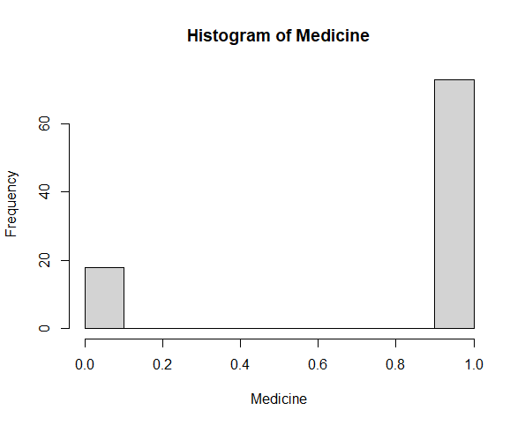

The smallest number of students belong to a certain area do you think AI would have a big impact?

Education | Medicine | Agriculture | Constructions
Min. :0.0000 | Min. :0.0000 | Min. :0.0000 | Min. :0.0000
1st Qu.:0.0000 | 1st Qu.:1.0000 | 1st Qu.:0.0000 | 1st Qu.:0.0000
Median :1.0000 | Median :1.0000 | Median :1.0000 | Median :1.0000
Mean :0.6703 | Mean :0.8022 | Mean :0.5055 | Mean :0.5495
3rd Qu.:1.0000 | 3rd Qu.:1.0000 | 3rd Qu.:1.0000 | 3rd Qu.:1.0000
Max. :1.0000 | Max. :1.0000 | Max. :1.0000 | Max. :1.0000

Marketing | Administration | Art
Min. :0.0000 | Min. :0.0000 | Min. :0.0000
1st Qu.:0.0000 | 1st Qu.:0.0000 | 1st Qu.:0.0000
Median :0.0000 | Median :0.0000 | Median :0.0000
Mean :0.3626 | Mean :0.3846 | Mean :0.1319
3rd Qu.:1.0000 | 3rd Qu.:1.0000 | 3rd Qu.:0.0000
Max. :1.0000 | Max. :1.0000 | Max. :1.0000

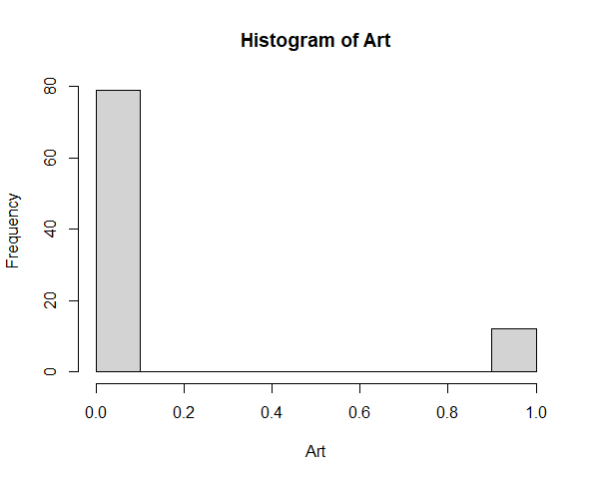

What is the opinion of the students with the highest GPA?
