Neural Target-Decoy FDR Report
Two-stage retrieval with InstaNovo/Casanovo-DB-style neural rescoring
Bottom line: The target-decoy competition implementation is internally consistent and gives an estimated 1.57% top-1 FDR overall. At q <= 0.01 it accepts 108,346 target PSMs at approximately 1% estimated FDR, corresponding to a neural score cutoff of about 0.056. The expanded score-threshold sweep agrees with this: score >= 0.06 keeps 97.6% of PSMs and lowers estimated FDR to 0.79%. Because benchmark labels are available, exact sequence accuracy should be reported alongside TDA-FDR: 81.98% overall and about 84.11% among q <= 0.01 accepted targets.

Executive Summary
- The code follows the standard target-decoy competition pattern: targets and reverse-inner decoys compete in the same candidate pool, and FDR is estimated from decoy winners over target winners.
- The score distributions show strong target/decoy separation: target median confidence is 0.516, while decoy median confidence is 0.0598.
- The headline TDA result is good for this setup: 108,346 accepted target PSMs at q <= 0.01.
- A practical raw-score cutoff near the 1% FDR boundary is around 0.056-0.060; score >= 0.06 gives 0.79% estimated FDR while keeping 97.6% of PSMs.
- The main caveat is interpretation: exact benchmark accuracy is lower than the TDA estimate because many mistakes are target-vs-target confusions, especially similar modified and unmodified peptide variants.

Key Results
Metric | Value | Interpretation
Spectra searched | 111,211 | Input spectra after excluding targets without valid 1:1 decoys.
Unique targets | 30,175 | Unique modified peptide sequences before decoy filtering.
Targets with decoys | 30,144 | Strict 1:1 target-decoy pairs used in the competition.
Top-1 target winners | 109,491 | Final neural winner was a target peptide.
Top-1 decoy winners | 1,720 | Final neural winner was a decoy peptide.
Estimated top-1 FDR | 1.57% | Computed as decoy winners divided by target winners.
q <= 0.01 accepted targets | 108,346 | Accepted target-only PSM set at estimated 1% FDR.
q <= 0.01 score cutoff | 0.0560 | Minimum neural score among accepted q<=1% target PSMs.
score >= 0.06 FDR | 0.79% | Mild raw-score cutoff; keeps 97.6% of PSMs.
Exact top-1 accuracy | 81.98% | Benchmark-only exact match against true_sequence.
Exact accuracy within q <= 0.01 targets | 84.11% | Benchmark-only exact match after the 1% q-value filter.

Threshold Behavior
The expanded raw-score sweep is now informative. Weak filtering near 0.03-0.04 keeps almost the entire dataset and remains close to the overall 1.57% FDR. The useful transition occurs around 0.05-0.06: score >= 0.05 gives 1.32% estimated FDR, while score >= 0.06 gives 0.79% estimated FDR. This aligns with the q <= 0.01 accepted set, whose implied score cutoff is about 0.056.
Threshold | Accepted | Targets | Decoys | Estimated FDR | % kept
0.03 | 111,207 | 109,488 | 1,719 | 1.57% | 100.0%
0.04 | 111,112 | 109,431 | 1,681 | 1.54% | 99.9%
0.05 | 110,509 | 109,071 | 1,438 | 1.32% | 99.4%
0.06 | 108,548 | 107,697 | 851 | 0.79% | 97.6%
0.07 | 106,787 | 106,325 | 462 | 0.43% | 96.0%
0.08 | 105,541 | 105,246 | 295 | 0.28% | 94.9%
0.09 | 104,544 | 104,329 | 215 | 0.21% | 94.0%
0.1 | 103,651 | 103,492 | 159 | 0.15% | 93.2%
0.125 | 101,587 | 101,489 | 98 | 0.10% | 91.3%
0.15 | 99,519 | 99,447 | 72 | 0.07% | 89.5%
0.2 | 95,074 | 95,029 | 45 | 0.05% | 85.5%
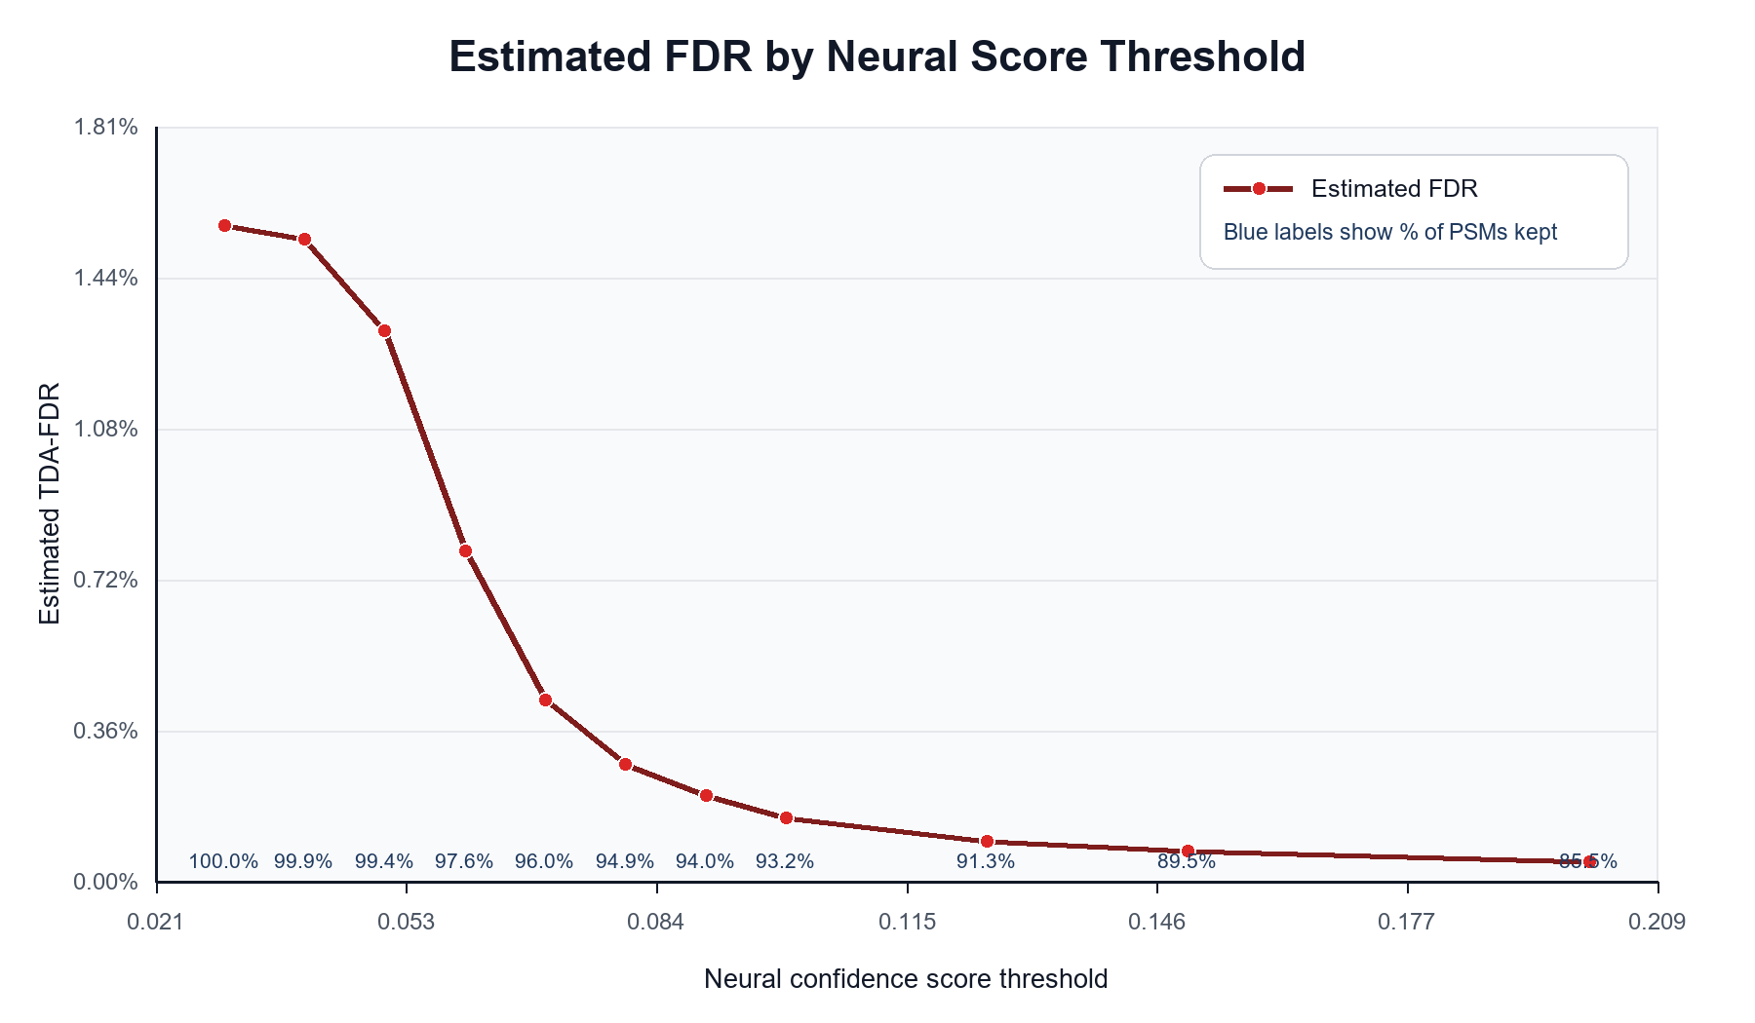
Figure 1. Estimated FDR decreases sharply once the neural score threshold moves through the target/decoy overlap region.

Interpretation for Discussion
The clean way to present the result is to separate the target-decoy estimate from benchmark exact-match accuracy. TDA-FDR answers: how many accepted target PSMs are expected to be false under the decoy model? Exact-match accuracy answers: how often did the selected target sequence equal the benchmark label?
- Supervisor-facing headline: the neural TDA-FDR machinery is working and gives approximately 1% estimated FDR at q <= 0.01.
- Required caveat: this does not mean 99% exact peptide correctness on the benchmark; exact sequence accuracy is about 84% within the accepted q <= 0.01 target set.
- Likely cause: target-vs-target errors, including modification-state or modification-localization confusions, are not fully captured by the decoy count.
- Recommended next step: report both TDA-FDR and exact benchmark accuracy, then inspect high-confidence incorrect target calls to understand modification-related failure modes.

Score Distribution Plots
The figures below show the raw confidence score and log-score distributions for target and decoy winners. The strong separation between targets and decoys supports the TDA estimate, while the benchmark accuracy caveat remains important for exact-sequence interpretation.

Decoy Distributions
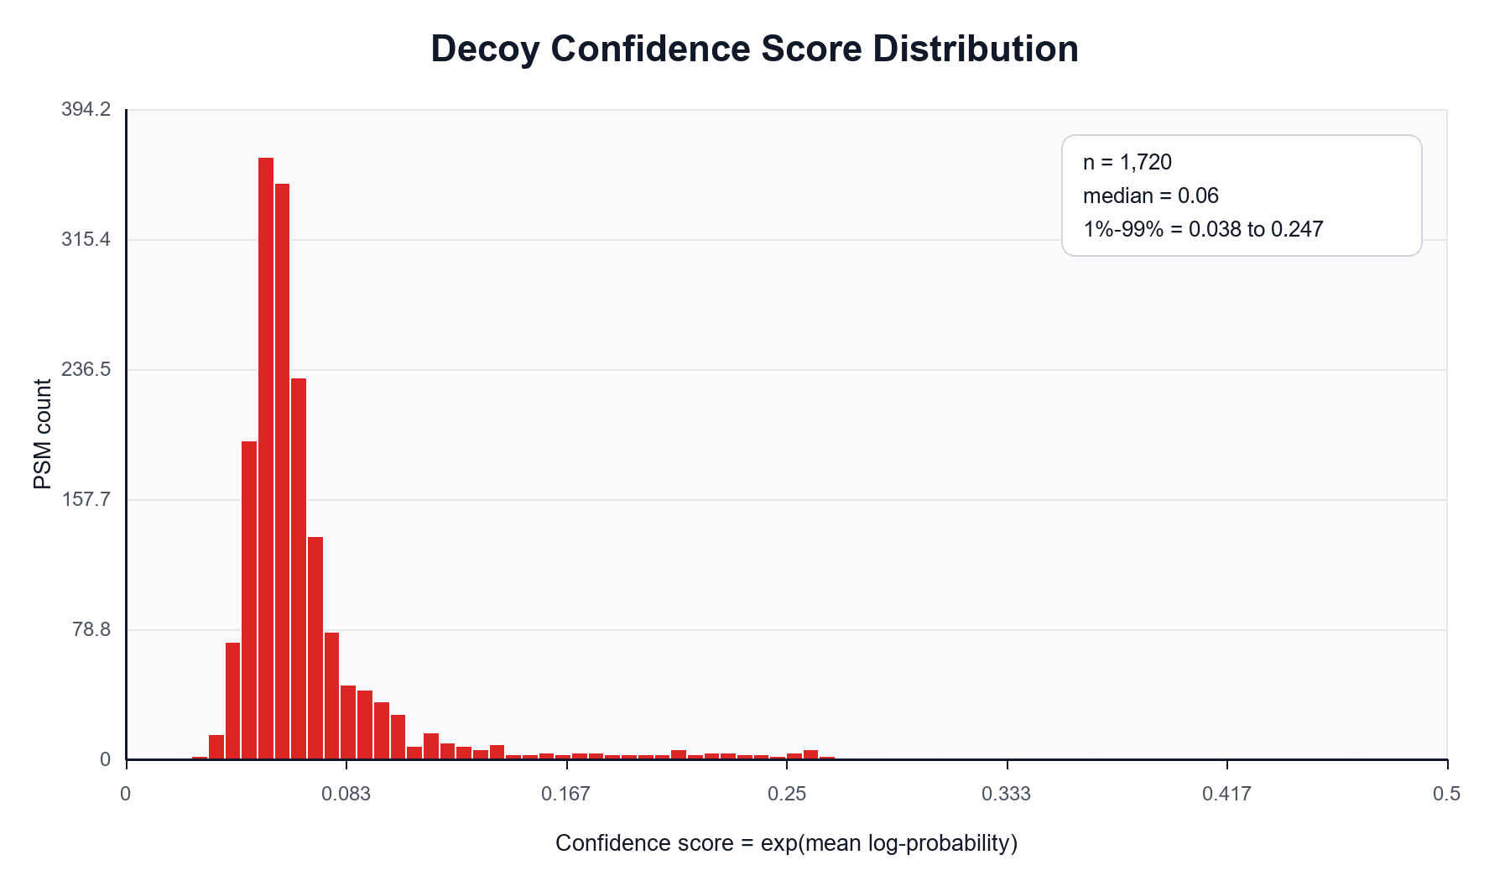
Figure 2. Decoy confidence scores are concentrated at low values.
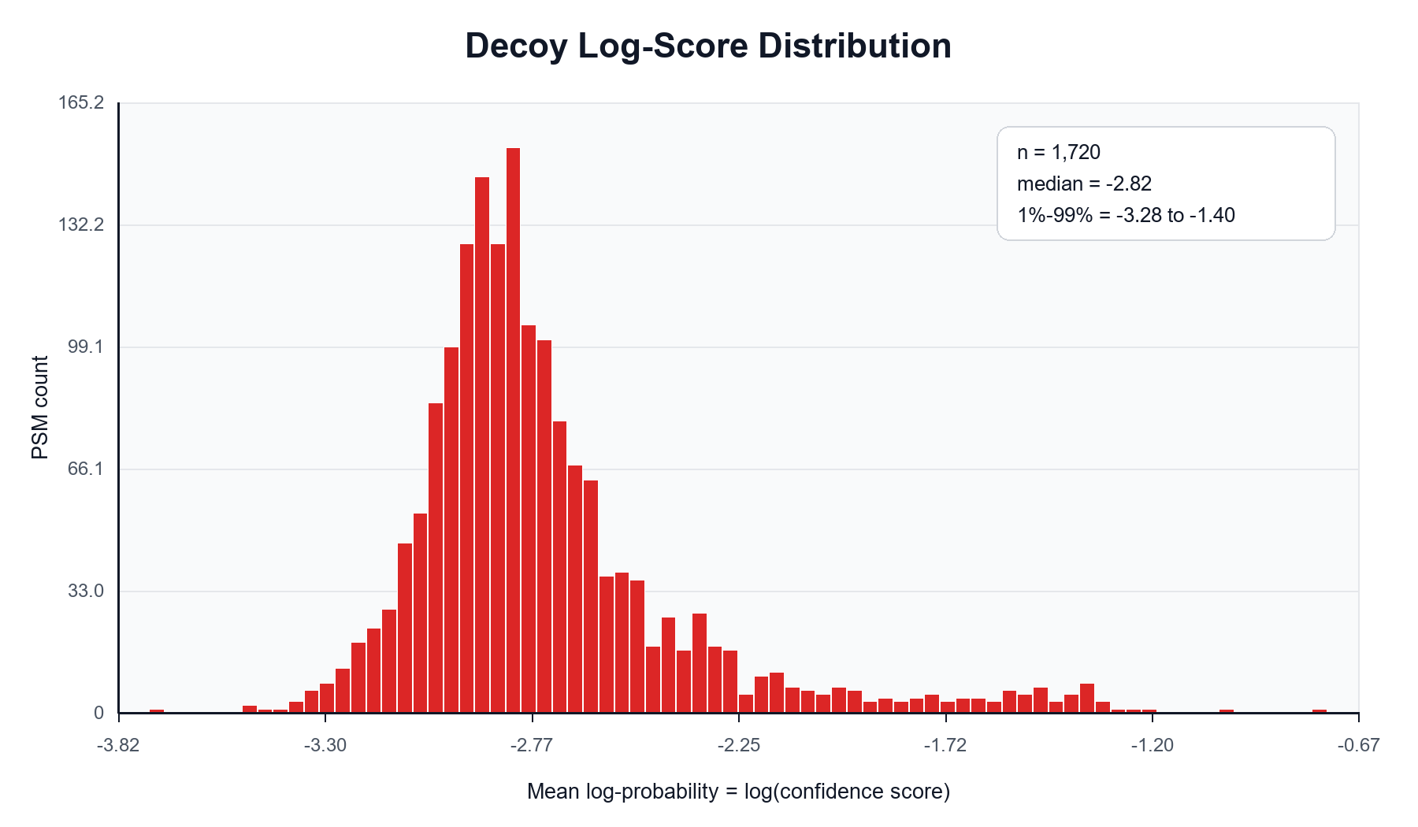
Figure 3. Decoy mean log-probabilities cluster far below the target median.

Target Distributions
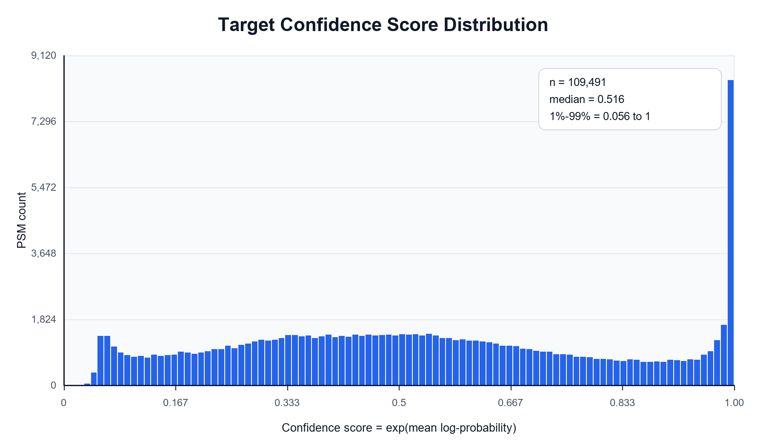
Figure 4. Target confidence scores are broadly shifted toward higher values.
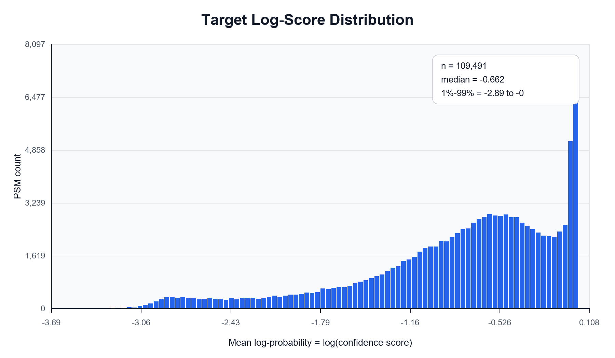
Figure 5. Target mean log-probabilities show the corresponding log-scale separation.

Suggested Wording
Suggested supervisor update: We implemented neural target-decoy competition after two-stage retrieval and InstaNovo/Casanovo-DB-style rescoring. The TDC procedure is internally consistent: with a 1:1 reverse-inner decoy database, the overall estimated top-1 FDR is 1.57%, and applying q <= 0.01 yields 108,346 accepted target PSMs at approximately 1% estimated FDR. The expanded score-threshold sweep confirms that the practical 1% boundary is near score 0.056-0.060; at score >= 0.06, the estimated FDR is 0.79% while keeping 97.6% of PSMs. The target and decoy score distributions are well separated. However, because benchmark labels are available, we also report exact sequence accuracy: about 82% overall and 84% among q <= 0.01 accepted targets. This indicates residual target-vs-target errors, especially likely around modified or closely related peptide variants, so the FDR result is promising but should be presented together with benchmark exact-match accuracy.

