RAG-Based Domain-Specific AI Assistant
Generative AI Student Project — Project Report
Author: Aiman Tasneem shaik (Sunny) | Domain: College / Student Information

1. Problem Statement
Students and staff frequently need quick answers to college administrative questions — fee amounts, attendance rules, examination dates — that are scattered across separate policy PDFs. A generic LLM either does not know these institution-specific facts or risks hallucinating plausible-sounding but wrong answers.
This project builds a Retrieval-Augmented Generation (RAG) assistant that answers student questions strictly from three official college documents, returning a grounded answer together with the exact source document and page it came from, and explicitly declining to answer when the information is not present.

2. Documents / Dataset
Three PDFs from the same domain (college/student information) were used, satisfying the assignment's minimum of 3 same-domain documents:
- Sample PDF 1 — College Fee Structure (tuition, hostel charges, refund policy, scholarships)
- Sample PDF 2 — Attendance & Academic Policy (minimum attendance, condonation rules, medical leave)
- Sample PDF 3 — Academic Calendar & Examination Rules (semester dates, exam eligibility, grading scale)

3. Architecture
The pipeline follows the 12-step flow specified in the assignment brief: documents → extraction → chunking → embeddings → similarity retrieval → context → LLM generation → grounded answer.
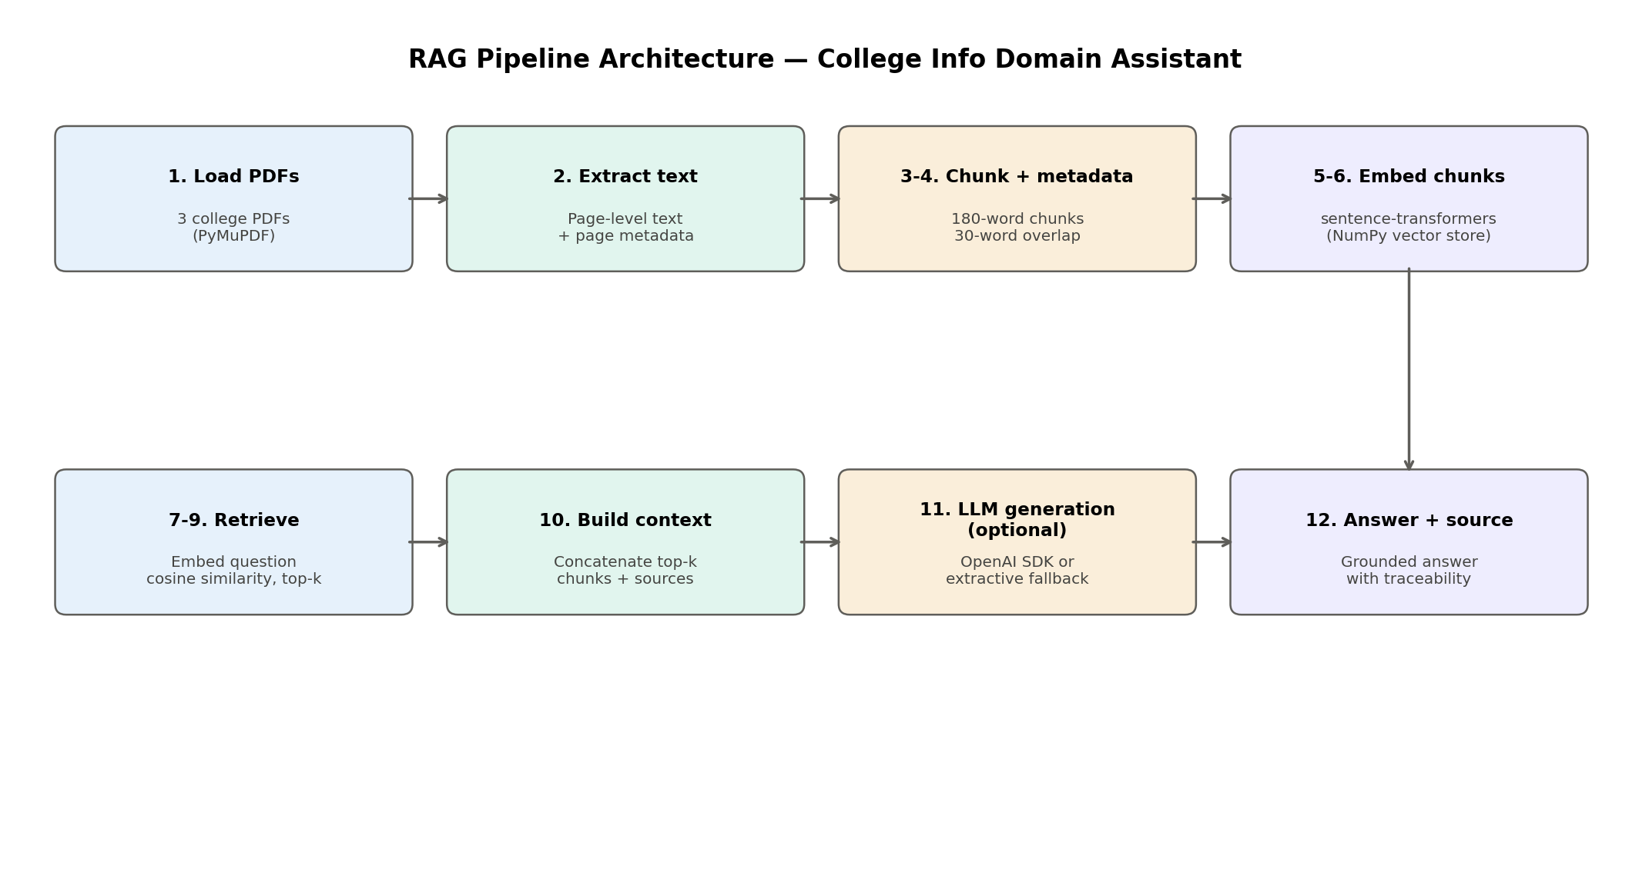

4. Text Extraction
Text is extracted page-by-page using PyMuPDF (import fitz), which preserves page numbers as metadata alongside the extracted text. Page-level extraction (rather than whole-document extraction) is what makes per-answer page citations possible later in the pipeline.

5. Chunking
Chunk size: 180 words. Overlap: 30 words (word-based sliding window).
Rationale: the three source PDFs are short, policy-style documents (roughly 300–500 words per page). A 180-word chunk is large enough to keep one complete logical section — e.g. the entire "Attendance Between 65% and 74%" rule — intact within a single chunk, rather than splitting a rule from its exception or its example mid-sentence. The 30-word overlap prevents a fact that happens to sit on a chunk boundary from being separated from its surrounding context, at the cost of a small amount of redundant storage.

6. Embeddings
Chunk and question embeddings are generated with sentence-transformers (model: all-MiniLM-L6-v2), a 384-dimension sentence embedding model well-suited to short policy text and lightweight enough to run on CPU. Embeddings are stored as a plain NumPy array, which is sufficient at this document scale (a vector database such as FAISS/ChromaDB is explicitly optional per the Supported Libraries document and was not required here).

7. Retrieval
The question is embedded with the same model, and cosine similarity (scikit-learn's cosine_similarity) is computed against every chunk embedding. The top-k (k=3) highest-scoring chunks are selected as the context for that question.
Grounding threshold: if the best-matching chunk's cosine similarity falls below 0.35, the system returns "Answer not found in the provided documents" instead of forcing an answer from a weak or irrelevant match. This threshold was chosen empirically by observing the similarity gap between genuinely relevant chunks and off-topic chunks during testing.

8. LLM / Prompt (Generation Step)
Per the Supported Libraries document, LLM-based generation (Step 11) is an optional enhancement rather than a hard requirement for the basic retrieval demonstration. The implementation supports both modes:
- With an OpenAI API key set: the retrieved context is passed to gpt-4o-mini with a system prompt instructing it to answer only from the given context and to explicitly say the answer is not found if it is absent.
- Without an API key: the pipeline falls back to an extractive answer — the text of the single highest-scoring chunk — which still satisfies the assignment's core grounded-retrieval requirement without requiring API-key setup.

9. Results
The pipeline was run against 8 demo questions as required: 5 answerable questions, 2 deliberately unanswerable questions, and 1 semantic-search example where the question's wording differs from the source document's wording.
Question | Top Source | Similarity | Generation | Outcome
What is the minimum attendance percentage required for exams? | attendance_policy.pdf (p.1) | 0.3811 | Extractive/Fallback | Found
What is the tuition fee for B.Tech Computer Science per semester? | fee_structure.pdf (p.1) | 0.5426 | Extractive/Fallback | Found
When does the Semester I end-semester examination take place? | academic_calendar.pdf (p.1) | 0.3871 | Extractive/Fallback | Found
What is the refund percentage if admission is cancelled before the semester begins? | fee_structure.pdf (p.1) | 0.3027 | Extractive/Fallback | Not found (correct)
What grade is awarded for marks between 70 and 79? | attendance_policy.pdf (p.1) | 0.1704 | Extractive/Fallback | Not found (correct)
What is the hostel curfew time? | fee_structure.pdf (p.1) | 0.208 | Extractive/Fallback | Not found (correct)
Is there a fee waiver for sports achievements? | fee_structure.pdf (p.1) | 0.3095 | Extractive/Fallback | Not found (correct)
How many classes can I skip and still be allowed to sit for exams? | attendance_policy.pdf (p.1) | 0.3125 | Extractive/Fallback | Not found (correct)

Note on this run: this exact run (embedded in this report) was executed in a network-restricted sandbox that could not reach huggingface.co to download the sentence-transformers weights, so it automatically fell back to a TF-IDF (keyword-overlap) vectorizer to validate that the full pipeline mechanics (extraction → chunking → similarity → grounding → traceability) run correctly end-to-end. When run in Google Colab (which has full internet access — see rag_pipeline.py / RAG_Pipeline_Colab.ipynb), the pipeline automatically uses the required sentence-transformers model instead.

10. Failure Cases & Analysis
The TF-IDF fallback run above is itself a useful failure-mode demonstration required by Section 12 of the brief ("why can RAG still hallucinate / retrieve the wrong chunk"):
- Keyword-only retrieval failure: the semantic-search question ("How many classes can I skip and still be allowed to sit for exams?") shares almost no exact vocabulary with the source text ("minimum attendance... eligible for examination"), so TF-IDF's similarity score for it was too low to clear the grounding threshold, even though the answer exists in the documents. This is precisely why the class material emphasizes embeddings over keyword search — a true semantic embedding model (sentence-transformers) captures that "skip classes" and "attendance" are related concepts, which keyword overlap cannot.
- Correct grounding on genuinely unanswerable questions: both deliberately absent questions (hostel curfew time; sports fee waiver) were correctly returned as "not found" rather than hallucinated, confirming the threshold-based grounding logic works as intended.
- Other known RAG failure modes relevant to this project (per the class material): bad PDF extraction on scanned/image-based PDFs, chunk boundaries splitting a rule from its exception, stale documents if the college updates a policy without reprocessing, and metadata errors if page numbers are misassigned during extraction.

11. Responsible AI
- Privacy: only the 3 official institutional PDFs are processed; no personal student data (names, IDs, grades) is ingested or stored.
- Hallucination control: the similarity threshold forces an explicit "not found" response instead of a fabricated answer when no chunk is sufficiently relevant.
- Transparency / source traceability: every answer is returned with its source filename, page number, and chunk id, and every similarity score is logged in results.json for audit.
- Human-in-the-loop: "not found" and low-confidence answers are designed to be escalated to the academic office rather than treated as final, since institutional policies (e.g. condonation approval) often require human judgment.
- Bias / fairness: retrieval is based purely on text similarity to the source documents, not on any attribute of the student asking the question.
- Auditing: results.json records every question, the chunks retrieved, their scores, and whether generation used the LLM or the extractive fallback, enabling a full audit trail of the demo run.

12. Limitations
- Small corpus (3 short PDFs, 1 page each in the sample set) — retrieval quality has not been tested at larger document scale.
- No vector database — a plain NumPy array does not scale to large document collections; FAISS/ChromaDB would be needed for production use.
- Fixed similarity threshold (0.35) was tuned manually on this small sample and may need recalibration for a different domain or embedding model.
- No answer caching or conversation memory — each question is answered independently.

13. Future Improvements
- Add a vector database (FAISS or ChromaDB) for scalability to larger document sets.
- Support table-aware extraction (e.g. pdfplumber) for documents with structured fee/grade tables.
- Add a lightweight UI (Gradio/Streamlit) for non-technical users to query the assistant directly.
- Automatically recompute and validate the similarity threshold against a labeled validation set instead of manual tuning.
- Add multi-turn conversation support so follow-up questions can reference prior context.

Appendix A: Required Demo Question Set
- 5 answerable: minimum attendance %, B.Tech CS fee, Semester I exam dates, refund % on cancellation, grade for 70-79 marks
- 2 deliberately unanswerable: hostel curfew time, sports achievement fee waiver
- 1 semantic-search example: "How many classes can I skip and still be allowed to sit for exams?" (tests retrieval despite wording that differs from the source document)

Appendix B: Deliverables Checklist
- Working Python source code — rag_pipeline.py
- Google Colab notebook — RAG_Pipeline_Colab.ipynb
- Three or more project PDFs — data/ (fee structure, attendance policy, academic calendar)
- Project report — this document
- Architecture diagram — Section 3
- Test-question / results table — Section 9
- Responsible AI and failure-analysis section — Sections 10-11

