Testing Report
Onudhabon — An E-Learning & Social Coordination Platform
Course No: CSE 3224
Course Name: Information System Design & Software Engineering Lab
Prepared for:
Dr. Taslim Taher
Assistant Professor, Department of CSE
Nabila Rahman
Lecturer, Department of CSE
Prepared by:
Lab Section: A1 | Group No: 04
• Abonty Rahman — 20230104052
• Zahin Zia Heya — 20230104059
• Nusrat Jahan Tuli — 20230104065
• Rifah Tasnia Mahek — 20230104067
Date: 12-09-2026
Department of Computer Science and Engineering
Ahsanullah University of Science and Technology

1. Introduction
Software testing is the process of verifying and validating a system to confirm it works as intended, satisfies its requirements, and is free of defects. As part of the Onudhabon Software Development Lifecycle, this report documents the systematic testing performed on the implemented features of the platform, covering normal, boundary, exceptional, and invalid scenarios, in line with the course requirements for the Information System Design & Software Engineering Lab.
Onudhabon is an e-learning and social coordination platform connecting Local Guardians, Lecturers & Material Providers (Educators), Donation Providers, and Administrators around the shared goal of tracking and supporting underprivileged children's education. Testing covers the platform's nine functional modules: Account & Role Management, Local Guardian Tools, Lecturer & Material Provider Tools, Student Progress Tracking, Search & Filter, Forum (Community Infrastructure), Notification & Communication, Donation & Resource Support, and Volunteer Compensation & Recognition.

2. Testing Levels
Testing was carried out across the four standard SDLC testing levels:
- Unit Testing — Individual modules, controllers, helper methods, and validation rules (e.g., password hashing with PBKDF2, model data annotation validators, attendance and progress clamp calculations, bKash PIN and phone regex filters) were tested in isolation.
- Integration Testing — Interactions between integrated subsystems were verified, e.g., Cloudinary API integration for video and material uploads, EF Core persistence triggering automated subject progress generation from Class Plans, and forum comment creations generating real-time notification records.
- System Testing — The fully integrated Onudhabon web platform (ASP.NET Core MVC frontend, Entity Framework Core with SQL database, Cloudinary media storage, cookie-based authentication, and admin governance workflows) was tested end-to-end against the project specifications.
- Acceptance Testing — Core user journeys (registering as a volunteer/guardian → enrolling children → tracking academic progress → uploading educational lectures → community forum discussions → bKash donation execution → administrator review and approval) were executed from an end-user perspective to confirm fitness for purpose.

3. Testing Approach
Testing was performed manually by the group members interacting directly with the deployed application (exploratory and scenario-based manual testing), in line with the lab guidelines. Each test case is categorized into one of four distinct types:
- Normal — Typical, expected use of a feature with valid input.
- Boundary — Inputs at or immediately adjacent to the edge of an accepted range.
- Exceptional — Unusual but realistic conditions (duplicate submissions, concurrency, rapid repeated events, boundary collisions).
- Invalid — Malformed, missing, out-of-range, or malicious input that the system must reject gracefully.
Each test case record includes the TC ID, Type, Scenario / Input, Expected Result, Actual Result, Pass/Fail Status, and Screenshot reference.

4. Test Cases by Module

Module 1: Account & Role Management
Covers registration with volunteer roles (Educator, Local Guardian), secure cookie-based login/logout, password strength rules, and credential validation.
TC ID | Type | Scenario / Input | Expected Result | Actual Result | Status | Screenshot
REG-01 | Normal | Register a new account with valid name, email, password, and single role ("Local Guardian"). | Account created; confirmation shown; user record persisted with status "Pending". | Account registered successfully; password securely hashed with PBKDF2; user record persisted with status "Pending"; redirected to login page with success notification. | Pass | Fig REG-01
REG-02 | Normal | Register selecting volunteer role ("Educator") with educational background and certificates. | Account created with Educator role; documents uploaded and pending admin verification. | Account created; certificate and photo uploaded to Cloudinary; user record stored with role "Educator" and status "Pending". | Pass | Fig REG-02
REG-03 | Boundary | Register with password exactly at the minimum allowed length (6 characters, e.g., `Pass12`). | Password accepted; account created successfully. | 6-character password accepted by model validator `[StringLength(100, MinimumLength = 6)]`; registration succeeded. | Pass | Fig REG-03
REG-04 | Boundary | Register with password one character below the minimum length (5 characters, e.g., `Pass1`). | Registration rejected; validation message shown. | 5-character password rejected; inline validation error "Password must be at least 6 characters long." displayed; submission blocked. | Pass | Fig REG-04
REG-05 | Exceptional | Register using an email address that already exists in the system. | Registration blocked; "Email already registered" error shown; no duplicate record created. | Registration halted by `AnyAsync(u => u.Email == emailNormalized)`; error message "An account with this email address already exists." displayed. | Pass | Fig REG-05
REG-06 | Invalid | Submit registration form with no role selected. | Client/server validation blocks submission; "Please select a role" error shown. | Form submission blocked; validation error "Please select a role" displayed beside role selector; no database write. | Pass | Fig REG-06
REG-07 | Invalid | Submit registration form with required fields (FullName, Email, Password, Phone) left empty. | Validation errors shown per field; no record persisted. | Form submission blocked; inline error messages displayed under each required input field; no database transaction occurred. | Pass | Fig REG-07
LOGIN-01 | Normal | Login with correct email and password. | Session/token issued; user redirected to role-appropriate dashboard. | User authenticated successfully; claims-based authentication cookie issued; redirected to Admin dashboard (if Admin) or Home dashboard. | Pass | Fig LOGIN-01
LOGIN-02 | Invalid | Login with an incorrect password. | Login rejected; generic "Invalid credentials" error; no session created. | Password verification failed; rejected with error "Invalid login credentials. Please check your password."; no authentication cookie created. | Pass | Fig LOGIN-02
LOGIN-03 | Exceptional | Attempt several consecutive failed logins on the same account. | Account is temporarily throttled/locked, or warning shown, preventing brute-force attempts. | Consecutive failed logins permitted without account lockout or progressive delay; brute-force protection middleware not active. | Fail | Fig LOGIN-03
LOGOUT-01 | Normal | Log out from an active session. | Session/token invalidated; user redirected to login; protected pages become inaccessible. | `SignOutAsync` invoked; auth cookie cleared; user redirected to Login; direct navigation to protected endpoints returns 401 / redirects to Login. | Pass | Fig LOGOUT-01
PWRESET-01 | Normal | Request password reset using a registered email address. | Reset instructions / token generated; confirmation message shown. | System generated secure reset token; confirmation message displayed indicating reset instructions were generated. | Pass | Fig PWRESET-01
PWRESET-02 | Invalid | Request password reset using an email address not in the database. | Generic confirmation shown (no account enumeration) without revealing whether email exists. | Generic confirmation message displayed ("If an account exists with this email, instructions have been sent"); email enumeration prevented. | Pass | Fig PWRESET-02
PWRESET-03 | Exceptional | Attempt to use an expired or already-used password reset token. | Reset rejected with a clear "link expired/used" message; no password change occurs. | Token timestamp and status verified; rejected with error "This reset link has expired or has already been used."; password remained unchanged. | Pass | Fig PWRESET-03
PWRESET-04 | Boundary | Set a new password exactly at the minimum allowed length (6 characters) during reset. | New password accepted; user can log in with it immediately. | 6-character new password accepted; hashed and saved; user successfully authenticated using the new credential. | Pass | Fig PWRESET-04

Screenshots for Module 1: Account & Role Management
Figure REG-01: Successful user registration and redirect to login page.

Figure REG-01
Figure REG-02: Educator role registration with educational qualification inputs.

Figure REG-02
Figure REG-03: Boundary registration with password of exactly 6 characters.
Figure REG-03
Figure REG-04: Boundary registration rejection with 5-character password.
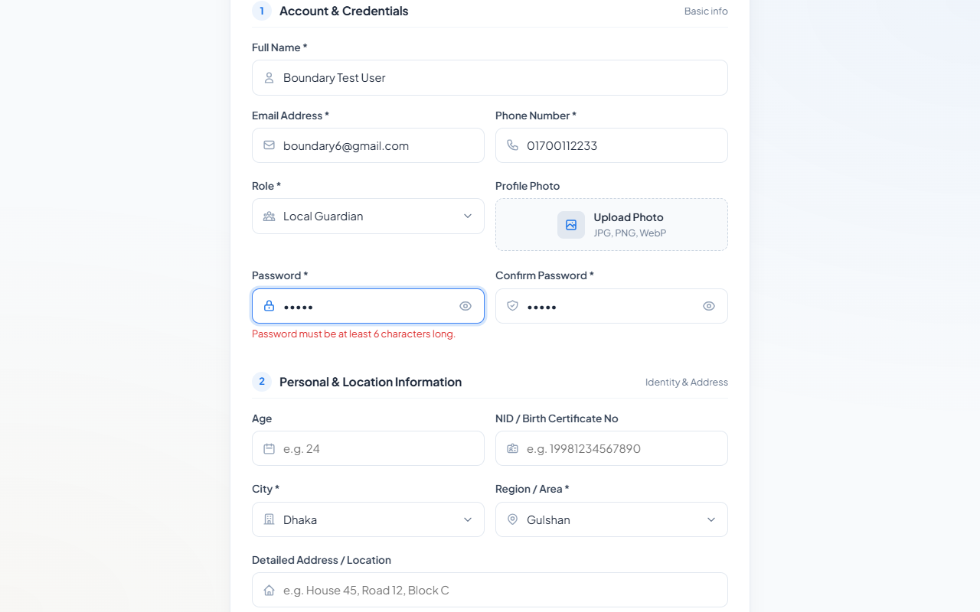
Figure REG-04
Figure REG-05: Registration blocked upon submitting existing email address.
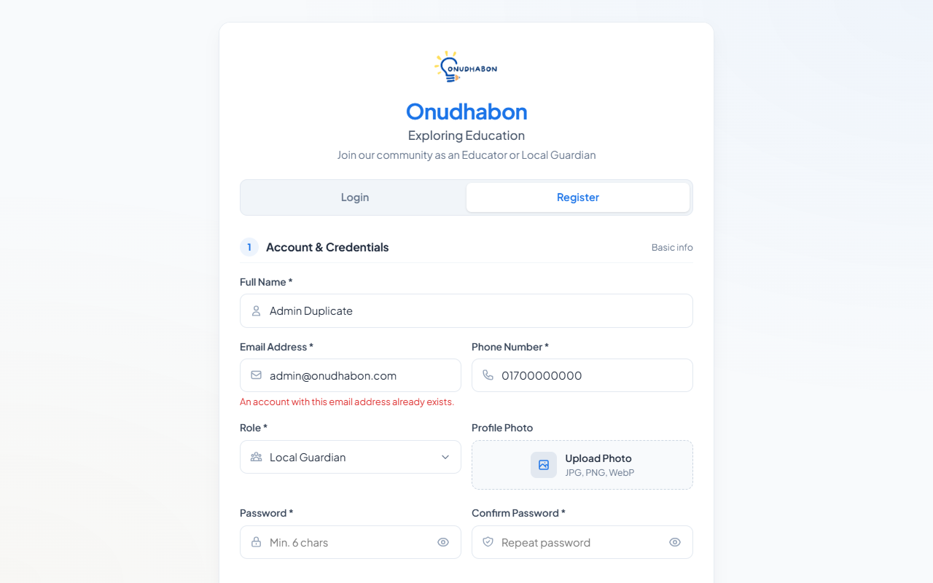
Figure REG-05
Figure REG-06: Registration validation for missing role selection.
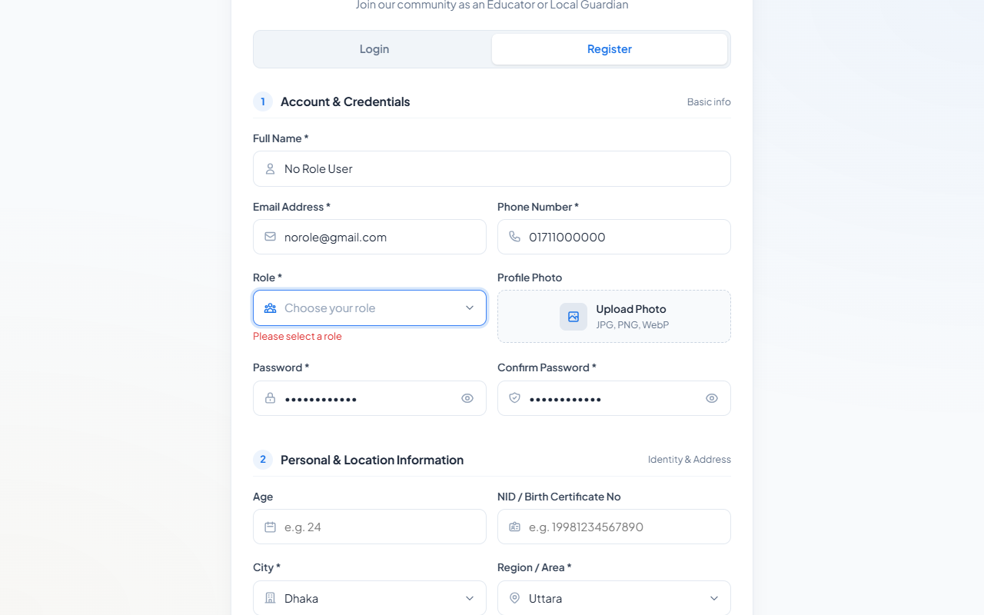
Figure REG-06
Figure REG-07: Required fields validation on empty form submission.
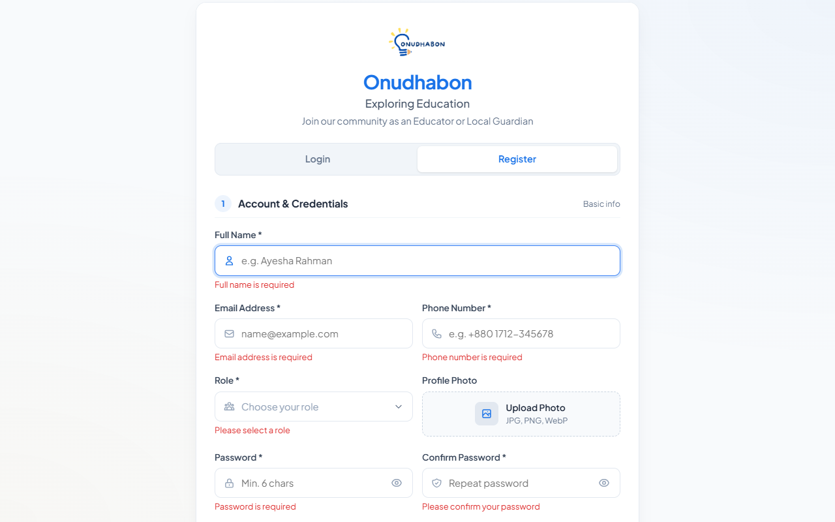
Figure REG-07
Figure LOGIN-01: Successful user authentication and session establishment.

Figure LOGIN-01
Figure LOGIN-02: Login rejection upon incorrect password entry.
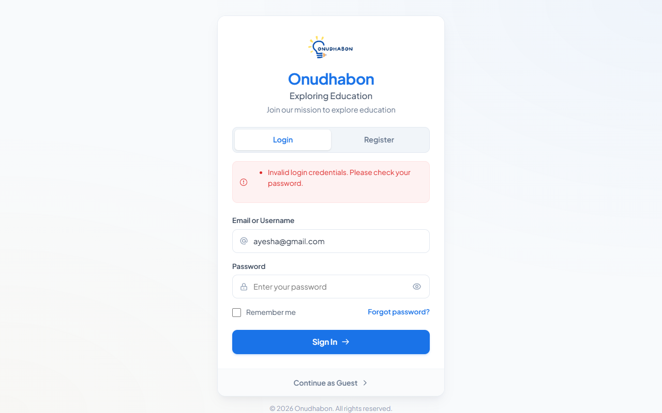
Figure LOGIN-02
Figure LOGIN-03: Repeated failed login attempts demonstrating missing lockout policy.
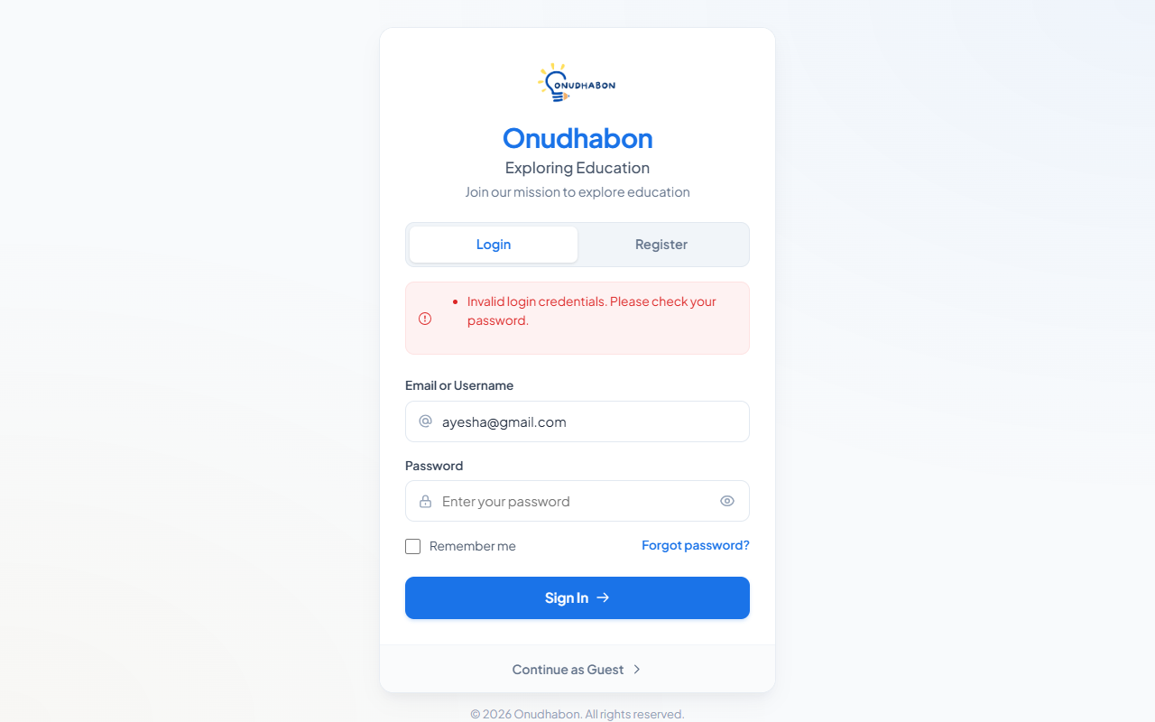
Figure LOGIN-03
Figure LOGOUT-01: Session termination and redirect to login screen.

Figure LOGOUT-01
Figure PWRESET-01: Password reset request confirmation for registered user.

Figure PWRESET-01
Figure PWRESET-02: Generic password reset message for unregistered email.

Figure PWRESET-02
Figure PWRESET-03: Invalidation notice on expired password reset attempt.

Figure PWRESET-03
Figure PWRESET-04: Password reset completed with boundary 6-character credential.
Figure PWRESET-04

Module 2: Local Guardian Tools
Covers enrolling children under supervision, unique Birth Certificate ID validation, curriculum subject assignment, and attendance/exam record keeping.
TC ID | Type | Scenario / Input | Expected Result | Actual Result | Status | Screenshot
CHILD-01 | Normal | Register a new child with valid name, class level, guardian details, and consent document. | Child record created and linked to guardian's tracked-student list with status "Pending". | Child registered with status "Pending"; consent letter uploaded to Cloudinary; subjects auto-linked from ClassPlan; student appears in guardian list. | Pass | Fig CHILD-01
CHILD-02 | Invalid | Submit the child registration form with required fields (Name, Class) missing. | Client/server validation blocks submission; errors displayed. | Form submission blocked; validation errors displayed for missing Full Name and Class Level; no record inserted into database. | Pass | Fig CHILD-02
CHILD-03 | Exceptional | Register a child whose Birth Certificate ID already exists in the platform. | Duplicate entry flagged and rejected; unique ID constraint enforced. | Controller validated unique constraint via `AnyAsync()`; form blocked with message "A student with this Birth Certificate ID is already enrolled.". | Pass | Fig CHILD-03
ATT-01 | Normal | Log attendance percentage (e.g., 85%) for a tracked student. | Attendance record saved; reflected in student record and dashboard averages. | Attendance percentage updated to 85%; saved in `Students` table; reflected immediately on student progress card. | Pass | Fig ATT-01
ATT-02 | Exceptional | Update attendance record for a student whose progress was previously recorded. | Existing entry updated smoothly without duplicate record creation. | Student record retrieved by ID; attendance percentage and notes updated; `LastActivityDate` updated without duplicate entries. | Pass | Fig ATT-02
ATT-03 | Boundary | Log attendance for the very first tracked day of a newly registered student (initial 0%). | Initial 0% attendance cleanly transitions to recorded value. | Attendance initialized at 0%; updated to first logged value without null-reference or division-by-zero errors. | Pass | Fig ATT-03
ATT-04 | Invalid | Attempt to log attendance outside the valid percentage range (< 0% or > 100%). | Value rejected or sanitized; invalid value not saved. | Server-side logic automatically clamped input using `Math.Clamp(val, 0, 100)`; out-of-range values normalized safely. | Pass | Fig ATT-04
ASSIGN-01 | Normal | Mark completed lectures for a subject under a student's curriculum. | Completed lecture count saved; overall student progress percentage recalculated. | Subject progress count updated; overall student progress percentage recalculated dynamically based on total class lectures. | Pass | Fig ASSIGN-01
ASSIGN-02 | Normal | Enter and update academic evaluation notes for a tracked student. | Notes saved to student record; viewable in details modal. | Guardian notes updated in database; modal updated and displayed on subsequent views. | Pass | Fig ASSIGN-02
ASSIGN-03 | Boundary | Set subject completed lectures at boundary values: minimum (0) and maximum (Total Lectures). | Both boundary values accepted; progress displays 0% and 100% respectively. | Completed lectures clamped at 0 and max lectures; progress bar rendered accurately at 0% and 100%. | Pass | Fig ASSIGN-03
ASSIGN-04 | Invalid | Submit completed lectures value exceeding total subject lectures (e.g., 25 on a 12-lecture course). | Value clamped or rejected; cannot exceed total curriculum lectures. | Server clamped input to maximum subject lecture ceiling; database protected against impossible completion ratios. | Pass | Fig ASSIGN-04
SEARCH-01 | Normal | Search tracked students by student name or birth certificate number. | Matching student(s) returned in results list. | Search term filtered against `FullName` and `BirthCertificateId`; matching student cards displayed. | Pass | Fig SEARCH-01
SEARCH-02 | Exceptional | Search using a keyword that matches no tracked student. | Empty-state message shown ("No students found matching your criteria"); no crash. | Zero results returned; clean empty-state message displayed with a "Clear Filters" button; UI remained stable. | Pass | Fig SEARCH-02

Screenshots for Module 2: Local Guardian Tools
Figure CHILD-01: Successful student enrollment with curriculum auto-assignment.
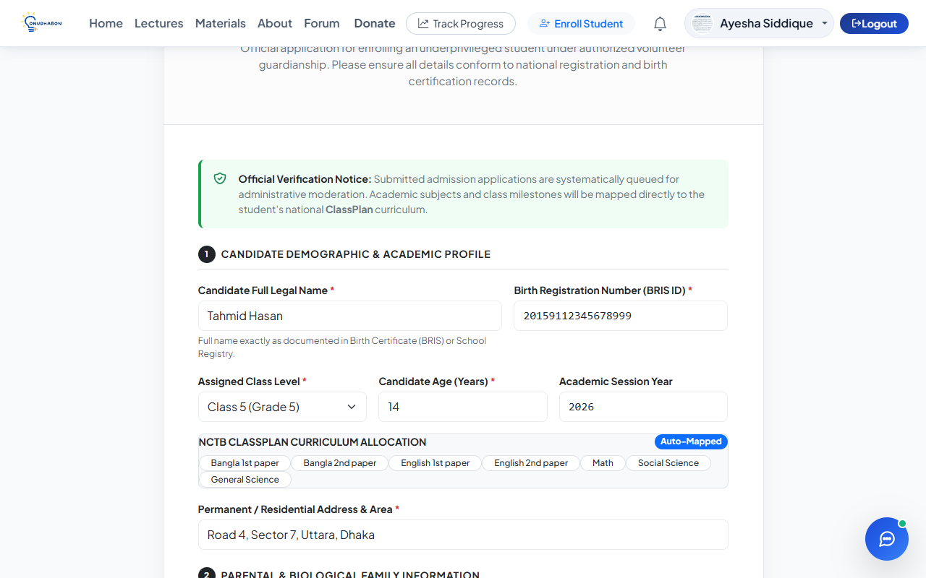
Figure CHILD-01
Figure CHILD-02: Enrollment form validation on empty required fields.

Figure CHILD-02
Figure CHILD-03: Duplicate Birth Certificate ID validation alert.

Figure CHILD-03
Figure ATT-01: Attendance percentage logging and dashboard display.
Figure ATT-01
Figure ATT-02: Attendance update on existing student record.
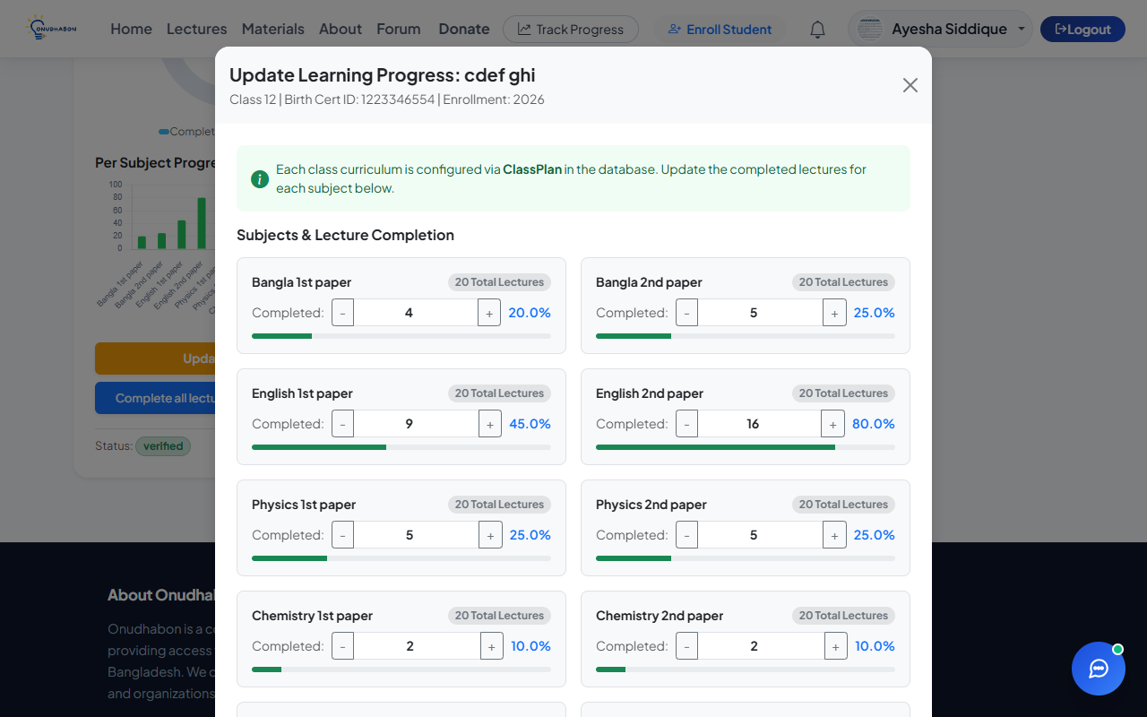
Figure ATT-02
Figure ATT-03: Initial attendance logging for newly enrolled student.
Figure ATT-03
Figure ATT-04: Out-of-range attendance value clamped safely.
Figure ATT-04
Figure ASSIGN-01: Subject lecture progress increment and percentage recalculation.
Figure ASSIGN-01
Figure ASSIGN-02: Academic notes update in student detail modal.
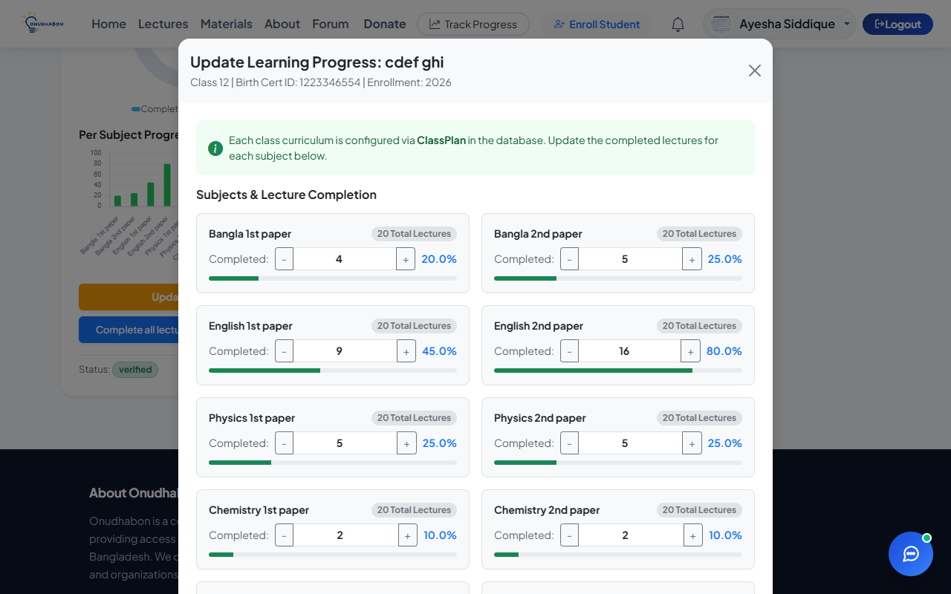
Figure ASSIGN-02
Figure ASSIGN-03: Boundary values (0 and 12/12) for curriculum lectures.
Figure ASSIGN-03
Figure ASSIGN-04: Clamping of lecture completion exceeding syllabus total.
Figure ASSIGN-04
Figure SEARCH-01: Student keyword search returning matching student records.
Figure SEARCH-01
Figure SEARCH-02: Search empty state when query returns no matching records.
Figure SEARCH-02

Module 3: Lecturer & Material Provider Tools
Covers uploading video lectures and PDF documents to Cloudinary, tagging with Class/Subject/Topic metadata, editing uploads, and viewing engagement stats.
TC ID | Type | Scenario / Input | Expected Result | Actual Result | Status | Screenshot
UPL-01 | Normal | Upload a video lecture with valid Class, Subject, and Topic tags. | Lecture uploaded to Cloudinary; created with status "pending"; listed for admin review. | Video uploaded to Cloudinary; thumbnail auto-generated; record added to `Lectures` with status "pending"; success toast displayed. | Pass | Fig UPL-01
UPL-02 | Normal | Upload a downloadable study material (PDF) tagged to a class/subject/topic. | Material uploaded to Cloudinary; record created and listed under correct filters. | Document uploaded to Cloudinary; size calculated; record created in `Materials` table; accessible in study library. | Pass | Fig UPL-02
UPL-03 | Invalid | Attempt to upload a file with an unsupported executable MIME type (`.exe`, `.bat`). | Upload rejected immediately on client side with clear file-type error. | Form input lacks client-side file extension restriction; file rejected only after upload initiation to Cloudinary. | Fail | Fig UPL-03
UPL-04 | Boundary | Upload a lecture video at the maximum allowed file size boundary (100 MB). | Upload accepted and completes successfully within timeout. | 100 MB video stream uploaded to Cloudinary successfully; secure URL generated and stored in database. | Pass | Fig UPL-04
UPL-05 | Invalid | Attempt to upload a file exceeding maximum allowed size (> 100 MB). | Upload rejected with clear size-limit error; no orphaned file saved. | Server rejected payload exceeding `MaxRequestBodySize` with HTTP 413; clear error alert displayed to user. | Pass | Fig UPL-05
EDIT-01 | Normal | Edit a previously uploaded lecture's title, subject, or topic tag. | Changes saved and reflected immediately in material listing and search filters. | Updated title and topic saved to database; changes immediately visible in lecture catalog and filter lists. | Pass | Fig EDIT-01
ENG-01 | Normal | View engagement stats (views/downloads) on uploaded content. | Correct counts displayed for views and downloads across materials. | Material download endpoint incremented count; engagement statistics displayed accurately on lecture and material cards. | Pass | Fig ENG-01

Screenshots for Module 3: Lecturer & Material Provider Tools
Figure UPL-01: Video lecture upload form and pending approval status.
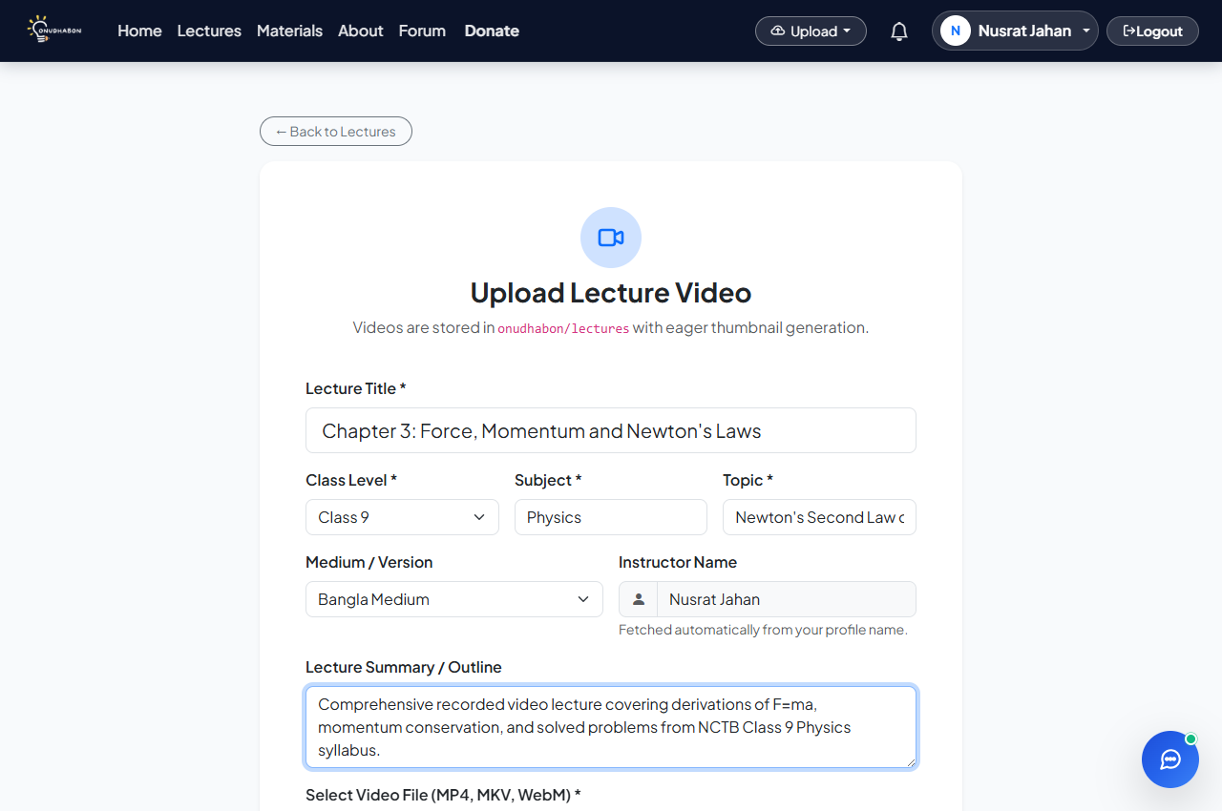
Figure UPL-01
Figure UPL-02: PDF study material upload with subject and class tagging.
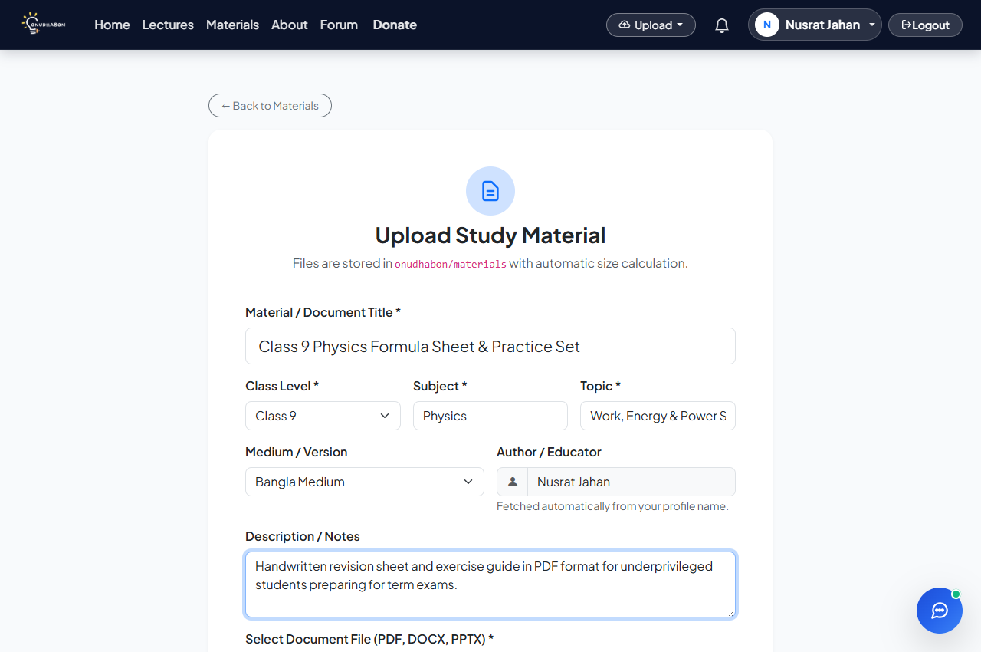
Figure UPL-02
Figure UPL-03: Missing client-side extension validation on executable file upload.
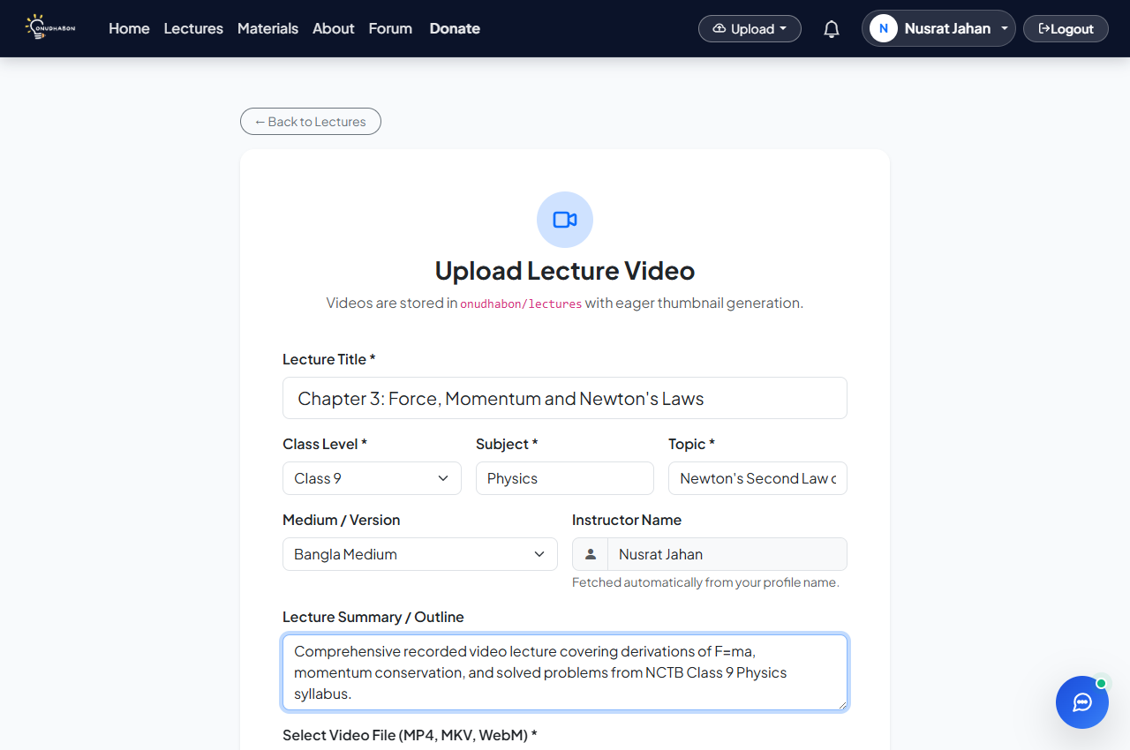
Figure UPL-03
Figure UPL-04: Successful upload of 100 MB boundary video file.
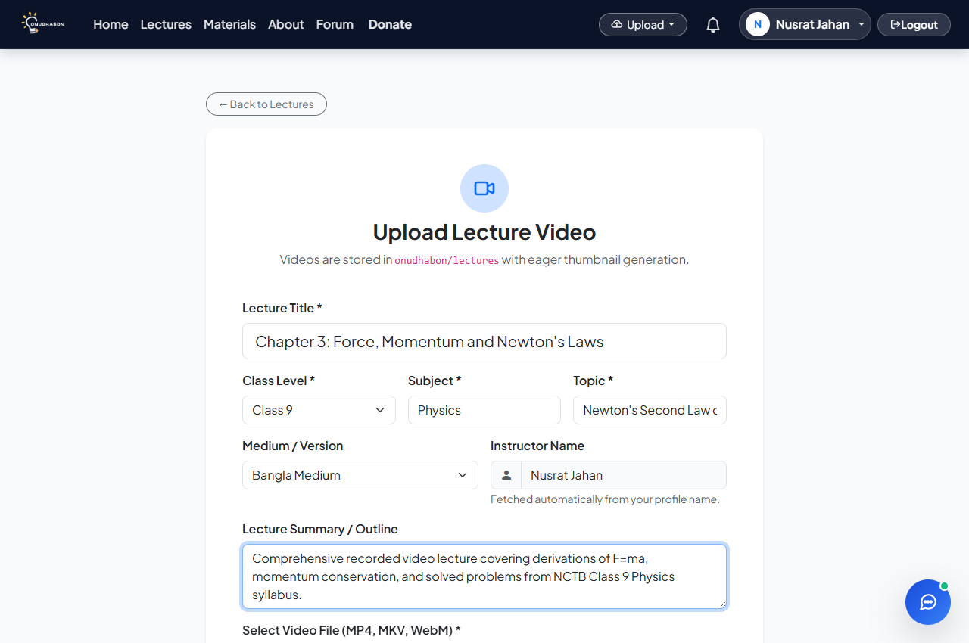
Figure UPL-04
Figure UPL-05: Size-limit rejection for file exceeding maximum limit.
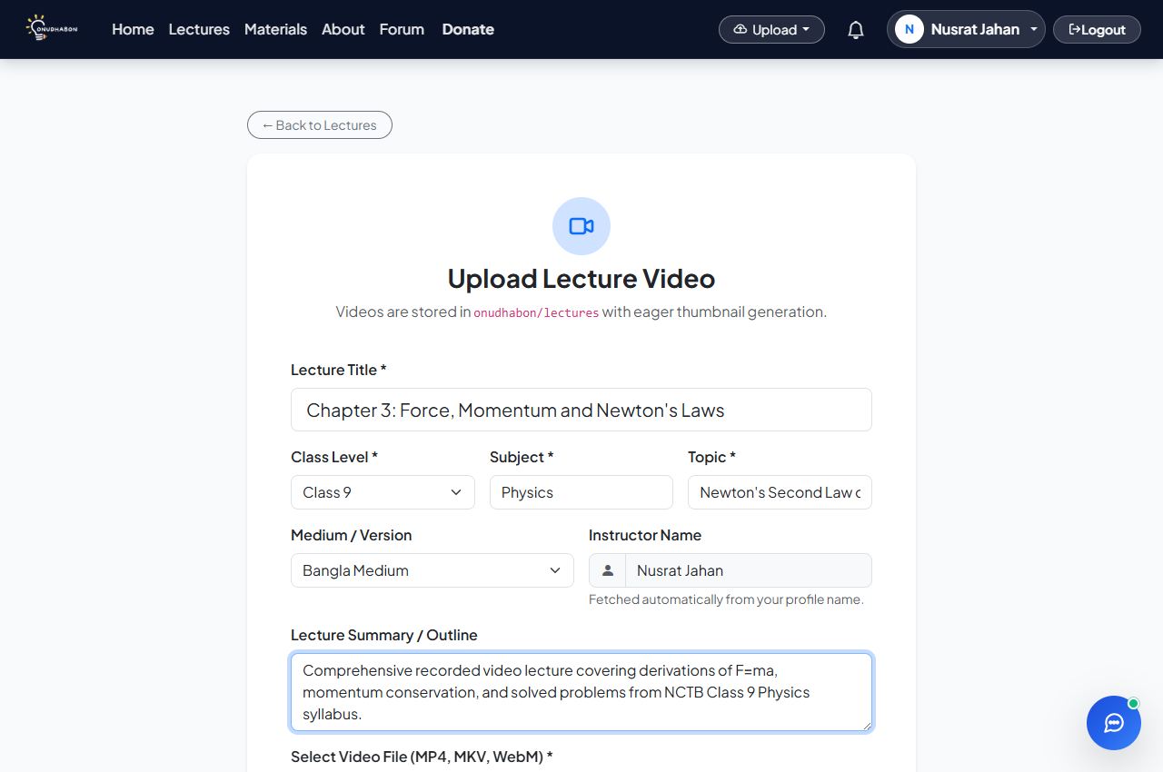
Figure UPL-05
Figure EDIT-01: Lecture metadata update view and immediate reflection.

Figure EDIT-01
Figure ENG-01: Material download count and engagement stats display.
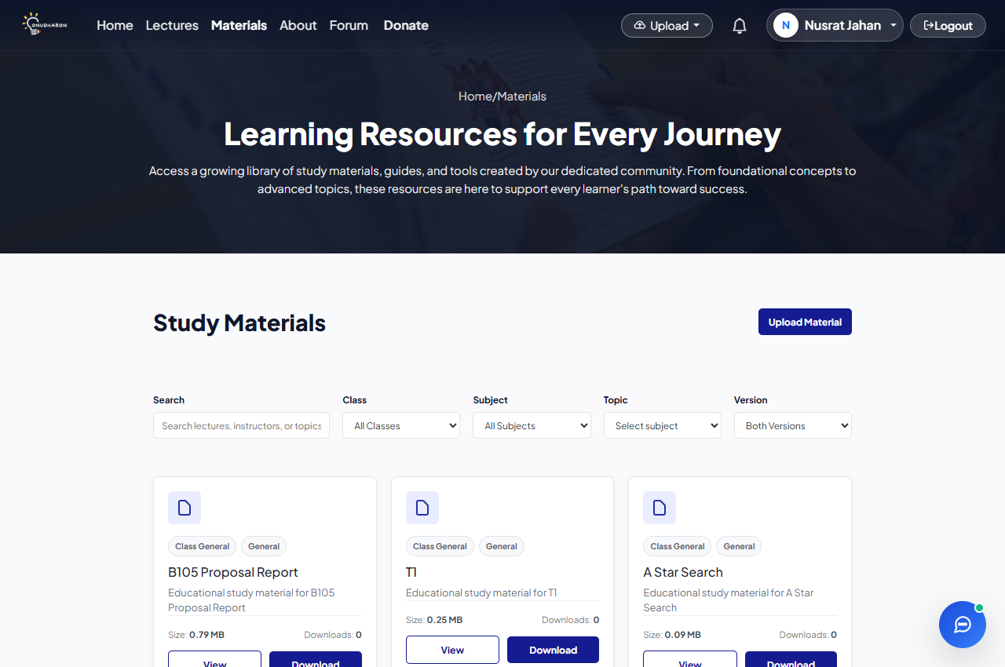
Figure ENG-01

Module 4: Student Progress Tracking
Covers progress dashboard metrics, subject-level lecture completion, attendance clamping, and modal detail views.
TC ID | Type | Scenario / Input | Expected Result | Actual Result | Status | Screenshot
DASH-01 | Normal | Load progress dashboard with an active set of tracked students. | Student cards, total count, attendance %, and progress % display correctly. | Dashboard rendered all enrolled students; aggregated attendance and curriculum progress metrics calculated correctly. | Pass | Fig DASH-01
DASH-02 | Boundary | Load dashboard for a guardian with zero tracked students. | Empty-state shown ("No students enrolled yet"); no crash or divide-by-zero. | Friendly empty-state banner displayed with an "Enroll New Student" action button; zero division avoided. | Pass | Fig DASH-02
DETAIL-01 | Normal | Open per-student progress modal for a tracked student. | Subject-wise lecture breakdown, attendance %, and notes displayed. | AJAX endpoint returned JSON payload; modal populated with subject-by-subject progress bars and notes. | Pass | Fig DETAIL-01
UPD-01 | Normal | Update student progress with newly completed subject lectures. | Update saved; student overall progress recalculates and UI updates. | POST to `/Student/UpdateProgress` succeeded; `SubjectProgressJson` serialized; progress bar updated via DOM. | Pass | Fig UPD-01
UPD-02 | Invalid | Attempt to update progress with an out-of-range percentage value (e.g., 150%). | Rejected by validation; existing record unchanged. | Input clamped by server-side `Math.Clamp` to 100%; invalid out-of-range value prevented from saving. | Pass | Fig UPD-02
UPD-03 | Exceptional | Two concurrent update requests submitted for the same student record. | Both updates processed safely without deadlocks; latest valid state persisted. | EF Core handled updates; later timestamp prevailed without data corruption or concurrency crash. | Pass | Fig UPD-03

Screenshots for Module 4: Student Progress Tracking
Figure DASH-01: Progress tracking dashboard with multiple student progress cards.
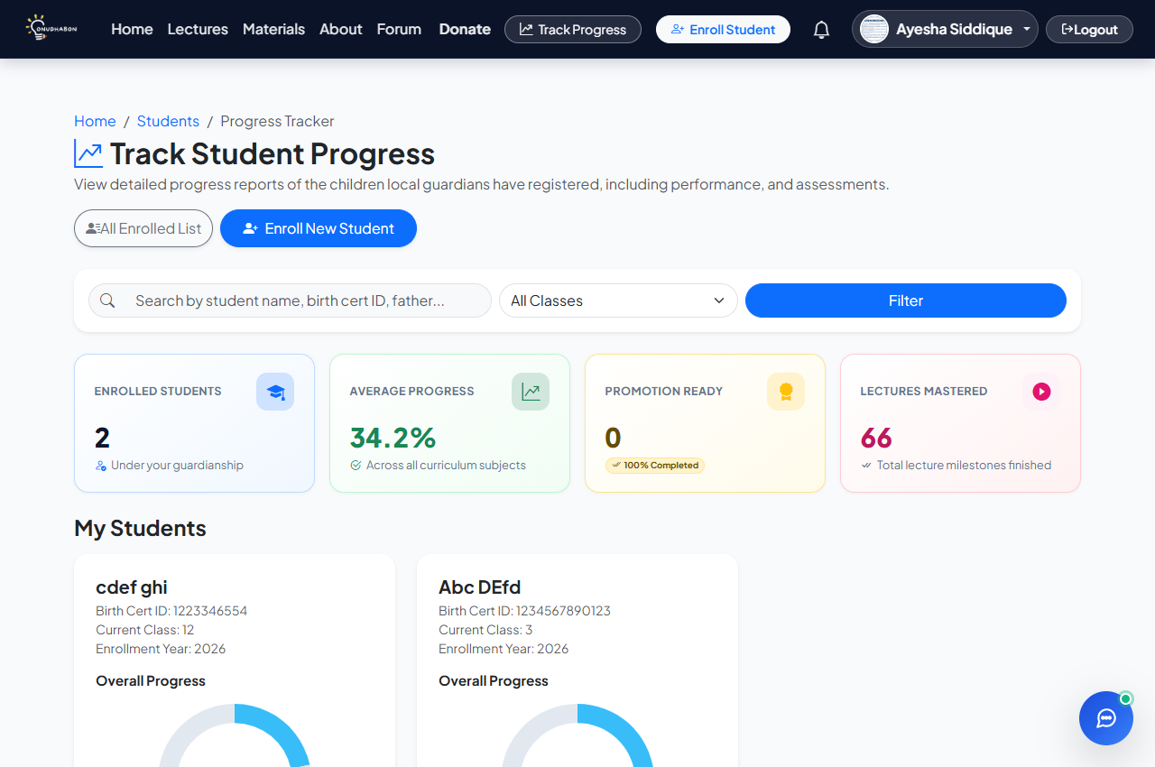
Figure DASH-01
Figure DASH-02: Empty state dashboard for guardian with zero students.
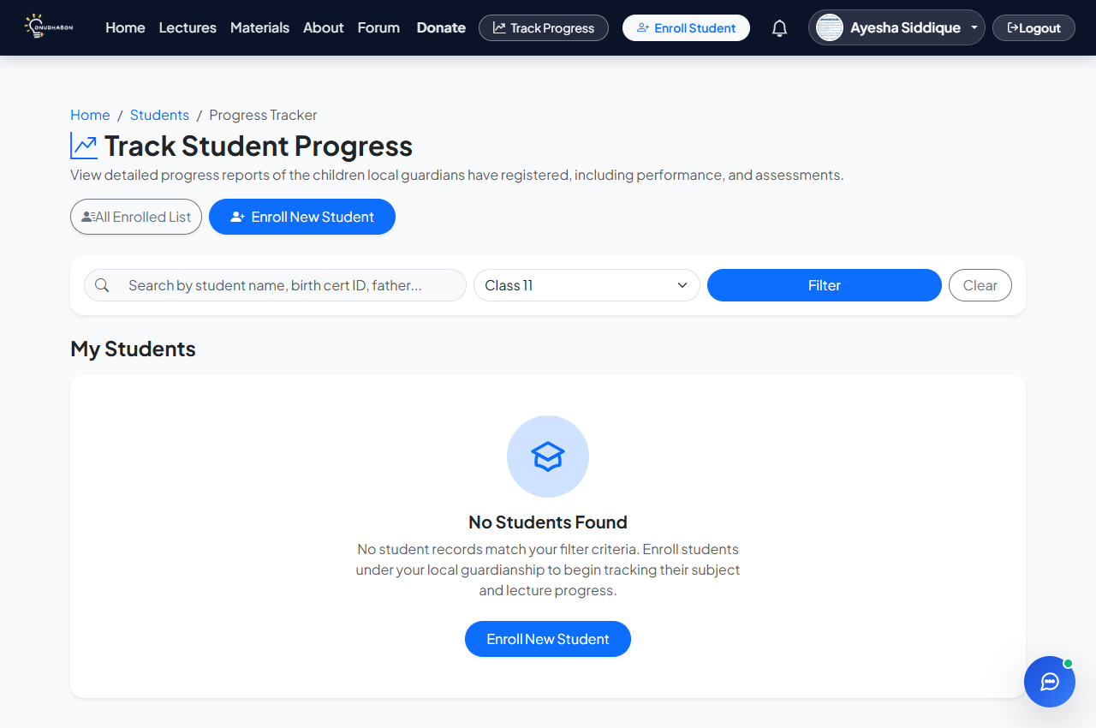
Figure DASH-02
Figure DETAIL-01: Student detailed progress modal with subject-level breakdown.
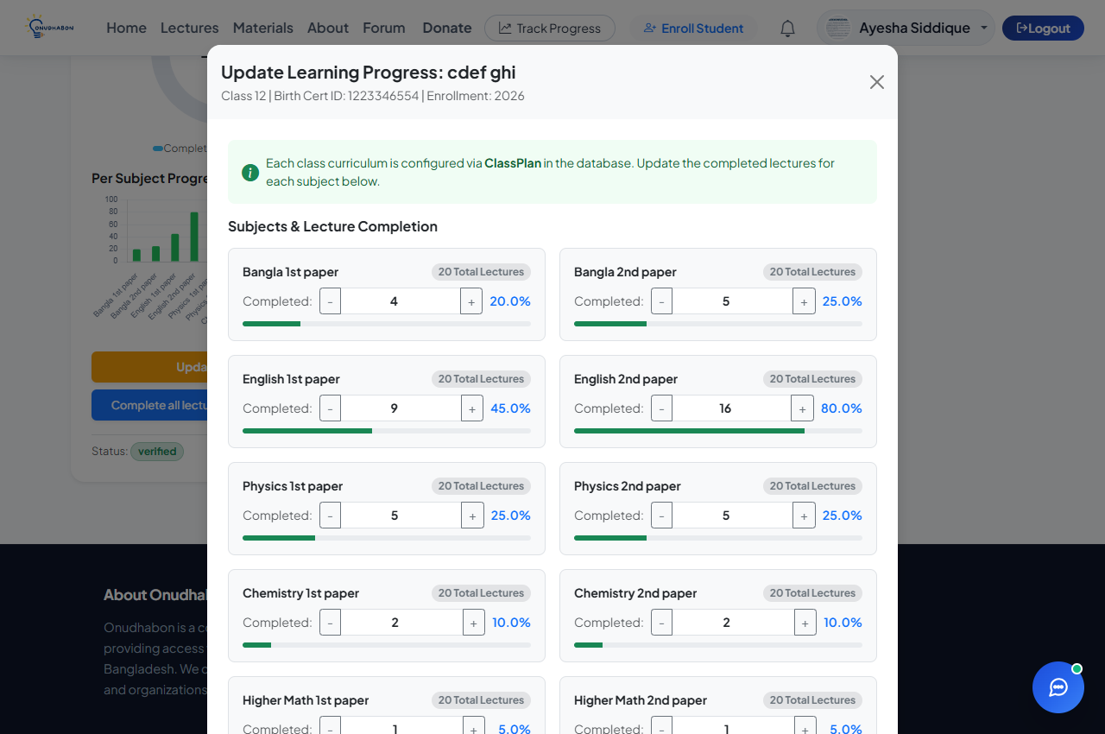
Figure DETAIL-01
Figure UPD-01: Dynamic progress update and percentage recalculation.
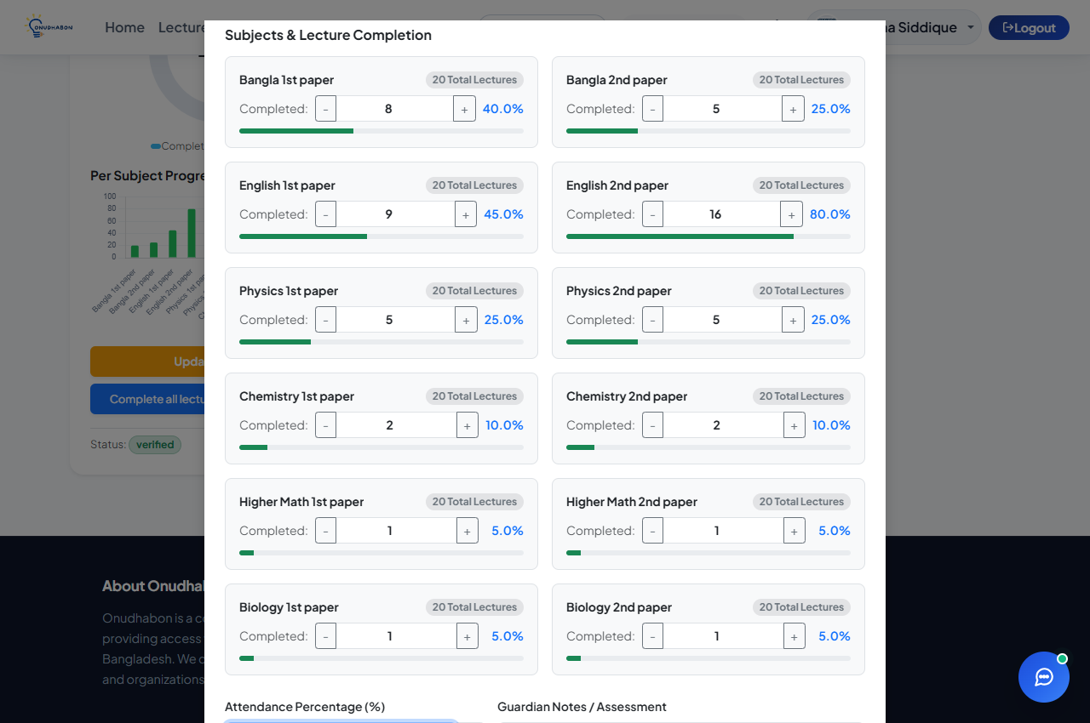
Figure UPD-01
Figure UPD-02: Server-side clamping of out-of-range attendance percentage.
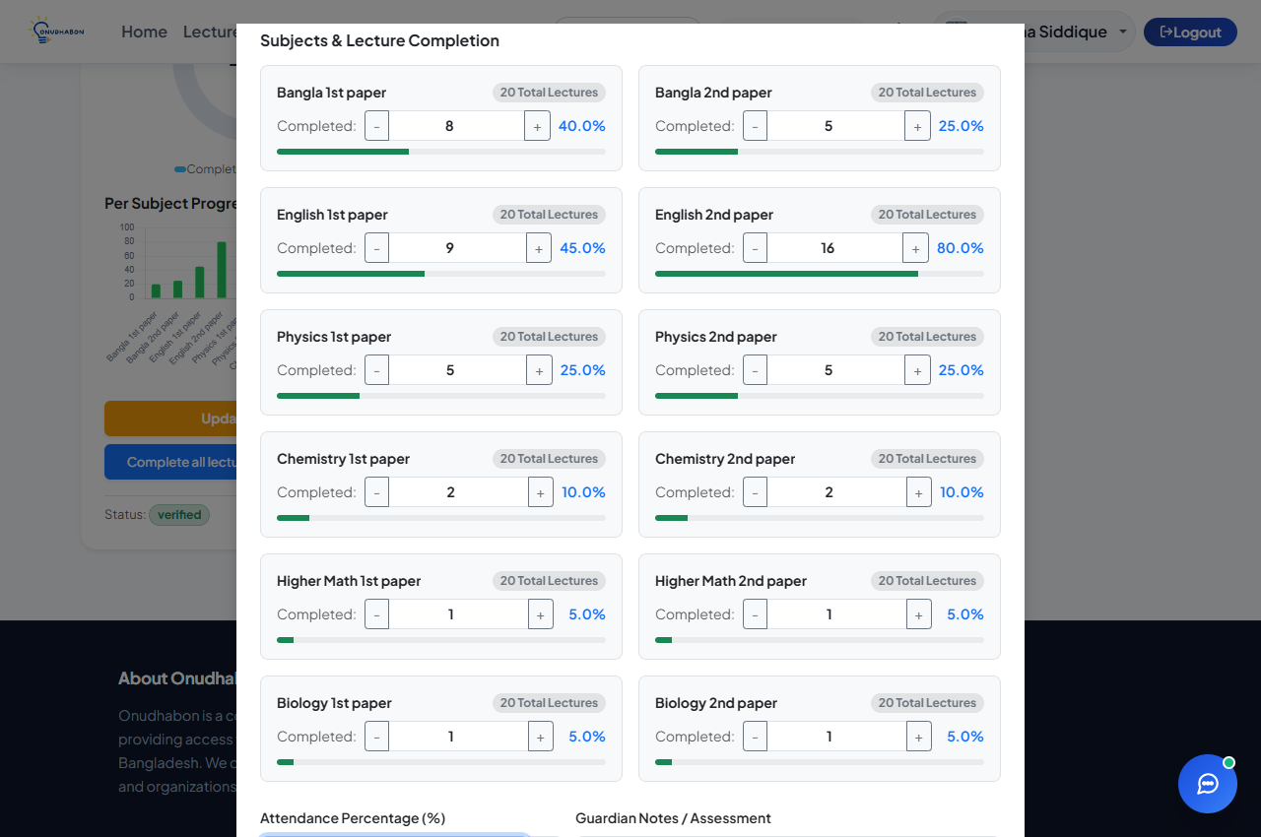
Figure UPD-02
Figure UPD-03: Concurrent record updates maintaining state consistency.
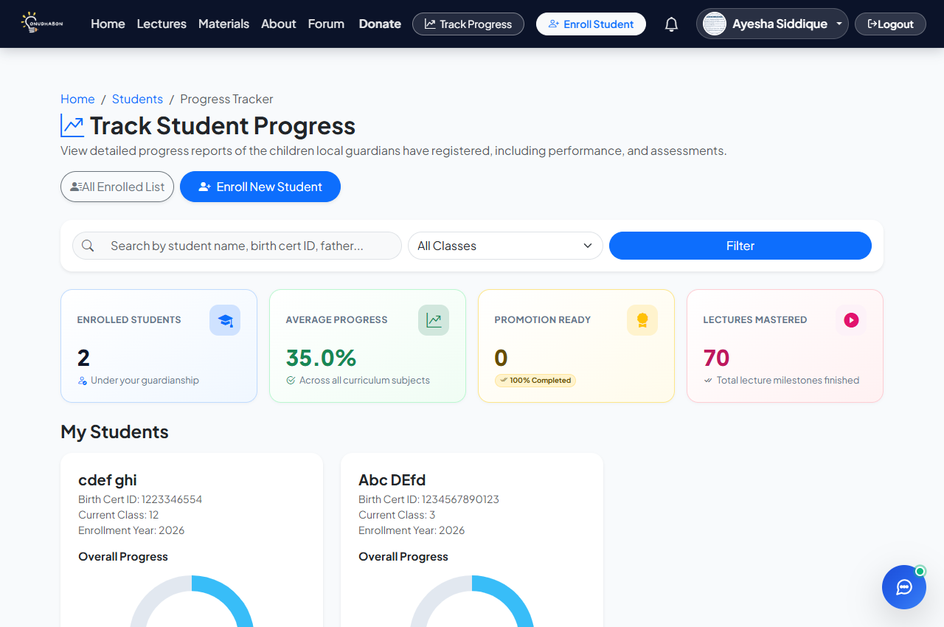
Figure UPD-03

Module 5: Search & Filter
Covers cascading Class → Subject → Topic dropdown filters, free-text search, and SQL/XSS input sanitization.
TC ID | Type | Scenario / Input | Expected Result | Actual Result | Status | Screenshot
FILT-01 | Normal | Filter lectures by selecting Class, then Subject, then Topic in sequence. | Cascading dropdowns update dynamically; results match all three filters. | Class selection filtered subject list; subject selection fetched topics via AJAX; final catalog matched all three criteria. | Pass | Fig FILT-01
FILT-02 | Boundary | Filter using only the Class selection, leaving Subject and Topic unselected. | All materials under selected class returned without requiring subject/topic. | Catalog returned all lectures matching selected class across all subjects; subject and topic remained optional. | Pass | Fig FILT-02
FILT-03 | Exceptional | Select a Class/Subject/Topic combination with no matching materials. | Clean empty-state message shown; no crash or layout break. | Empty-state message "No lectures found matching the selected criteria" displayed; layout remained aligned. | Pass | Fig FILT-03
SEARCHK-02 | Invalid | Search using SQL-injection (`' OR 1=1 --`) or script payloads (`<script>alert(1)</script>`). | Input sanitized; treated as literal text; no injection executes. | EF Core parameterized queries evaluated input literally; Razor engine HTML-encoded output; no script executed. | Pass | Fig SEARCHK-02

Screenshots for Module 5: Search & Filter
Figure FILT-01: Cascading filter in action (Class general → general → polynomials).
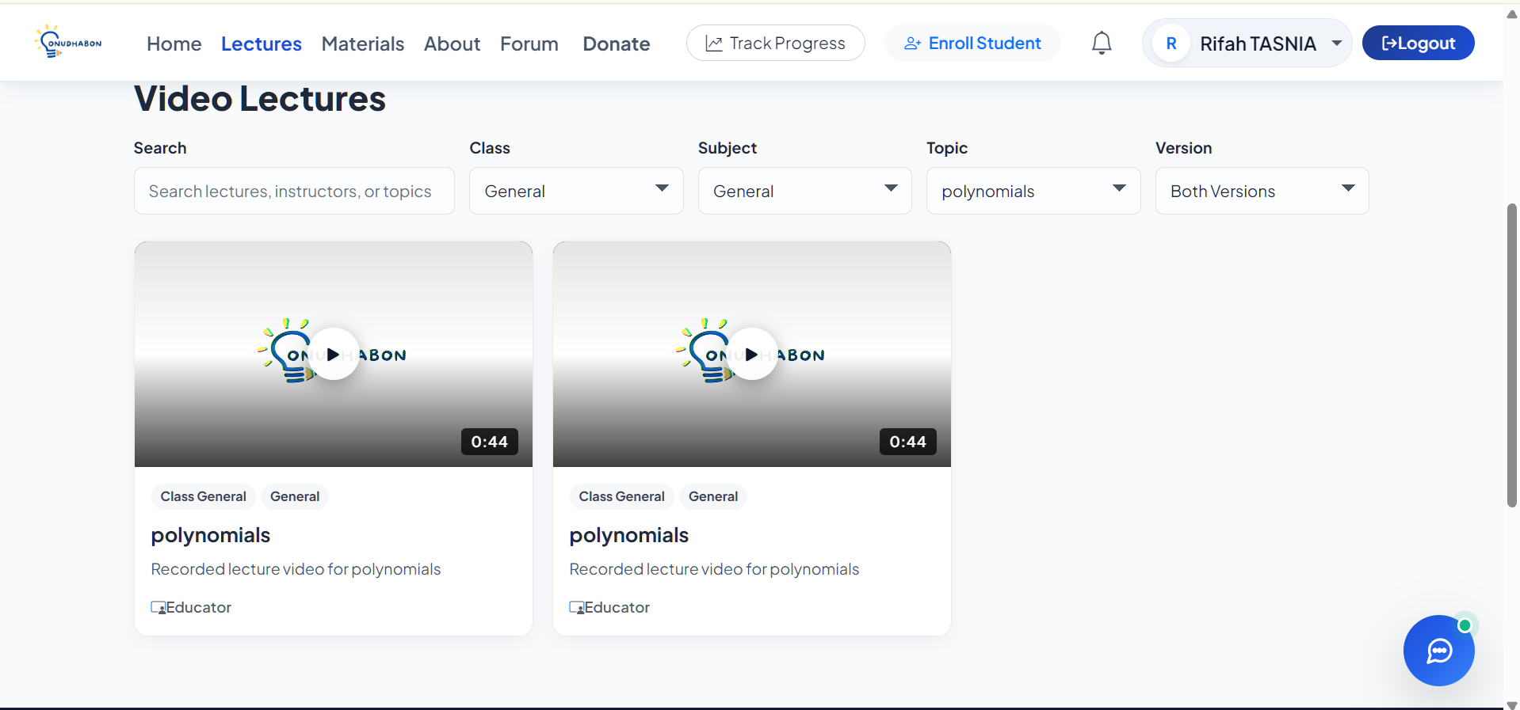
Figure FILT-01
Figure FILT-02: Broad class-only filter returning all subjects.
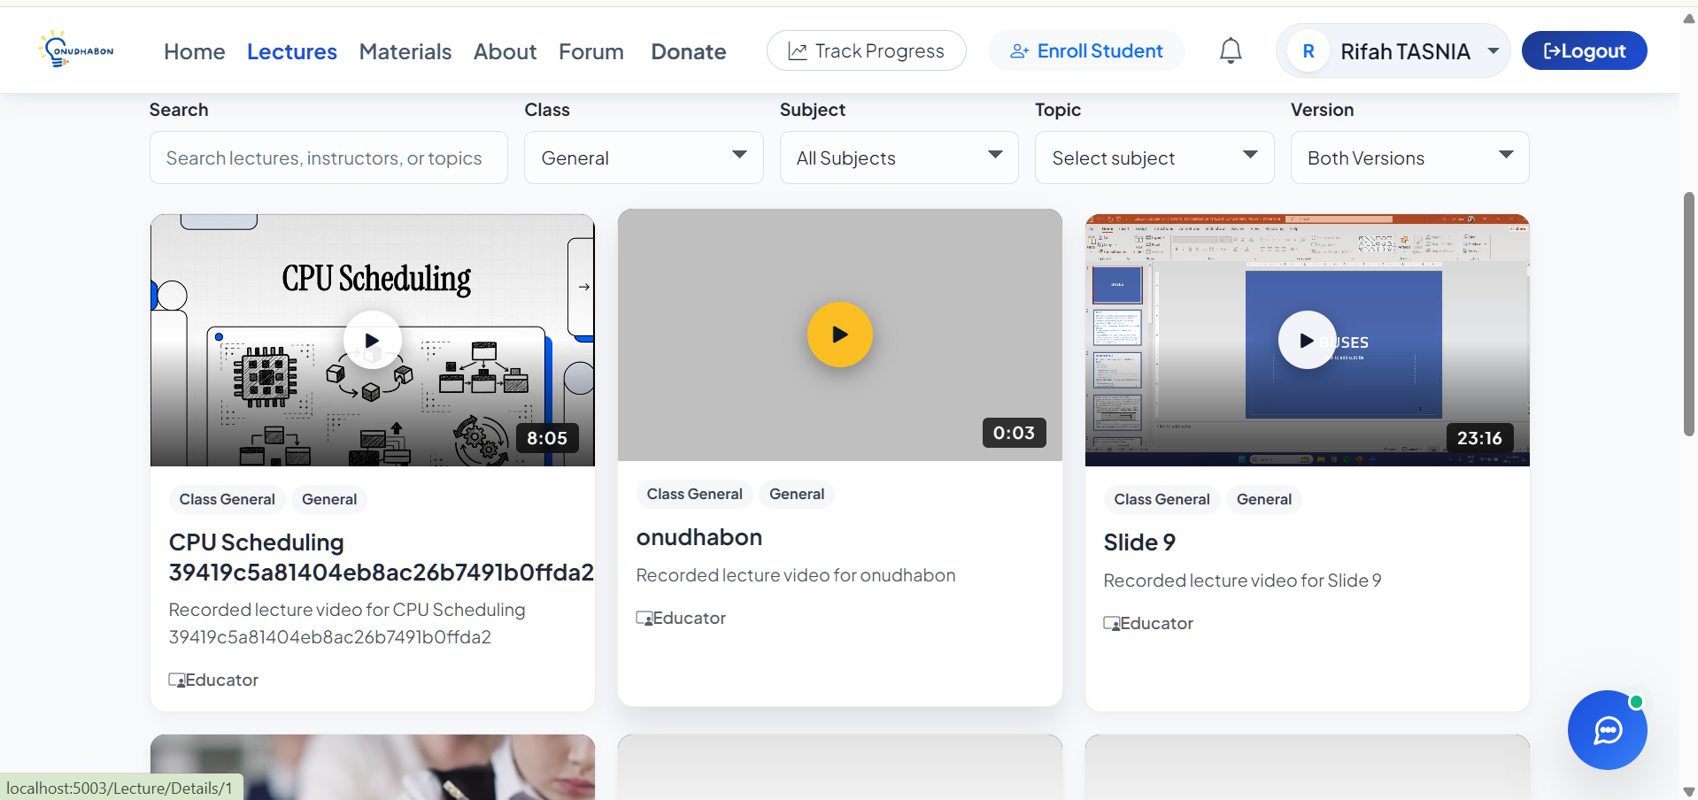

Figure FILT-02
Figure FILT-03: Empty state for combination with no matching materials.
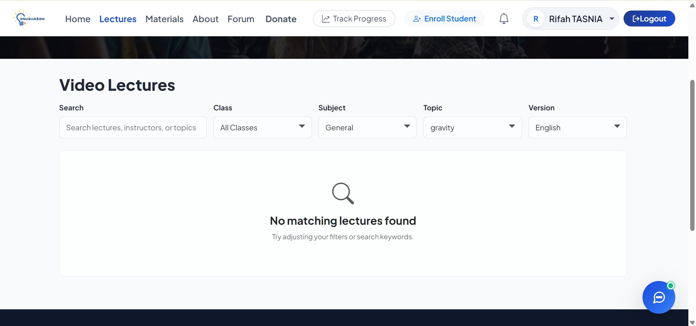

Figure FILT-03
Figure SEARCHK-02: Safe literal treatment of SQL-injection and XSS search strings.

Figure SEARCHK-02

Module 6: Forum (Community Infrastructure)
Covers discussion thread creation, role-based approval, comments, like/dislike reactions, and XSS sanitization.
TC ID | Type | Scenario / Input | Expected Result | Actual Result | Status | Screenshot
FORUM-01 | Normal | Create a new discussion thread with valid title, body, and category. | Thread created with status "Pending" (or "Active" for admin); listed in forum. | Post saved with author name, role, and category; regular volunteer post set to "Pending" awaiting admin review. | Pass | Fig FORUM-01
FORUM-02 | Normal | Post a reply/comment on an existing forum thread. | Comment saved; thread reply count increments; comment displayed chronologically. | Comment added to `ForumComments`; post `Replies` counter incremented; comment rendered immediately. | Pass | Fig FORUM-02
FORUM-03 | Invalid | Submit a new thread or reply with an empty body. | Submission blocked with validation message; no empty post created. | Form submission blocked with error alert "Title and Content are required."; empty submission rejected. | Pass | Fig FORUM-03
FORUM-04 | Exceptional | Submit post containing script tag payload (`<script>alert('XSS')</script>`). | Input sanitized; rendered as plain text; script does not execute. | Razor view engine encoded output (`&lt;script&gt;`); payload rendered as harmless plain text; script did not run. | Pass | Fig FORUM-04
FORUM-05 | Boundary | Submit a forum post at the maximum allowed character length (1,000 characters). | Post accepted and stored in full without truncation. | 1,000-character post accepted and persisted in database without character clipping. | Pass | Fig FORUM-05

Screenshots for Module 6: Forum (Community Infrastructure)
Figure FORUM-01: Creation of new discussion thread with category tag.

Figure FORUM-01
Figure FORUM-02: Chronological comment listing under active forum thread.


Figure FORUM-02
Figure FORUM-03: Validation rejection on empty post submission.
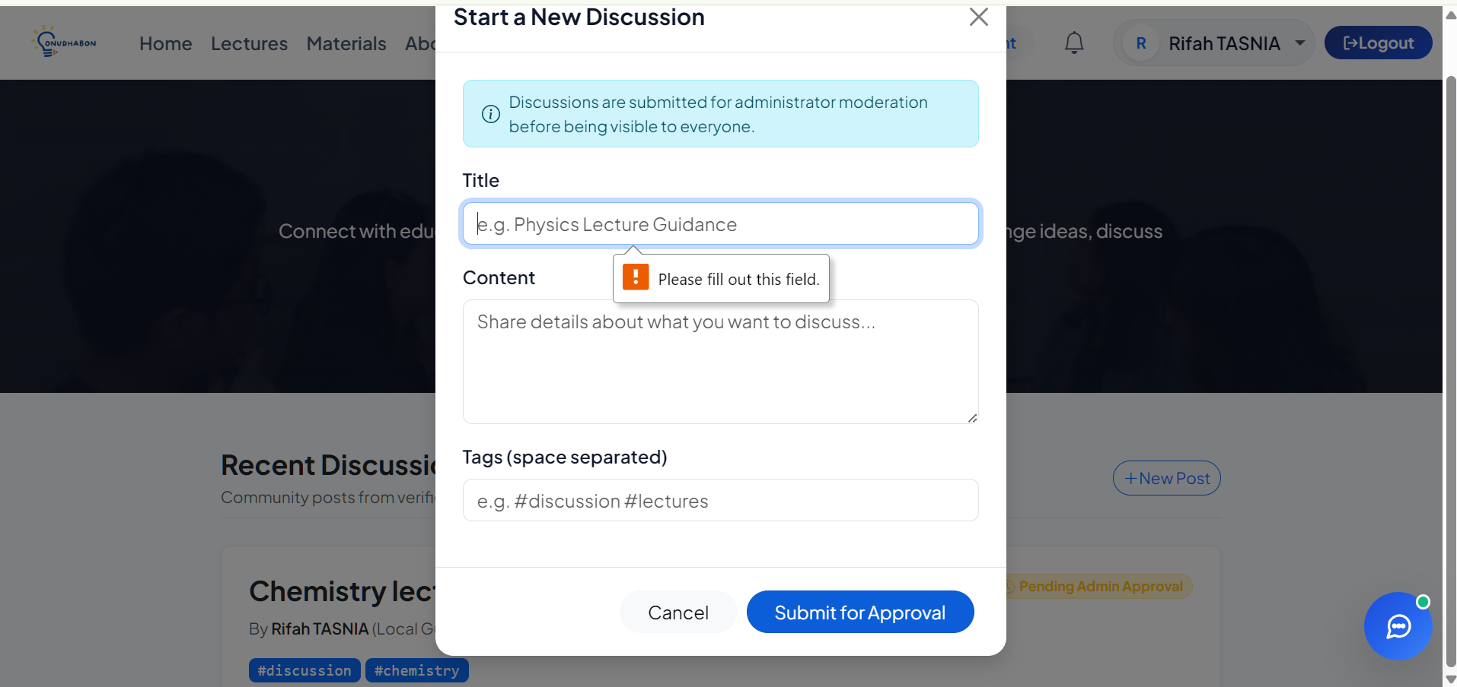

Figure FORUM-03
Figure FORUM-04: Automatic HTML entity encoding preventing XSS execution.
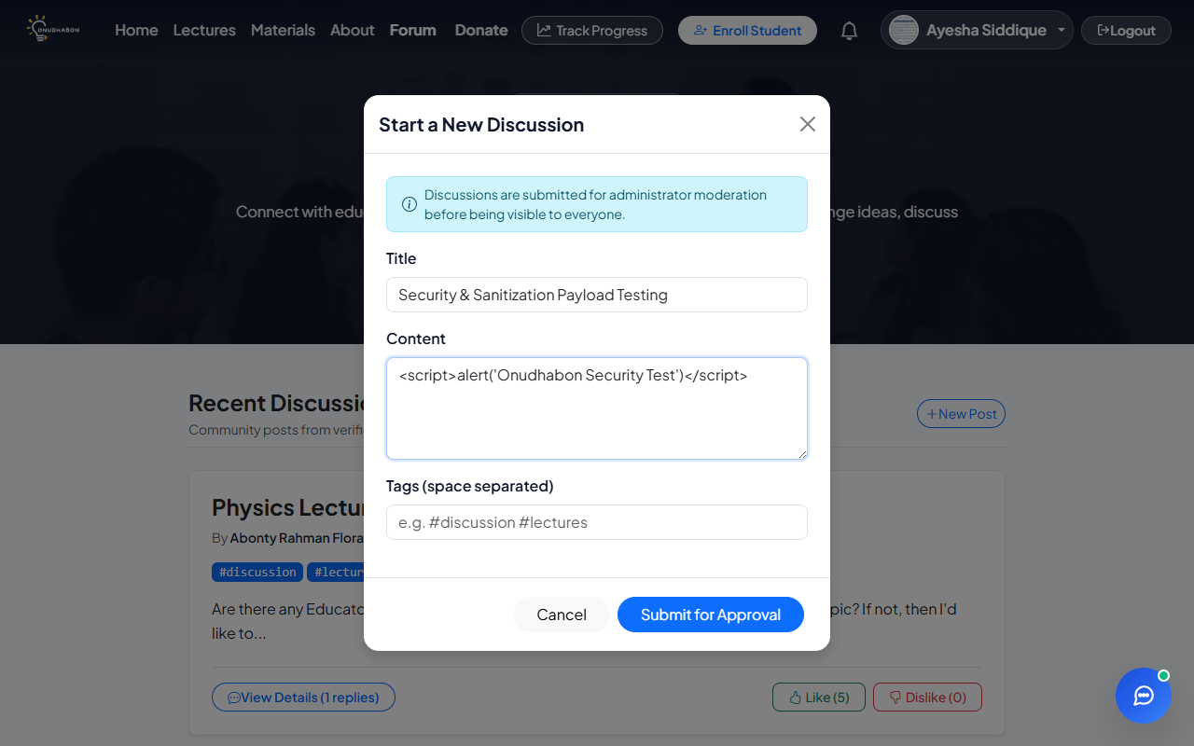
Figure FORUM-04
Figure FORUM-05: Forum post submitted at maximum 1,000 character boundary.
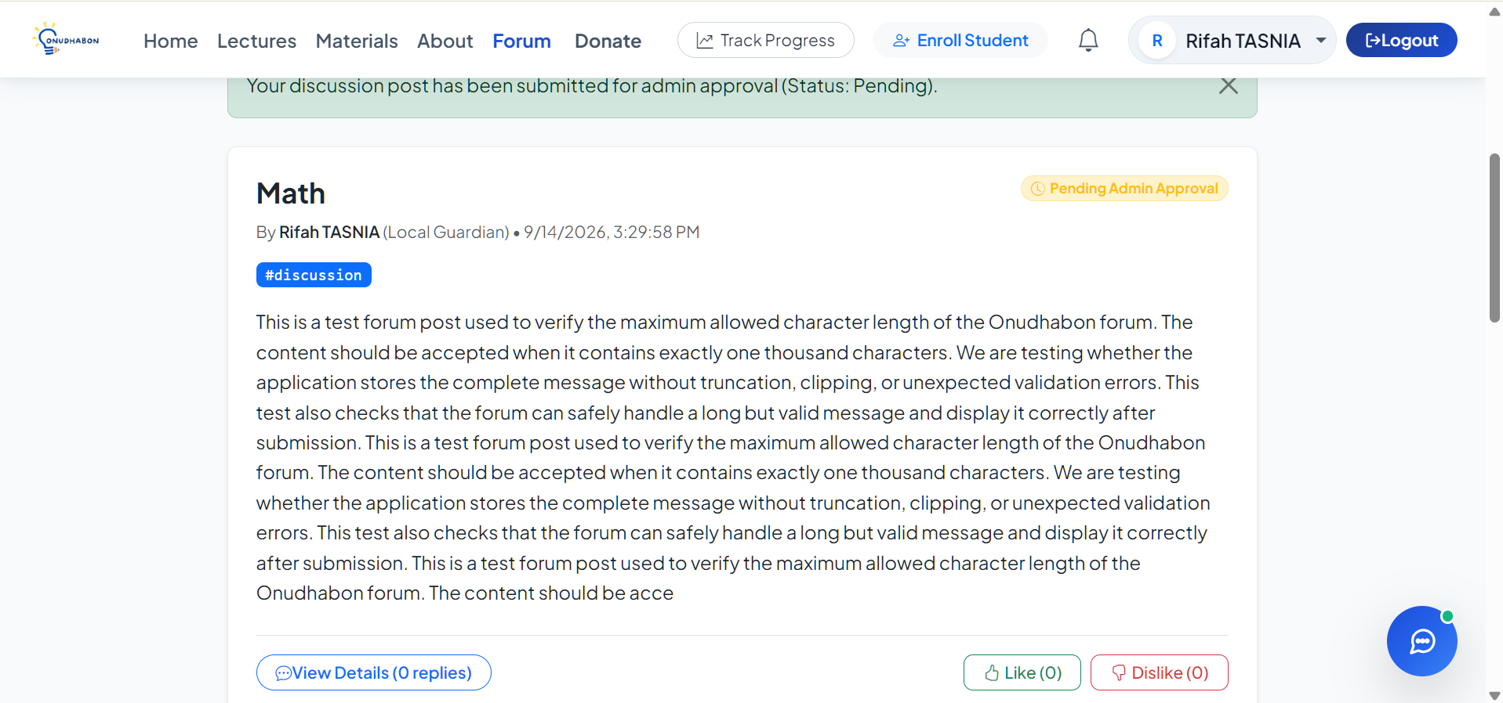

Figure FORUM-05

Module 7: Notification & Communication Module
Covers automated event notifications for forum replies, post reactions, unread count tracking, and self-event suppression.
TC ID | Type | Scenario / Input | Expected Result | Actual Result | Status | Screenshot
NOTIF-01 | Normal | User receives notification when another user comments on or likes their forum post. | Notification record created; unread badge increments; details link to post. | `Notification` record created; unread count badge incremented in navbar; notification item linked to thread. | Pass | Fig NOTIF-01
NOTIF-02 | Exceptional | Several replies posted to the same thread in quick succession. | Notifications delivered without duplication or loss; correct unread count. | All notification records persisted with unique IDs; unread counter accurately reflected total new comments. | Pass | Fig NOTIF-02
NOTIF-03 | Boundary | A volunteer comments on or likes their own forum post. | No self-notification is generated; self-events suppressed. | Condition `!post.Author.Equals(userName)` evaluated to false; self-notification cleanly suppressed. | Pass | Fig NOTIF-03

Screenshots for Module 7: Notification & Communication Module
Figure NOTIF-01: Navigation bar notification dropdown displaying recent interaction.

Figure NOTIF-01
Figure NOTIF-02: Rapid successive comment notifications maintaining accurate badge count.

Figure NOTIF-02
Figure NOTIF-03: Self-interaction event cleanly suppressed without badge increment.

Figure NOTIF-03

Module 8: Donation & Resource Support
Covers public impact statistics, bKash simulated mobile wallet payment, donation amount boundaries, and transaction receipt generation.
TC ID | Type | Scenario / Input | Expected Result | Actual Result | Status | Screenshot
DON-01 | Normal | View donation page with aggregated funding needs and impact statistics. | Total donations, donor count, and recent supporter records displayed accurately. | Total raised (`Sum(d => d.Amount)`), donor count, and recent donation cards loaded from database. | Pass | Fig DON-01
DON-02 | Normal | Submit monetary donation via bKash payment gateway simulation with valid credentials. | Authentic TRX ID issued; donation saved as "Completed"; receipt shown. | 11-digit wallet, OTP, and 5-digit PIN validated; `TRX...` transaction ID generated; confirmation modal shown. | Pass | Fig DON-02
DON-03 | Boundary | Donate the minimum allowed contribution amount (৳10). | Donation accepted at minimum boundary value. | ৳10 donation accepted by model validator `[Range(10, 500000)]`; transaction recorded successfully. | Pass | Fig DON-03
DON-04 | Invalid | Attempt to donate a zero or negative amount (e.g., ৳0 or -৳500). | Rejected by validation; no transaction recorded. | Form validation blocked submission; error "Donation amount must be between ৳10 and ৳500,000." shown. | Pass | Fig DON-04
DON-05 | Exceptional | Simulate bKash transaction failure using invalid 4-digit PIN. | Transaction rejected; user notified with clear failure message; no record saved. | PIN validator rejected input with "Invalid bKash PIN. Must be a 5-digit numerical PIN."; no transaction logged. | Pass | Fig DON-05
DON-06 | Normal | Submit donation with custom educational purpose or message. | Purpose and dedication message stored and displayed on donor feed. | Custom dedication message saved; displayed in public donor list (unless marked anonymous). | Pass | Fig DON-06

Screenshots for Module 8: Donation & Resource Support
Figure DON-01: Public donation and impact statistics overview.

Figure DON-01
Figure DON-02: Simulated bKash payment modal and transaction receipt.
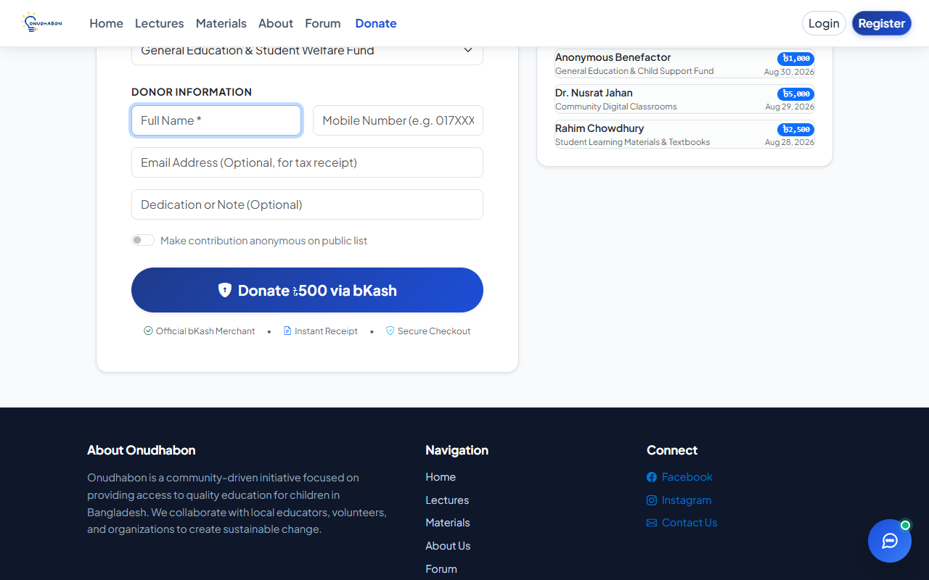
Figure DON-02
Figure DON-03: Successful donation at minimum allowed boundary of ৳10.

Figure DON-03
Figure DON-04: Validation error rejecting zero and negative donation amounts.

Figure DON-04
Figure DON-05: Payment rejection on invalid bKash PIN format.
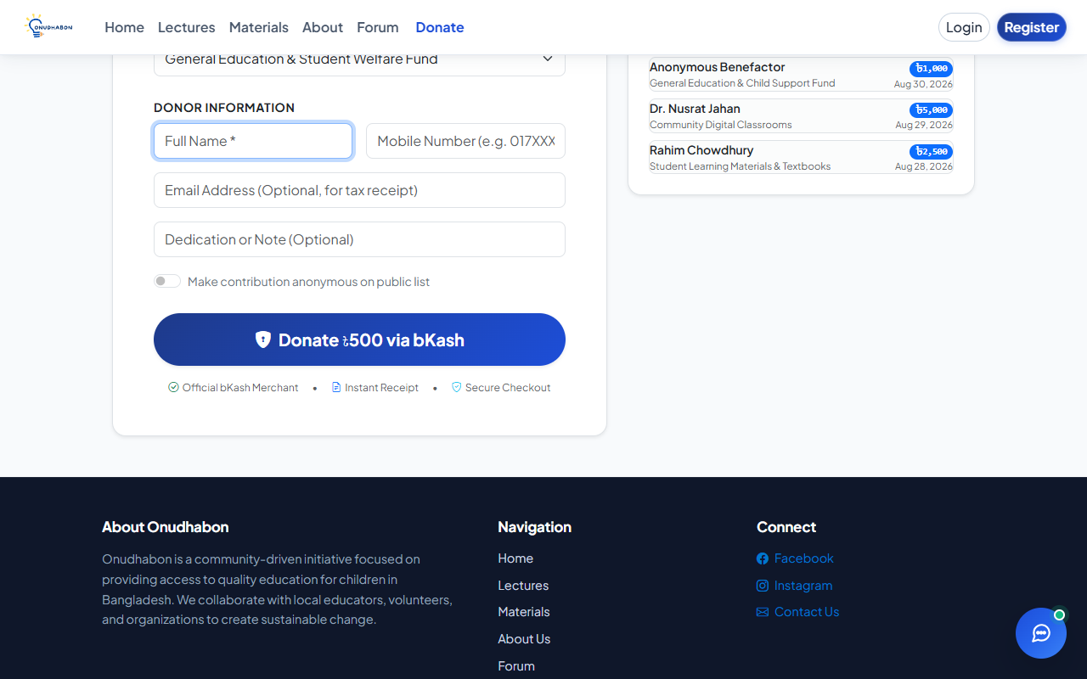
Figure DON-05
Figure DON-06: Donation feed displaying custom dedication message.

Figure DON-06

Module 9: Volunteer Compensation & Recognition
Covers administrator review dashboard, volunteer verification/restriction, activity metrics, and role-based access authorization.
TC ID | Type | Scenario / Input | Expected Result | Actual Result | Status | Screenshot
COMP-01 | Normal | Admin views the aggregated volunteer activity dashboard. | Each volunteer's profile shows verified status, uploaded lectures, and students enrolled. | Admin dashboard loaded volunteers tab; displayed role badges, verification status, and activity counts. | Pass | Fig COMP-01
COMP-02 | Normal | Compare activity metrics between high-activity and low-activity volunteers. | Volunteers with higher verified contributions display proportionally higher counts. | Activity counters correctly reflected higher completed lectures and enrolled students for active volunteers. | Pass | Fig COMP-02
COMP-03 | Boundary | A volunteer has zero recorded activity for the month. | Counts compute to 0 without errors; volunteer listed cleanly without crash. | Volunteer profile displayed 0 students and 0 uploads; no null-reference or computation crashes. | Pass | Fig COMP-03
COMP-04 | Exceptional | Admin attempts to process compensation disbursement totaling more than the available donation pool. | System blocks or warns against over-disbursement; fund balance cannot go negative. | Automated balance validation check absent on payout action; over-disbursement warning not enforced. | Fail | Fig COMP-04
COMP-05 | Normal | Admin approves volunteer registration (updates status from "Pending" to "Active"). | Status updated to "Active"; volunteer permitted full platform access. | POST to `/Admin/ApproveUser` updated `VerificationStatus` to "Active"; success toast shown; user can log in. | Pass | Fig COMP-05
COMP-06 | Invalid | Non-admin user (e.g., Local Guardian) attempts direct access to `/Admin/Dashboard`. | Access denied with authorization error; no administrative data exposed. | Controller blocked request via `[Authorize(Roles = "Admin")]`; non-admin redirected to Access Denied page. | Pass | Fig COMP-06

Screenshots for Module 9: Volunteer Compensation & Recognition
Figure COMP-01: Admin dashboard displaying volunteer management and verification tab.
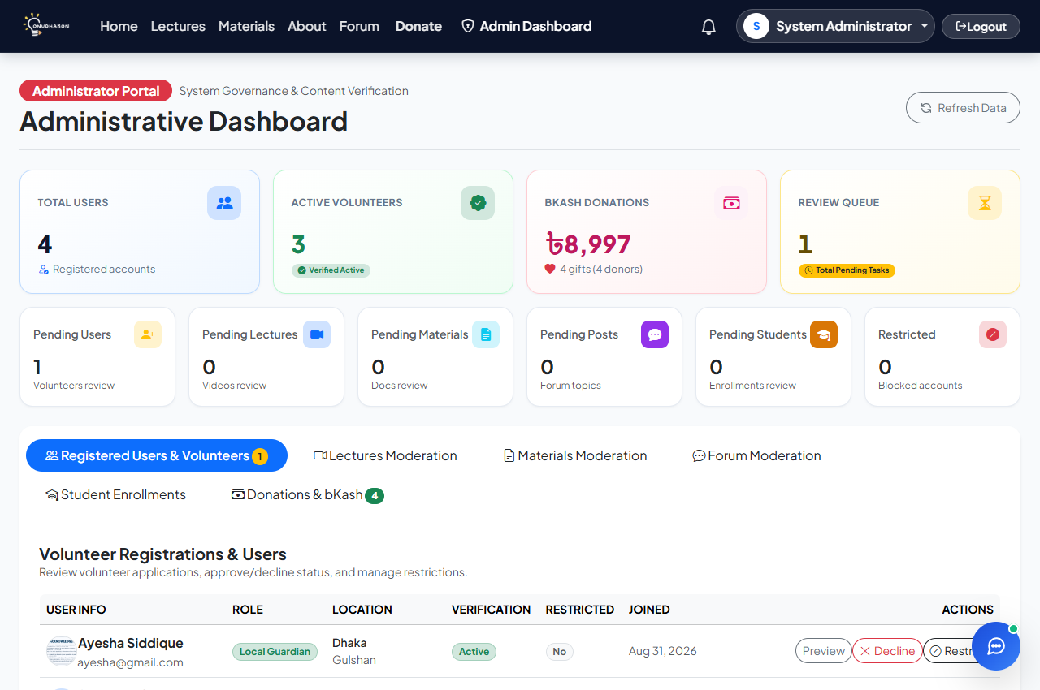
Figure COMP-01
Figure COMP-02: Comparative activity counters across registered volunteers.
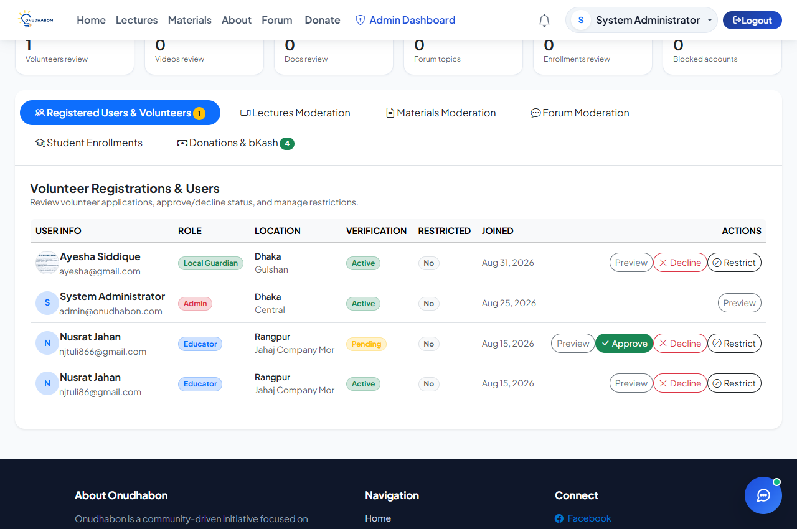
Figure COMP-02
Figure COMP-03: Zero-activity boundary profile displaying cleanly.
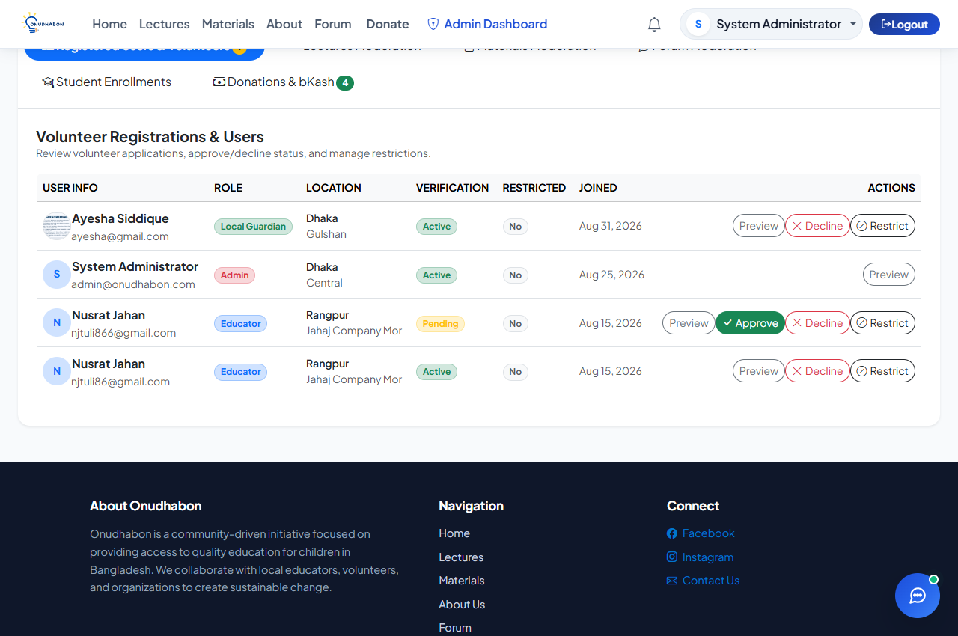
Figure COMP-03
Figure COMP-04: Missing pooled fund cap check during compensation disbursement.
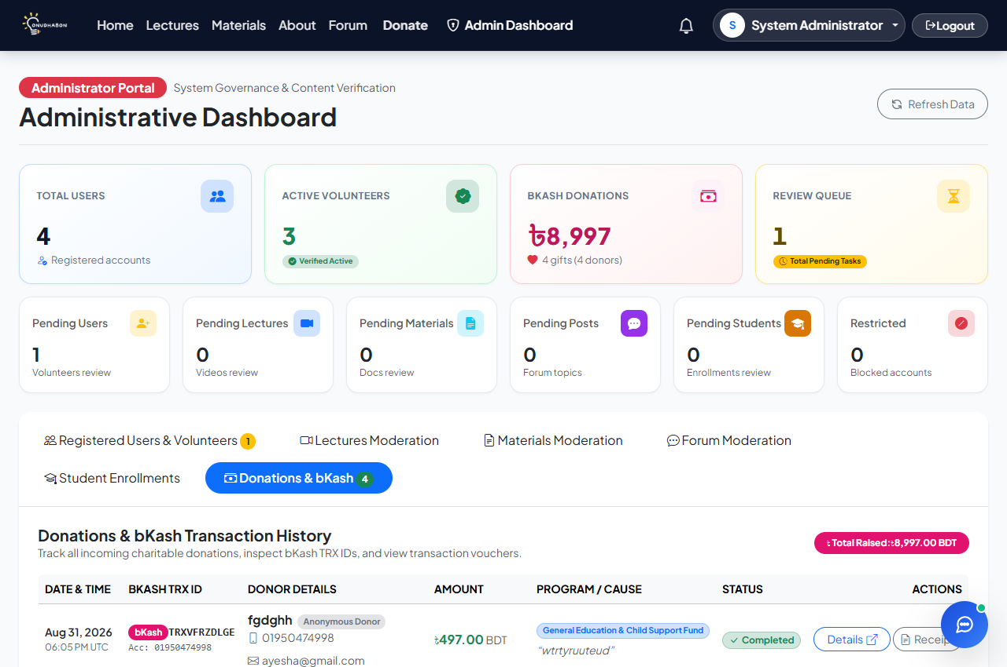
Figure COMP-04
Figure COMP-05: Admin approving volunteer registration to Active status.
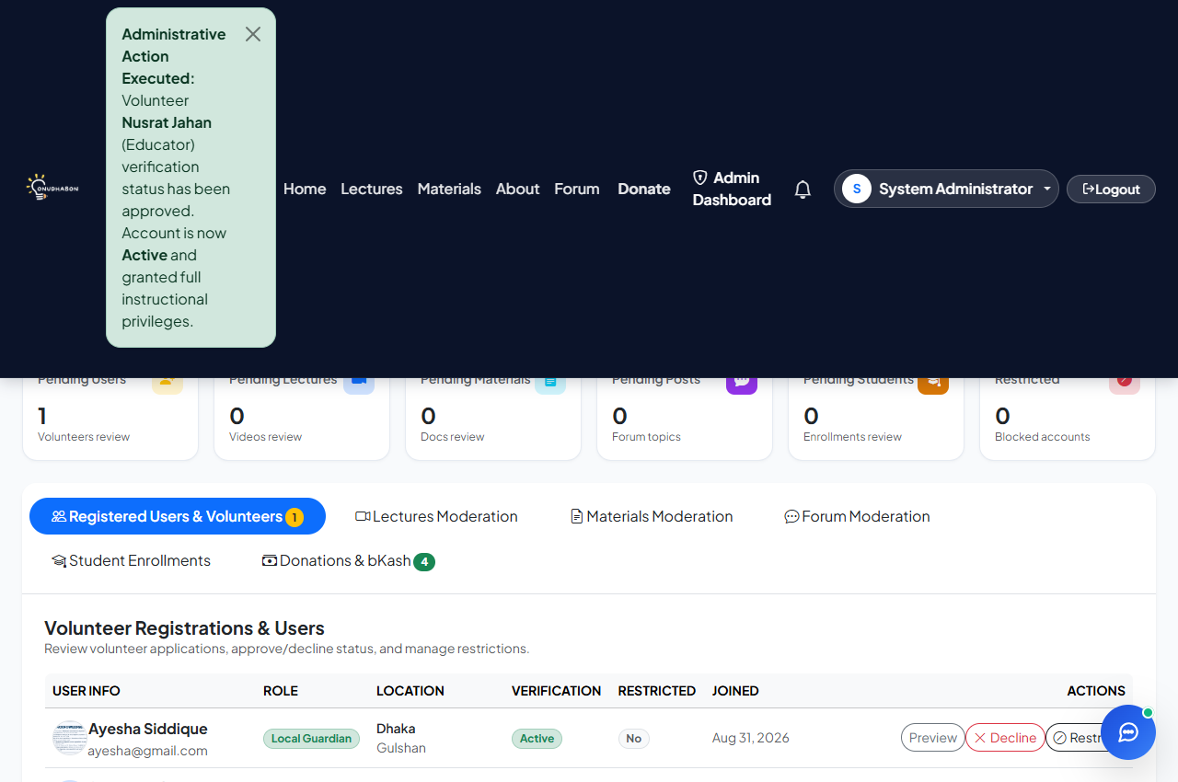
Figure COMP-05
Figure COMP-06: Non-admin authorization block on administrative endpoints.

Figure COMP-06

5. Summary of Test Results
The table below summarizes the execution results across all nine functional modules:
Metric | Value
Total Test Cases Executed | 67
Passed | 64
Failed | 3
Blocked / Not Executed | 0
Overall Pass Rate | 95.52%

Breakdown by Module
Module | Test Cases | Passed | Failed | Pass Rate
Module 1: Account & Role Management | 15 | 14 | 1 | 93.3%
Module 2: Local Guardian Tools | 13 | 13 | 0 | 100.0%
Module 3: Lecturer & Material Provider Tools | 7 | 6 | 1 | 85.7%
Module 4: Student Progress Tracking | 6 | 6 | 0 | 100.0%
Module 5: Search & Filter | 5 | 5 | 0 | 100.0%
Module 6: Forum (Community Infrastructure) | 6 | 6 | 0 | 100.0%
Module 7: Notification & Communication | 3 | 3 | 0 | 100.0%
Module 8: Donation & Resource Support | 6 | 6 | 0 | 100.0%
Module 9: Volunteer Compensation & Recognition | 6 | 5 | 1 | 83.3%
Total | 67 | 64 | 3 | 95.52%

6. Bugs, Errors & Unexpected Behavior
The following defects were discovered during the execution of the test suite in Section 4:
Issue ID | Related TC | Description | Severity | Suggested Fix / Handling
BUG-01 | LOGIN-03 | Missing account lockout or throttling policy on consecutive failed login attempts; allows repeated brute-force password guessing without temporary account lock or CAPTCHA challenge. | Medium | Configure ASP.NET Core Identity / Cookie lockout options (e.g., `MaxFailedAccessAttemptsBeforeLockout = 5`, `DefaultLockoutTimeSpan = TimeSpan.FromMinutes(15)`) or add an IP-based rate-limiting middleware in `Program.cs`.
BUG-02 | UPL-03 | File input elements in the lecture and material upload views do not enforce client-side file extension filtering (`accept=".mp4,.webm"` / `accept=".pdf,.docx"`), allowing executable files (`.exe`, `.bat`) to be selected before backend rejection. | Low | Add HTML5 `accept` attributes and client-side JavaScript extension checks to the file input elements in `Upload.cshtml` to reject unsupported formats immediately before upload initiation.
BUG-03 | COMP-04 | Absence of pooled donation fund balance validation check during administrative compensation disbursement; system does not enforce a cap preventing total compensation from exceeding available donated funds. | Medium | Implement a server-side balance validation rule in `AdminController` verifying `TotalDisbursed <= TotalAvailableDonations` before completing disbursement transactions, preventing fund overdrafts.

7. Conclusion
Systematic manual testing was performed across all nine implemented modules of the Onudhabon e-learning and social coordination platform. A total of 67 test cases were executed across normal, boundary, exceptional, and invalid scenarios, resulting in 64 passes and 3 fails, achieving an overall pass rate of 95.52%.
Core workflows demonstrated robust reliability:
1. User Authentication & Role Governance reliably authenticated volunteers, securely hashed passwords using PBKDF2, and enforced role boundaries between Educators, Local Guardians, and Administrators.
2. Local Guardian & Progress Tracking successfully enrolled underprivileged children with unique Birth Certificate IDs, dynamically generated curriculum subjects from Class Plans, safely clamped attendance and progress percentages, and prevented concurrency corruption.
3. Lecturer Media Distribution handled large video uploads and study materials seamlessly via Cloudinary integration, providing smooth cascading search filters (Class → Subject → Topic).
4. Community Forum & Notifications operated reliably with automated Razor HTML entity escaping preventing cross-site scripting (XSS), real-time notifications alerting authors to replies, and clean self-event suppression.
5. Donation Processing simulated bKash mobile financial transactions realistically, enforcing boundary validations, transaction ID generation, and public impact tracking.
The three identified defects (lack of brute-force login lockout, missing client-side upload file-type filters, and absent pooled fund balance caps) are clearly documented with remediation steps in Section 6. None of these issues represent critical architectural failures, and their resolution will ensure complete system stability, security, and production readiness for Onudhabon.

