
Lab Task: 03
Course Name: Advance Database System
Course Title: CSE464
Section: 01
Semester: Fall – 2025

Submitted By:
Name: Mujahida Nazmoon Nazmoon
ID: 2022-2-60-099

Submitted To:
Antu Chowdhury
Lecturer
Department of Computer Science & Engineering

Date of Submission: 13 November 2025
For the lab task, we first need to create a table and insert data into it.
- Creating a table:
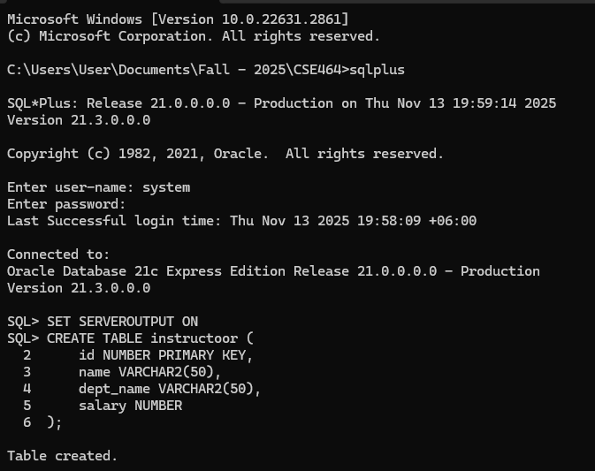
- Inserting data into it:
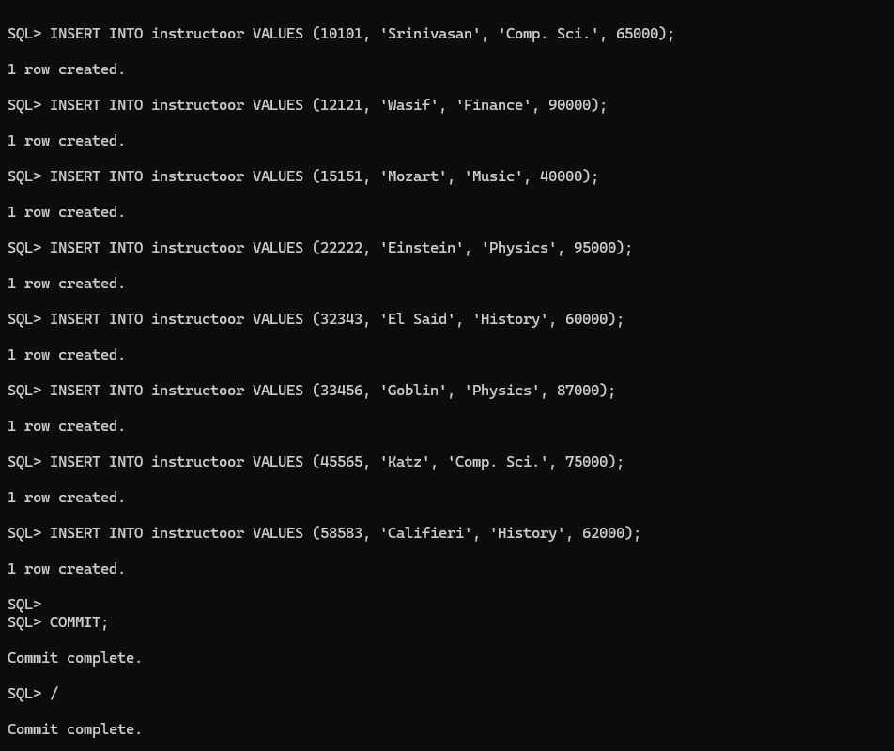
Task 01: Write a PL/SQL block using implicit cursor to update the salary of instructor with id = 15151 by increasing it by 500. Use SQL%ROWCOUNT to print how many rows were updated.
Code:
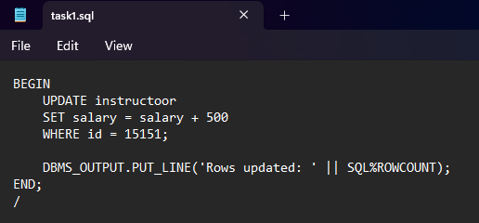
Output:
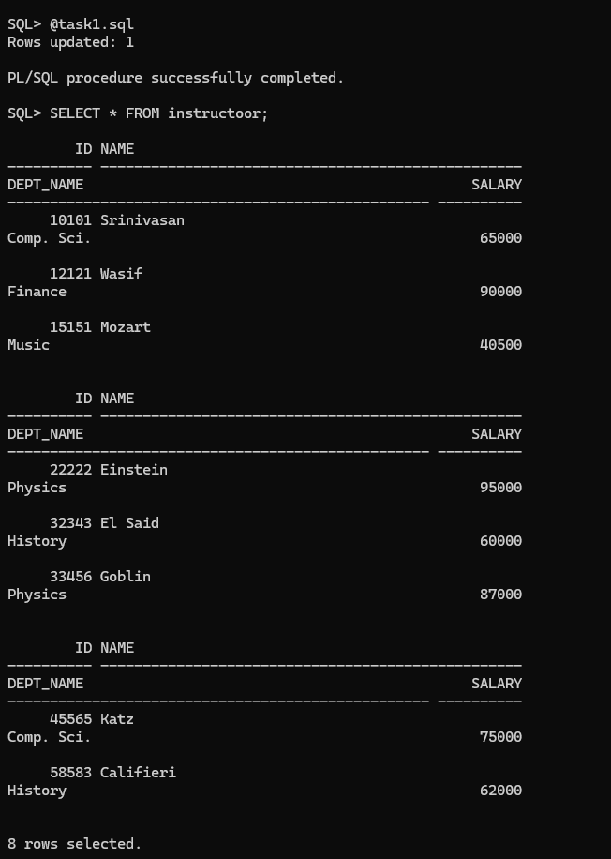
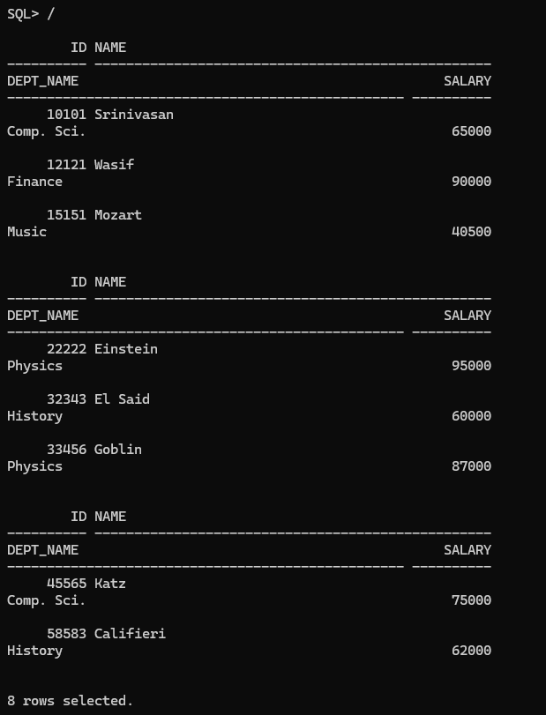

Task 02: Declare variables for name and salary using %TYPE. Write a PL/SQL block to select the details of the instructor with id = 22222 into these variables and print them.
Code:
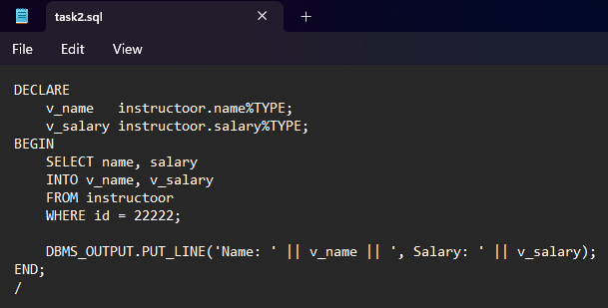
Output:
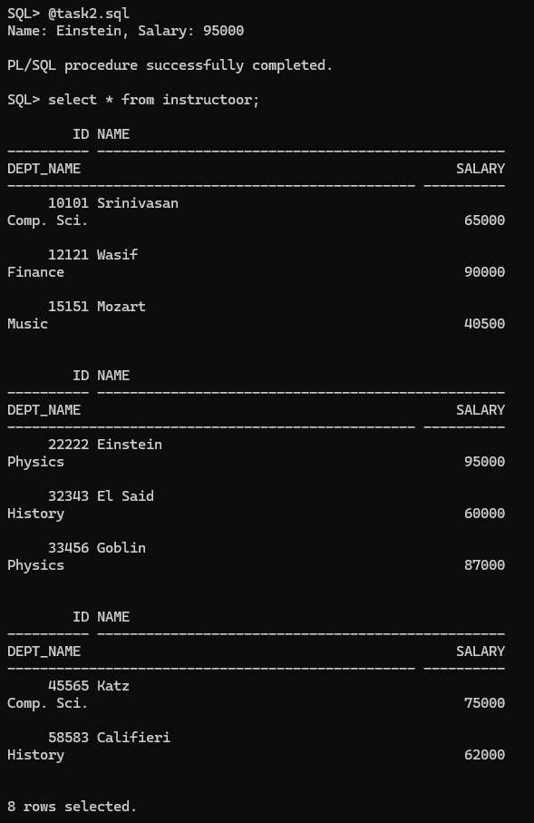
Task 03: Write a PL/SQL block using exception handling to select instructor details for id = 99999. If no data is found, print “Instructor not found”.
Code:
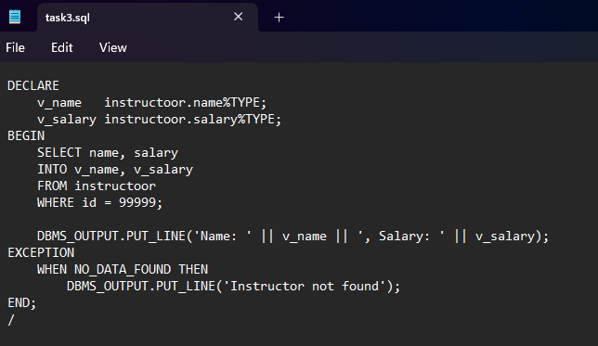
Output:
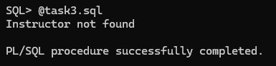
Task 04: Write a PL/SQL block using an explicit cursor to fetch and print the details of all instructors from the table. Include steps for declaring, opening, fetching in a loop, and closing the cursor.
Code:
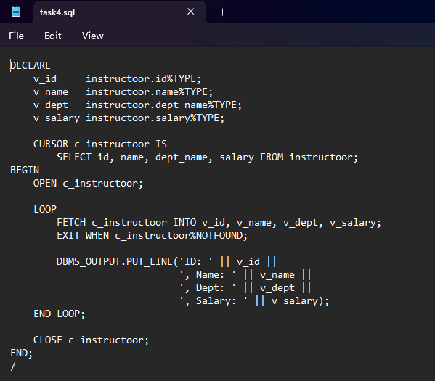
Output:
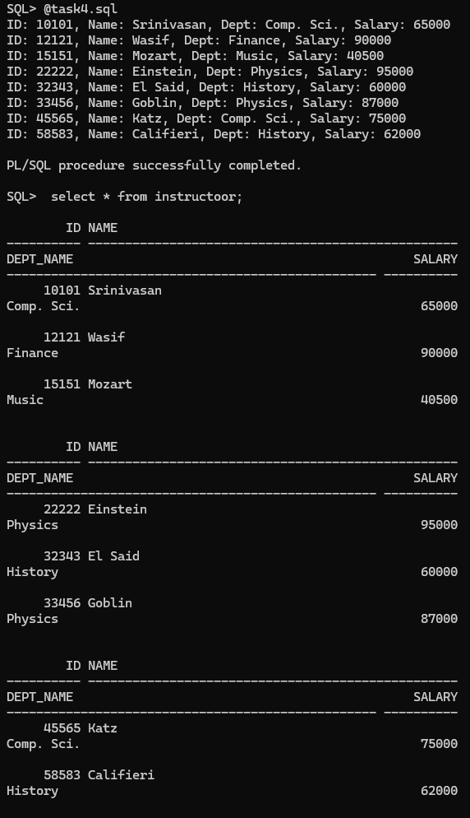

Task 05: Write a PL/SQL block to delete an instructor with id = 12345. Use SQL%NOTFOUND to print “Instructor not found” if no record was deleted, otherwise print “Instructor deleted successfully”.
Code:
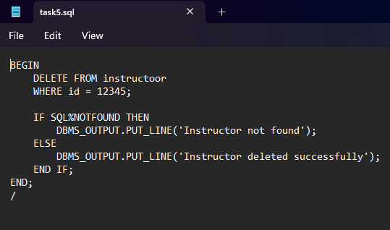
Output:
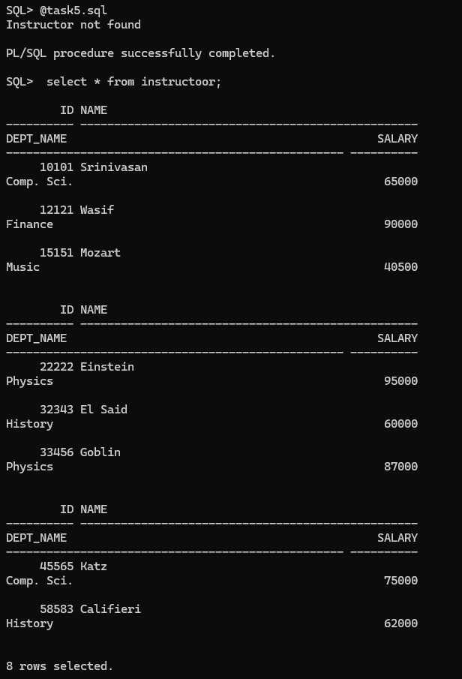
Task 06: Write a PL/SQL block using an explicit cursor to fetch all instructors whose salary is less than 60000, update their salary by adding 1000, and count how many instructors were updated. Print the total count after processing.
Code:
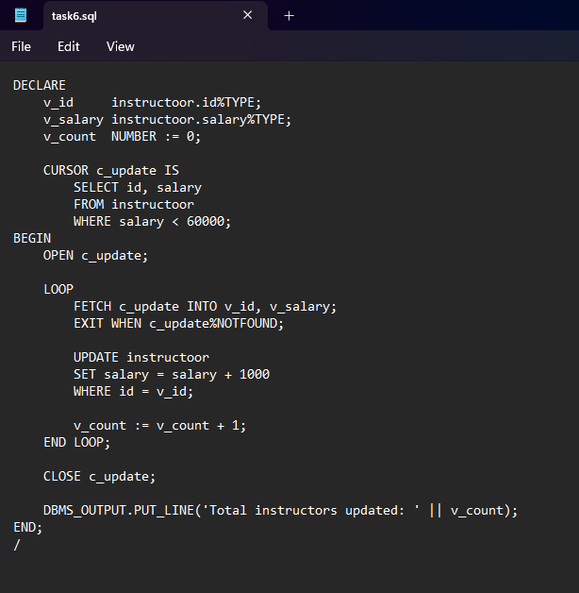

Output:
