**Project**

**Tasnia Chowdhury**

**HD3932**

**PROJECT INFORMATION:**

* What is the purpose of the site?
  + The purpose of the site is to display a coffee shop. The coffee shop’s name is Quickly Coffee, and the website provides useful information about the café such as location, hours, menu, and even allows customers to leave reviews and apply to work there. Viewers can also check out the most popular drinks at the moment before checking the full menu as well.
* Who is your intended audience?
  + The intended audience would be people who love coffee and cafes and are looking into visiting our location. Viewers can preview our menu so they can go into the shop prepared to order. They can also look at what’s new on the menu and what’s happening in the shop through the newsletter. Anyone interested in coffee and exploring our café are welcome to visit the site.
* What is the new web technology that you added to your website?
  + The new web technology that I added was the bootstrap onto my newsletter page for rounded images.
* What opportunity, problem, or issue is your site addressing?
  + The site addresses any questions visitors, both future and past, may have about the menu and location of the café. There are also hours the shop is opened, which addresses any questions viewers may have about visiting hours. The newsletter is always updating, so any new events being hosted get posted, and viewers can be informed in advance of the events. They can also leave a review through the survey to address any concerns.
* What type of content might be included in your site?
  + Some of the things I included in my site were promotional videos, so viewers know the ambiance of the coffee shop and get a feel through the screen. I also included a featured menu items tab, in addition to the menu, so that those who are looking for the most popular drinks can find those easily. I also included a survey that viewers and customers can complete to allow us to get to know our customers better. There is also a job application tab which allows people to apply for a position if they wish to.
* List at least two related or similar sites found on the web.
  + <https://www.lulacafe.com/>
  + <https://www.friendsandfamilyla.com/>

***Site map:***

***Codes:***

***Index.html***

<!--HOME PAGE-->

<!DOCTYPE html>

<html lang="en">

<head>

  <meta charset="UTF-8">

  <meta http-equiv="X-UA-Compatible" content="IE=edge">

  <meta name="viewport" content="width=device-width, initial-scale=1.0">

  <title>Quickly Coffee</title>

  <link rel = "stylesheet" href="index.css">

  <style>

  </style>

</head>

<body>

  <header>

    <nav>

      <ul>

        <li><a href="file:///C:/Users/chowd/Downloads/CSC3750%20Project/index.html">Home </a></li>

        <li><a href="file:///C:/Users/chowd/Downloads/CSC3750%20Project/menuprev.html">New on the Menu! </a></li>

        <li><a href="file:///C:/Users/chowd/Downloads/CSC3750%20Project/table.html">Menu</a></li>

        <li><a href="file:///C:/Users/chowd/Downloads/CSC3750%20Project/news.html">News </a></li>

        <li><a href="file:///C:/Users/chowd/Downloads/CSC3750%20Project/surveypage.html"> Survey </a></li>

        <li><a href="file:///C:/Users/chowd/Downloads/CSC3750%20Project/videopage.html"> How it's Made </a></li>

        <li><a href="file:///C:/Users/chowd/Downloads/CSC3750%20Project/Apply.html"> Apply today! </a></li>

      </ul>

    </nav>

  </header>

  <main>

    <h2>Welcome to Quickly Coffee!</h2>

    <h3>1234 Park Ave. Toronto, ON</h3>

    <iframe width="560" height="315" src="https://www.youtube.com/embed/Z6Dx-o3vfJY"

    title="Quickly Coffee promotional video"

    frameborder="0" allow="accelerometer; autoplay; clipboard-write; encrypted-media; gyroscope; picture-in-picture"

    allowfullscreen></iframe>

  </main>

  <main>

    <h2>Delicious and Fresh</h2>

    <h3>Coffee</h3>

    <p>

      want to enjoy a fresh cup of coffee made with the utmost care and skill? come to Quickly Coffee where not does the environment welcome everyone, but the coffee keeps everyone coming back for more! From a classic black coffee to the creamiest and sweetest coffees, Quickly can guarantee it will be delicious regardless of the variation!<img src="coffee-image-assignment7.png" alt="fresh cup of coffee with creamer/foam">

    </p>

    <p class="more"><a href="file:///C:/Users/chowd/Downloads/CSC3750%20Project/menuprev.html">Check out what's popular today.</a></p>

  </main>

  <main>

    <h1>The Quickly Menu Preview</h1>

  <table>

    <tr>

    <th>Drinks</th>

    <th>Price</th>

    <th>Desserts</th>

    <th>Price</th>

    </tr>

    <tr>

      <td>Cold coffee</td>

      <td>$6.50</td>

      <td>Butter croissant</td>

      <td>$4.50</td>

    </tr>

    <tr>

      <td>Iced americano</td>

      <td>$5.55</td>

      <td>Brownies</td>

      <td>$2.20</td>

    </tr>

    <tr>

      <td>Matcha latte</td>

      <td>$6.50</td>

      <td>Cinnamon crumb cake</td>

      <td>$3.00</td>

    </tr>

    <tr>

      <td>Drip Coffee</td>

      <td>$3.20</td>

      <td>Jiggly Japanese cheesecake</td>

      <td>$3.00</td>

    </tr>

  </table>

  </main>

  <main>

    <h2>Hours</h2>

    <table>

    <tr>

      <td>Mon-Thurs</td>

      <td>7am - 8pm</td>

    </tr>

    <tr>

      <td>Fri - Sun</td>

      <td>9am - 8pm</td>

    </tr>

    </table>

  </main>

  <footer>All content copyright &copy; 2022, Quickly Coffee and Tasnia Chowdhury</footer>

</body>

</html>

***Image:***

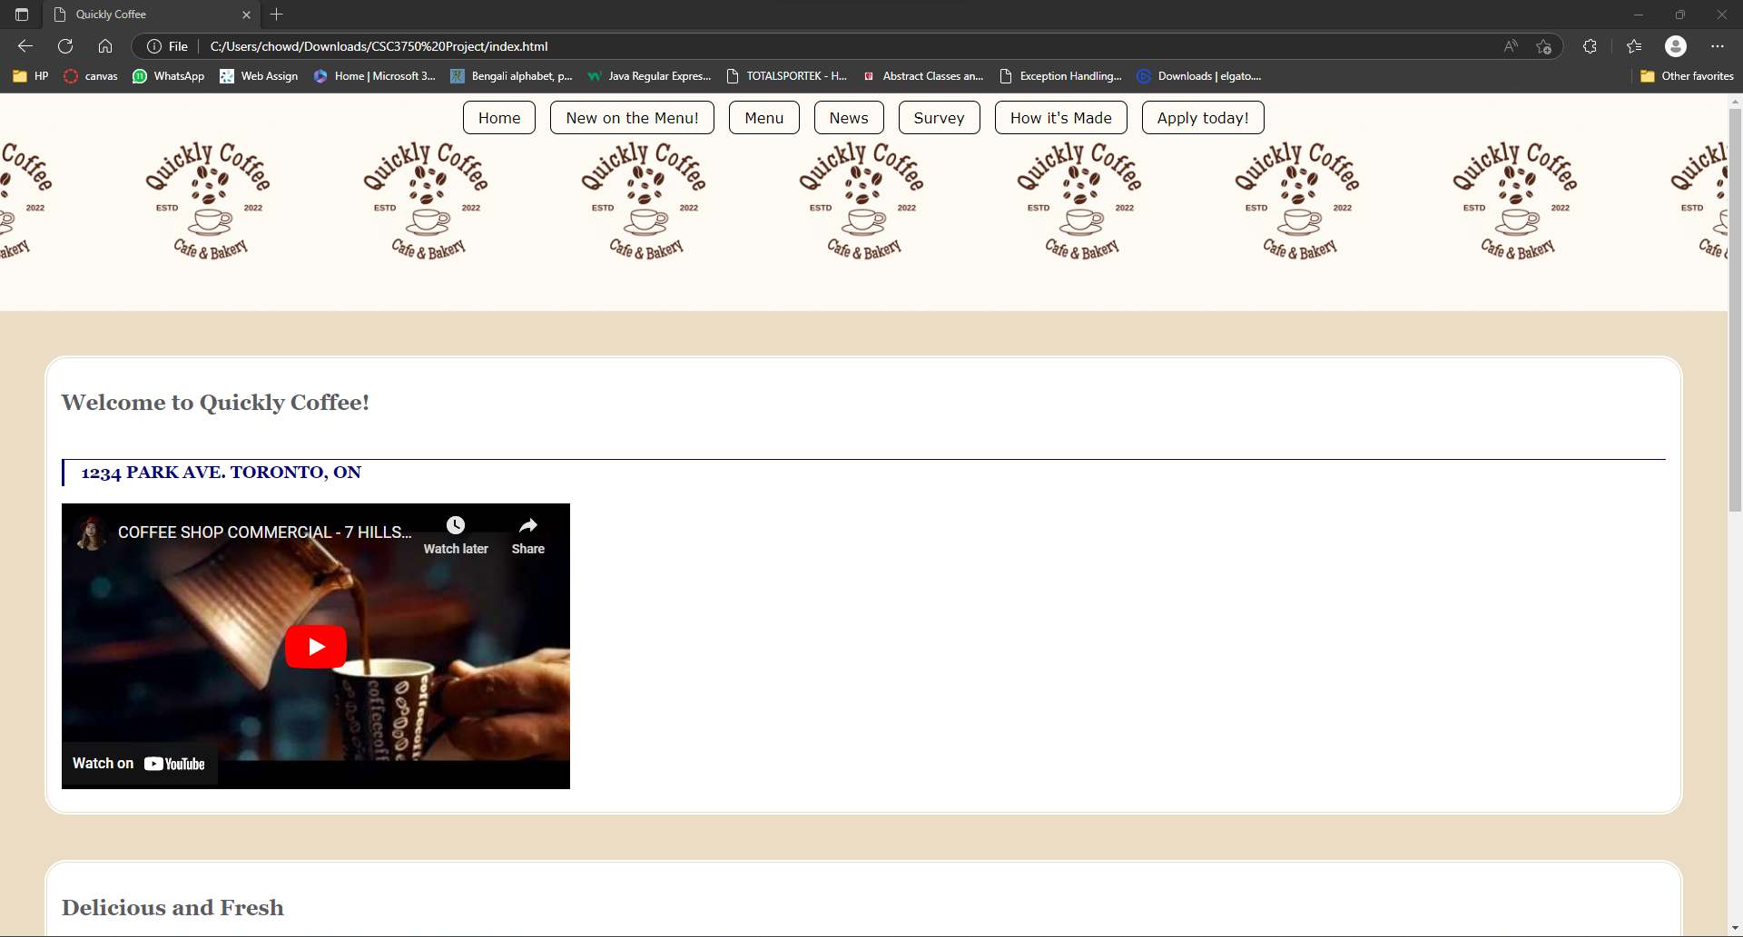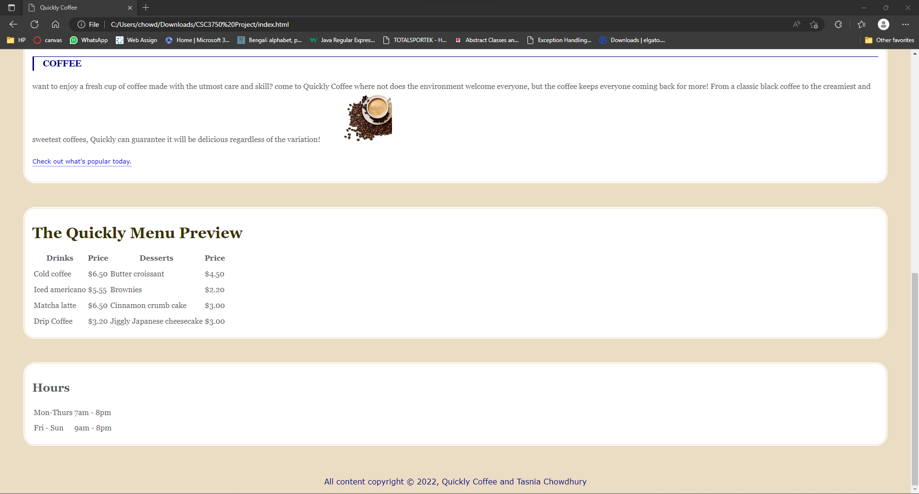

***Menuprev.html***

<!DOCTYPE html>

<html lang="en">

<head>

  <meta charset="UTF-8">

  <meta http-equiv="X-UA-Compatible" content="IE=edge">

  <meta name="viewport" content="width=device-width, initial-scale=1.0">

  <title>Menu Preview</title>

  <link rel = "stylesheet" href="index.css">

  <style>

    html {

  box-sizing: border-box;

}

*, *:before, *:after {

  box-sizing: inherit;

}

body {

  font-family: Georgia, serif;

  line-height: 1.5em;

}

h1 {

  font-size: 4em;

  font-weight: normal;

}

h2 {

  font-size: 1.2em;

  margin-top: 0;

}

#menu {

  border: 3px solid #274778;

}

section {

  background: #F6F3ED;

  margin: 10px;

  padding: 20px;

  border: 1px dotted rgb(0, 45, 128);

  width: 240px;

}

.title {

  background-color: #5a6d8f;

  color: #f0e6af;

  line-height: 4em;

}

.price {

  font-weight: bold;

  background: #ebddc4;

  padding: 5px;

  width: 100%;

  text-align: center;

}

  </style>

</head>

<body>

  <header>

    <nav>

      <ul>

        <li><a href="file:///C:/Users/chowd/Downloads/CSC3750%20Project/index.html">Home </a></li>

        <li><a href="file:///C:/Users/chowd/Downloads/CSC3750%20Project/menuprev.html">New on the Menu! </a></li>

        <li><a href="file:///C:/Users/chowd/Downloads/CSC3750%20Project/table.html">Menu</a></li>

        <li><a href="file:///C:/Users/chowd/Downloads/CSC3750%20Project/news.html">News </a></li>

        <li><a href="file:///C:/Users/chowd/Downloads/CSC3750%20Project/surveypage.html"> Survey </a></li>

        <li><a href="file:///C:/Users/chowd/Downloads/CSC3750%20Project/videopage.html"> How it's Made </a></li>

        <li><a href="file:///C:/Users/chowd/Downloads/CSC3750%20Project/Apply.html"> Apply today! </a></li>

      </ul>

    </nav>

  </header>

  <div id="menu">

    <section class="title">

    <h1>Quickly Menu</h1>

    </section>

    <section class="drink">

      <h2>1<br>Caramel macchiato</h2>

      <p class="info">the freshest coffee with the perfect blend of vanila and caramel drizzle.</p>

      <p class="photo"><img src="coffee.jpg" width = "200" height = "100" alt=""></p>

      <p class="price">$4.05</p>

      </section>

      <section class="dessert">

      <h2>2<br>Macarons</h2>

      <p class="info">Try our delicious maracons, coming in a variety of flavors. All made in-house and fresh everyday.</p>.</p>

      <p class="photo"><img src="macarons.jpg" width = "200" height = "100" alt=""></p>

      <p class="price">$5.55</p>

      </section>

      <section class="drink 2">

        <h2>2<br>Flat White</h2>

        <p class="info">A class flat white. Customize in-store with us.</p>.</p>

        <p class="photo"><img src="flat white.jpg" width = "200" height = "100" alt=""></p>

        <p class="price">$5.00</p>

        </section>

        <h3><a href="file:///C:/Users/chowd/Downloads/CSC3750%20Project/table.html">Click here for the full menu!<---- </a></h3>

</body>

<footer>

  <p><small>All content copyright &copy; 2022, Quickly Coffee and Tasnia Chowdhury.</small></p>

</footer>

</html>

***Image:***

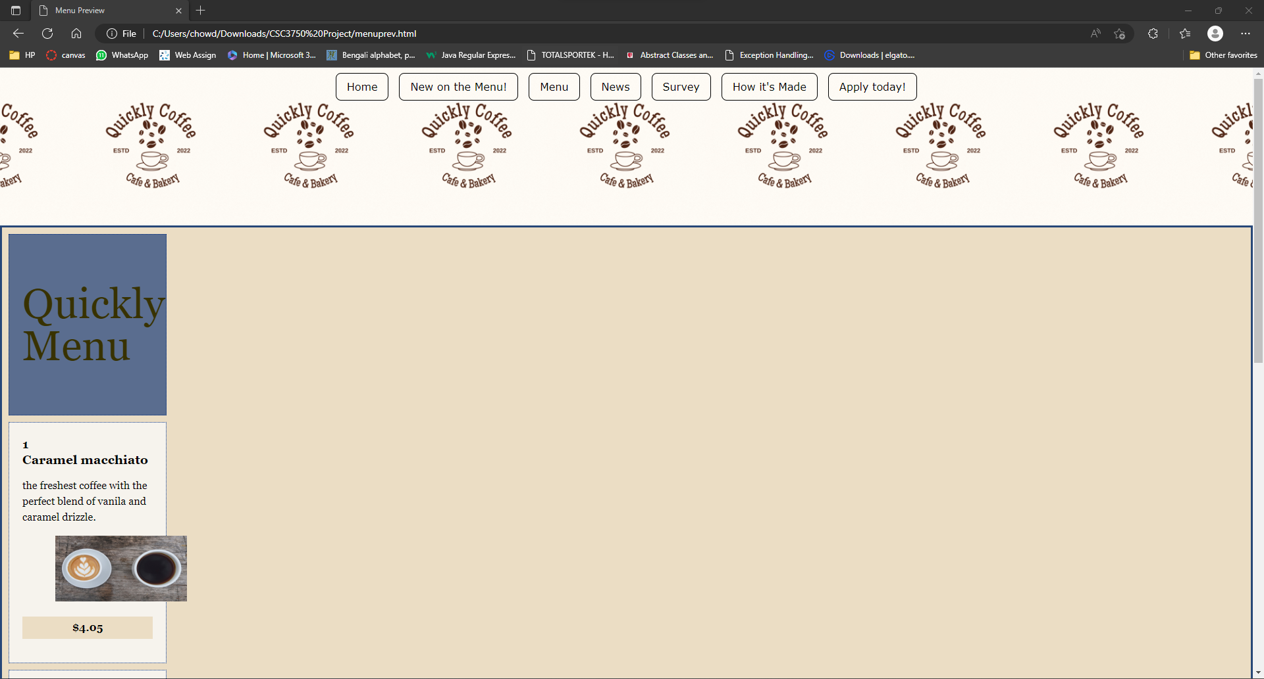

***Table.html***

<!DOCTYPE html>

<html lang="en">

<head>

  <meta charset="UTF-8">

  <meta http-equiv="X-UA-Compatible" content="IE=edge">

  <meta name="viewport" content="width=device-width, initial-scale=1.0">

  <title>the table challlenge exercise 8-4</title>

  <link rel = "stylesheet" href="index.css">

  <style>

    td, th { border: 1px solid rgba(63, 2, 2, 0.685);}

    table { border: 1px solid rgba(90, 2, 2, 0.596);}

    body

    {

      background-color: bisque;

      margin: 0 10%;

      font-family: sans-serif;

    }

  </style>

</head>

<body>

  <header>

    <nav>

      <ul>

        <li><a href="file:///C:/Users/chowd/Downloads/CSC3750%20Project/index.html">Home </a></li>

        <li><a href="file:///C:/Users/chowd/Downloads/CSC3750%20Project/menuprev.html">New on the Menu! </a></li>

        <li><a href="file:///C:/Users/chowd/Downloads/CSC3750%20Project/table.html">Menu</a></li>

        <li><a href="file:///C:/Users/chowd/Downloads/CSC3750%20Project/news.html">News </a></li>

        <li><a href="file:///C:/Users/chowd/Downloads/CSC3750%20Project/surveypage.html"> Survey </a></li>

        <li><a href="file:///C:/Users/chowd/Downloads/CSC3750%20Project/videopage.html"> How it's Made </a></li>

        <li><a href="file:///C:/Users/chowd/Downloads/CSC3750%20Project/Apply.html"> Apply today! </a></li>

      </ul>

    </nav>

  </header>

  <h1>The Quickly Menu Preview</h1>

  <main>

  <table>

    <tr>

    <th>Drinks</th>

    <th>Price</th>

    <th>Desserts</th>

    <th>Price</th>

    </tr>

    <tr>

      <td>Cold coffee</td>

      <td>$6.50</td>

      <td>Butter croissant</td>

      <td>$4.50</td>

    </tr>

    <tr>

      <td>Iced americano</td>

      <td>$5.55</td>

      <td>Brownies</td>

      <td>$2.20</td>

    </tr>

    <tr>

      <td>Matcha latte</td>

      <td>$6.50</td>

      <td>Cinnamon crumb cake</td>

      <td>$3.00</td>

    </tr>

    <tr>

      <td>Drip Coffee</td>

      <td>$3.20</td>

      <td>Jiggly Japanese cheesecake</td>

      <td>$3.00</td>

    </tr>

  </table>

  </main>

  <p><span style="color: black">Many more options in-store and coming soon!</span></p>

</body>

<footer>

  <p><small>All content copyright &copy; 2022, Quickly Coffee and Tasnia Chowdhury.</small></p>

</footer>

</html>

***Image:***

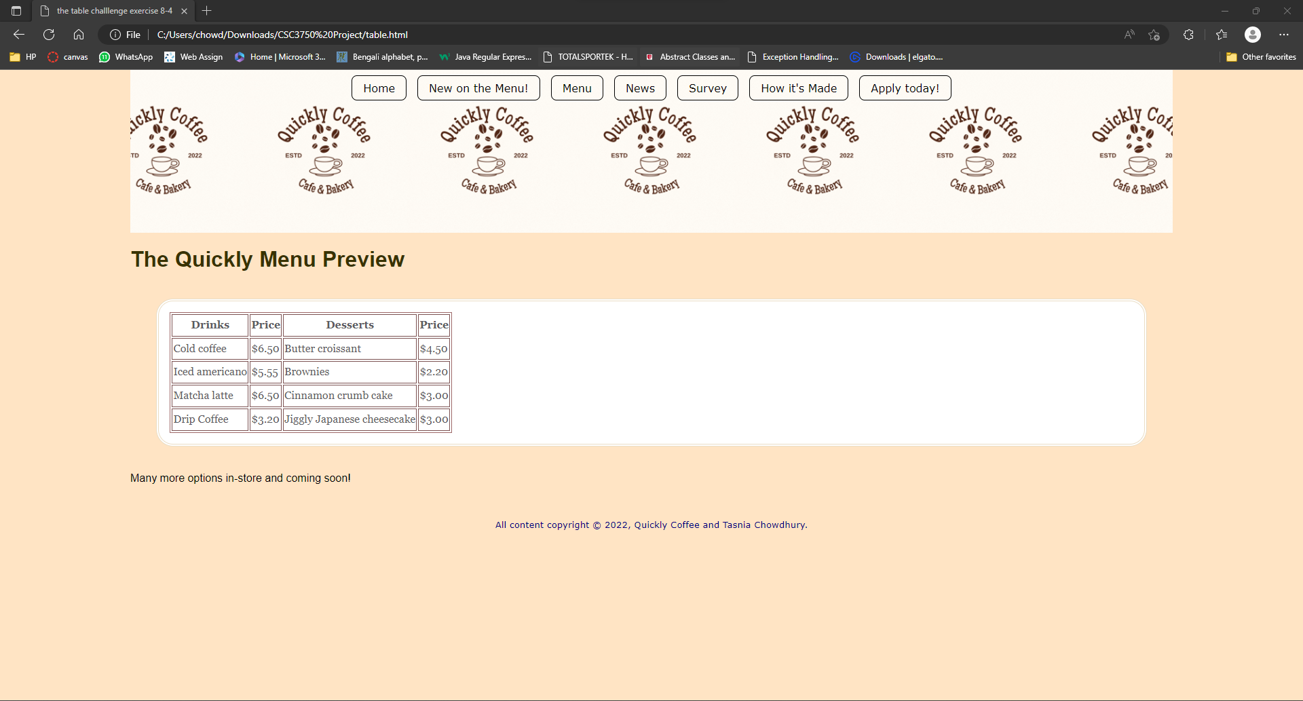

***News.html***

<!DOCTYPE html>

<html lang="en">

<head>

  <meta charset="UTF-8">

  <meta name="viewport" content="width=device-width, initial-scale=1">

  <title>The Quickly Cafe News</title>

  <link rel="stylesheet" href="index.css">

  <link rel="stylesheet" href="https://maxcdn.bootstrapcdn.com/bootstrap/3.4.1/css/bootstrap.min.css">

  <script src="https://ajax.googleapis.com/ajax/libs/jquery/3.6.1/jquery.min.js"></script>

  <script src="https://maxcdn.bootstrapcdn.com/bootstrap/3.4.1/js/bootstrap.min.js"></script>

  <style>

    body {

      background-color: #f1f3f2;

      margin: 0 10%;

      font-family: sans-serif;

      }

    h1 {

      text-align: center;

      font-family: serif;

      font-weight: normal;

      text-transform: uppercase;

      border-bottom: 1px solid #57b1dc;

      margin-top: 30px;

    }

    h2 {

      color: #d1633c;

      font-size: 1em;

    }

    h3 {

      color: #d1633c;

      font-size: 1em;

    }

    h4 {

      color: #d1633c;

      font-size: 1em;

    }

    div

    {

      color:#57b1dc;

      margin: 2px;

      font-size:18px;

    }

    </style>

</head>

<header>

  <nav>

    <ul>

      <li><a href="file:///C:/Users/chowd/Downloads/CSC3750%20Project/index.html">Home </a></li>

      <li><a href="file:///C:/Users/chowd/Downloads/CSC3750%20Project/menuprev.html">New on the Menu! </a></li>

      <li><a href="file:///C:/Users/chowd/Downloads/CSC3750%20Project/table.html">Menu</a></li>

      <li><a href="file:///C:/Users/chowd/Downloads/CSC3750%20Project/news.html">News </a></li>

      <li><a href="file:///C:/Users/chowd/Downloads/CSC3750%20Project/surveypage.html"> Survey </a></li>

      <li><a href="file:///C:/Users/chowd/Downloads/CSC3750%20Project/videopage.html"> How it's Made </a></li>

      <li><a href="file:///C:/Users/chowd/Downloads/CSC3750%20Project/Apply.html"> Apply today! </a></li>

    </ul>

  </nav>

</header>

  <section>

  <h1>The Quickly Cafe News</h1>

  <article>

  <h2>New Fall Menu Items</h2>

  <time>Posted on September 20, 2022</time>

  <p>Fall is just around the corner and Quickly Cafe is happy to be bringing back the beloved Pumpkin Cold Brew!</p>

  </section>

  <section>

  <dt>

  <p><dl>For limited time only, members of the Quickly Rewards can redeem a free drink upon purchasing the Pumpkin Cold Brew this Fall.</dl></p>

  </dt>

  </section>

  <section>

    <p>Good news! The Quickly team has decided to post the recipe for our famous flat white, so if you'd like to make it, feel free to!</p>

    <p class="more"><a href="https://www.thespruceeats.com/flat-white-recipe-765371">Try to make your own flat white at home!</a></p>

  </section>

  <p class="more"><a href="file:///C:/Users/chowd/Downloads/CSC3750%20Project/menuprev.html">Check out what's popular today.</a></p>

  <p class="more"><a href="file:///C:/Users/chowd/Downloads/CSC3750%20Project/surveypage.html">Give us feedback!</a></p>

  <img src="animatedgif.gif"class="img-rounded" alt="Cinque Terre" width="304" height="236">

  </article>

</body>

<footer>

  <p><small>All content copyright &copy; 2022, Quickly Coffee and Tasnia Chowdhury.</small></p>

</footer>

</html>

***Image:***

***Surveypage.html***

<!--SURVEY PAGE-->

<!DOCTYPE html>

<html lang="en">

<head>

  <meta charset="UTF-8">

  <meta http-equiv="X-UA-Compatible" content="IE=edge">

  <meta name="viewport" content="width=device-width, initial-scale=1.0">

  <title>Thank you for your feedback!</title>

  <link rel="stylesheet" href="index.css">

  <style type="text/css">

    ol, ul {

       list-style-type: none;

        }

    body {

      background-color: #ecf0e4;

      margin: 0 10%;

      font-family: sans-serif;

    }

    h1 {

      text-align: center;

      font-family: serif;

      font-weight: normal;

      text-transform: uppercase;

      border-bottom: 1px solid #92c25b;

      margin-top: 30px;

    }

    h2 {

      color: #188630;

      font-size: 1em;

    }

    p.disclaimer {

      border-top: 1px solid #188630;

      padding-top: 1em;

    }

    </style>

</head>

<body>

  <header>

    <nav>

      <ul>

        <li><a href="file:///C:/Users/chowd/Downloads/CSC3750%20Project/index.html">Home </a></li>

        <li><a href="file:///C:/Users/chowd/Downloads/CSC3750%20Project/menuprev.html">New on the Menu! </a></li>

        <li><a href="file:///C:/Users/chowd/Downloads/CSC3750%20Project/table.html">Menu</a></li>

        <li><a href="file:///C:/Users/chowd/Downloads/CSC3750%20Project/news.html">News </a></li>

        <li><a href="file:///C:/Users/chowd/Downloads/CSC3750%20Project/surveypage.html"> Survey </a></li>

        <li><a href="file:///C:/Users/chowd/Downloads/CSC3750%20Project/videopage.html"> How it's Made </a></li>

        <li><a href="file:///C:/Users/chowd/Downloads/CSC3750%20Project/Apply.html"> Apply today! </a></li>

      </ul>

    </nav>

  </header>

<article>

  <h1>QUICKLY CAFE SURVEY</h1>

  <form action = "mailto:quicklycoffee@gmail.com" method = "POST" enctype="text/plain">

    <fieldset>

      <legend>Your Information...</legend>

    <p>Before beginning the survey, we would like to ask your cooperation with providing your name and contact information below. :)</p>

    <br>

    <ul>

      <li>Name:  <input type = "text" name = "customername"></li>

      <li>Cell: <input type="text" cell="customnum"></li>

      <li>Email: <input type ="text" email="customemail"></li>

    </ul>

    </fieldset>

    <br>

    <h2>........</h2>

    <fieldset>

      <legend>General</legend>

      <p>How did you hear about Quickly Cafe?</p>

      <ul>

        <li><label>From a friend <input type="radio" name="choice[]" value="friend"></label></li>

        <li><label>flyer ad<input type="radio" name="choice[]" value="flyer"></label></li>

        <li><label>facebook page <input type="radio" name="choice[]" value="facebookad"></label></li>

        <li><label>Instagram page <input type="radio" name="choice[]" value="igpage"></label></li>

        <li><label>Other <input type="radio" name="choice[]" value="otherreason"></label></li>

        <br>

        <!--added a textbox from exercise 9-1-->

        <legend><em>If you selected other, please explain:</em></legend><br>

        <textarea name="other reason" rows="4" cols="60" maxlength="400" placeholder="No more than 400 characters long."></textarea></textarea></li>

      </ul>

    </fieldset>

      <fieldset>

        <legend>Visiting info</legend>

      <p>How often do you visit the cafe?

        <select> name="visits" size="1">

          <option>once a week</option>

          <option>twice a week</option>

          <option>once a month</option>

          <option>everyday</option>

          <option>every other day</option>

          <option>unsure</option>

        </select>

      </p>

      </fieldset>

      <br>

      <input type="submit" value="submit"><input type="reset">

  </form>

  <h2>Leave us a review on <a href= "https://www.yelp.com/biz/cafe-1923-hamtramck-3">Yelp!</a></h2>

</body>

<footer>

  <p><small>All content copyright &copy; 2022, Quickly Coffee and Tasnia Chowdhury.</small></p>

</footer>

</html>

***Image:***

***Videopage.html***

<!DOCTYPE html>

<html lang="en">

<head>

  <meta charset="UTF-8">

  <meta http-equiv="X-UA-Compatible" content="IE=edge">

  <meta name="viewport" content="width=device-width, initial-scale=1.0">

  <title>Resource Page</title>

  <link rel="stylesheet" href="index.css">

</head>

<body>

  <header>

    <nav>

      <ul>

        <li><a href="file:///C:/Users/chowd/Downloads/CSC3750%20Project/index.html">Home </a></li>

        <li><a href="file:///C:/Users/chowd/Downloads/CSC3750%20Project/menuprev.html">New on the Menu! </a></li>

        <li><a href="file:///C:/Users/chowd/Downloads/CSC3750%20Project/table.html">Menu</a></li>

        <li><a href="file:///C:/Users/chowd/Downloads/CSC3750%20Project/news.html">News </a></li>

        <li><a href="file:///C:/Users/chowd/Downloads/CSC3750%20Project/surveypage.html"> Survey </a></li>

        <li><a href="file:///C:/Users/chowd/Downloads/CSC3750%20Project/videopage.html"> How it's Made </a></li>

        <li><a href="file:///C:/Users/chowd/Downloads/CSC3750%20Project/Apply.html"> Apply today! </a></li>

      </ul>

    </nav>

  </header>

  <h2>How our coffee is made :) </h2>

  <iframe width="560" height="315" src="https://www.youtube.com/embed/cxmpRL8bVU8" title="Watch how our coffee's made!" frameborder="0" allow="accelerometer; autoplay; clipboard-write; encrypted-media; gyroscope; picture-in-picture" allowfullscreen></iframe>

  <!--attached a youtube video using iframe instead of the video tag and used an embedded link instead of a regular one.-->

  <h2>Benfits of Coffee!</h2>

  <p>Read up on the benefits of coffee, and consider stopping by Quickly Coffee for your drink of choice.

    <img src="plain black coffee.jpg" alt="fresh cup of plain black coffee">

  </p>

  <h3 class="more"><a href="https://www.hsph.harvard.edu/nutritionsource/food-features/coffee/">Link to Harvard Article!!</a></h3>

</body>

<footer>

  <p><small>All content copyright &copy; 2022, Quickly Coffee and Tasnia Chowdhury.</small></p>

</footer>

</html>

***Image:***

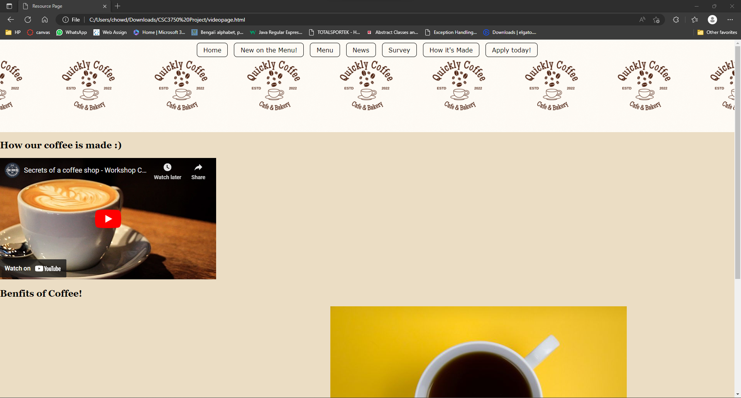

***Apply.html***

<!--SURVEY PAGE-->

<!DOCTYPE html>

<html lang="en">

<head>

  <meta charset="UTF-8">

  <meta http-equiv="X-UA-Compatible" content="IE=edge">

  <meta name="viewport" content="width=device-width, initial-scale=1.0">

  <title>Apply today!</title>

  <link rel="stylesheet" href="index.css">

  <style type="text/css">

    ol, ul {

       list-style-type: none;

        }

    body {

      background-color: #ecf0e4;

      margin: 0 10%;

      font-family: sans-serif;

    }

    h1 {

      text-align: center;

      font-family: serif;

      font-weight: normal;

      text-transform: uppercase;

      border-bottom: 1px solid #92c25b;

      margin-top: 30px;

    }

    h2 {

      color: #188630;

      font-size: 1em;

    }

    p.disclaimer {

      border-top: 1px solid #188630;

      padding-top: 1em;

    }

    </style>

</head>

<body>

  <header>

    <nav>

      <ul>

        <li><a href="file:///C:/Users/chowd/Downloads/CSC3750%20Project/index.html">Home </a></li>

        <li><a href="file:///C:/Users/chowd/Downloads/CSC3750%20Project/menuprev.html">New on the Menu! </a></li>

        <li><a href="file:///C:/Users/chowd/Downloads/CSC3750%20Project/table.html">Menu</a></li>

        <li><a href="file:///C:/Users/chowd/Downloads/CSC3750%20Project/news.html">News </a></li>

        <li><a href="file:///C:/Users/chowd/Downloads/CSC3750%20Project/surveypage.html"> Survey </a></li>

        <li><a href="file:///C:/Users/chowd/Downloads/CSC3750%20Project/videopage.html"> How it's Made </a></li>

        <li><a href="file:///C:/Users/chowd/Downloads/CSC3750%20Project/Apply.html"> Apply today! </a></li>

      </ul>

    </nav>

  </header>

<article>

  <h1>QUICKLY CAFE JOB APPLICATION</h1>

  <form action = "mailto:quicklycoffee@gmail.com" method = "POST" enctype="text/plain">

    <fieldset>

      <legend>Your Information...</legend>

    <p>Please provide your contact information below.</p>

    <br>

    <ul>

        <li><label for="form-firstname">First Name:</label> <input type="text" name="firstname" id="form-firstname"></li>

        <li><label for="form-lastname">Last Name:</label> <input type="text" name="lastname" id="form-lastname"></li>

        <li><label for="form-email">Email: <input type="text" name="email" id="form-email"></label></li>

    </ul>

    </fieldset>

    <br>

    <h1>--------------------------------------------------------</h1>

      <fieldset>

        <legend>Visiting info</legend>

      <p>What is your preferred method of communication?

        <small>(we will contact you through both, however, time sensitive messages will go to the preferred method chosen below.)</small>

        <select> name="visits" size="1">

          <option>Cell</option>

          <option>Email</option>

          <option>Both</option>

      </p>

      </fieldset>

      <br>

      <input type="submit" value="submit"><input type="reset">

  </form>

  <h3>Thank you for applying!</h3>

</body>

<footer>

  <p><small>All content copyright &copy; 2022, Quickly Coffee and Tasnia Chowdhury.</small></p>

</footer>

</html>

***Image:***

***Index.css***

@charset "UTF-8";

html {

  box-sizing: border-box;

}

* {

  box-sizing: inherit;

}

body {

  margin: 0;

  font-family: Verdana, Geneva, Tahoma, sans-serif;

  font-size: 100%;

  background-color:#ebddc4;

}

/*link styles*/

a:link, a:visited { color: rgb(16, 13, 218); }

a:focus, a:hover, a:active { color: #ffffff; }

/* header info */

header{

  color: rgb(68, 46, 13);

  background: url(header-background.jpg) no-repeat center center center;

  background-size: cover;

  text-align: center;

  height: 15em;

}

h1 {

  font-weight: bold;

  color: rgb(56, 50, 0);

  font-size: 32px;

}

main {

  padding: 1em;

  font-family: Verdana, Geneva, Tahoma, sans-serif;

  background-color: white;

  color: rgb(91, 91, 99);

  border: double 4px #be9342;

  border-radius: 25px;

  margin: 2.5%;

}

header {

  background: url(Quickly\ Coffee\ Logo.gif) center center;

  background-size: contain;

}

header h1 {

  margin-top: 1.5em;

}

header p {

  margin-top: -12px;

  font-style: italic;

}

h3 {

  border-top: 1px solid;

  border-left: 3px solid;

  padding-left: 1em;

  text-transform: uppercase;

  color: navy;

  margin-top: 2.5em;

}

header p {

  display: none;

}

p.more {

  clear: left;

  font-family: Verdana, Geneva, Tahoma, sans-serif;

  font-size: .8em;

}

a {

  text-decoration: none;

  border-bottom: 1px dotted;

  padding-bottom: .2em;

}

img[src*="coffee"] {

  margin-left: 50px;

  -webkit-shape-outside: ellipse(130px 95px at 50% 50%);

  shape-outside: ellipse(130px 95px at 50% 50%);

}

aside {

  padding: 4em;

  padding-left: 45px;

  background-color: rgb(252, 249, 246);

  border-top-right-radius: 25px;

  margin: 1em 2.5% 0 10%;

}

footer {

  padding: 1em;

  color: navy;

  text-align: center;

  font-size: 1em;

}

nav ul {

  margin: 0;

  padding: 0;

  list-style-type: none;

  display: flex;

  justify-content: center;

  flex-wrap: wrap;

}

nav ul li a {

  display: block;

  border: 1px solid;

  border-radius: .5em;

  padding: .5em 1em;

  margin: .5em;

  flex: 1 1 50%;

}

nav ul li a:focus,

 nav ul li a:hover {

  color: #f1f1f1;

 }

 nav ul li a:active {

  color: rgb(0, 0, 0);

 }

 nav ul li a:link,

  nav ul li a:visited {

  color: #000000;

}

@media screen and (min-width: 600px) {

  header p {

  display: block;

  margin-top: -1.5em;

  font-family: Georgia, serif;

  font-style: italic;

  font-size: 1.2em;

  }

  main, h2, h3 {

  font-family: 'Stint Ultra Expanded', Georgia, serif;

  }

  h2, h3 {

  font-weight: bold;

  }

  main {

  line-height: 1.8em;

  padding: 1em;

  border: double 4px #EADDC4;

  border-radius: 25px;

  margin: 2.5%;

  }

 }

nav, footer {

  font-family: verdana, sans-serif;

}

@media screen and (min-width: 940px) {

  #container {

  display: grid;

  grid-template-rows: auto min-height 5em;

  grid-template-columns: minmax(25em, 1fr) 16em;

  grid-template-areas:

  "banner banner"

  "main hours"

  "footer footer";

  max-width: 1200px;

  margin: 0 auto;

  position: relative;

  }

  header {

  grid-area: banner;

  }

  main {

  grid-area: main;

  }

  aside {

  grid-area: hours;

  background: url(images/scallop.png) repeat-y left top;

  background-color: #F6F3ED;

  padding: 1em;

  padding-left: 45px;

  }

  footer {

  grid-area: footer;

  }

  #award {

  position: absolute;

  top: 30px;

  left: 50px;

  }

 }