The purpose of this application to make a simple todo list, that can add task, view task, and delete task.

**Functional Requirements**

1) Add Task – takes user input and inserts it into the database.

2) Delete Task –delete an entry from the database.

3) View Tasks –shows all the data .

**Non-Functional Requirements**

1. Performance / response time: Application should be able to output all the data in linear time.
2. Data management: max 511-character task on list.
3. Environment: Run with Apache and MySQL

**System Architecture Diagram**

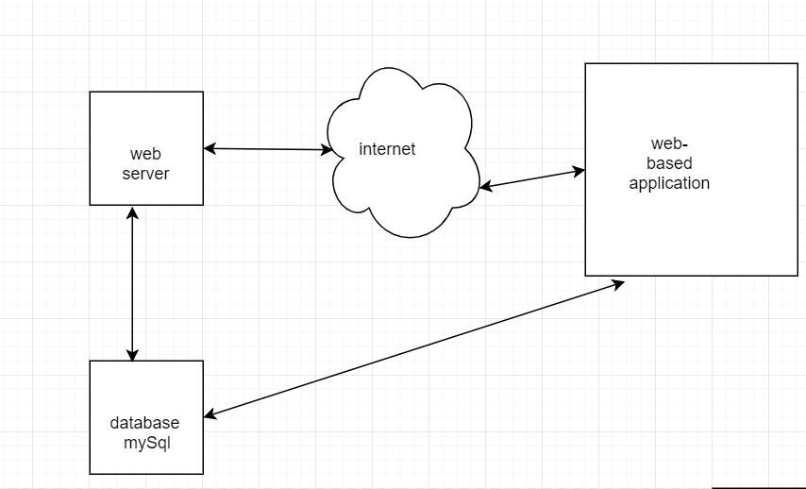

**Data Flow Diagram**

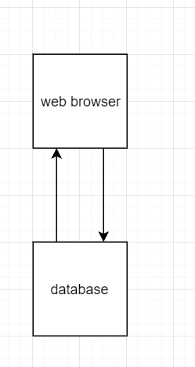

**Use Case**

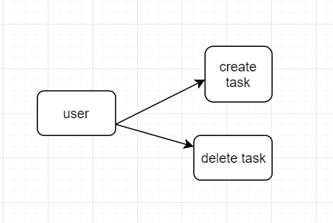

**Sequence Diagram**

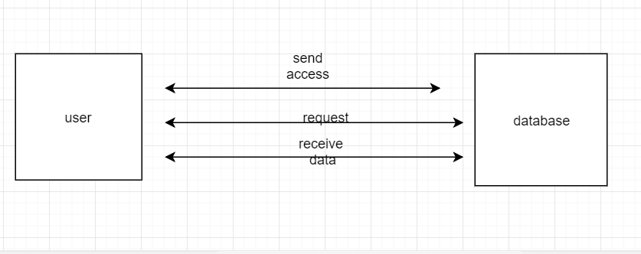

**Database Design**

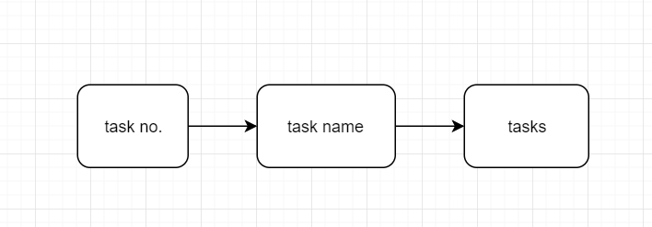

**Test Case**

Add task: input any string in the text box and submit. If there is error, output: you must fill in the task.

View task: show the data in database

Delete task: click on action button to delete the task that shows in database.