

American International University-Bangladesh (AIUB)  
**Department of Computer Science  
Faculty of Science &Technology (FST)  
Fall 19_20**

**Section:   
Group No:**

**PROJECT TITLE: Patient Portal**

A software Engineering project submitted

By

*Sakib Sadat Uddin (17-35888-3)(SadatSakib123)*

*Erfanul Haque (17-35338-3)(ErfanulHaq)*

*Nishat Tasnim (18-37044-1)( tasnim007nishat)*

*Fahim Farajannat (17-35634-3)(Fahim364)*

The project will be evaluated for the following Course Outcomes

|  |  |
| --- | --- |
| CO3: Choose appropriate software engineering model in a software development environment | Total Marks |
|  |
| Project Background Analysis (needs, goal, benefits, etc.) [5Marks] |  |
| Appropriate Process Model Selection [5Marks] |  |
| Argumentation for model selection with Evidence [5Marks] |  |
| Completeness, Spelling, Grammar and Organization of the Answer [5Marks] |  |
|  | |
| CO4: Explain the roles and their responsibilities in the software project management activities | Total Marks |
|  |
| Content Knowledge (e.g. System Requirements, System Design) [5Marks] |  |
| Project Role identification [5Marks] |  |
| Responsibility Description [5Marks] |  |
| Completeness, Spelling, grammar and Organization of the Answer [5Marks] |  |

Contents

1. PROBLEM DOMAIN 3

1.1 Background to the Problem 3

1.2 Solution to the Problem 3

1.3 Existing / Related Solutions 3

2. SOFTWARE DEVELOPMENT LIFE CYCLE 3

2.1 Process Model 3

2.2 Project Roll Identification and Responsibilities 4

3. PRODUCT AND PROJECT DESCRIPTION 4

3.1 Stakeholders 4

3.2 System Features 4

4. System Quality Attributes 4

4.1 System Architecture 4

4.2 System Interface 5

4.3 Project Requirements 5

# PROBLEM DOMAIN

## Background to the Problem

Patient portal means a portal that contains patients details and to-do work.In first world countries almost every patient has a portal so they can take proper decision and proper treatment routine to get well soon. It’s also in our country but in limited edition as many hospitals give treatment to the patient in old typical way.

Services received from country’s hospitals are not sufficient enough. Those who can’t afford the high budget hospitals don’t get the advantage of the portal. Also some old people can’t take proper care as they need others help to take medicine and to reach doctor. This is the root problem we are trying to solve.

## Solution to the Problem

We are like a bridge between the hospitals and patients. With most of the affiliated hospitals and patient we have access to their data.

From our app user will be a patient who can always check their medical condition, nearby doctors, emergency, notification to remind of the medicine time, medicine amounts etc.

Our goal is to make the entire system as easy and user friendly as possible.

## Existing / Related Solutions

Many hospitals like square, Labaid now contain patients portal in our country.

But as we know the portals are only available in costly hospitals where poor people cat afford. With our app any body can get the service of having a patient portal.

# SOFTWARE DEVELOPMENT LIFE CYCLE

## Process Model

As we work in a team and our time is short ,so we think that if we follow FDD process model then we can finish timely. And another benefit is that we can change our project feature and add any feature anytime by our following process model. That’s the extra benefit for us.

## Project Roll Identification and Responsibilities

In our project we follow five steps. At first we develop an overall model then we build the feature list. We distributed our work among all three members of our group. We continued our works in plan base way. We also help each other when any group member fall in problem. Our target was to finish the project in time and to make our project changebale.

# PRODUCT AND PROJECT DESCRIPTION

## Stakeholders

* Team
* User
* Hospitals
* Doctors

## System Features

1. System Login **Functional Requirements**

* 1. User admin CEO random login.
  2. Show hide password

**Priority Level:** High **Precondition:** user has valid user id and password

**System Signup  
functional Requirements:**

* 1. User Signup
  2. Insert all credential
  3. Check user id validity for duplication.

Priority level : High

Precondition: valid prescription with birth certificate.

Add document:

Functional requirements

User can apply for validation.

Reset Password  
1.1 user or super admin or admin can access it.

* 1. Need to enter previous password
  2. If world password match then move forward.  
     priority .

Update Issue Card:   
1.1 All data should be crosschecked with hospital and user

1.2 when id and password is issued details will be updated automatically

Priority Level :HIGH  
Precondition: User must checkout final portal outlook.

# System Quality Attributes

*Our system is user friendly fast and reliable. We think everybody can understand our system process easily They would feel very flexible to use software. Every single patient can use our software The poor patients who cant afford to do treatment using more money in selected hospitals will be able to take the full advantage of our easy and flexible portal. Another benefit is that our software have testability, so that if users face any problem we can test and give a solution easily. Customer can also reuse our software.*

## System Architecture

ER DIAGRAM: 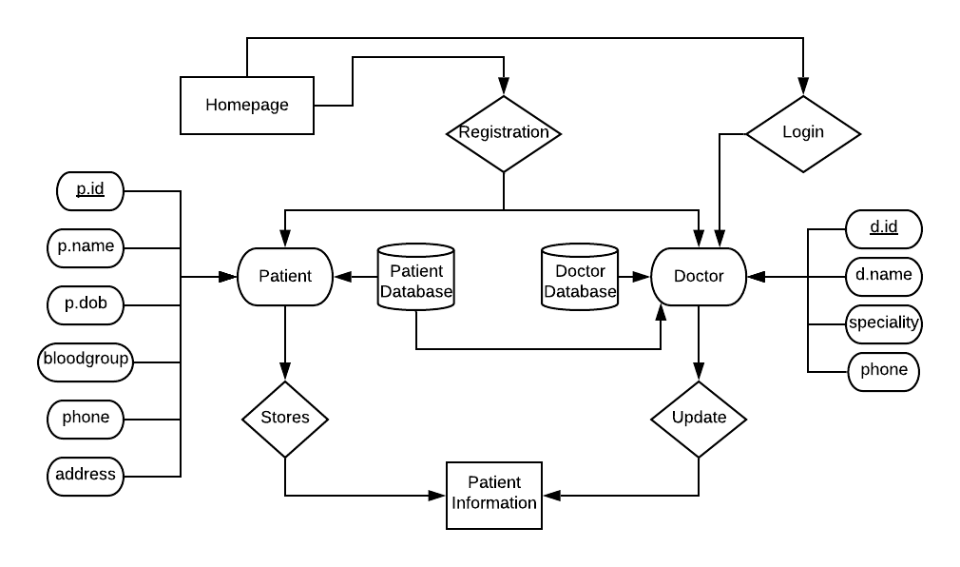

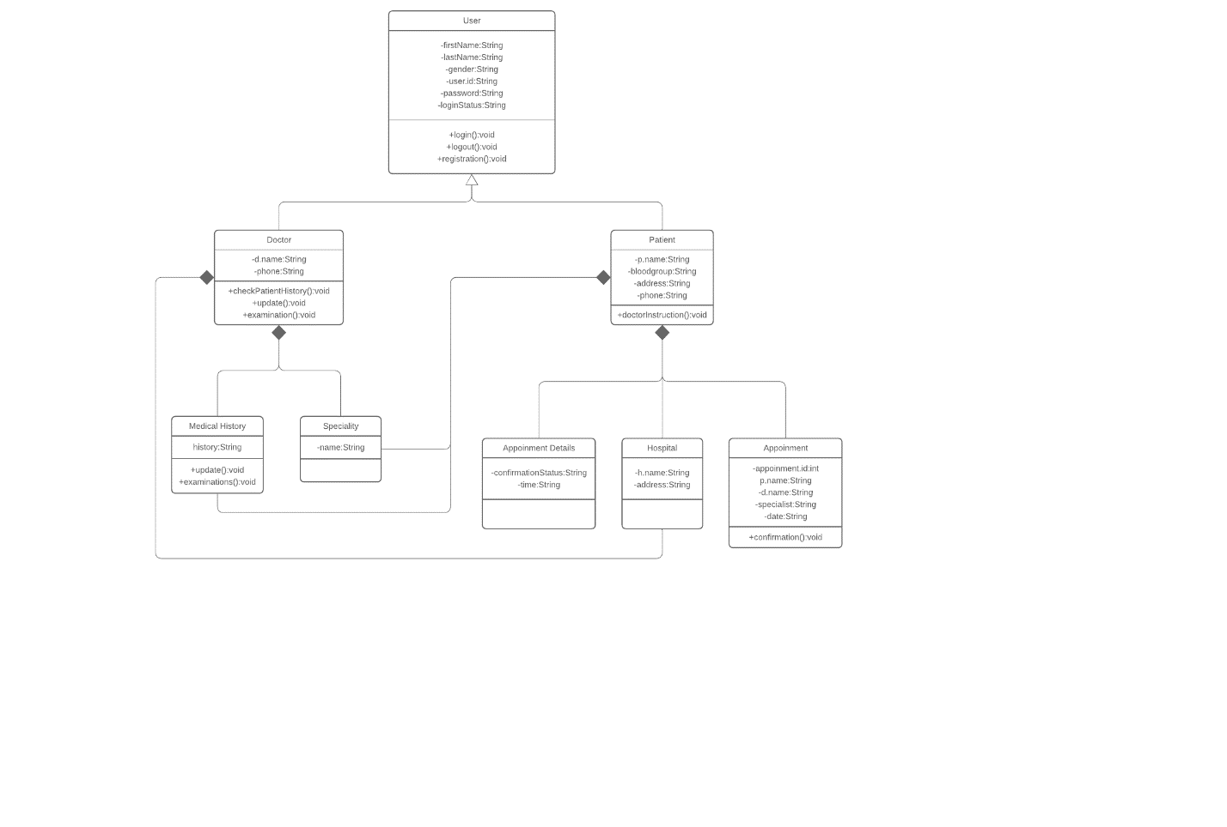

## C:\Users\erfan\AppData\Local\Microsoft\Windows\INetCache\Content.Word\Photo from Sakib Sadat (1).jpgSystem Interface

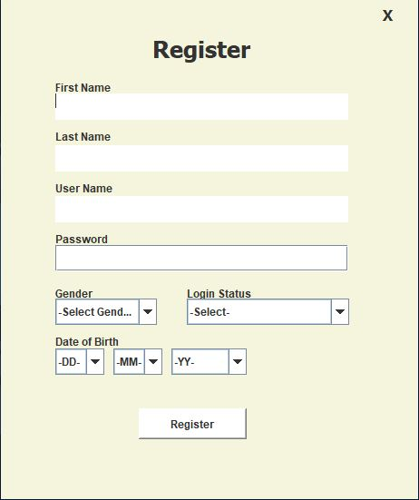

## 

## Project Requirements

1. JAVA Swing
2. ECLIPSE (IDE)
3. GUI
4. DIA

**REFFERENCE:**

* + - * **Roger S. Pressman | Bruce R. Maxim  
        SOFTWARE ENGINEERING  
        EIGHTH EDITION**