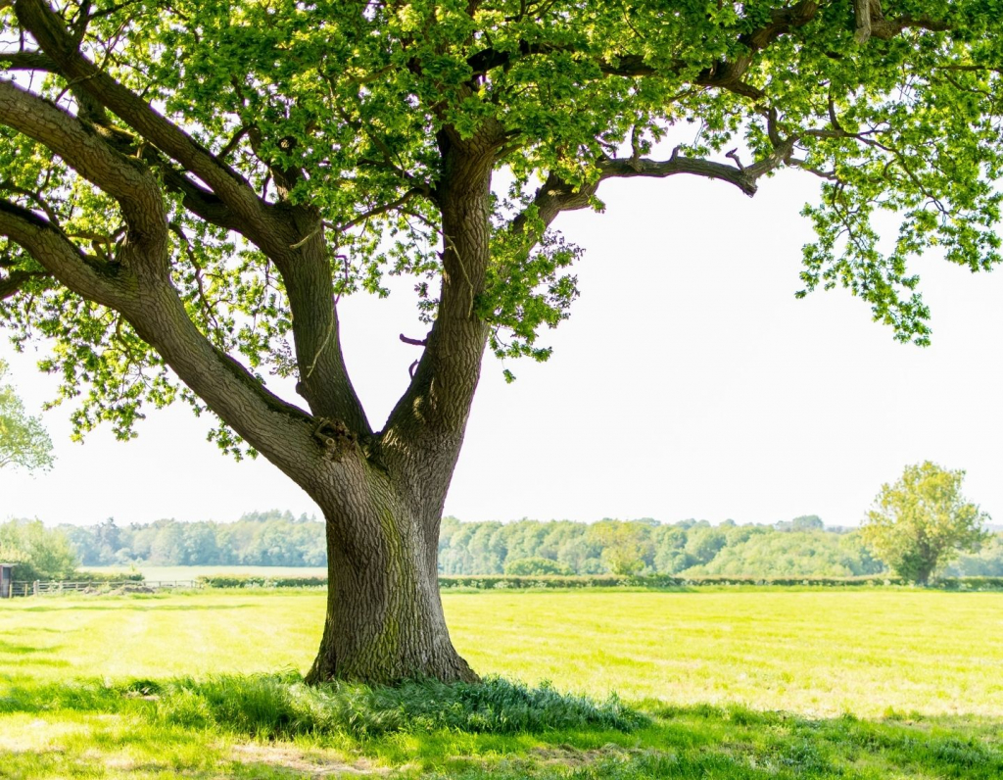

**Contribution to Carbon Absorption and Environmental sustainability**

**of Bangladeshi Plants**

**Maximizing the role of Bangladeshi Plants in Carbon**

**Trading : An Analysis**

**Submitted by**

Tasnim Azad

Roll : 23

Batch :44

Department : Botany

**Submitted to**

MD Erfan

Associate Professor and Chairman

Department of CSE

University of barishal

Submission Date :

### ****Index****

Serial no. Particulars Page no.

01. **Introduction 01**

Overview of Carbon Trading………………………………01

Mechanism and goals………………………………………. 02

Need for Carbon Market………………………………..….02

02.  **Oppertunities for Bangladesh…………………………..02**

Importance of Native Plants ……………………..……….04

**03. Methodology…………………………………………..………04**

Dataset……………………………………………………….……04

Criteria of Study…….…………………………………………05

**04. Results and Discussion……………………** Production of carbon credit

Top-performing Plants

**05. Conclusion**

**Impact on Carbon Trading in Bangladesh**

Economic and Environmental Benefits

Future Directions

06. Challenges

**07. References**

# Introduction

As the world faces the growing threat of climate change, one of the most powerful solutions lies right in front of us—our trees. In Bangladesh, a country rich in biodiversity, trees offer a unique opportunity to combat global warming by absorbing carbon dioxide from the atmosphere. By planting and nurturing tree species that thrive in local conditions, we can significantly increase carbon sequestration, contributing to both environmental sustainability and the global carbon trading market.

## Carbon Trading

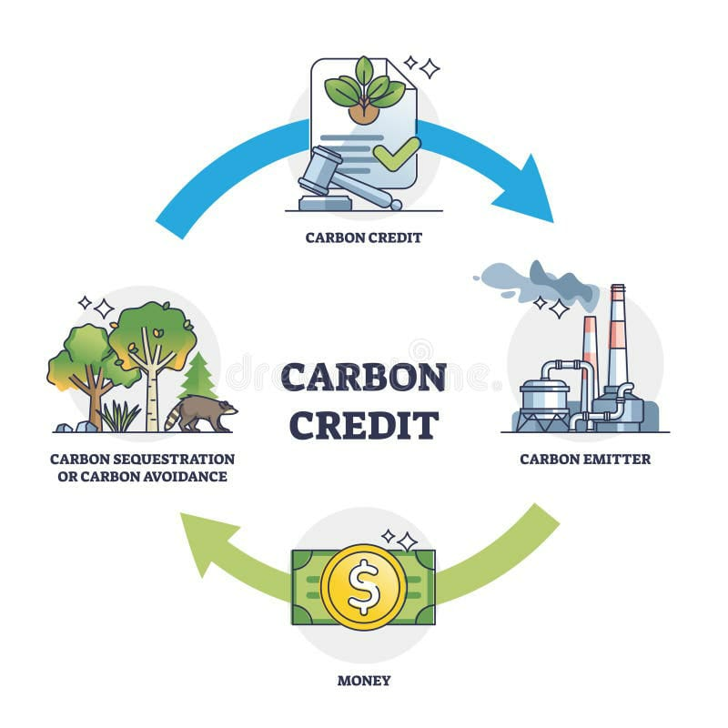

Carbon trading refers to the buying and selling of carbon credits, which allow companies or entities to emit a specific amount of carbon dioxide or other greenhouse gases (GHGs). One carbon credit permits the emission of one ton of carbon dioxide.

**Cap-and-Trade System:**  
In this system, a government sets a cap on emissions and allocates a corresponding number of emission allowances to entities. Those emitting less than their allowance can sell the surplus as carbon credits, while those exceeding the limit must buy credits or face penalties.

The primary objective of carbon trading is to reduce global carbon emissions, fostering a sustainable climate for future generations.

**Carbon Credit:**  
A certificate representing the reduction of one metric ton of CO2 emissions. It's issued for projects that reduce or remove greenhouse gases.

**Goal of Carbon Trading:**  
The primary objective of carbon trading is to reduce global carbon emissions, fostering a sustainable climate for future generations .To reduce global greenhouse gas emissions by providing financial incentives for emissions reductions and investments in sustainable practices. **Importance of Carbon Trading:**  
It encourages cost-effective emission reductions, promotes green technologies, and helps fight climate change by making polluters pay for their carbon footprint.

·

### The Need for Carbon Trading

Developed countries contribute significantly to global carbon emissions, exacerbating climate change and global warming. To address this, caps are imposed to limit their emissions.

In this context, the **Voluntary Carbon Market** plays a key role. It involves eco-friendly projects, such as renewable energy and reforestation, which generate carbon credits. Companies and countries that exceed their carbon limits can buy these credits instead of incurring fines.

### Bangladesh’s Role and Opportunities in Carbon Trading

· · **How Carbon Trading Works:**

It works as cap-and-trade system, the government sets an emissions cap and issues a quantity of emission allowances consistent with that cap. Governments set emission limits for companies. If a company reduces emissions below their limit, they can sell the excess credits. If they exceed the limit, they must buy credits from others.

Trees are nature's carbon sinks, capturing carbon dioxide during photosynthesis and storing it in their biomass. With Bangladesh's diverse range of native and fast-growing tree species, we have the potential to make a substantial impact in reducing the carbon footprint. By understanding the best species for different regions and maximizing growth through optimal practices, we can enhance the rate at which our forests absorb carbon, mitigate climate change, and create opportunities for carbon trading—a win for both the environment and the economy.



**Low Carbon Emissions:**  
Bangladesh emits far less carbon compared to developed nations, positioning it as a country that can generate surplus carbon credits.

**Mangrove Forests and Biodiversity:**  
The Sundarbans, the largest mangrove forest in the world, has a high carbon sequestration capacity. Forests and other natural ecosystems in Bangladesh can absorb significant amounts of carbon, creating opportunities for selling carbon credits.

Opportunity for Bangladesh

**How Carbon Trading Works:**

It works as cap-and-trade system, the government sets an emissions cap and issues a quantity of emission allowances consistent with that cap. Governments set emission limits for companies. If a company reduces emissions below their limit, they can sell the excess credits. If they exceed the limit, they must buy credits from others We can produce carbon credit and sell to them. By participating in carbon trading, Bangladesh can earn foreign currency through the sale of carbon credits and contibute to make a suntainable climate . These funds can be reinvested in sustainable development and climate resilience projects.

# Methodology

For my analysis I took 2000 plant data , some of which are nativ to Bangladesh or easily growing.

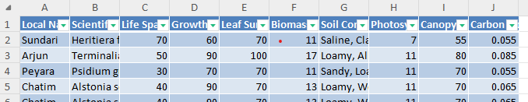

Figure : Representing my dataset.

Criteria of my analysis

1.Absorption of carbon / year ( ton )by specific plants.

2.How plants canpoy density is related to carbon absorption.

3.Impact of soil and life span of plant on carbon absorption and sequestration.

4.Top performing plants.

1.Absorption of carbon / year ( ton )by specific plants.

1.Absorption of carbon / year ( ton )by specific plants.

Modifcication

To analyse this large number of data I used pivot table and I did some modification of the data. I added an extra coloumn to the data set as Absorption of carbon/year (Ton) and calculate the value using a formula.

The Equation

Absorption of carbon per year =( Biomass accumulation/per *0.5/100)

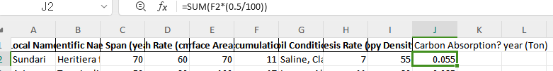

2.How plants canpoy density is related to carbon absorption.

Canopy density is on of the significant factor for carbon absorption of plant. I studied on the ratio of canopy density and how it impacts on carbon absorption.

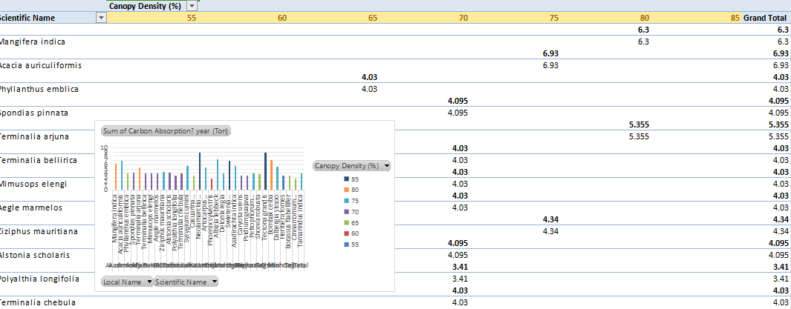

Figure : Analysis on canopy density.

The follwing analysis shows that most of the plant absorb more carbon with 70% canopy density among the range 55% to 85%.

1. Impact of soil and life span of plant on carbon absorption and sequestration.

I analyse about how much carbon a plant absorob per yaer as well as through its life. And here the result is,

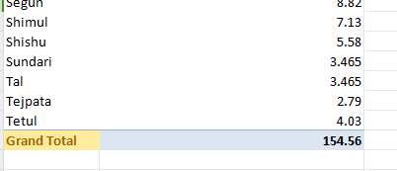

Figure : Yearly carbon absorption

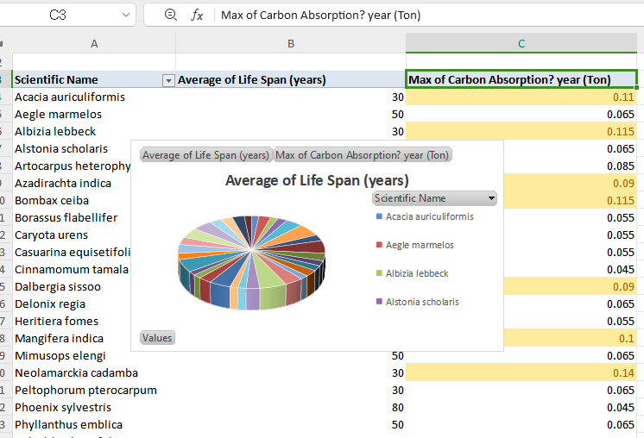

Figure : Carbon absorption through out their life span.

Result of my analysis

This information is pivotal in understanding the role of native plants in enhancing carbon trading opportunities for Bangladesh.

**Analysis Summary**  
The analysis revealed the following key insights:

Production of carbon credit

**Carbon absorption**:A significant total carbon absorption capacity of **154.56 tons/year** was observed across the analyzed species.



Figure : Total production of carbon per year in ton

We know that 1 Ton of carbon absorption = 1 credit . So we could able to produce 154.56 carbon credit using these plans.

**Top-performing plants**:

Plants such as Segun, Shimul, Shishu, Sundari, Tal, Tejpat, and Tetul were identified based on their contribution to carbon absorption.

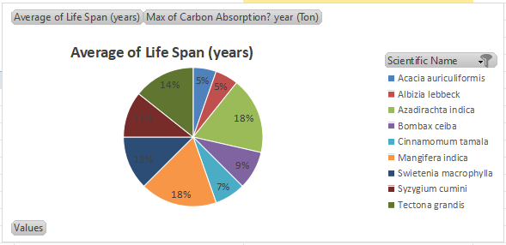

Figure : The pie chart illustrated the average lifespan of the studied species and their maximum carbon absorption potential.

Here this pie chart showing the top 10 performing plants. We can enhache our carbon credit production by planting thses plants in great number.

**My recommandations**

**Impact on Carbon Trading**  
Carbon trading relies heavily on robust carbon sequestration capabilities. By leveraging the data:

1. **Strategic plantation initiatives**: Bangladesh can focus on planting these high-performing species to maximize carbon credits.
2. **Economic benefits**: Promoting these plants for carbon trading can help Bangladesh monetize its natural resources on global carbon markets.
3. **Climate mitigation**: Widespread plantation of these species will also contribute to climate change mitigation and biodiversity preservation.

Conclusion

This analysis demonstrates the immense potential of Bangladesh's native plants in contributing to global carbon trading markets. By focusing on strategic plantation and proper management, Bangladesh can unlock significant environmental and economic benefits.

Challenges

* I faced much difficulities to find out an appropriate dataset for my analysis.
* As I faced difficality to find out data I made a user form for people who can contribute to the dataset providing aqqurate information.. I faced some diffica;ities to write the code for the VBA form.

Reference

1. [Carbon-market](https://icvcm.org/voluntary-carbon-market-explained/)
2. [Cap-and-trade]( https:/www.c2es.org/content/cap-and-trade-basics/)
3. [Climate-finance/carbon-markets](3.https:/www.unep.org/topics/climate-action/climate-finance/carbon-markets)