# Bangladesh University of Engineering & Technology

## Department of Electrical & Electronic Engineering

Course No: 312

Course Title: Digital Signal Processing Lab

Date of Performance: 09.03.2021

Date of Submission: 16.03.2021

Tasnim Nishat Islam

Student Id: 1706092

Section: B1

Level 3 Term 1

Part A:

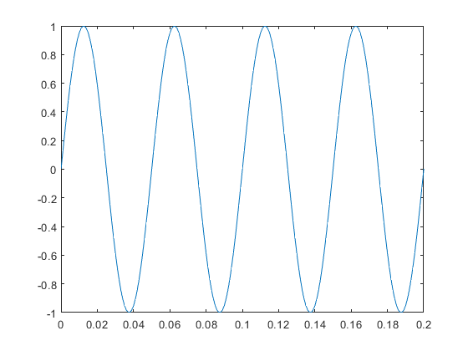Codes:

clc

clear all

close all

%%load the signal

t = 0:0.001:0.2;

signal = sin(2*pi*20*t);

%%sample the signal

n = 0:1:40

fs = 200

stem_sig = sin(2*pi*(10/fs)*n)

%%plot the original signal

figure("Name", "original");

plot(t, signal);

%plot the sampled version

figure("Name", "sampled_signal");

Figure : Original Signal

stem(stem_sig);

%%reconstruct

recon = interp1(n/fs, stem_sig, t, 'spline');

figure("Name", "recon");

plot(recon);

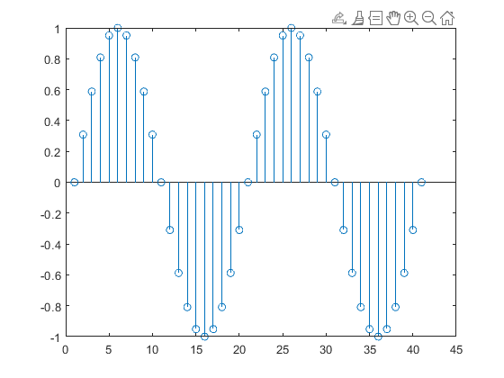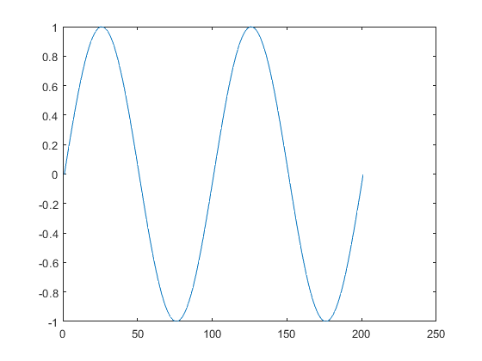

Figure : Sampled at 200 Hz

Figure : Reconstructed Signal after sampling

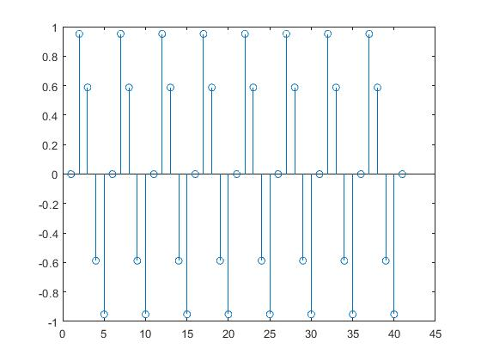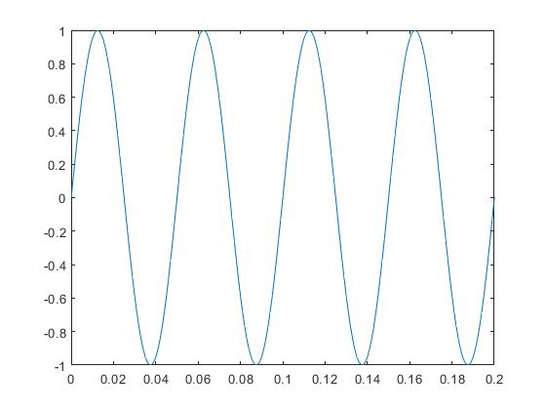For 50 Hz

Figure : Sampled at 50 Hz

Figure : Original signal

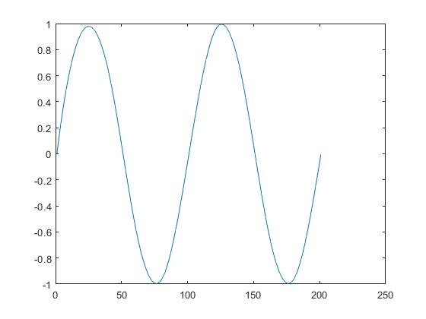

Figure : Reconstructed after sampling in 50 Hz

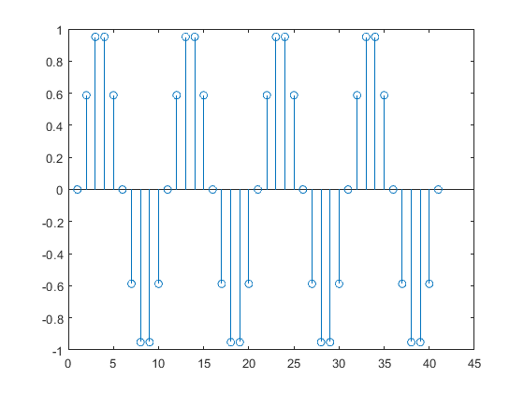For 100 Hz

Figure : Sampled at 100 Hz

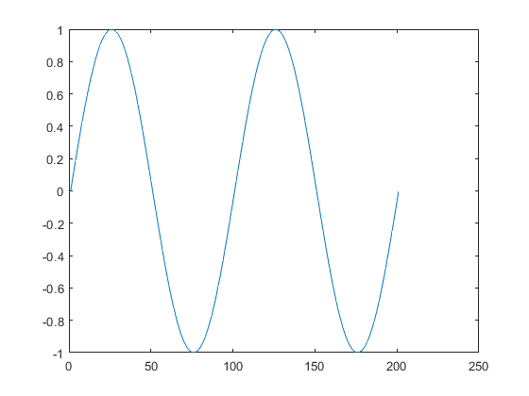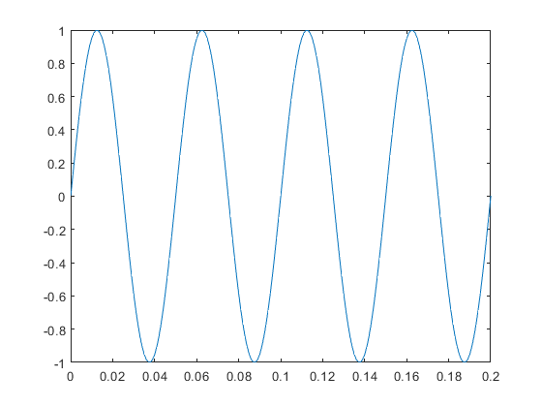

Figure : Reconstructed signal sampled at 100 Hz

Figure : Original Signal

For 10 Hz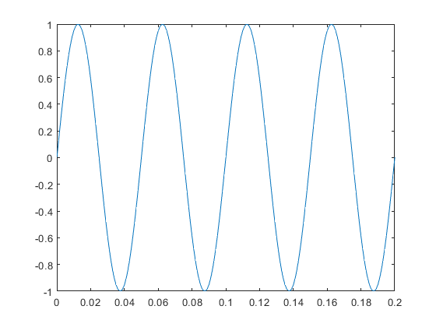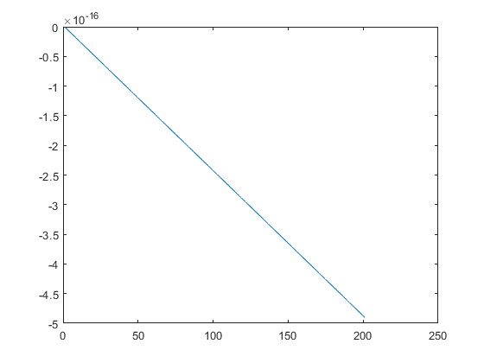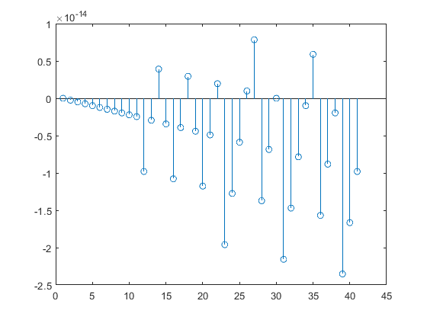

Figure : Reconstructed after sampling

Figure : Sampled at 10 Hz

Figure : original Signal

Step 5

signal = sin(2*pi*10*t)+sin(2*pi*50*t)+sin(2*pi*100*t);

%%plot the original signal

figure("Name", "original");

plot(t, signal);

title("original signal")

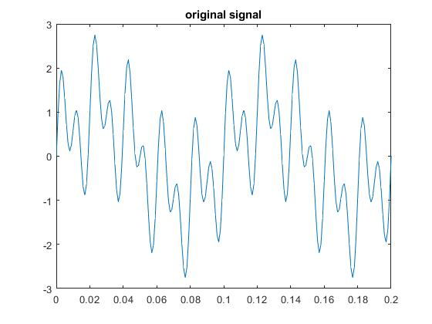

Figure : Plot of the original Signal

Part B:

Uniform 3-bit Quantizer:

function y_quantized= quantize(x_sampled,bit)

N=length(x_sampled);

L=2^bit;

del=((max(x_sampled)+0.0000000001)-min(x_sampled))/(L-1);

for j=1:L

level(j)=min(x_sampled)+del*(j-1);

end

for i=1:N

for j=1:L-1

if(x_sampled(i)>=level(j)&& x_sampled(i)<level(j+1))

if(x_sampled(i)>=level(j)+.5*del)

y_quantized(i)=level(j+1);

else

y_quantized(i)=level(j);

end

end

end

end

y_quantized

clc

clear all

close all

%%load the signal

t = 0:0.001:0.2;

signal = sin(2*pi*10*t)+sin(2*pi*50*t)+sin(2*pi*100*t);

%%sample the signal

n = 0:1:40

fs = 200

stem_sig = sin(2*pi*(10/fs)*n)+sin(2*pi*(50/fs)*n)+sin(2*pi*(100/fs)*n);

%%plot the original signal

figure("Name", "original");

plot(t, signal);

title("original signal")

%plot the sampled version

figure("Name", "sampled_signal");

stem(stem_sig);

title("sampled signal")

%%quantized

bit = 3;

y_quantized = quantize(stem_sig,bit);

figure("Name", "quantized");

stem(y_quantized);

title("quantized")

%%reconstruct

recon = interp1(n/fs,y_quantized,t,'spline');

figure("Name", "recon");

plot(recon);

title("reconstracted")

%%SQNR

SQNR_hard_coded = signal_noise_ratio(stem_sig, y_quantized);

SQNR_eq=1.76+6*bit;

**Outputs**

SQNR in theory: 19.760000000000000

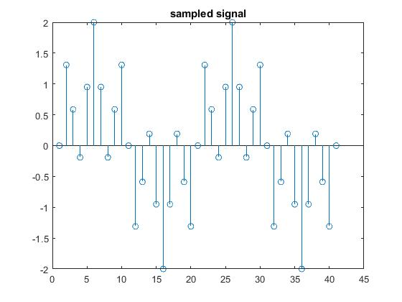SQNR in Experiment: 15.067902412367973

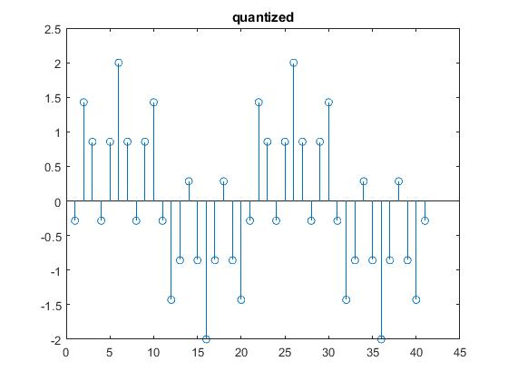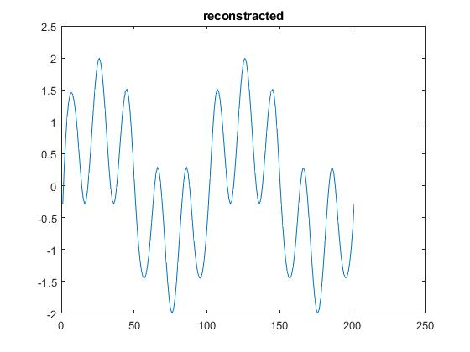

**Uniform 4 bit Quantizer :**

SQNR in theory: 25.7600000000000

SQNR in Experiment: 21.823594170954390



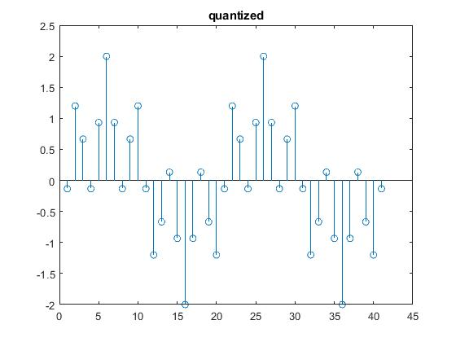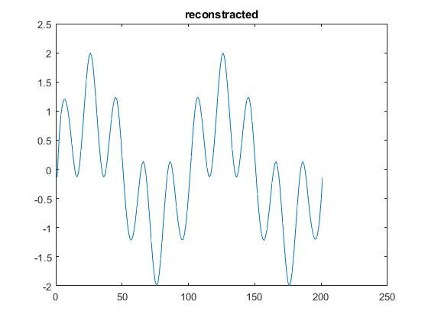

**Uniform 6-bit Quantiezer**

SQNR in theory: 37.760000000000000

SQNR in experiment: 32.482166417366216

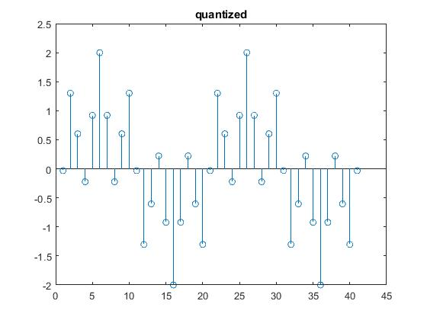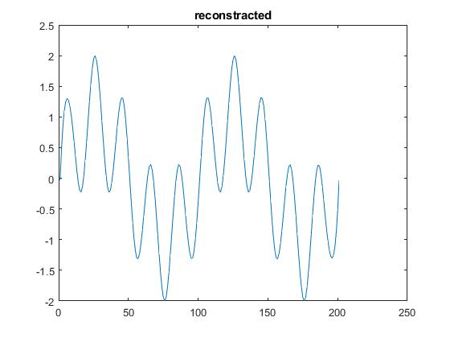

**Comment**: By increasing the number of bits, quantization noise power is decreasing due to increased number of quantization level and reconstructed signal will be more accurate.

**Part C:**



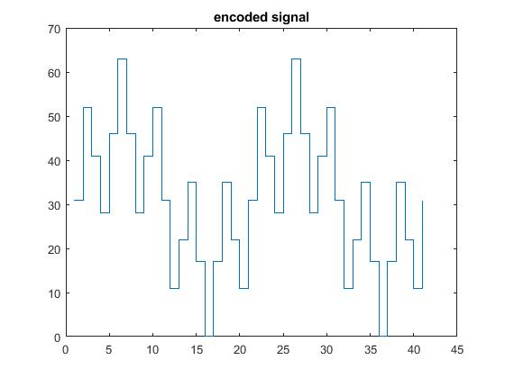

**Home task**

function sampled_com = u_law_compressor(signal, u)

signal = double(signal)

sampled_norm = signal/max(abs(signal))

figure("Name", "sampled_norm")

stem(sampled_norm)

sampled_com=log(1+u*abs(sampled_norm))/log(1+u).*sign(sampled_norm);

function y_quantized= quantize(x_sampled,bit)

N=length(x_sampled);

L=2^bit;

del=((max(x_sampled)+0.0000000001)-min(x_sampled))/(L-1);

for j=1:L

level(j)=min(x_sampled)+del*(j-1);

end

for i=1:N

for j=1:L-1

if(x_sampled(i)>=level(j)&& x_sampled(i)<level(j+1))

if(x_sampled(i)>=level(j)+.5*del)

y_quantized(i)=level(j+1);

else

y_quantized(i)=level(j);

end

end

end

end

y_quantized

clc

clear all

close all

%%load the signal

t = 0:0.001:0.2;

signal = sin(2*pi*10*t)+sin(2*pi*50*t)+sin(2*pi*100*t);

%%sample the signal

n = 0:1:40

fs = 200

stem_sig = sin(2*pi*(10/fs)*n)+sin(2*pi*(50/fs)*n)+sin(2*pi*(100/fs)*n);

%%plot the original signal

figure("Name", "original");

plot(t, signal);

title("original signal")

%plot the sampled version

figure("Name", "sampled_signal");

stem(stem_sig);

title("sampled signal")

%u_law_compressor

u = 255

sampled_com = u_law_compressor(stem_sig, u)

figure("Name", "u_law_compressed");

stem(sampled_com)

title("u law compressed")

%quantized

bit = 8;

y_quantized = quantize(stem_sig,bit);

figure("Name", "quantized");

stem(y_quantized);

title("quantized")

%reconstruct

recon = interp1(n/fs,y_quantized,t,'spline');

figure("Name", "recon");

plot(recon);

title("reconstracted")

%SQNR

SQNR_hard_coded = signal_noise_ratio(stem_sig, y_quantized);

SQNR_eq=1.76+6*bit;

%Encoding

N = 8;

encoded_n = encoder(N, stem_sig, bit, y_quantized);

encod = encoded_n;

**Output**

encod values =

'01111111'

'11010011'

'10100101'

'01110011'

'10111100'

'11111110'

'10111100'

'01110011'

'10100101'

'11010011'

'01111111'

'00101011'

'01011010'

'10001100'

'01000011'

'00000000'

'01000011'

'10001100'

'01011010'

'00101011'

'01111111'

'11010011'

'10100101'

'01110011'

'10111100'

'11111110'

'10111100'

'01110011'

'10100101'

'11010011'

'01111111'

'00101011'

'01011010'

'10001100'

'01000011'

'00000000'

'01000011'

'10001100'

'01011010'

'00101011'

'01111111'

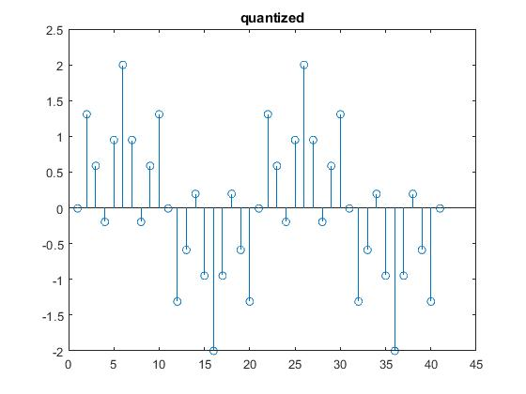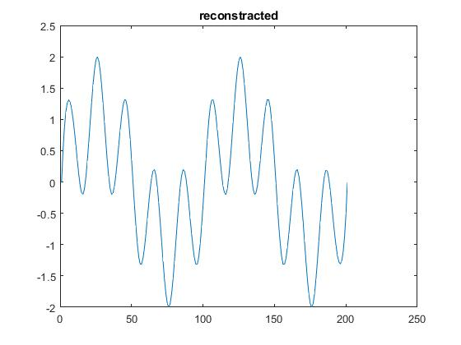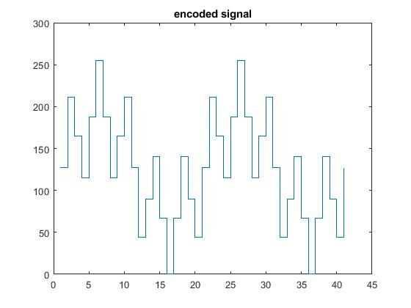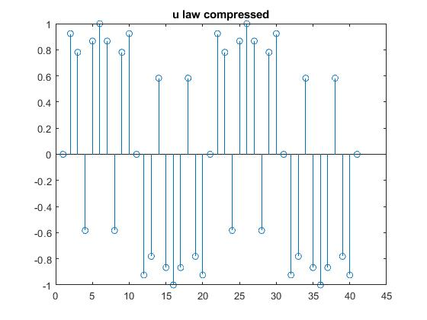

Codes : [link to github repository](https://github.com/tasnimislam/1706092_dsp_projects.git)