

East West University
Department of Computer Science and Engineering (CSE) Semester: (Spring, Year: 2025), B.Sc. in C SE

A University Network

Course Title: Computer Networks CourseCode:CSE405
Section: 06
Students Details

Name | ID
Md. Rahat Khan | 2021-1-60-090
Tasnim Jabir | 2022-3-60-283
Md. Mostahid Hossain Sami | 2022-3-60-108

Submission Date: 18-12-2025
Course Teacher’s Name: Rabea Khatun

[For teachers use only: Don’t write anything inside this box]

Date:
Comments:
Signature:
Marks:
Lab Project Status

Contents

Introduction
  - Overview ...........................................................................................................
  - Motivation .........................................................................................................
  - Design Goals/Objectives ...................................................................................

Design/Development/Implementation of the Project
  - Project Details ...................................................................................................
  - Implementation..................................................................................................
    - IP Configuration ...................................................................................
    - Dynamic Routing..................................................................................
    - SMTP & POP3 (Email Configuration)………………………………
    - FTP Configuration ...............................................................................

Result and Discussion 8
3.1.1 Necessary Sections
- Conclusion

Chapter 1 Introduction

Overview:
East West University, operates a multi-campus environment with a wide range of academic and administrative facilities. Its network infrastructure must support thousands of users across different campuses with reliable wired and wireless connectivity, centralized services, and scalability for future growth.
This project focuses on designing a complete network model using Cisco Packet Tracer, Integrating SMTP & POP3 (Email Configuration), FTP Configuration, Routing Configuration, Web Server HTTP, and DHCP to achieve seamless connectivity across our campuses.

Motivation:

East West University needs a strong and reliable network to support thousands of users across its multiple campuses. As the demand for both wired and wireless connectivity grows, the network must be scalable and efficient to meet future needs. This project aims to design a network using Cisco Packet Tracer that integrates services like email, file transfer, web hosting, and DHCP. By implementing routing protocols like OSPF, we will ensure smooth communication between campuses. This network will not only improve current services but also support future growth as the university expands.

Objectives:
The primary Objectives of the network are:

- Provide wired and wireless access in each campus.
- Ensure centralized DHCP service for IP allocation.
- Deploy a single DNS server for name resolution.
- Host a web server accessible via http://www.ewubd.edu.
- Implement Dynamic routing (RIP) for Inter- campus comunity.
- Support future expansion of subnets and services.

Chapter 2
Implementation of the Project

Project Details:
Router Connections Table:
Network | IP Range
Server Network | 172.0.0.0
Main Campus | 172.1.0.0
FUB | 172.2.0.0
AB1 | 172.3.0.0
AB2 | 172.4.0.0

Implementation
    - IP Configuration: We use DHCP for IP configuration Dynamically. Multiple PCs connected through a 2960 switch.Local router connects the campus LAN to the core routerDevices receive IP addresses dynamically from the DHCP server Full access to email, FTP, and web services.
Main Campus PC1: 172.1.0.2
PC2: 172.1.0.3
PC3: 172.1.0.4
    - Dynamic Routing: We use 5 Router, One is central router, other 4 is connected for LAN connection.

    - SMTP & POP3 (Email Configuration): We use SMTP server for mail transfer. This is configured in IP 172.0.0.1.
    - FTP Configuration: We use FTP server for file transfer and file save in server. This is configured in IP 172.0.0.4.

Chapter 2

Result and Discussion:
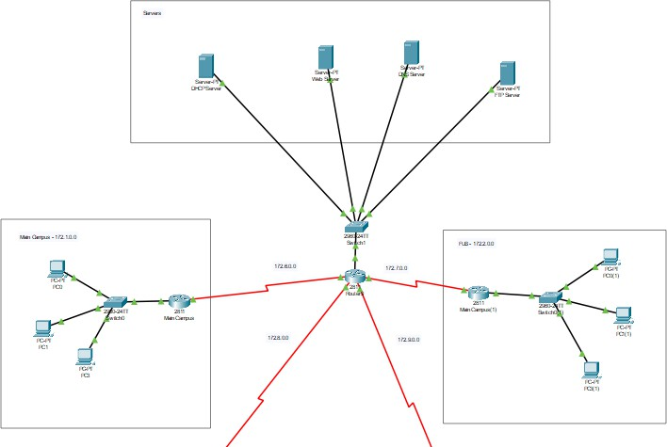

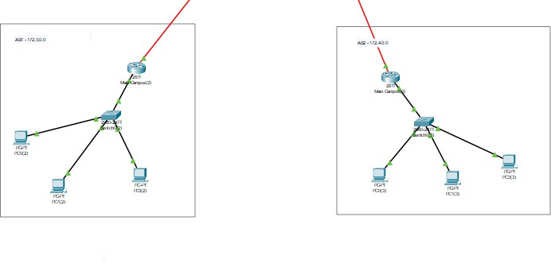
Conclusion: This project successfully demonstrates the design and implementation of a University Campus Network using Cisco Packet Tracer. All required components, including dynamic routing, DHCP, email (SMTP & POP3), FTP, and web services, were configured and tested successfully. Proper IP addressing, inter-department communication, and centralized server management ensured reliable network operation. The project meets all stated requirements and reflects a clear understanding of fundamental computer networking concept.

