Temperature Coversion Program

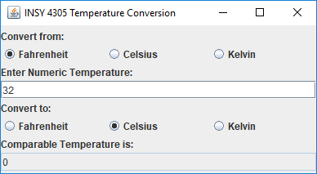

Write a temperature-conversion GUI application as shown in the picture. The input temperature should be entered from the keyboard (via a JTextField). A JLabel should be used to display the converted temperature. The application should allow the user to make coversion between any two scales.

Use the following formula for the conversion:

***Celsius = (5/9) * (Fahrenheit – 32)***

***Kelvin = Celsius + 273.15***