Impact of Market Sentiment on Trader Performance in Crypto Markets
Introduction
1.1 Background
The cryptocurrency market is strongly affected by investor emotions. Feelings such as fear and greed influence how traders decide when to buy or sell, how much money they invest, and how much risk they are willing to take.
To measure these emotions, the Bitcoin Fear and Greed Index is widely used. It shows whether the market is driven more by fear or by greed:
- Fear – when traders are cautious and prefer to avoid risk
- Greed – when traders are confident and more willing to take higher risks
Understanding trader behavior under these two market conditions is important for creating better trading strategies and improving risk management.

1.2 Data Used
This study uses two main datasets to understand how market sentiment affects trading behavior.
- Hyperliquid Historical Trading Data
This dataset includes real cryptocurrency trades made on the Hyperliquid exchange. Each trade record contains:
- Trader account ID
- Trade size in US dollars
- Buy or sell action
- Time of execution
- Profit or loss (PnL) after the trade is closed
This data shows how real traders behave in actual market conditions.
- Bitcoin Fear & Greed Index
This dataset measures overall market sentiment on a daily basis. It is calculated using factors such as:
- Market volatility
- Trading volume
- Price trends (momentum)
- Social media activity
Each day is labeled as either Fear or Greed.

1.3 Objective
The objective of this study is to understand how trader behavior and performance change during different market moods. By combining real trading data with market sentiment, this analysis aims to find useful patterns that can help in:
- Increasing trading profits
- Managing and reducing risk
- Avoiding decisions driven by emotions

Market Sentiment vs Trader Behavior
2.1 Trading Volume by Market Sentiment
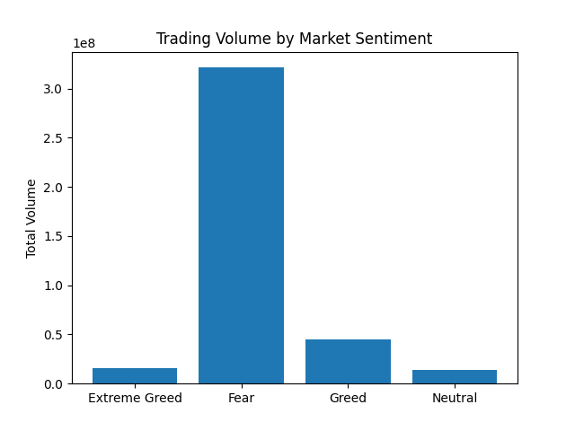
Trading activity is highest during Fear, indicating that traders actively adjust their positions when the market is uncertain. Trading volume is also high during Greed, as traders participate more when confidence in the market increases.

2.2 Average Trade Size (Risk)
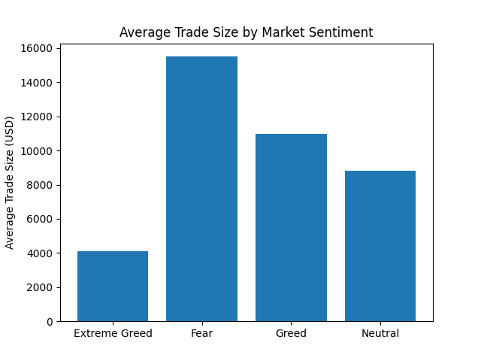
The average trade size is highest during Fear, showing that traders take stronger, high-confidence positions during market stress. In comparison, Greed and Neutral periods involve more moderate trading exposure.

2.3 Average PnL by Sentiment
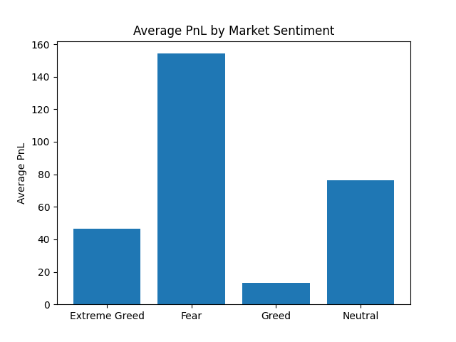
Trades made during Fear generate the highest average profit, while trades during Greed have the lowest profitability. This suggests that excessive optimism may lead to emotional and less disciplined trading.
Business Impact & Strategy Insights
1. Risk Management
The analysis shows that trader behavior becomes more aggressive during periods of Greed, which increases exposure to losses. Trading systems can reduce risk by automatically lowering position sizes and applying stricter limits when market sentiment is highly optimistic.

2. Better Trade Timing
Trades executed during Fear tend to be more disciplined and deliver better average performance. This suggests that entering longer-term positions during Fear may lead to more stable returns, while Greed phases should be approached with more caution.

3. Sentiment-Aware Trading Systems
Market sentiment provides a strong signal about trader psychology. By using the Fear–Greed Index in trading strategies, traders and platforms can avoid emotional decision-making, improve consistency, and protect capital during extreme market conditions.

Conclusion
By combining Hyperliquid trading data with the Bitcoin Fear - Greed Index, this study shows that market sentiment has a strong impact on trader behavior and profitability. Greed increases trading activity and risk but often reduces efficiency, while Fear encourages more careful and disciplined trading. These insights can be used to design smarter, sentiment-aware trading strategies in modern crypto markets.

