INSTALLER GUIDE

MAIN PANEL CONNECTIONS

All Main panel connections are shown below. Terminal Inputs - Outputs and on board external modules.
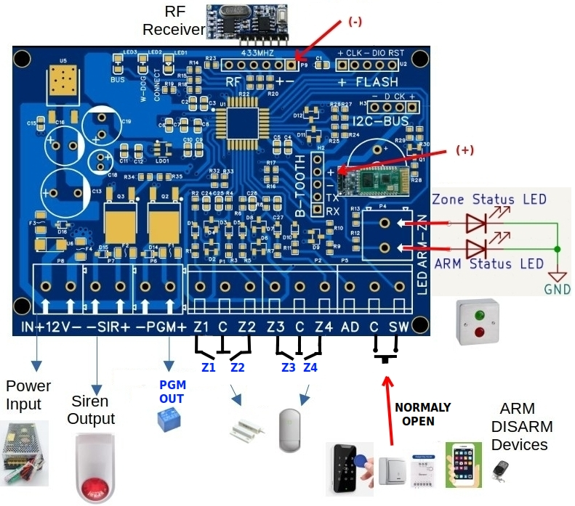

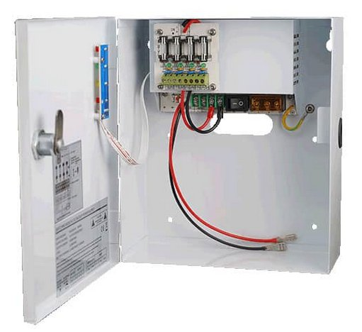

Terminal Inputs and Outputs
1. System Power Supply Input ( IN+12V- ) .
The system require 12V/2A power supply. The voltage limits are 10.5V – 15V and the current
must be at minimum 2A.
It is a good idea to also have a backup battery circuit (as shown in the image above right) , so that
the alarm will work in the event of a power loss .The power supply cabinet also could be used as
enclosure box for the Main Panel Board ( as DIY job ).

2) Siren Output ( -SIR+ ).
The board provide 12V/1A on that Output for an indoor or outdoor Siren

3) PGM Output ( -PGM+ ).
The board provide 12V/100ma on that Output. This output is programmable and
triggered in some system events.

4) Zone Inputs ( Z1 – C – Z2 + Z3 – C – Z4 ).
The Sensor Inputs for the zone terminals, must be a dry contact.
Those inputs are Normally Closed ( NC )

5) Alarm activation and deactivation input ( SW – C ).
This input must be Dry contact and Normally Open (NO). For the command to be accepted, the
contact must be closed for at least 700msec and then return to the previous Normally Open state.

6) Arm Status and Zone Status LED Outputs ( ARM – ZN ).
When these outputs are enabled, they can drive a LED at 3 volt and a maximum of 15 mA.

ON BOARD EXTERNAL MODULES

1) RF433MHZ Receiver Module.
By installing this receiver, we are given the opportunity to use Remote Controls to
operate the alarm.

2) BlueTooth Module ( HC05 or HC06 ).
By installing this Module, the user is given the opportunity to use the alarm from the mobile
application (PA_SW_Mon_V4.apk). The installer can also program the panel with
the PA_SW_Prog_V4.apk application.

NOTE: Attention should be paid to the correct polarity of the Module placement.
As shown in the picture above.

MAIN PANEL PROGRAMMING
To program the panel, you need to:
1) Place the BlueTooth Module on the panel and
2) Install the PA_SW_Prog_V4.apk application on your mobile phone.
Attention: The application is only for Android phones. It is also possible to use Iphone, but the
procedure is more specific and described in the file Engineer_Guide.pdf

Connecting the mobile phone to the panel:
1) After downloading the PA_SW_Prg_V4.apk application, you should install it on your mobile.
2) The Bluetooth of the mobile should be activated
3) You should pair your mobile with the BlueTooth Module(HC-05 or HC-06). On the mobile,
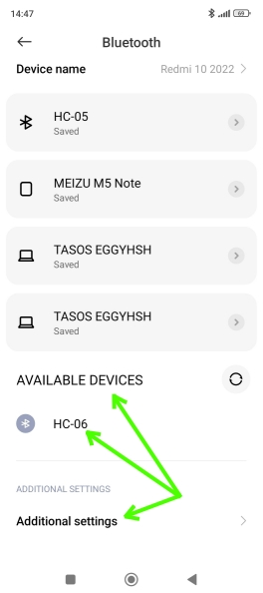
go to Settings → Bluetooth → More Settings → Available Devices.
There you should see the HC-05 or HC-06 device. You should pair
your mobile with the Bluetooth Module(HC-05 or HC-06).
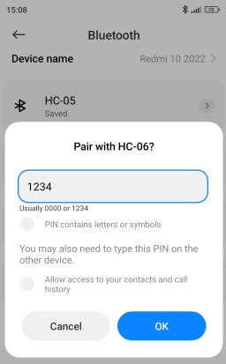
Select the device as shown on the left icon and enter the
code 1234 to Register the device, as shown on the
right icon
If you have already done this on your mobile for this
particular device, then skip this step.

Note: The setup path followed is for a Xiaomi device.
It may be different for your mobile.

4) Run the Application PA_SW_Prg_V4. You should see a screen as shown in the image-1 below.

5) Press the icon that shows the bluetooth.
And there from the list that will appear, select the device you paired and wait for the
mobile to connect to the panel. If everything has gone well, the programming data fields should
be colored, as shown in image-2 below.
If something goes wrong, then a message will appear as shown in image-3 below.
Note: On initial connection, it takes some time for the board to synchronize with the mobile. At
this point the mobile may give you this message. If this happens, then you should select → Wait.
Image-1 Image-2 Image-3 Image-4
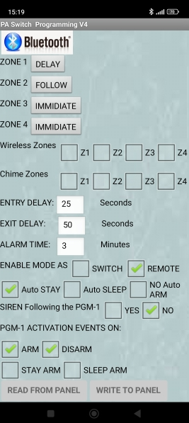
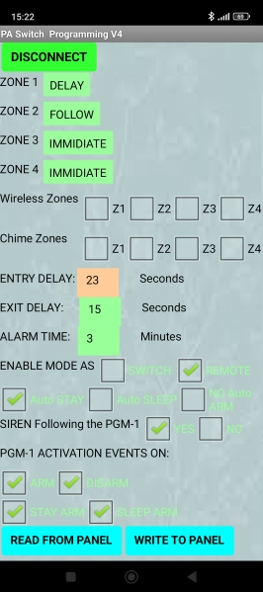
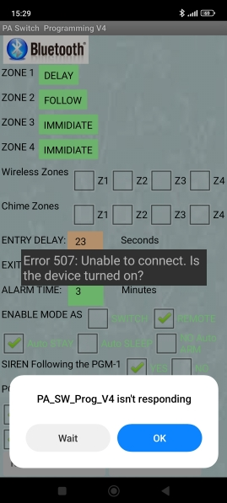
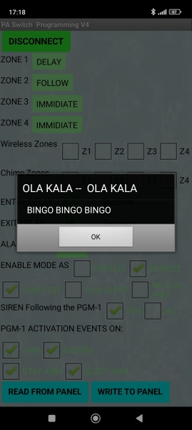

Programming of the main panel features:
Before we try to change the data in the Main Panel, it is a good idea to first read the existing data.
This is to ensure that the board is communicating properly with the mobile phone and that the data
is synchronized. To do this, we press the button → Read From Panel. If the data is read
successfully, then the message in image-4 will be displayed. From this point on, the panel data is
synchronized with the application data. For this reason, the data it is marked with the green color.
If we change, for example, the entry time to a value of 23 from 25, which is the initial value, then
this field will change color and become orange, as shown in image-2. In order to be able to update
the panel with the changes we have made, then we press the → Write To Panel button. If the data
is successfully written to the panel, then the message in image-4 will appear.

Explanation of the programming data values:
1) Zone 1 – Zone 4. Here we define the type of each zone.
2) Wireless Zones Z1 – Z4. For future use.
3) Chime Zones Z1 – Z4. We define which zone(s) will generate sound on the
central panel's Buzzer.
4) Entry Delay. The entry delay time in seconds.
5) Exit Delay. The exit delay time in seconds.
6) Alarm Time. Siren time in minutes, in case Alarm of the system.
7) Enable Mode. It should be enabled the option → Remote.
The option → Switch, comes from an older version of the system.
8) Auto Arm. If the entrance door is not opened during the exit delay time, then we can choose in
which state the alarm will arm. It can be set to arm as Stay - Sleep - No Auto Arm (Regular
Arm). This is very convenient because the user does not need to choose how to arm the alarm,
nor does he need to Bypass the zones. So by using only 1 Push-Button the user can arm when
leaving the house in Regular Arm mode, while when not leaving the house in
Stay or Sleep mode.
9) Siren Follow PGM. With this option it is possible for the siren to be activated when the
programmable PGM is activated too. This way the user can be given confirmation that he has
armed or disarmed the alarm (Different sound in each case). This is very convenient when the
user uses Remote Control to activate the alarm and is not inside the house, so that he has audible
confirmation from the central panel.
10) PGM Activation Event On. With this option we can choose which system events will trigger
the PGM output.
Monitoring the system using mobile Application:
To do this, the procedure as described above in the section → Connecting the mobile phone to
the panel must be followed, with the difference that the corresponding application for the user
is → PA_SW_Mon_V4.apk and the application screens before and after connecting to the panel
are those shown in images-5-6-7.

Image-5 Image-6 Image-7
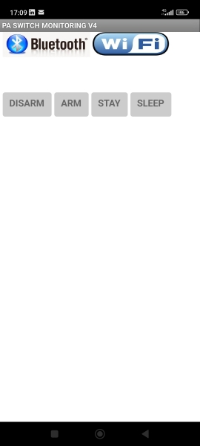
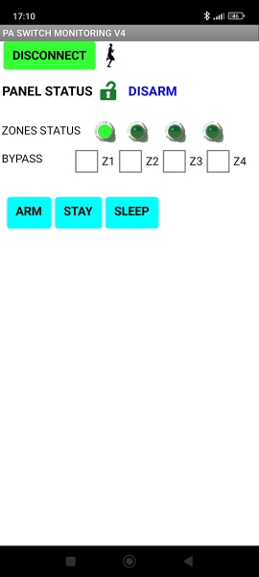
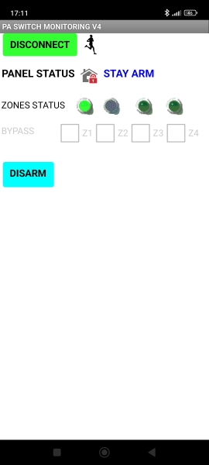

In this application, the user can choose to Bypass simply by clicking the corresponding zone
Z1-Z4. It is also possible to see the current zone status. The status of the zones is determined
by the LED color, according to the table below.

LED Color | Light Green | Dark Green | Grey | Red
Zone Status | Zone Open | Zone Closed | Zone Bypassed | Zone in Alarm

The user can choose to activate the alarm in any desired Mode → Arm – Stay – Sleep. In Stay
and Sleep mode, the zones that are FOLLOW are automatically disabled (Bypassed). whereas
only in Sleep mode, the zones that are DELAY are automatically converted to IMMEDIATE
(Instant).
Note: The runner icon shown on the application, indicate the active communication between the
Main Panel and the App. Every runner step means packet of data exchange.

