Ahadu Bank Payroll
Comprehensive Product Documentation & User Guide
Custom Odoo 18 Module for Ethiopian Banking Operations
Prepared by: Ahadu Dev Team
Website: www.ahadubank.com
Date: June 2026
Version: 18.0.1.0.0

1. Overview
The Ahadu Bank Payroll (ahadu_payroll) Odoo 18 module is built on top of Odoo 18's core HR modules and the OCA base payroll engine. It addresses the unique regulatory, fiscal, and operational requirements of the Ethiopian banking sector. It provides deep integrations between employee records, work contracts, attendance data, loan schemes, tax structures, and general ledger journal distributions.
Key objectives of the module include:
- Full automation of Ethiopian personal income tax (PIT) calculations.
- Support for local pension contributions (Employee 7%, Employer 11%).
- Complete automation of employee loans, approval workflows, and amortization schedules.
- Streamlined management of bank-specific allowances (e.g., fuel allowance, cash indemnity).
- Backpay calculations for retroactive salary adjustments.
- Integrated resignation and termination settlement processing.

2. Core Features & User Guide

2.1 Payroll Dashboard
The Payroll Dashboard provides HR Managers and Finance Executives with real-time financial KPIs and visual charts illustrating payroll trends, employee distribution, active loans, and overall financial liability.
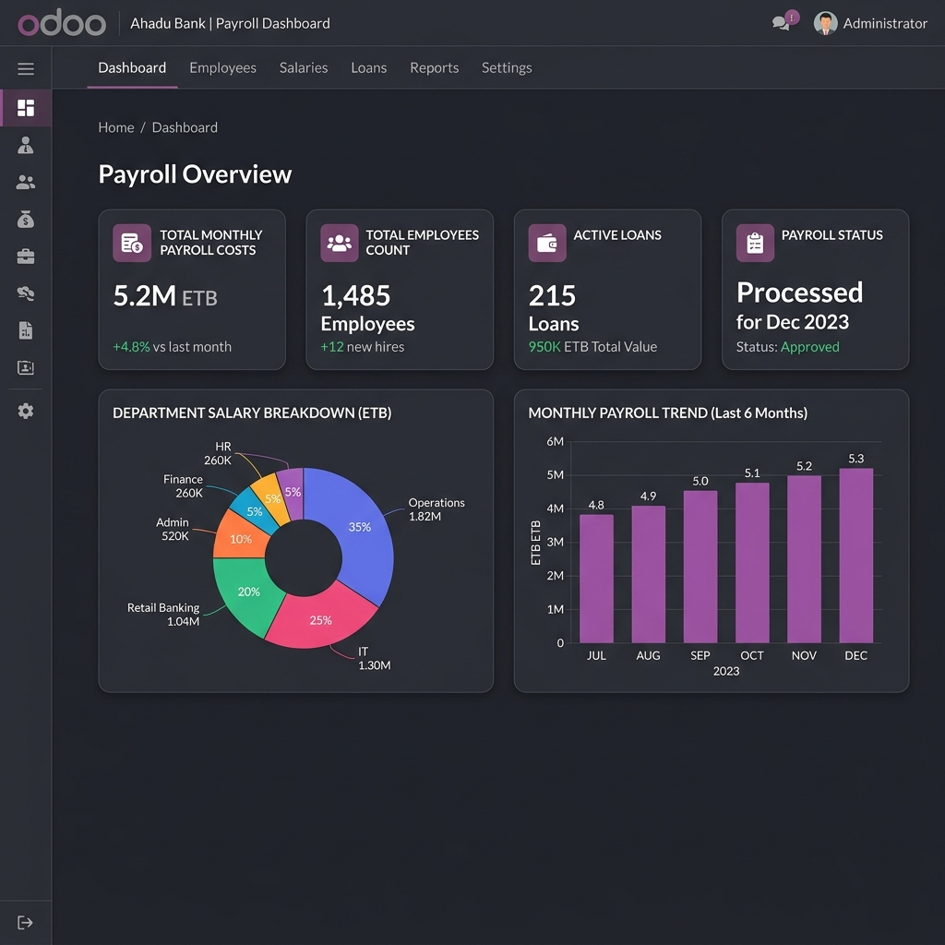
Figure 2.1: Ahadu Bank Payroll dashboard with real-time analytics KPIs.

2.2 Taxation & Parameter Configuration
Ethiopian tax laws require progressive income brackets and specific handling of taxable allowances. The taxation engine is fully configurable via the Tax Brackets screen, featuring authorization workflows (Draft -> Submitted -> Approved) to prevent unauthorized changes.
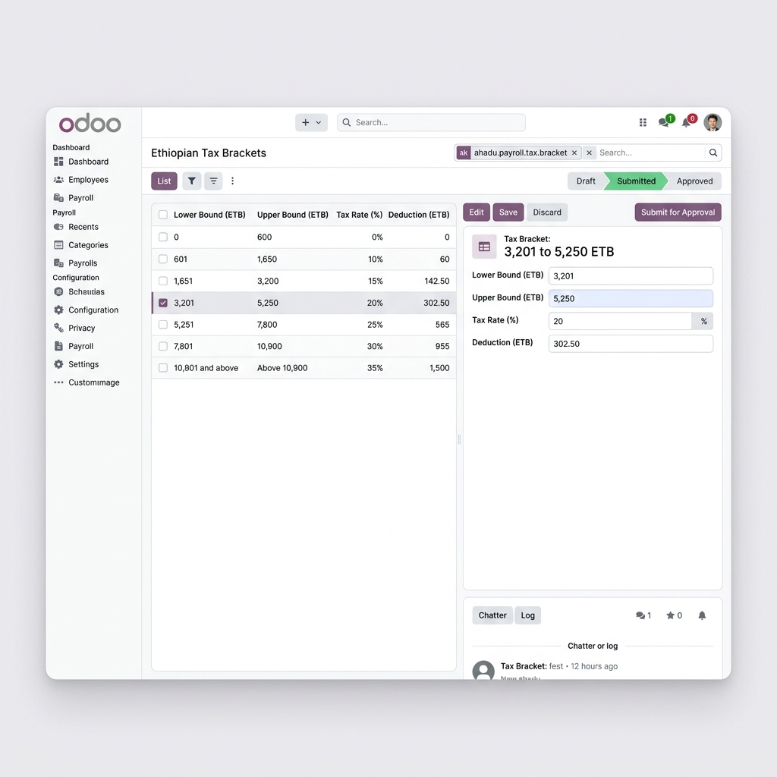
Figure 2.2: Ethiopian progressive tax bracket configuration settings.
Below are the standard Ethiopian progressive personal income tax brackets implemented in the module:
Income Range (ETB) | Tax Rate (%) | Deduction (ETB)
0 - 600 | 0% | 0.00
601 - 1,650 | 10% | 60.00
1,651 - 3,200 | 15% | 142.50
3,201 - 5,250 | 20% | 302.50
5,251 - 7,800 | 25% | 565.00
7,801 - 10,900 | 30% | 955.00
Above 10,900 | 35% | 1,500.00

2.3 Loan Management System
The module provides an automated employee loan management process. Employees or HR Officers can submit loan requests, structure installments, and track repayments. When a payslip is computed, the system automatically deducts the current installment due.
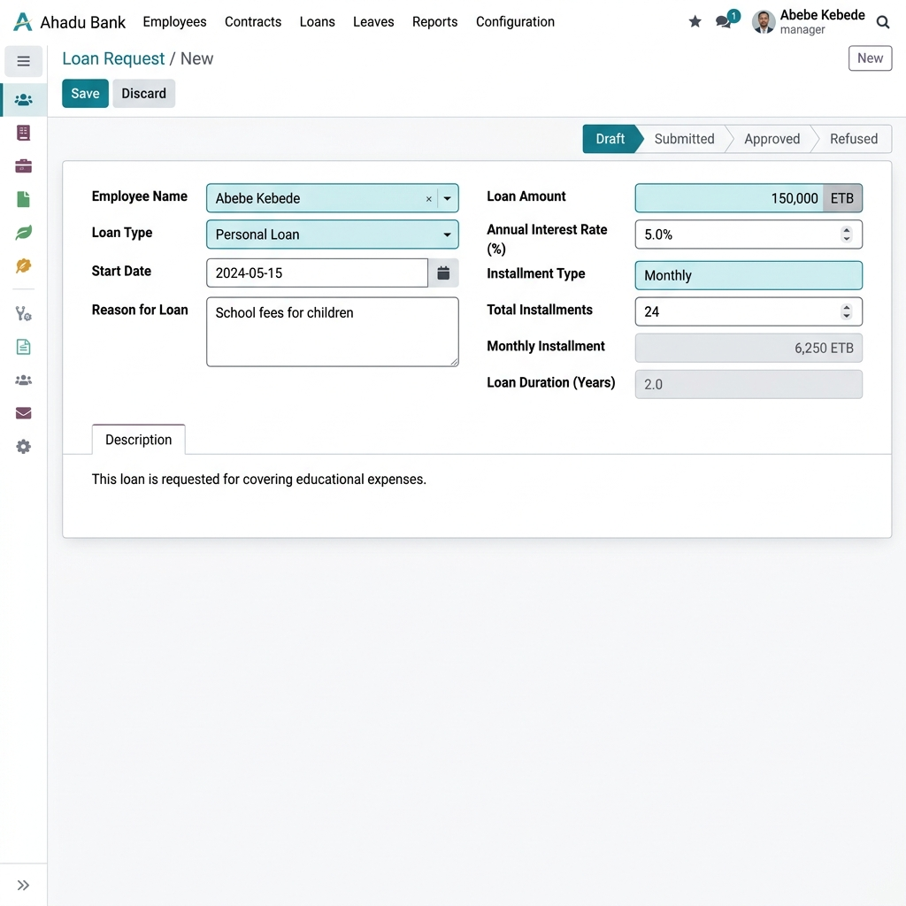
Figure 2.3: Employee loan request form showing the approval workflow states.

2.4 Overtime & Attendance Integration
Overtime requests are integrated with employee attendance verification. The module handles four overtime types applying multiplier rates relative to the hourly basic rate:
- Normal Overtime: Applied for hours worked after standard shifts (Multiplier: 1.25x).
- Night Overtime: Applied for night shifts worked between 10:00 PM and 6:00 AM (Multiplier: 1.50x).
- Sunday Overtime: Applied for weekend rest days (Multiplier: 2.00x).
- Holiday Overtime: Applied for work performed on official public holidays (Multiplier: 2.50x).
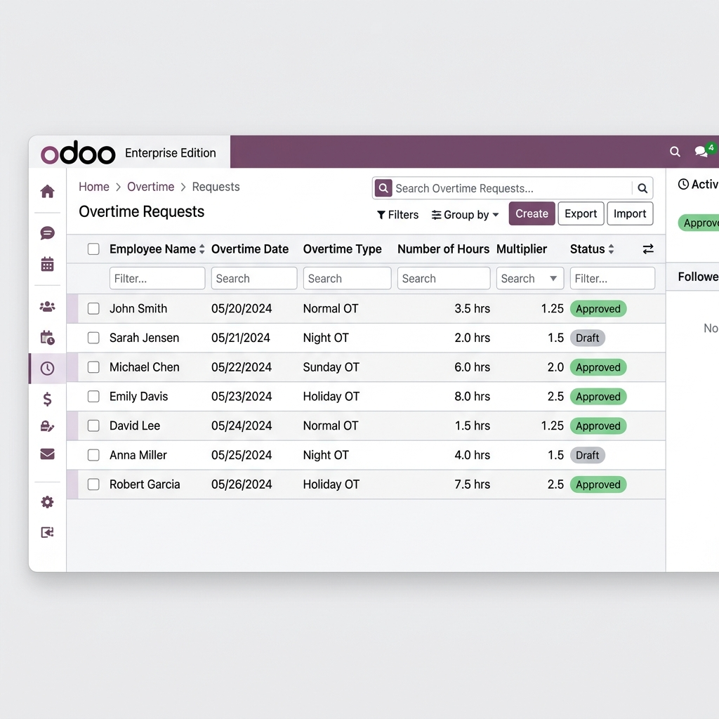
Figure 2.4: Overtime requests list view with rates and approval status.

2.5 Backpay & Retroactive Adjustments
In the event of delayed promotions or salary increments, the Backpay engine calculates the variance between what was paid and what should have been paid across a defined range of historical months. The system then automatically injects these adjusting lines into the active payroll cycle.

2.6 Bonus Management
Supports performance-based and festival-based bonus payouts. Enables customized configuration of tax-exempt portions according to company policy or governing laws.

2.7 Resignation & Termination Payslips
Automated final settlements handle employee departures smoothly. Resignation workflows calculate notice period penalties and leave encashment, while Termination workflows calculate severance payouts based on the Ethiopian Labour Proclamation (relying on years of service).

3. Technical Architecture & Data Models
The custom tables/models introduced by the module include:
Model Name | Description
hr.loan | Employee loan request records, principal amount, amortization plan.
hr.loan.line | Amortization installments mapped to active contract payroll lines.
ahadu.payroll.tax.bracket | Ethiopian personal income tax brackets details.
ahadu.payroll.tax.config | Main parameters linking tax brackets and fuel parameters.
ahadu.overtime | Employee overtime logs, hours, rates, and approval states.
ahadu.backpay | Retroactive backpay computations and adjustments.
cash.indemnity | Cash risk handling allowances for tells/cashiers.

4. Configuration & Installation

Installation Steps
- Clone or extract the ahadu_payroll module into the custom addons folder.
- Restart the Odoo 18 server.
- Activate developer mode in Odoo, go to Apps, and click 'Update Apps List'.
- Search for 'Ahadu Bank Payroll' and click Install.
- All required dependencies (hr, hr_contract, payroll, ahadu_hr_leave, ahadu_hr) will install automatically.

Post-Installation Setup Checklist
- Go to Payroll > Configuration > settings and configure Tax Brackets, setting status to Approved.
- Verify fuel prices are updated to reflect the latest tariffs.
- Verify Employee bank account records are correctly mapped in hr.employee.bank.account.
- Configure salary rules and map them to payroll accounting journal entries.

