**Installation Guide**

Software Requirement

1. JDK 1.8
2. Tomcat 9
3. Editor ex. Notepad++, Visual Studio Code, Eclipse
4. MySQL (JDBC connect database)

Setup Step

1. Go to <https://www.oracle.com/java/technologies/javase/javase8-archive-downloads.html> download & install JDK depending on OS platform

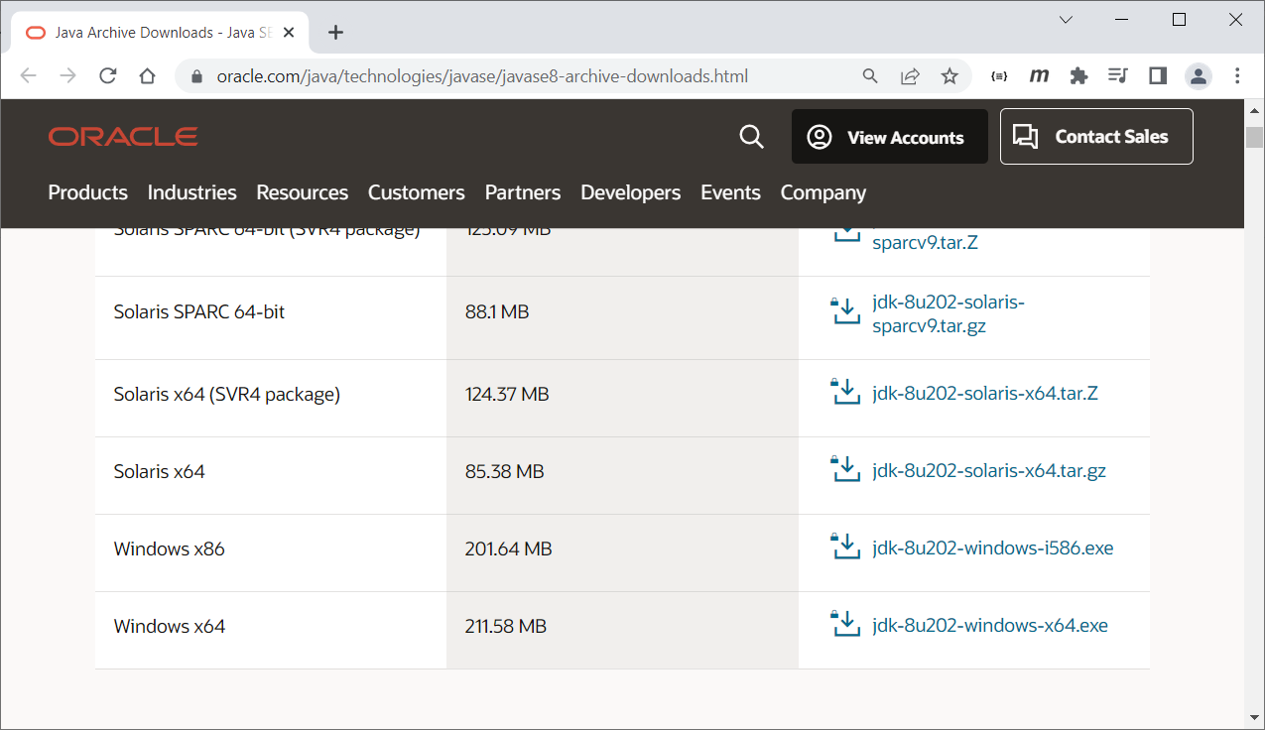

We recommend to install under drive c: with short path ex. c:\jdk180

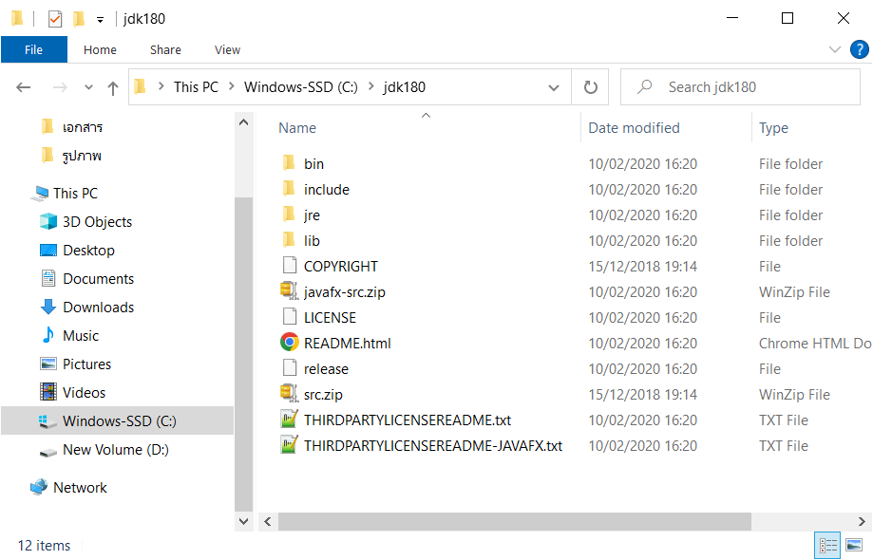

1. Try to examine that JDK is already work

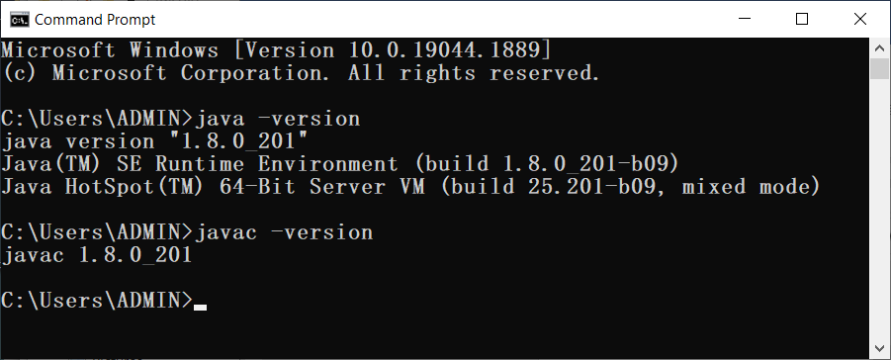

If not work try to set PATH environment point to bin directory of JDK

Settings -> System -> About -> Advanced system settings -> Advanced -> Environment Variables

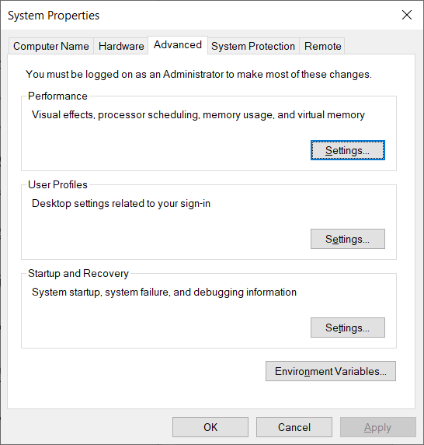

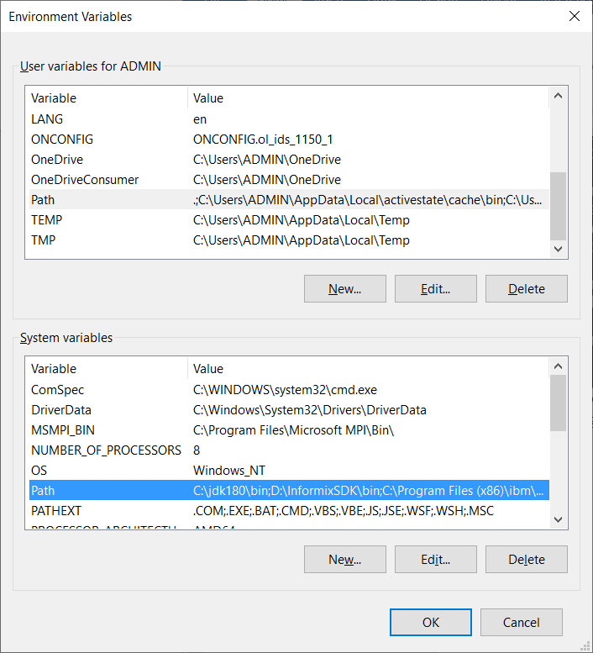

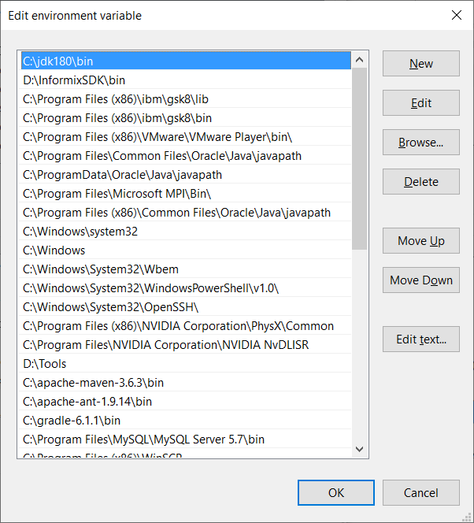

This make PATH environment point to bin directory where java.exe and javac.exe existed.

1. Go to <https://tomcat.apache.org/download-90.cgi> download & install

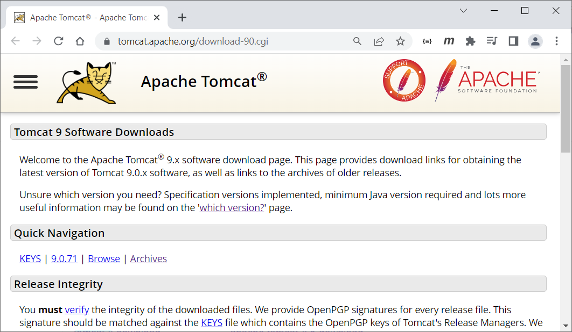

We recommend to download zip file ex. apache-tomcat-9.0.71.zip

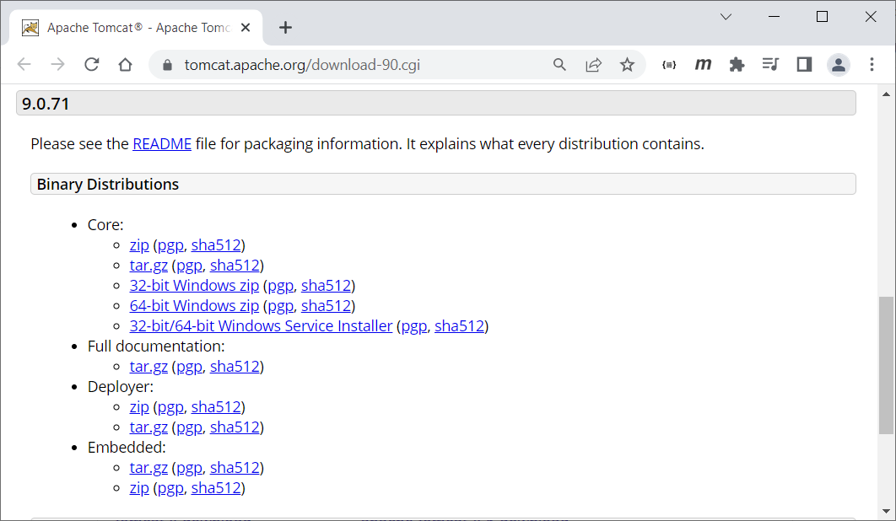

1. Try to extract or unzip tomcat zip file to your working directory ex. c:

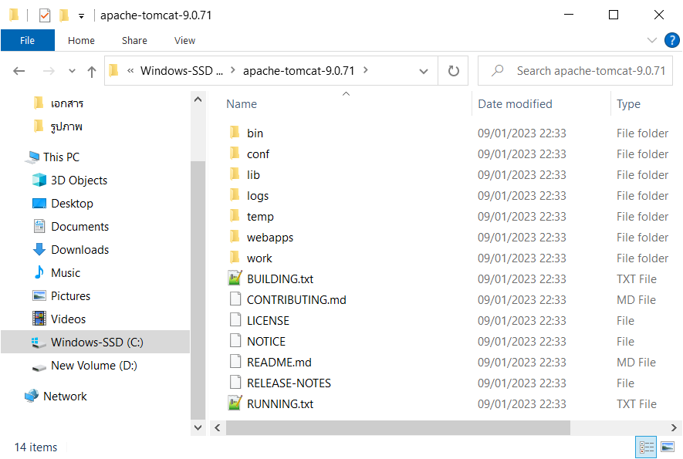

1. Go to bin directory of tomcat and launch startup.bat

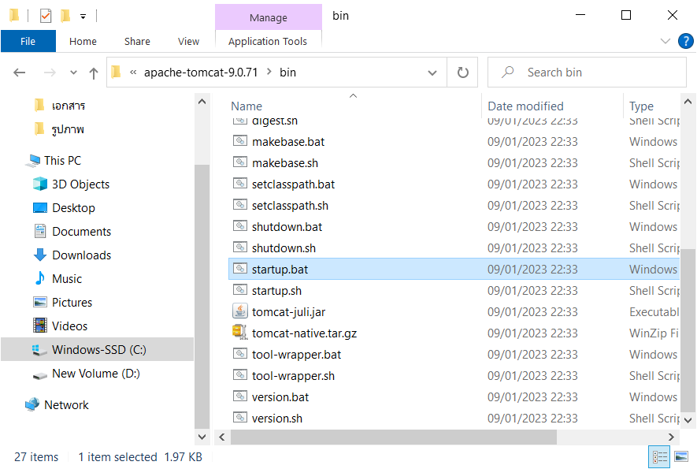

You will see console application running

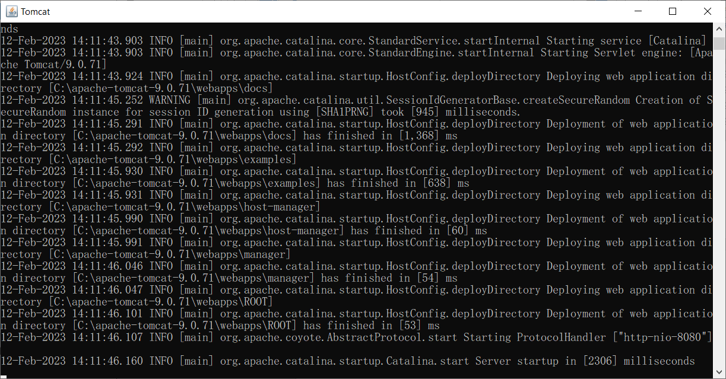

This may not work cause it required JAVA_HOME environment variables setting, then repeat step 2 with variable name JAVA_HOME=c:\jdk180

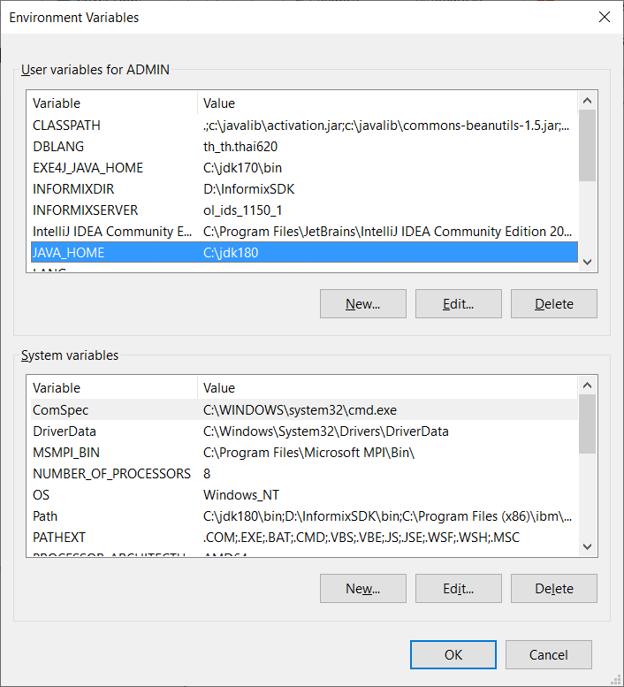

1. Try to examine tomcat is already work. Go to http://localhost:8080/

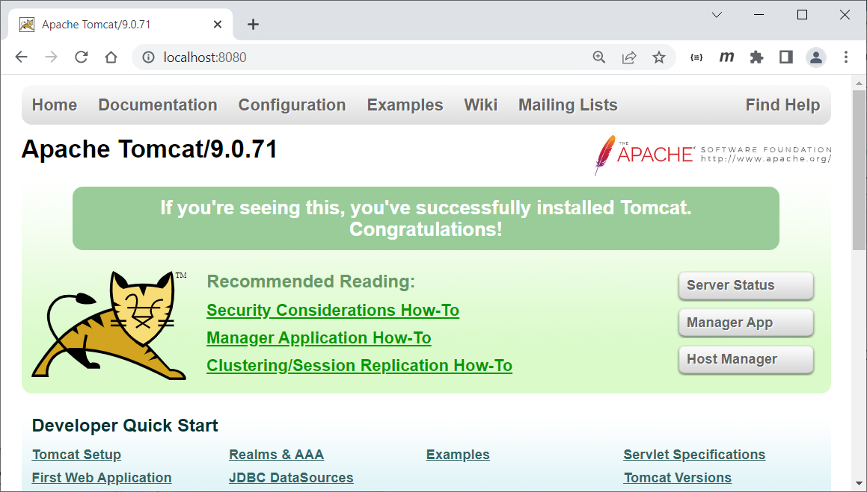

1. Extract material JSP.zip under tomcat webapps folder

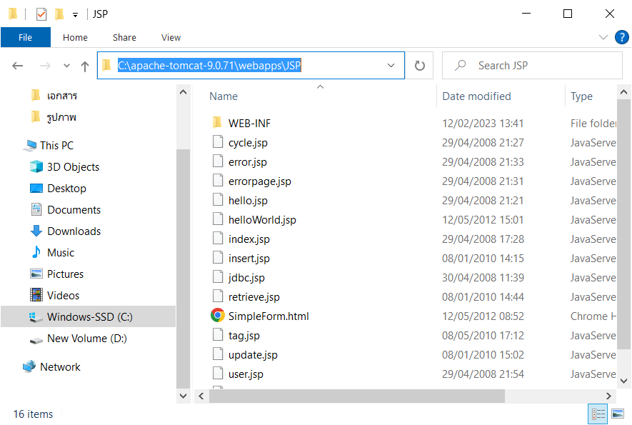

1. Try to restart tomcat service by close startup.bat console application and launch again. Then go to <http://localhost:8080/JSP/>

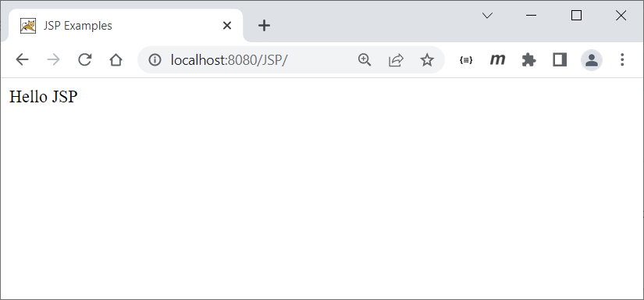

1. For editor or IDE
   1. Visual studio code , go to <https://code.visualstudio.com/download>
   2. Notepad++, go to <https://notepad-plus-plus.org/downloads/>
   3. Eclipse, go to <https://www.eclipse.org/downloads/>
2. For Database MySQL, go to <https://dev.mysql.com/downloads/installer/>

You may need mysql client administrator tool we recommend HeidiSQL

<https://www.heidisql.com/download.php>