|  |  |  |
| --- | --- | --- |
| **LAB221 Assignment** | **Type:** | **Long Assignment** |
| **Code:** | **J2.L.P0003** |
| **LOC:** | **450** |
| **Slot(s):** | **10** |

**Title: Hiding data in image using LSB (Least Significant Bit) Substitution**

**Background**

Image hiding is a technique used to embed secret data in image, i.e., data is hidden in a publishable image, but the hiding process does not damage the original image. The image in which the secret data is hidden is called a stego-image. The stego-image will not attract suspicion so that attacks can be prevented. But an intended receiver can successfully decode the secret data hidden in the stego-image.

The simplest method for hiding data is the least significant bit (LSB) method. It hides data in the least significant bit of each image pixel. Because the variation between the original pixel value and the embedded pixel value is small, the image quality is often not bad even after hiding progress is completed.

Ref: A **LS Substitution Oriented Image Hiding Strategy Using Genetic Algorithms**

Ming-Ni Wu, Min-Hui Lin, and Chin-Chen Chang

**Program Specifications**

**Hiding data in image using LSB Substitution** software is a set of 02 programs.

1. The LSB encrypt program hides a text message in a selected image using LSB Substitution method. It should allow the user to select an image to hide a secret text.
2. The LSB decrypt program extracts the text from the stego-image, in which the secret data is hidden. It should allow user to select a stego-image to get the hidden data.

**Features:**

* Hide the data

The LSB encrypt program should have user interface as:

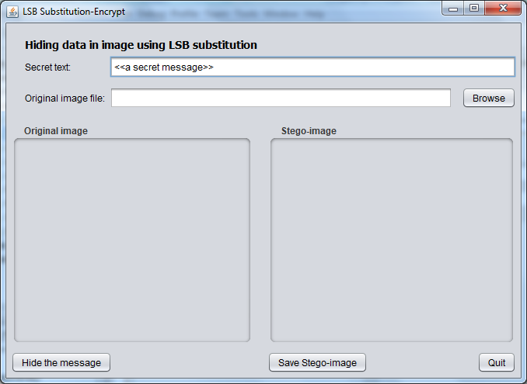

* Save the stego-image to file
* Get the hidden data

The LSB decrypt program should have user interface as:

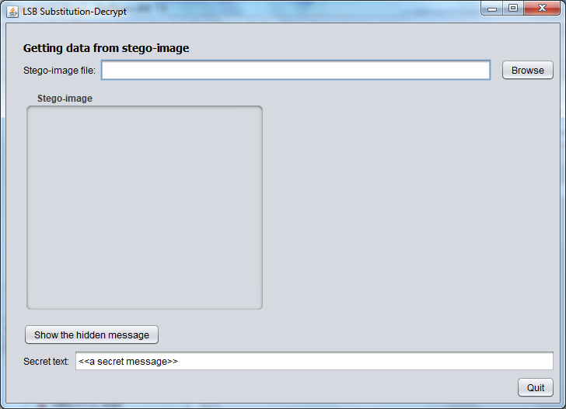

**Guidelines**

-Detect the image type (bmp, jpg, gif, png)

-Read the image data into a 2-dimensions array

-Apply LSB Substitution method to hide/extract secret message