|  |  |  |
| --- | --- | --- |
| **LAB221 Assignment** | **Type:** | **Long Assignment** |
| **Code:** | **J2.L.P0004** |
| **LOC:** | **500** |
| **Slot(s):** | **10** |

**Title: Draw Function Graph (DFG)**

**Background**

In mathematics, the graph of a function f(x) is the collection of all ordered pairs (x, f(x)). If the function input x is a scalar, the graph is a two-dimensional graph, and for a continuous function is a curve. Informally, if x is a real number and f is a real function, graph may mean the graphical representation of this collection, in the form of a line chart: a curve on a Cartesian plane, together with Cartesian axes, etc.

In science, engineering, technology, finance, and other areas, graphs are tools used for many purposes.

**Program Specifications**

The Draw Function Graph (DFG) is a small program that helps user to draw graph of a polynomial function.

It allows user to enter a function f(x), set a range of x and draw the graph. It also supports user to save the graph as an image.

**Features:**

The program should have the following GUI:

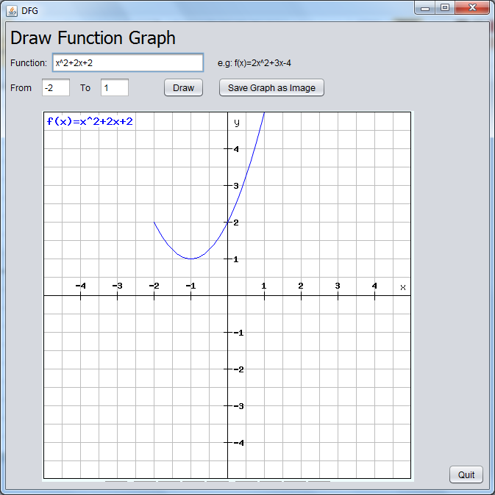

**Guidelines**

* Use Canvas component to draw graph.
* Save image in canvas to file solution:

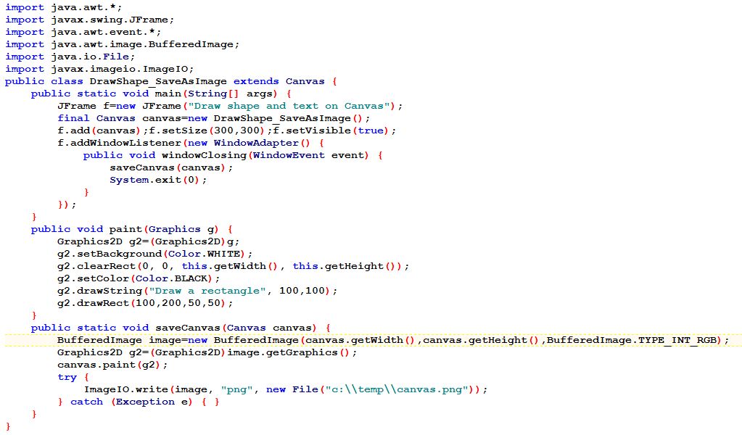

-Use stack data structure to parse the equation (use post/pre-fix notation)