|  |  |  |
| --- | --- | --- |
| **LAB221 Assignment** | **Type:** | **Long Assignment** |
| **Code:** | **J2.L.P0023** |
| **LOC:** | **300** |
| **Slot(s):** | **5** |

**Title: MyFile Explorer**

**Background**

File Explorer, previously known as Windows Explorer, is a file manager application that is included with releases of the Microsoft Windows operating system from Windows 95 onwards. It provides a graphical user interface for accessing the file systems.

Windows Explorer displays the hierarchical structure of files, folders, and drives on your computer. It also shows any network drives that have been mapped to drive letters on your computer. Using Windows Explorer, you can copy, move, rename, and search for files and folders.

**Program Specifications and Features**

MyFile Explorer is a small program that imitates the Windows Explorer with the following functions:

1. Display the hierarchical structure of folders, and drivers on your computer.
2. Copy, move, and rename file/folder.
3. Display folder properties. The following properties of a selected folder should be displayed.

Location: <path of folder>

Size: …(bytes)

Contains: .. folders, …files

1. Display file properties. The following properties of a selected file should be displayed.

Name:

Extension:

Location: <path of file>

Size: …(bytes)

The functions 2, 3, 4 are accessed by right mouse click.

***Expectation of User interface:***

When the program starts, the GUI should look like:

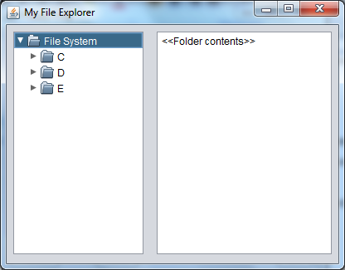

The left part is a JTree. It displays the hierarchical structure of folder (e.g: C, D, E are the drives of the computer).

The right part is a JList. It displays the files contained in the selected folder.

When user right-clicks on a file or a folder, a context menu (popup menu) is displayed. In the context menu, Copy, Move, Rename, and Properties menu items are shown. User can choose any items to do the corresponding function.

**Guidelines**

* Use File[] drives = File.listRoots(); to get the list of drives.
* Use JPopupMenu to display context menu (menu displayed when user right click on file or folder)
* Use JTree for the left part, JList for the right.
* Use recursive programming to travel the folder hierarchical structure.