|  |  |  |
| --- | --- | --- |
| **LAB221 Assignment** | **Type:** | **Short Assignment** |
| **Code:** | **J2.S.P0001** |
| **LOC:** | **42** |
| **Slot(s):** | **1** |

**Title**

Display and resize an image

**Background Context**

When it comes to images, users could have images with differences size, to have better look, we need to resize these images before displaying. This assignment will guide you how to do it.

**Program Specifications**

Create an application using java swing to create a frame look like below figure.

**1. ImageIcon.java**

Make a frame look like description below.

**2. ImageTool.java**

Complete 2 functions in this class to:

* Create an ImageICon from the path and description.
* Scale the image to fit with the size of buttons and frame.

***Function details:***

1. Display the GUI like below figure.
2. When users select a thumbnail picture, show the corresponding picture on frame and make sure that the size of picture is fitted to frame.

***Expectation of User interface:***

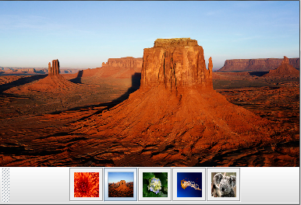

**Guidelines**