|  |  |  |
| --- | --- | --- |
| **LAB221 Assignment** | **Type:** | **Short Assignment** |
| **Code:** | **J2.S.P0002** |
| **LOC:** | **100** |
| **Slot(s):** | **2** |

**Title**

**Networking – sending files**

**Background Context**

Network is important today and one of advanced of network is sharing resources. In the network application, it’s important to make a network connection before doing any transfer data. This assignment will guide you how to do transfer data from a computer system to other one.

**Program Specifications**

Create an application using java swing to create frames like description below

1. **ServerApp.java**
2. **ClientApp.java**

***Function details:***

1. Display the frames for client and server side.
2. Client application accepts the complete path of the file to be sent to the server and the IP address of the server to which the file is to be sent. The server application is started by clicking the “Start” button. The user is asked to choose the location for saving the received files. When the client sends a file to the server a message is displayed in a text area that a file has been received from a client.

***Expectation of User interface:***

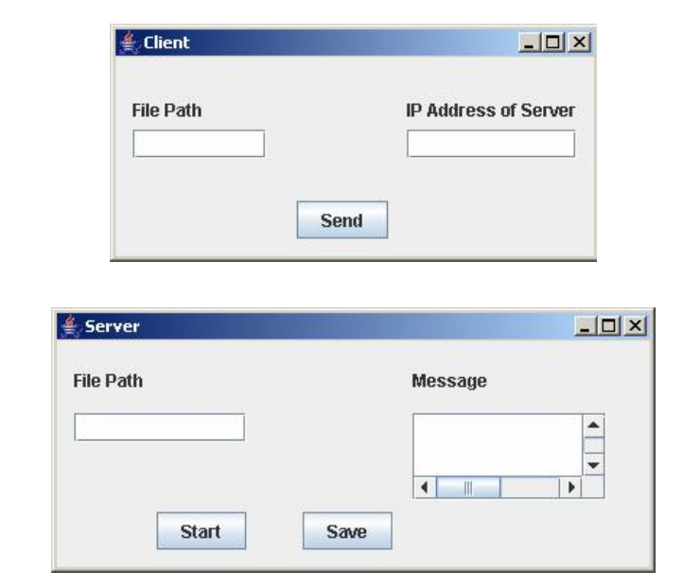

**Guidelines**