|  |  |  |
| --- | --- | --- |
| **LAB221 Assignment** | **Type:** | **Short Assignment** |
| **Code:** | **J2.S.P0006** |
| **LOC:** | **66** |
| **Slot(s):** | **1** |

**Title**

Working with JList, JCombobox and images

**Background Context**

In java, you can use JLabel component to display an image inside. An image sometime is important especially when it comes to management problem, like a contact list or product list. This assignment will guide you and show you how to display an image inside a frame.

**Program Specifications**

Create an application using java swing to create a frame look like (1) and (2)

1. **ListDemo.java**
2. **ComboboxDemo.java**

***Function details:***

1. Display the GUI like figure (1) and (2)
2. When users select an item that is also the name of an animal, display corresponding picture of selected animal.

***Expectation of User interface:***

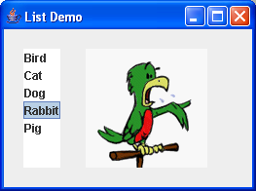***(1)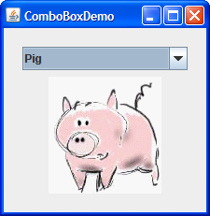 (2)***

**Guidelines**