|  |  |  |
| --- | --- | --- |
| **LAB221 Assignment** | **Type:** | **Short Assignment** |
| **Code:** | **J2.S.P0007** |
| **LOC:** | **29** |
| **Slot(s):** | **1** |

**Title**

Font family chooser (combobox)

**Background Context**

Combobox or sometimes called dropdownlist – is one of the most popular java component in almost every desktop java application. You often see this one in both desktop and web application. It allows users to select available item or sometime can edit them. This assignment will guide you how to work with list of items inside combobox and the use of them.

**Program Specifications**

Create an application using swing combobox that firstly add all the system font family to combobox and each time, when users select a particular font family from the list, update the font family of Jlabel.

**1. Main.java**

Make a frame look like description below.

***Function details:***

1. Display the GUI like figure
2. When users select a font family from the list, update the font family of below Jlabel.

***Expectation of User interface:***

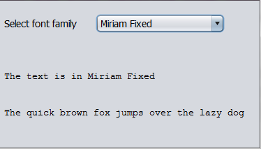

**Guidelines**

To get all system font, you can use class **GraphicsEnvironment** in the package of java.awt.