|  |  |  |
| --- | --- | --- |
| **LAB221 Assignment** | **Type:** | **Short Assignment** |
| **Code:** | **J2.S.P0009** |
| **LOC:** | **29** |
| **Slot(s):** | **1** |

**Title**

A Simple notepad

**Background Context**

We often use a very simple text editor that is available in every window family. With java swing, you can also easily make a simple notepad with basic functions of edit menu: **cut, copy, paste, select all.**

**Program Specifications**

Create an application using swing jtextarea and jmenu to create a simple notepad (1)

**1. Main.java**

Make a frame look like description below.

***Function details:***

1. Display the GUI like figure (1)
2. When users a menu item from Edit menu, the system will do corresponding task.

***Expectation of User interface:***

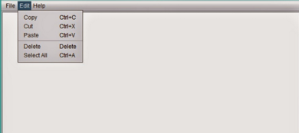 ***(1)***

**Guidelines**

You can use JTextArea for the editor.