|  |  |  |
| --- | --- | --- |
| **LAB221 Assignment** | **Type:** | **Short Assignment** |
| **Code:** | **J2.S.P0010** |
| **LOC:** | **20** |
| **Slot(s):** | **1** |

**Title**

Change background color of textarea.

**Background Context**

Working with table or charts, sometime we need to format the display of them like set background color for particular row/column.

In this assignment, you are required to make a java swing application (the design look like figure (1)). There are 4 buttons with background colors are: red, green, blue and cross button. The cross button can be used as toggle button to determine whether the background color is to be modified or the foreground.

**Program Specifications**

Create an application using java swing to create a frame look like (1)

**1. Main.java**

Make a frame look like description below.

***Function details:***

1. Display the GUI like below figure. This is simple design and requires you to make that frame by your coding.
2. When users clicks on these button do the corresponding task.

***Expectation of User interface:***

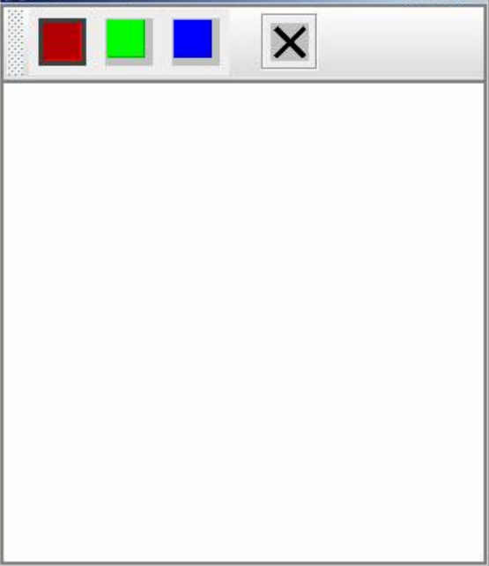 ***(1)***

**Guidelines**