|  |  |  |
| --- | --- | --- |
| **LAB221 Assignment** | **Type:** | **Short Assignment** |
| **Code:** | **J2.S.P0011** |
| **LOC:** | **64** |
| **Slot(s):** | **2** |

**Title**

Simple calculator

**Background Context**

We often use a simple calculator in window family that is available in every window family. With java swing, you can also easily make your calculator, just for some basics calculation.

**Program Specifications**

Create an application using java swing to create a simple calculator.

You can implement your application by making some classes:

**1. CalculatorLogic.java**

This class contains method for calculation like +, -, *, / or event for conversion.

**2. MyCaculator.java**

Make a GUI for simple calculator and do the calculation.

***Function details:***

1. Display the GUI like figure (1).
2. When users click on a button, do the corresponding task.

***Expectation of User interface:***

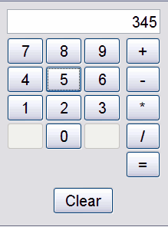 *(1)*

**Guidelines**