|  |  |  |
| --- | --- | --- |
| **LAB221 Assignment** | **Type:** | **Short Assignment** |
| **Code:** | **J2.S.P0012** |
| **LOC:** | **20** |
| **Slot(s):** | **1** |

**Title**

A puzzle game with number.

**Background Context**

A puzzle is a game, problem, or toy that tests a person's ingenuity or knowledge. In a puzzle, one is required to put pieces together in a logical way, in order to arrive at the correct solution of the puzzle.

In this assignment, you are required to design a simple puzzle game with number, there are 9 buttons (label from 1 to 8) a special button with label is empty. Randomly the position of these buttons.

Users are allow to switch/swap/exchange an empty button with the one next to left/right/top/bottom, until the empty button reach to the button that is on the top left most. Also display the number of clicks on these button to be able to move the empty button to the top left most.

**Program Specifications**

Create an application using java swing to create a simple puzzle game look like (1)

**1. Main.java**

Make a frame look like description below.

***Function details:***

1. Display the GUI like figure (1). The design is quite simple and requires you to design it manually.
2. Switch/swap/exchange an empty button with the one next to left/right/top/bottom, until the empty button reach to the button that is on the top left most.

***Expectation of User interface:***

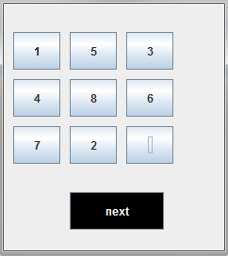 ***(1)***

**Guidelines**