|  |  |  |
| --- | --- | --- |
| **LAB221 Assignment** | **Type:** | **Short Assignment** |
| **Code:** | **J2.S.P0013** |
| **LOC:** | **30** |
| **Slot(s):** | **1** |

**Title**

A puzzle game with images.

**Background Context**

A puzzle is a game, problem, or toy that tests a person's ingenuity or knowledge. In a puzzle, one is required to put pieces together in a logical way, in order to arrive at the correct solution of the puzzle.

In this assignment, you are required to design a simple puzzle game with icons; there are 9 buttons (label from 1 to 8) a special button with icon **star**. Randomly the position of these buttons for each running time.

Users are allow to switch/swap/exchange an empty button with the one next to left/right/top/bottom, until the star button reach to the button that is on the top left most. Also display the number of clicks on these buttons to be able to move the empty button to the top left most.

**Program Specifications**

Create an application using java swing to create a simple puzzle game look like (1).

**1. Main.java**

Make a frame look like description below.

***Function details:***

1. Display the GUI like figure (1).
2. Switch/swap/exchange an empty button with the one next to left/right/top/bottom, until the star button reach to the button that is on the top left most.

***Expectation of User interface:***

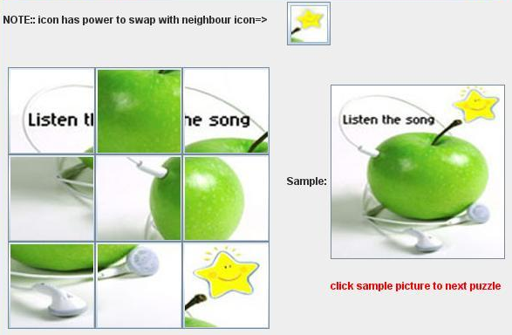 ***(1)***

**Guidelines**