|  |  |  |
| --- | --- | --- |
| **LAB221 Assignment** | **Type:** | **Short Assignment** |
| **Code:** | **J2.S.P0014** |
| **LOC:** | **20** |
| **Slot(s):** | **1** |

**Title**

Advanced notepad

**Background Context**

To complete your notepad with enrichment features. Open the J2.S.P0009 assignment and add more features for your notepad, this time, use java.io **to load, save, open and print a text document**

**Program Specifications**

Create an application using swing jtextarea and jmenu to create an advanced notepad (1) and (2).

**1. Main.java**

Make a frame look like description below.

***Function details:***

1. Display the GUI like figure (1) and (2).
2. When users a menu item from Edit menu, the system will do corresponding tasks.

***Expectation of User interface:***

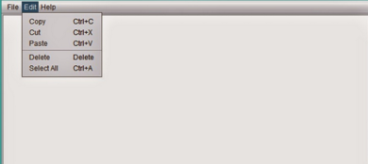 *(1)*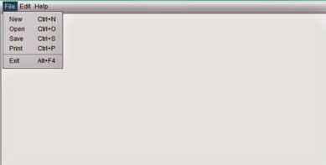(2)

**Guidelines**

You can use JTextArea for the editor.